RL HW4 Report: PPO on Pendulum-v1
Team: Abhijeet Pandey, Ganesh Adhikari (R12032481), Vishal Thapa

Team Contribution Statement
All team members will work together through group discussion, shared coding, testing, debugging, experiments, plotting, and final analysis. Tasks were reviewed collaboratively before final submission.

Task 1: Environment Loop and Replay Buffer
We implemented a Pendulum-v1 interaction loop and a replay buffer to store one-step transitions. The buffer records states, actions, rewards, done flags, and reward-to-go targets. Actions are sampled from a Gaussian policy head (mean + log-std), tanh-squashed, and then rescaled into the environment action bounds. This design keeps action sampling differentiable at the policy level while enforcing valid control limits.

Task 2: Vanilla Policy Gradient (VPG)
We trained VPG with rewards-to-go using two step sizes (1e-4 and 3e-4). Both runs are noisy, which is expected because vanilla policy gradients have high variance and no trust-region style update constraint. The larger step size (3e-4) tends to move the policy faster, so it can improve earlier but also shows larger oscillations when gradient estimates are noisy. Mechanistically, a larger update can overshoot to a worse policy because each batch gradient is only an estimate of the true objective. The smaller step size (1e-4) is more conservative and therefore typically more stable per update, but convergence is slower because each parameter step is small. For this task, the practical trade-off is speed versus stability: larger step sizes may reach good returns faster but with higher volatility, while smaller step sizes reduce volatility at the cost of slower improvement.
Figure: Task 2 learning curves (rewards-to-go, two learning rates).
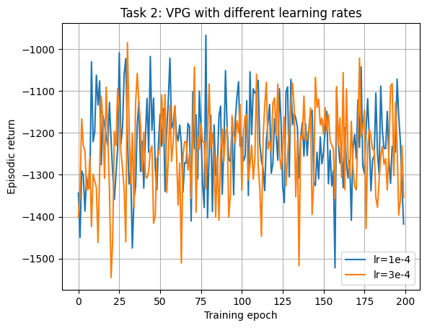

Task 3: Critic + GAE
We compared rewards-to-go against a critic-based advantage estimator using GAE. In this run, the GAE curve underperforms rewards-to-go. This is plausible when the value baseline is not yet accurate: GAE computes advantages from temporal-difference residuals, so errors in V(s) directly affect the policy gradient target. GAE is controlled by lambda (here 0.95), which sets a bias-variance trade-off: lambda -> 1 approaches Monte Carlo advantages (lower bias, higher variance), while smaller lambda uses shorter-horizon bootstrapping (higher bias, lower variance). In theory GAE improves learning by reducing variance enough to make updates more sample efficient; in practice it helps only if the critic is sufficiently well trained and synchronized with policy updates. Our result suggests critic quality or optimization mismatch limited that benefit in this experiment.
Figure: Task 3 learning curves (rewards-to-go vs GAE).
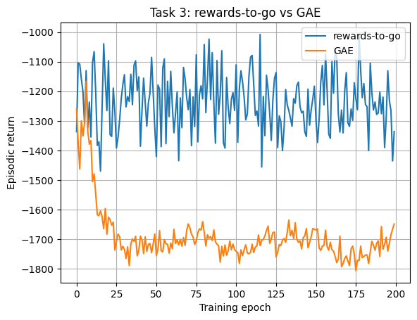

Task 4: PPO Surrogate Objective
We compared unclipped and clipped PPO objectives. PPO uses the likelihood ratio r_{t}(θ) = π_{θ}(a_{t}|s_{t}) / π_{θ,old}(a_{t}|s_{t}) and optimizes a surrogate based on r_{t}(θ)A_{t}. The clipped form uses min(r_{t}(θ)A_{t}, clip(r_{t}(θ), 1−ε, 1+ε)A_{t}), with ε = 0.2 in our runs. The purpose of clipping is to stop policy updates from moving too far in one step when advantages are large or noisy. Without clipping, maximizing r_{t}(θ)A_{t} can incentivize overly aggressive updates that temporarily improve the surrogate but degrade true performance, which appears as larger swings in episodic return. Our curves match this mechanism: the unclipped variant has higher volatility and sharper drops, while clipping produces steadier progress by acting as an implicit trust region around the old policy.
Figure: Task 4 episodic return (clipped vs unclipped).
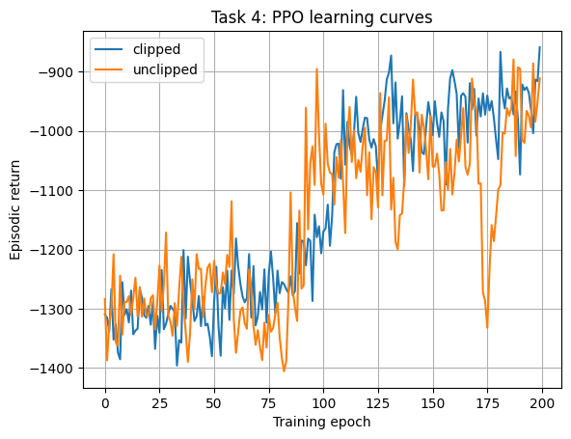
Figure: Task 4 loss curves (clipped vs unclipped).
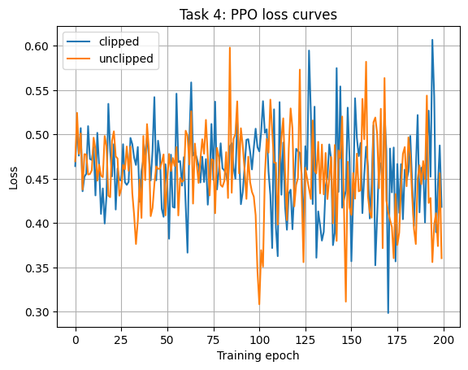

Task 5: Full PPO
For full PPO we used GAE + clipping + multiple SGD epochs per batch, and compared learning rates 1e-4 vs 3e-4. Final performance is higher for 3e-4 in this run, indicating faster policy improvement, while 1e-4 remains more conservative. The component roles are complementary: GAE reduces gradient variance (if the critic is reliable), clipping limits destructive policy jumps, and repeated minibatch updates improve sample efficiency from collected trajectories. Hyperparameter sensitivity is visible even in this small sweep. Learning rate controls update magnitude; clip epsilon controls how tightly updates are constrained; lambda controls bias-variance in advantages; and SGD epochs/minibatch settings control how strongly each rollout batch is fit before new data is gathered. A practical interpretation is that PPO stability comes from balancing these terms, not from any single parameter. In our results, 3e-4 gave better returns but with higher loss volatility, which is consistent with stronger optimization pressure.
Figure: Task 5 episodic return (learning-rate sweep).
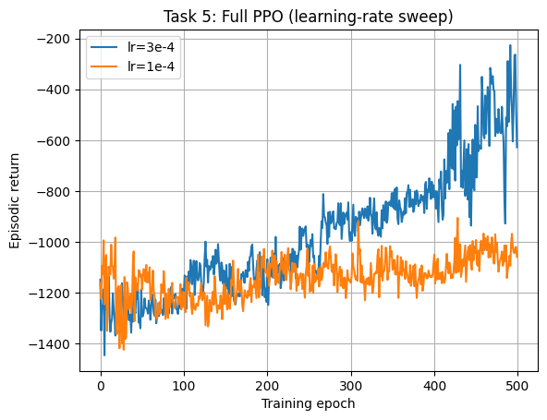
Figure: Task 5 total loss (learning-rate sweep).
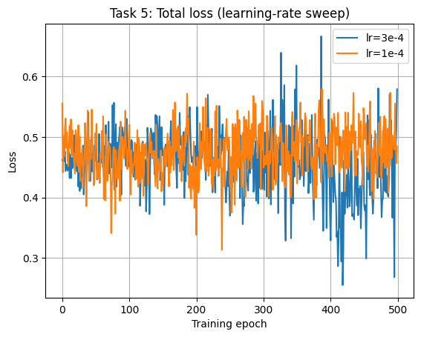

Hyperparameters (Key Defaults)
Discount gamma=0.99, GAE lambda=0.95, PPO clip eps=0.2, learning rate=3e-4 (and 1e-4 for the sweep), steps per iteration=2048, SGD epochs=10, hidden size=64.

