HACKER RANK DIY

Just a fun project trying to replicate the working of a code editor on competitive programming sites ,

Working :

Two python files are used

* Main.py which contains all the necessary print functions and write functions which updates the second file submission.py.
* Line by line input is taken using while loop.
* Subprocess library is used to execute submission.py right after giving input.
* Print output is redirected to variable named output to compare it with correct answer using io library .

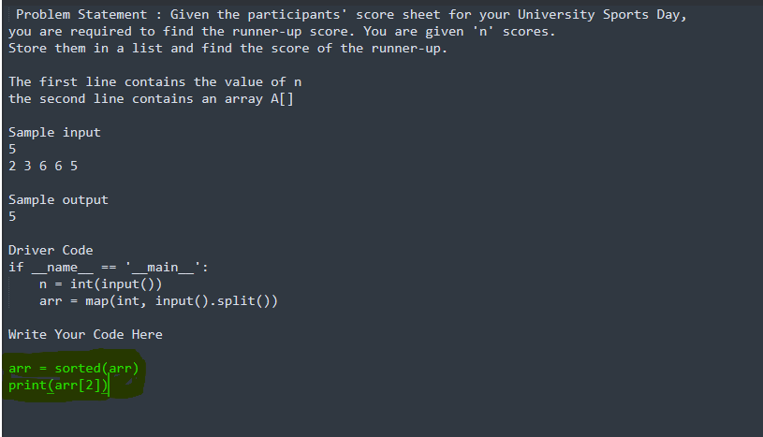

Fig 1: input given is highlighted

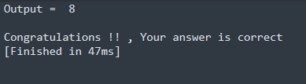

Fig 2