EXPERIMENT 1

*INTRODUCTION TO JAVA ENVIRONMENT*

* INSTALLATION OF JDK
* SETTING PATH AND CLASS PATH
* INTRODUCTION TO IDE (ECLIPSE)

INSTALLING JDK

**Step 1** Go to <https://www.oracle.com/java/technologies/javase-downloads.html> Click on JDK Download for Java JDK download.

**Step 2** When you click on the Installation link the popup will be open. Login by creating an account with basic credentials.

**Step 3** Once the Java JDK 8 download is complete, run the exe for install JDK. Click Next

**Step 4** Once you install Java in windows, click Close.

SETTING ENVIRONMENTAL VARIABLES

**Step 1** Right Click on the My Computer and Select the properties

**Step 2** Click on advanced system settings

**Step 3** Click on Environment Variables

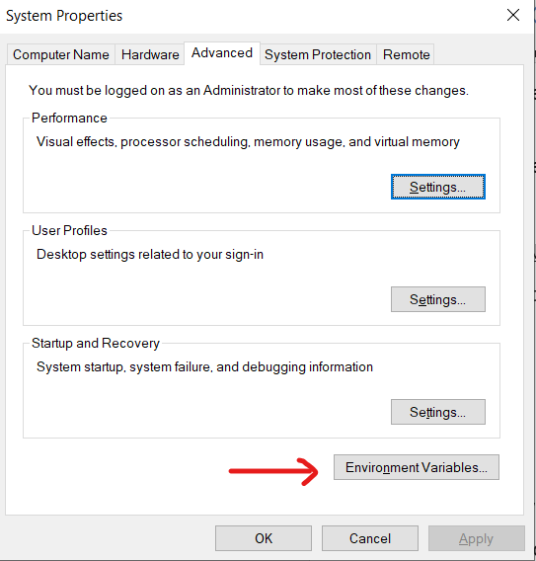

**Step 4** Click on new Button of User variables

**Step 5** Type PATH in the Variable name.

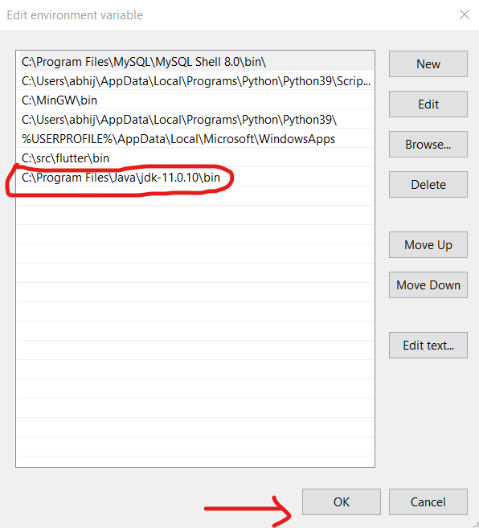

**Step 6** Copy the path of bin folder which is installed in JDK folder.

**Step 8**We followed a similar process to set CLASSPATH.

**Step 10** Go to command prompt and type javac commands.

If you see a screen like below, Java is installed.

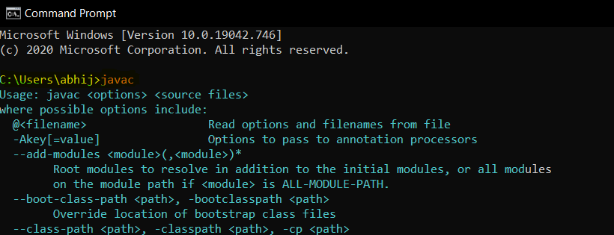

SETTING UP IDE

**Step 1** Navigate to the following URL – <https://www.eclipse.org/downloads/packages/> and select the download link depending on your system architecture – (Windows, Mac OS or Linux) and download it.

**Step 2**Once the download is over, extract the zipped file by right-clicking on the folder and choose **Extract All**.

**Step 4** After extracting files, open the folder and launch**eclipse.exe.**

**Step 5** Then, we have to choose the Launch directory for Eclipse and then click on Launch.

___________________________________________________________________