EXPERIMENT 2

BASIC JAVA PROGRAMMING

Implement these programs using notepad and terminal, as discussed in class.

* Setting up terminal, directory and executing file:
* OPEN COMMAND PROMPT
* CREATE DIRECTORY USING **mkdir**
* OPEN NOTEPAD WITH CLASS NAME USING **notepad class_name.java**
* WRITE JAVA CODE FOR DESIRED QUESTION IN NOTEPAD AND SAVE IT
* TYPE **javac class_name.java** CODE.
* TYPE **dir** IN TERMINAL IF YOU SEE A FILE NAMED **class_name.class** YOUR CODE WAS COMPILED SUCCESSFULLY
* TYPE **java class_name**  TO RUN THE PROGRAM AND SEE OUTPUT
* 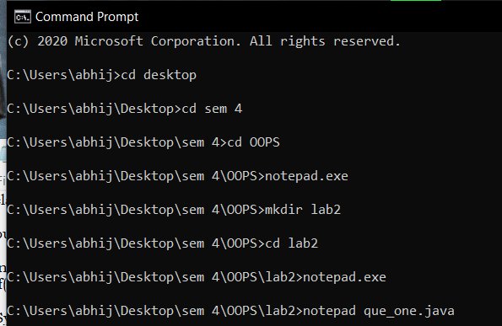

1. WRITE A PROGRAM TO FIND LARGEST OF THREE GIVEN NUMERS:

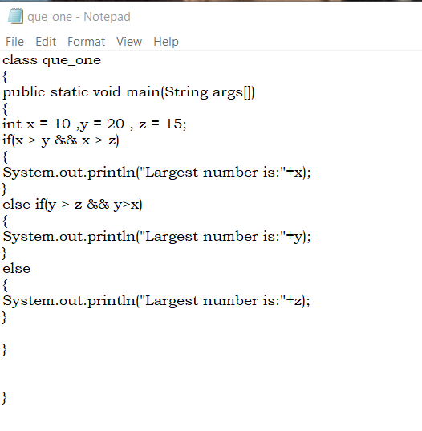

OUTPUT –

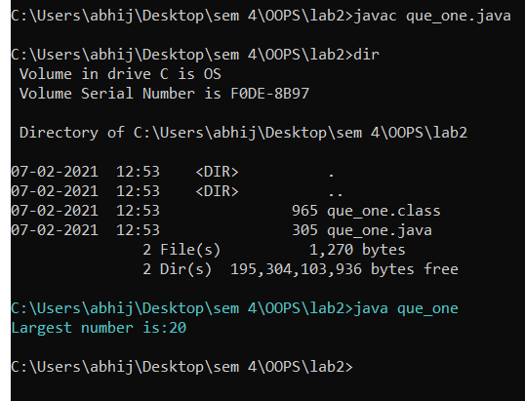

1. WRITE A PROGRAM TO IMPLEMENT A COMMMAND LINE CALCULATOR:

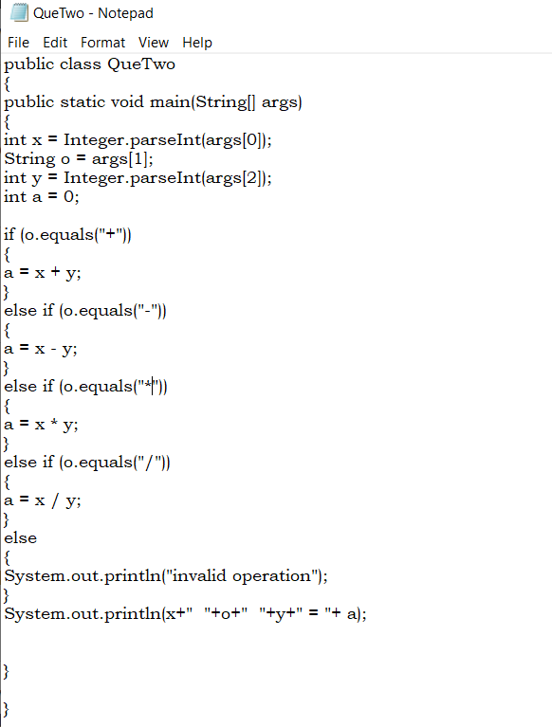

OUTPUT –

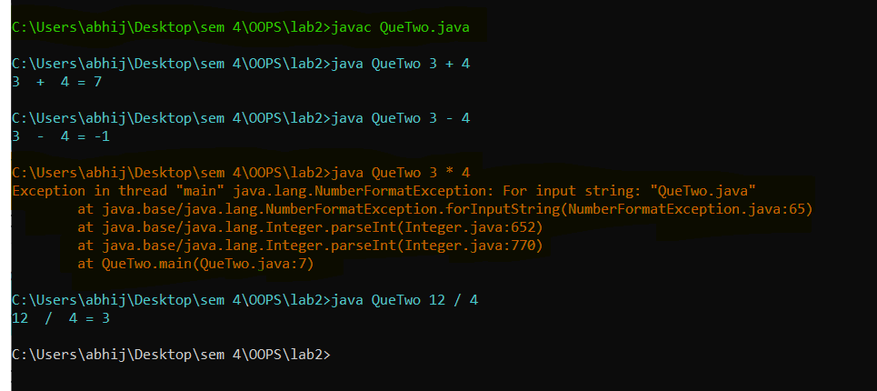

* ADDITION ,SUBTRACTION AND DIVISION WORKED FINE BUT MULTIPLICATION WAS RAISING ERRORS (MARKED IN ORANGE)

3) WRITE A PROGRAM USING CLASSES AND OBJECT IN JAVA:

Creating states and behaviours

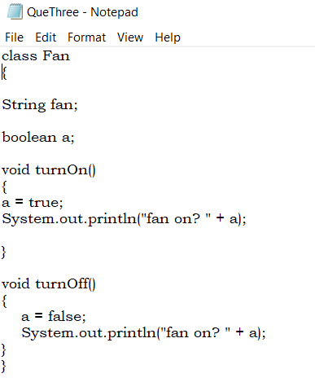

Creating objects

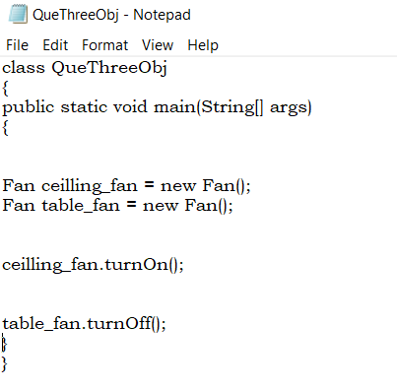

OUTPUT-



