

MINI PROJECT SYNOPSIS
ON

IntelliReport AI: A Multi-Agent AI Report Generation System

SY MCA
A.Y 2026-2027
Division – A

PROJECT MEMBERS

Sr. No. | Name | PRN No.
1 | Abhijeet Khot | 1272250081
2 | Niveedita Deshpande | 1272250104

Under the Guidance of
Mrs. Apurva Sharma
Department of Computer Science and Applications
School of Computer Science and Engineering
DR. VISHWANATH KARAD MIT WORLD PEACE UNIVERSITY, PUNE, MAHARASHTRA, INDIA -411038

TABLE OF CONTENTS

SR.NO | TOPIC
1 | Introduction
2 | Problem Statement
3 | Objectives
4 | Use-Case Diagram and Work-Flow Diagram
5 | Proposed Solution
6 | Scope
7 | Tools/Technologies
8 | System Architecture
9 | Modules
10 | Expected Outcomes
11 | References

1. INTRODUCTION
Artificial Intelligence (AI) has transformed the way information is processed, analyzed, and presented across various industries. Large Language Models (LLMs) such as Google's Gemini have significantly improved the capability of machines to understand and generate human-like text. However, generating high-quality technical reports still requires multiple stages including research, content organization, writing, review, and formatting, which are often performed manually and consume considerable time and effort.
To address this challenge, IntelliReport AI is proposed as a Multi-Agent AI-based Report Generation System that automates the complete report creation process. The system employs seven specialized AI agents, namely the Research Agent, Outline Agent, Writer Agent, Grammar Agent, Fact Checker Agent, Citation Agent, and Reviewer Agent. Each agent performs a dedicated responsibility within the workflow to ensure high-quality, structured, and professionally reviewed reports. The complete workflow is orchestrated using LangGraph, allowing seamless communication between agents through a shared state architecture.
The application is developed using Python and Streamlit for the user interface, LangGraph for orchestrating the multi-agent workflow, LangChain for AI integration, and Google's Gemini API as the underlying Large Language Model. The generated reports are available in a professional format and can be exported as PDF documents.
The project demonstrates how Multi-Agent AI Systems can improve productivity, ensure consistency, reduce manual effort, and generate professional-quality reports with minimal user interaction.

2. PROBLEM STATEMENT
Preparing professional reports manually requires extensive research, logical organization, technical writing skills, and proofreading. The traditional process is time-consuming and often results in inconsistencies, grammatical errors, incomplete information, and poor formatting.
Although modern AI tools can generate text, most applications rely on a single AI model to perform all tasks simultaneously. Such an approach often produces generic content without structured planning or quality review.
Therefore, there is a need for an intelligent report generation system capable of dividing the report creation process into specialized stages using multiple AI agents. This project aims to design and develop a Multi-Agent AI application that automates research, outline creation, report writing, and technical review while producing accurate, well-structured, and professional reports. Existing AI tools generally rely on a single language model without task specialization, resulting in inconsistent report quality and lack of verification mechanisms such as grammar correction, fact checking, and citation generation.

3. OBJECTIVES
The primary objectives of the proposed system are:
• To automate professional report generation using Artificial Intelligence.
• To implement a Multi-Agent Architecture for task specialization.
• To generate structured research and report outlines automatically.
• To produce detailed, well-formatted technical reports.
• To review reports for grammar, readability, and completeness.
• To provide downloadable reports in PDF format.
• To reduce manual effort and report preparation time.
• To demonstrate practical implementation of LangGraph-based Multi-Agent Systems.

4. USE-CASE DIAGRAM & WORKFLOW DIAGRAM
Workflow :
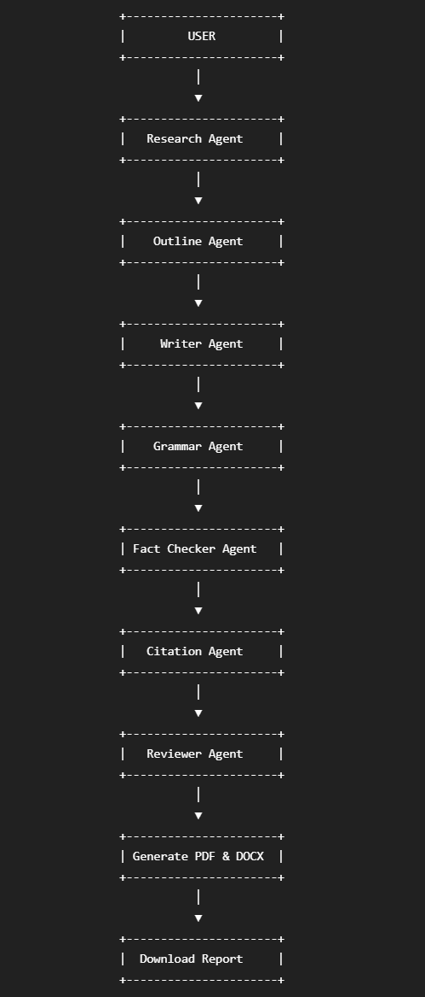

Use Case Description
The user enters the report topic through the Streamlit interface. The system initiates the Multi-Agent workflow where individual AI agents perform research, create the report outline, write the report, review the generated content, and finally provide downloadable reports.

5. PROPOSED SOLUTION
IntelliReport AI is a web-based Multi-Agent Artificial Intelligence application developed to automate professional report generation. Instead of depending on a single AI model, the proposed system divides the entire report creation process into seven specialized AI agents.
The Research Agent gathers detailed information about the selected topic. The Outline Agent prepares a logical structure for the report. The Writer Agent generates detailed content based on the outline. The Grammar Agent improves language quality and readability. The Fact Checker Agent verifies logical consistency and factual correctness. The Citation Agent prepares citation-ready content, while the Reviewer Agent performs final quality assessment before presenting the report.
The workflow is managed using LangGraph, whereas Google's Gemini API powers every AI agent. Users can download the final report in PDF and Microsoft Word formats through the Streamlit web application.

6. SCOPE
The proposed system has applications in educational institutions, research organizations, industries, and corporate environments where technical documentation is frequently required.
The system can be used for:
• Academic project reports
• Research documentation
• Technical documentation
• Business reports
• Market analysis reports
• Literature reviews
• Seminar reports
• AI-assisted academic documentation

• Automated professional documentation

• Enterprise report generation
• AI-powered technical documentation

Future enhancements include:
- Internet-enabled Real-Time Research
- Retrieval Augmented Generation (RAG)
- Multi-language Reports
- PowerPoint Generation
- AI Image Generation
- Cloud Deployment
- Database Integration
- User Authentication

7. TOOLS / TECHNOLOGIES
Technology | Purpose
Python | Backend Programming
Streamlit | User Interface
LangGraph | Multi-Agent Workflow
LangChain | LLM Integration
Google Gemini API | AI Model
ReportLab | PDF Export
python-docx | Word Export
Pillow | Logo/Image Processing
VS Code | IDE
Git & GitHub | Version Control

8. SYSTEM ARCHITECTURE
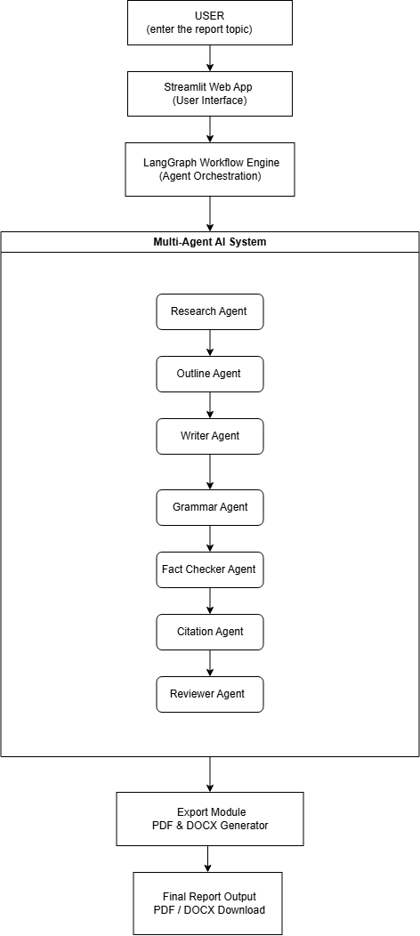
Figure 8.1: System Architecture of IntelliReport AI
The system architecture illustrates the sequential execution of seven specialized AI agents orchestrated using LangGraph. The Streamlit interface accepts the report topic, executes the complete workflow, and generates downloadable PDF and DOCX reports after automated research, writing, grammar correction, fact verification, citation generation, and final review.

9. MODULES

Module 1 – User Interface
Provides the Streamlit-based interface for entering report topics, viewing analytics, and downloading generated reports.

Module 2 – Research Agent
Collects detailed information using Google Gemini AI.

Module 3 – Outline Agent
Creates a structured outline based on research.

Module 4 – Writer Agent
Generates the complete technical report.

Module 5 – Grammar Agent
Improves grammar, readability, spelling, and sentence structure.

Module 6 – Fact Checker Agent
Reviews the generated report to identify factual inconsistencies and improve content reliability.

Module 7 – Citation Agent
Enhances the report by preparing citation-ready content and improving document credibility.

Module 8 – Reviewer Agent
Evaluates grammar, readability, completeness, and overall report quality.

Module 9 – Report Export Module
Generates downloadable PDF and Microsoft Word reports.

10. EXPECTED OUTCOMES
The proposed system is expected to:
• Automated professional report generation

• Improved report accuracy

• Better grammar and readability

• Structured technical reports
• AI-assisted content verification

• Citation-ready documentation

• Reduced report preparation time

• Professional PDF and Word export
• Demonstration of LangGraph Multi-Agent AI architecture

11. REFERENCES
- LangGraph Documentation – https://langchain-ai.github.io/langgraph/
- LangChain Documentation – https://python.langchain.com/
- Google Gemini API Documentation – https://ai.google.dev/
- Streamlit Documentation – https://streamlit.io/
- Python Documentation – https://docs.python.org/
- ReportLab User Guide – https://www.reportlab.com/
- Google AI Studio Documentation
- Research Papers on Multi-Agent Systems and Large Language Models

