**ME543**

**Assignment 1**

**Abhijeet**

**234103001**

**Problem 1:-** grid size delx=dely=0.2

J is use for y-axis. From 1 to 21.

I is used for x-axis. From 1 to 31.

1. Jacobi iterative method

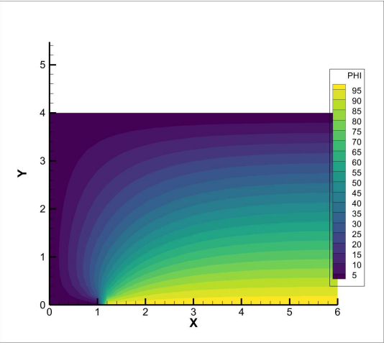

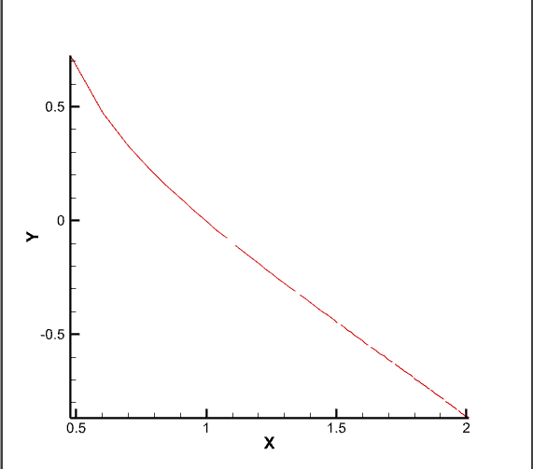 Log_iteration VS log_error plot

X-Axis= log(iteration)

Y-Axis=log(error)

For error =1e-8

Number of iterations are **2487**

Txt file of iteration vs error is attached with the code.

1. Point Gauss-Seidel iterative method.

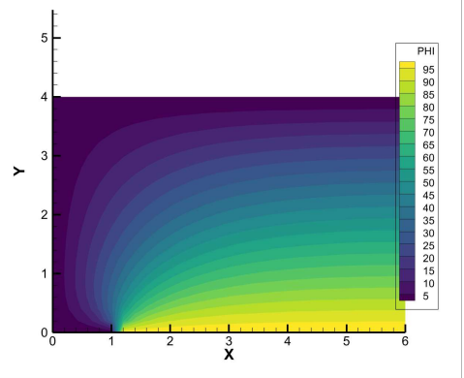

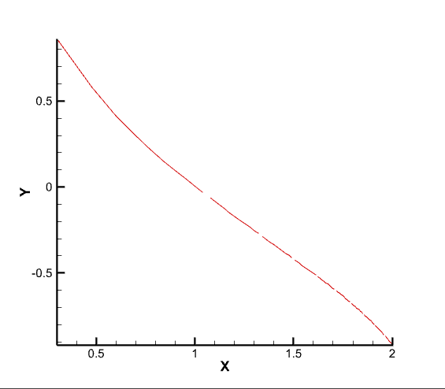

Log_iteration VS log_error plot

X-Axis= log(iteration)

Y-Axis=log(error)

For error =1e-8

Number of iterations are **1308**

Txt file of iteration vs error is attached with the code.

1. 3. Point Successive Over Relaxation (PSOR) method

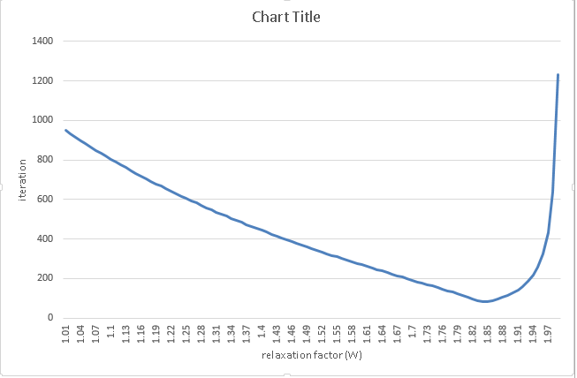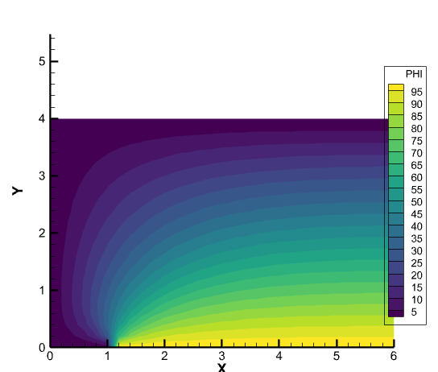

W optimum is **1.84**

No. of iteration for W=1.84 is **84**

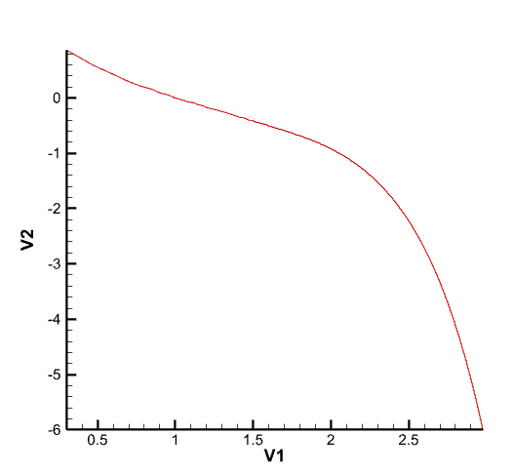

Log_iteration VS log_error plot

X-Axis= log(iteration)

Y-Axis=log(error)

For error =1e-6

Txt file of iteration vs error is attached with the code.

1. 4. Line Gauss-Seidel iterative method (TriDiagonal Matrix Algorithm)

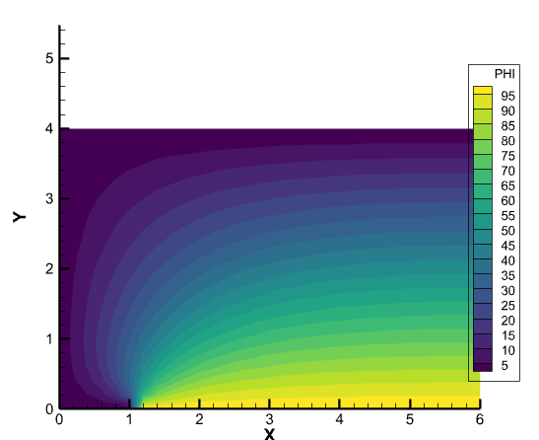 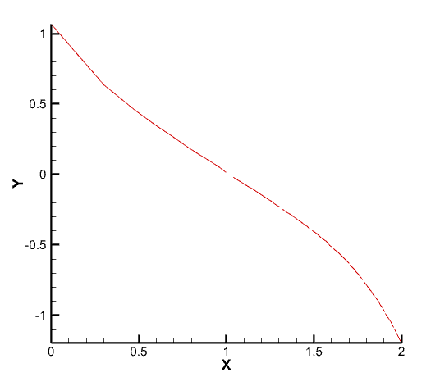

Log_iteration VS log_error plot

X-Axis= log(iteration)

Y-Axis=log(error)

For error =1e-8

Number of iterations are **533**

Txt file of iteration vs error is attached with the code.

1. 5. Alternating Direction Implicit method (ADI)

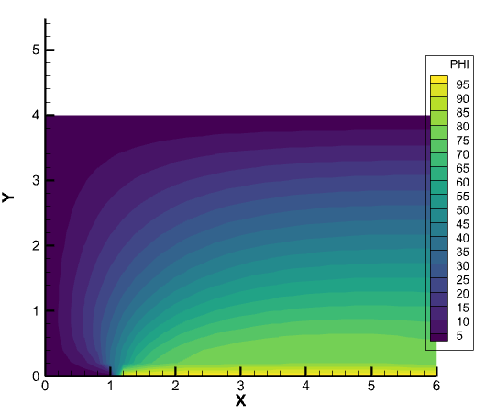

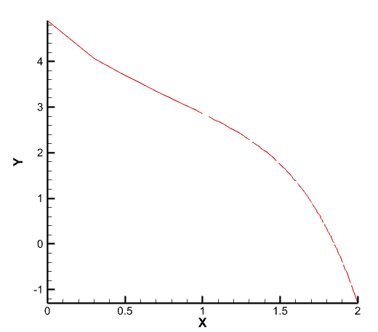

Log_iteration VS log_error plot

X-Axis= log(iteration)

Y-Axis=log(error)

For error =1e-8

Number of iterations are **206**

Txt file of iteration vs error is attached with the code.

**Problem 2:-** grid size delx=dely=0.1

J is use for y-axis. From 1 to 11.

I is used for x-axis. From 1 to 11.

1. Jacobi iterative method

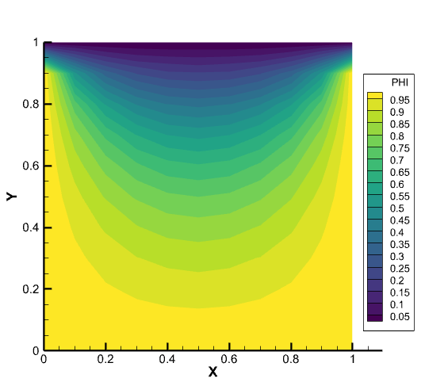

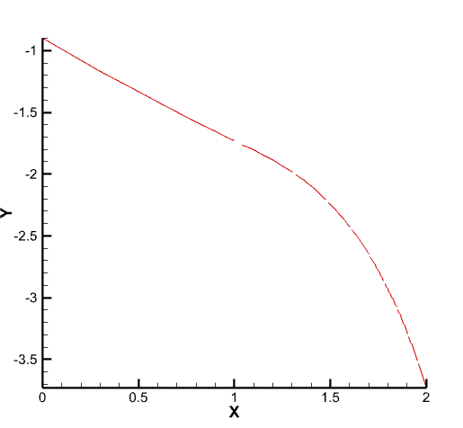

Log_iteration VS log_error plot

X-Axis= log(iteration)

Y-Axis=log(error)

For error =1e-8

Number of iterations are **296**

Txt file of iteration vs error is attached with the code.

2. Point Gauss-Seidel iterative method

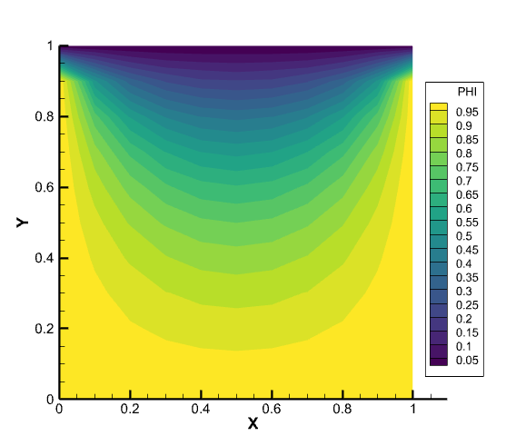

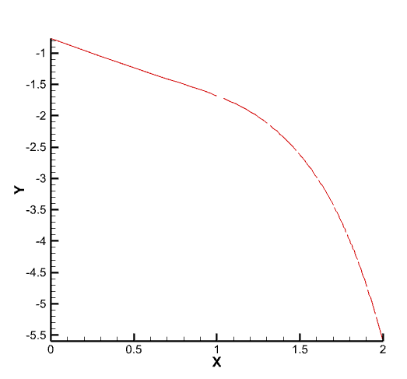

Log_iteration VS log_error plot

X-Axis= log(iteration)

Y-Axis=log(error)

For error =1e-8

Number of iterations are **156**

Txt file of iteration vs error is attached with the code.

3. Point Successive Over Relaxation (PSOR) method

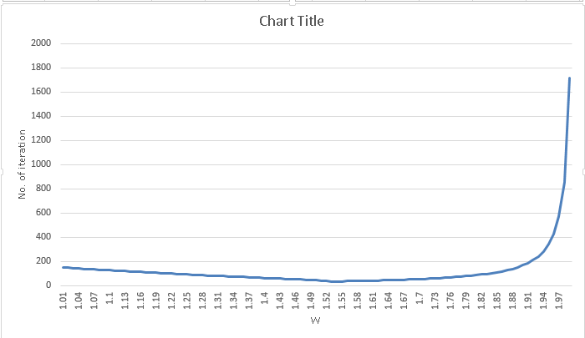

W optimum is **1.53**

no. of iteration **34**

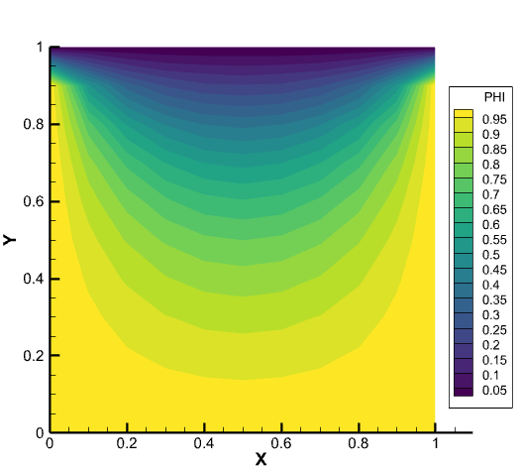

4. Line Gauss-Seidel iterative method (TriDiagonal Matrix Algorithm)

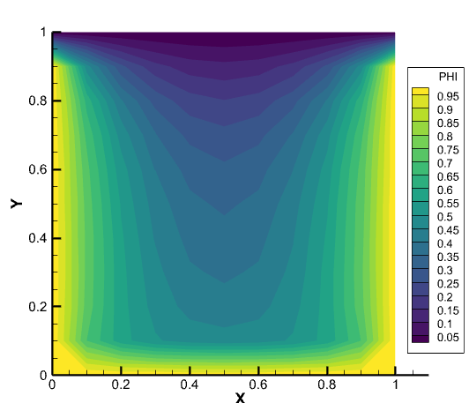

No. of iteration **56**

5. Alternating Direction Implicit method (ADI)

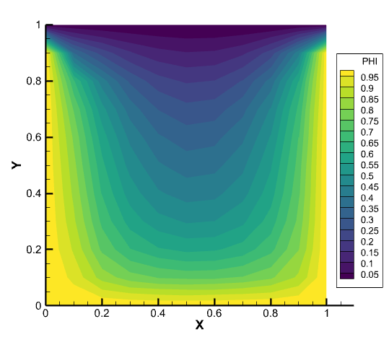

No. of iteration = **23**

Log_iteration VS log_error plot

X-Axis= log(iteration) Y-Axis=log(error) For error =1e-8