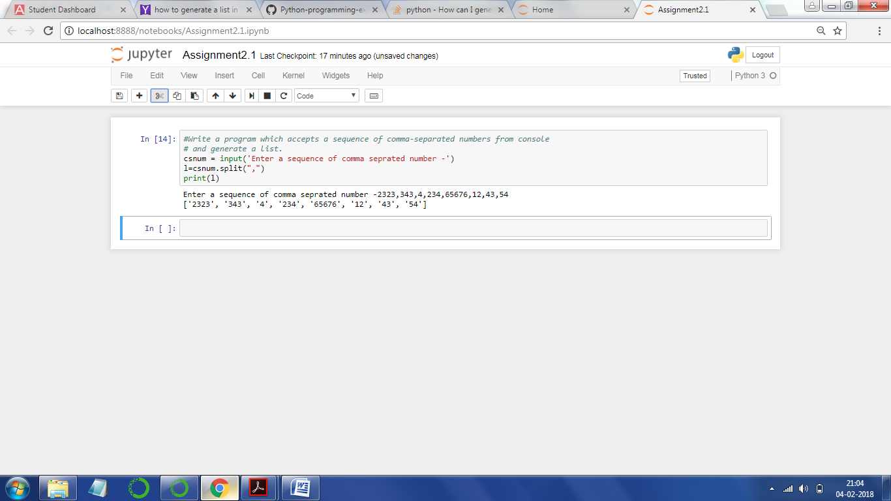

#Write a program which accepts a sequence of comma-separated numbers from console

# and generate a list.

csnum = input('Enter a sequence of comma seprated number -')

l=csnum.split(",")

print(l)

------------------

Output

Enter a sequence of comma seprated number -2323,343,4,234,65676,12,43,54

['2323', '343', '4', '234', '65676', '12', '43', '54']