Write a Python program to reverse a word after accepting the input from the user.

Sample Output:

Input word: AcadGild

Output: dilGdacA

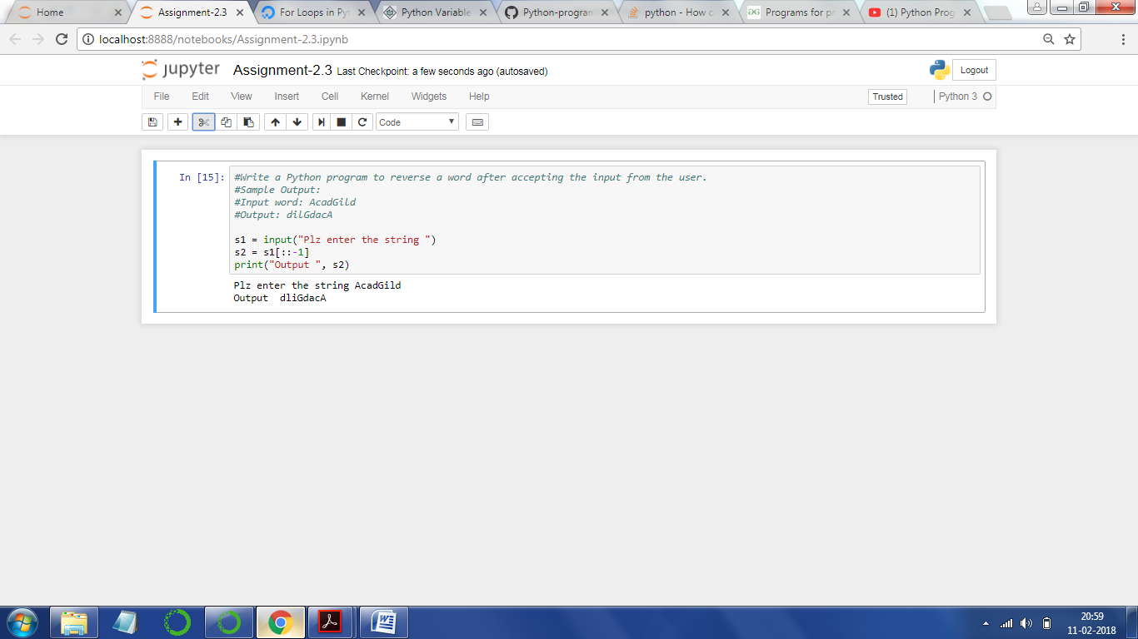

s1 = input("Plz enter the string ")

s2 = s1[::-1]

print("Output ", s2)

--------------

Plz enter the string AcadGild

Output dliGdacA