Write a Python Program to print the given string in the format specified in the sample

output.

WE, THE PEOPLE OF INDIA, having solemnly resolved to constitute India into a

SOVEREIGN, SOCIALIST, SECULAR, DEMOCRATIC REPUBLIC and to secure to all

its citizens

Sample Output:

WE, THE PEOPLE OF INDIA,

having solemnly resolved to constitute India into a SOVEREIGN, !

SOCIALIST, SECULAR, DEMOCRATIC REPUBLIC

and to secure to all its citizens:

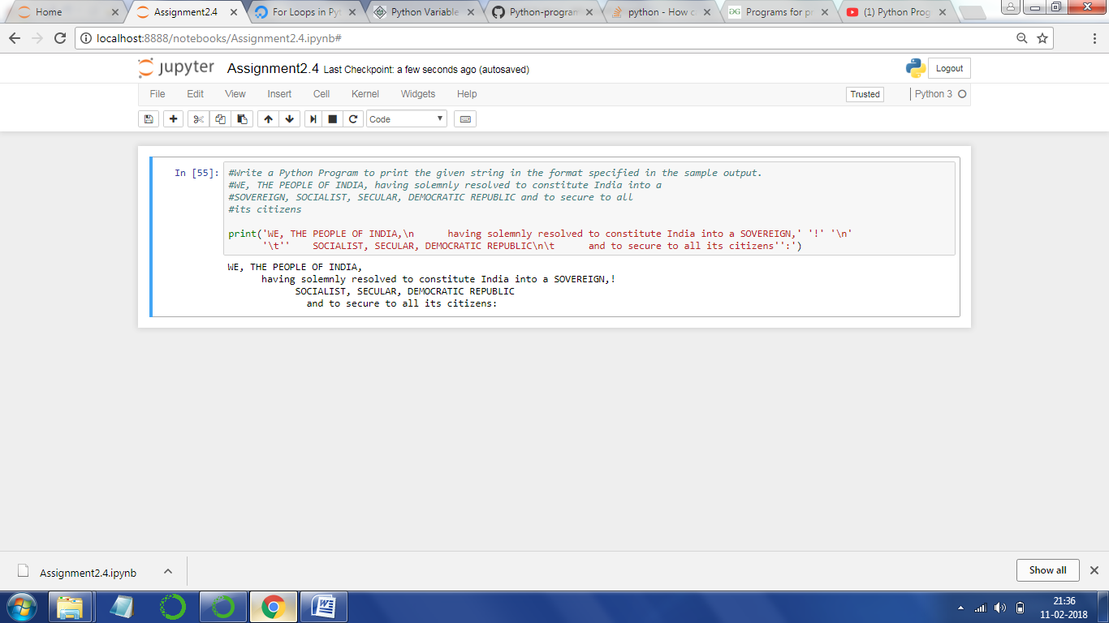

Program

print('WE, THE PEOPLE OF INDIA,\n having solemnly resolved to constitute India into a SOVEREIGN,' '!' '\n'

'\t'' SOCIALIST, SECULAR, DEMOCRATIC REPUBLIC\n\t and to secure to all its citizens'':')

---------------------------------------------------------------------------------------

Output

WE, THE PEOPLE OF INDIA,

having solemnly resolved to constitute India into a SOVEREIGN, !

SOCIALIST, SECULAR, DEMOCRATIC REPUBLIC

and to secure to all its citizens: