Report Assignment 2 network Simulator

Set up: There are two routers , 2 source and 2 receivers sending ftp packets over TCP Reno and 1 source and 1 receiver sending cbr packets over UDP

Case 1:

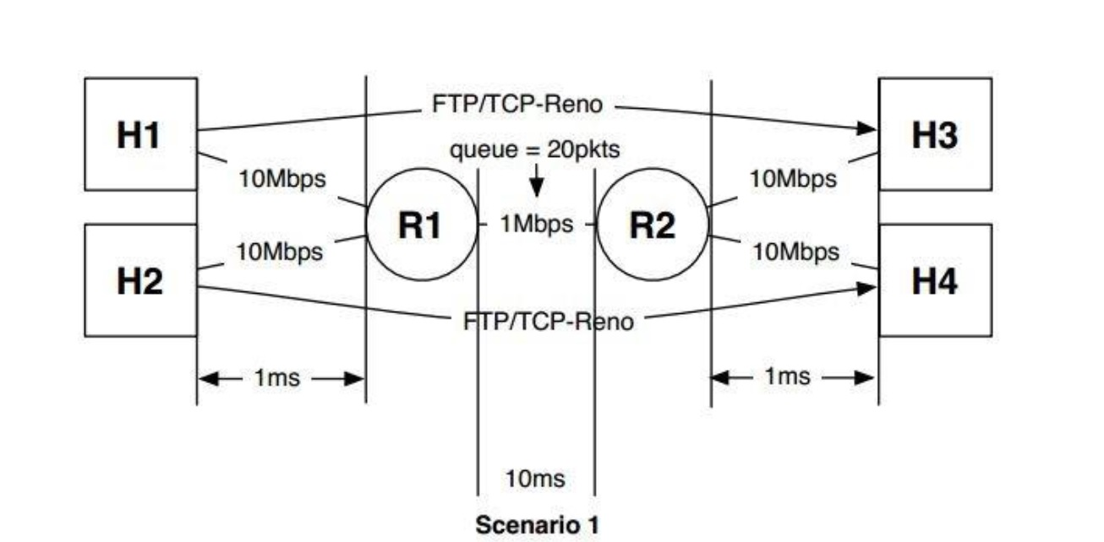

Case 2:

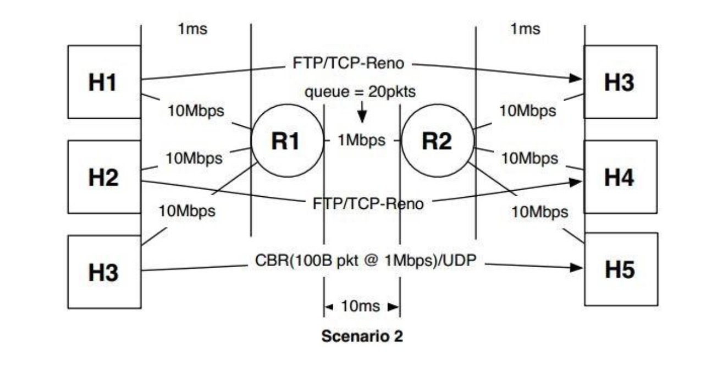

***Simulation Result for Case 1 with the use of RED Queue Buffer :***

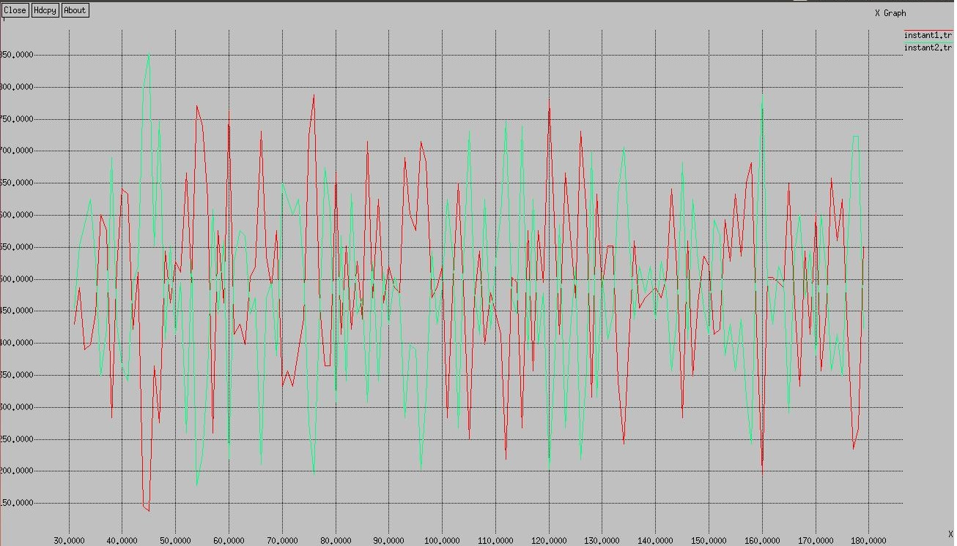

Instantaneous throughput of the link H1-H3 and H2-H4

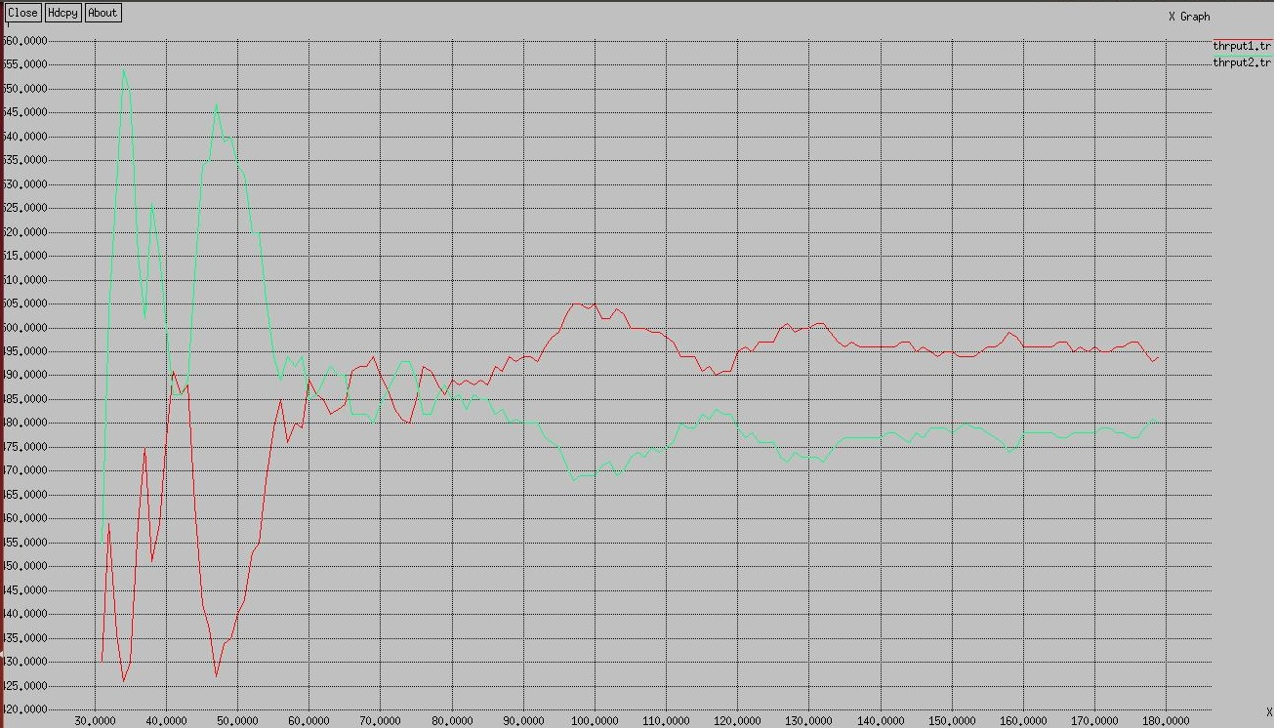Average throughput of the link H1-H3 and H2-H4

**Simulation Result for Case1 with the use of DropTail Queue Buffer:**

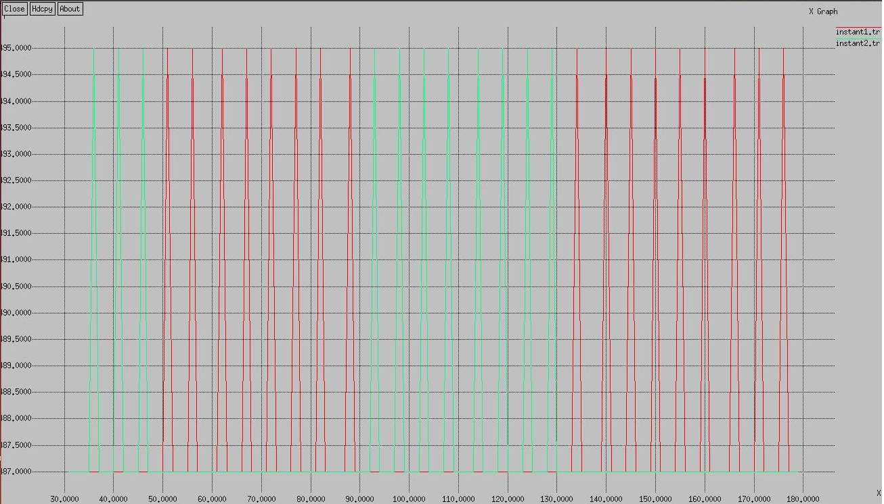

Instantaneous throughput of the link H1-H3 and H2-H4

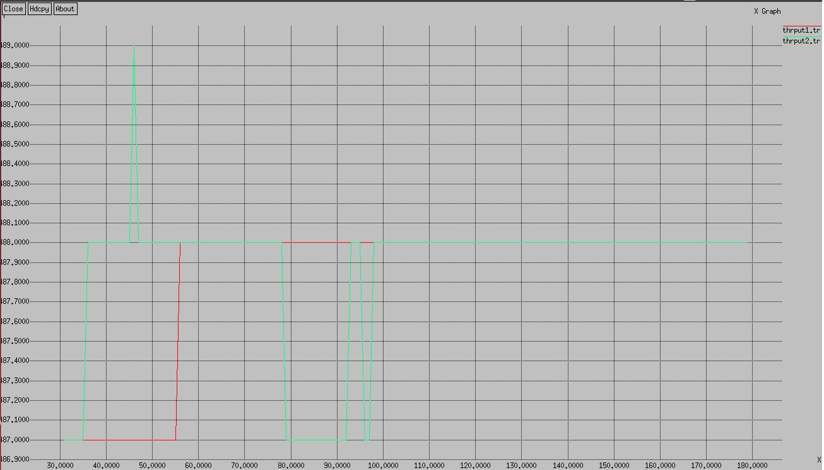

Average throughput of the link H1-H3 and H2-H4

**Simulation Result for Case2 with the use of RED Queue Buffer:**

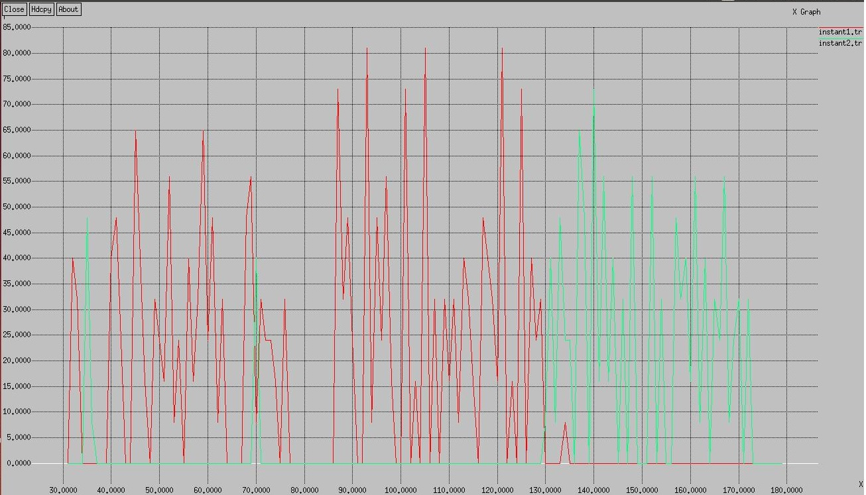

Instantaneous throughput of the link H1-H3 and H2-H4

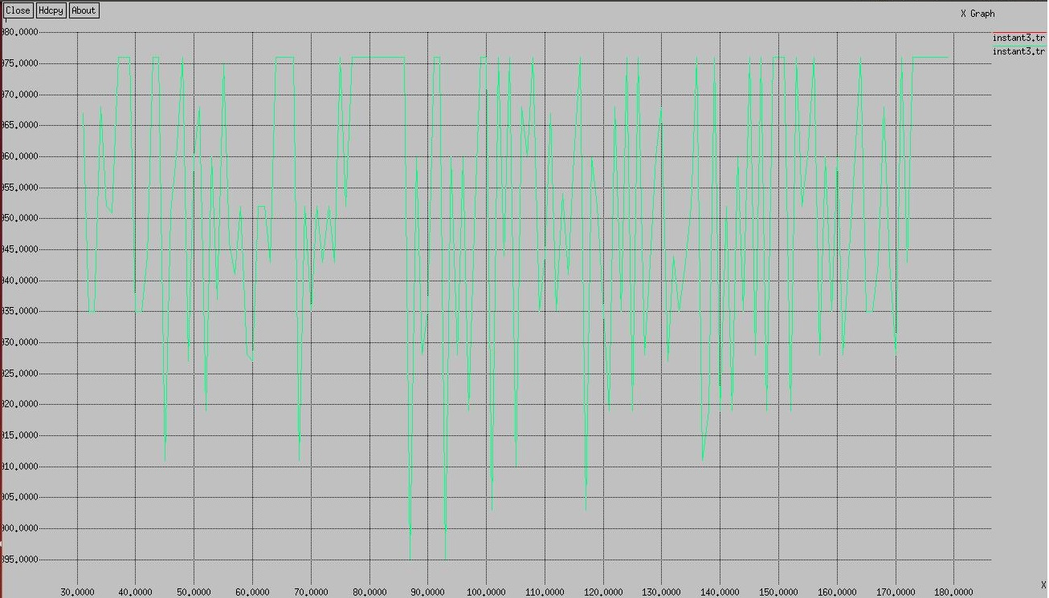

Instantaneous throughput of the link H5-H6

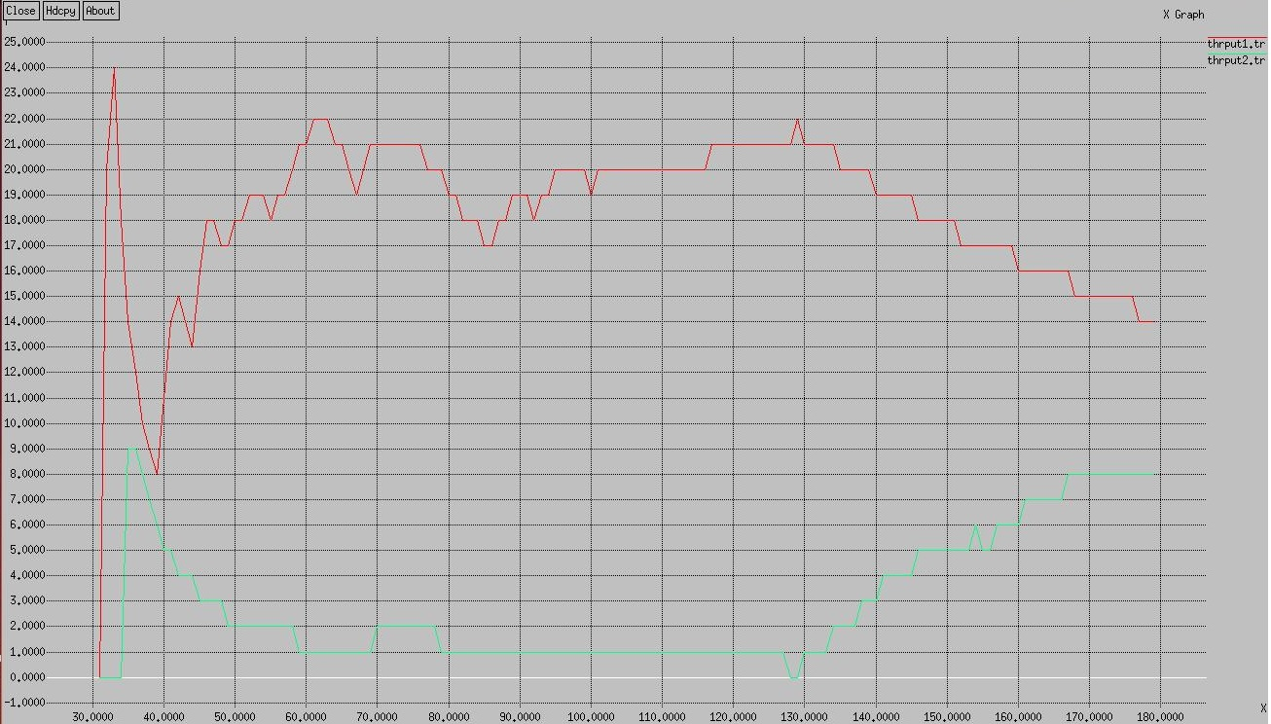

Average throughput of the link H1-H3 and H2-H4

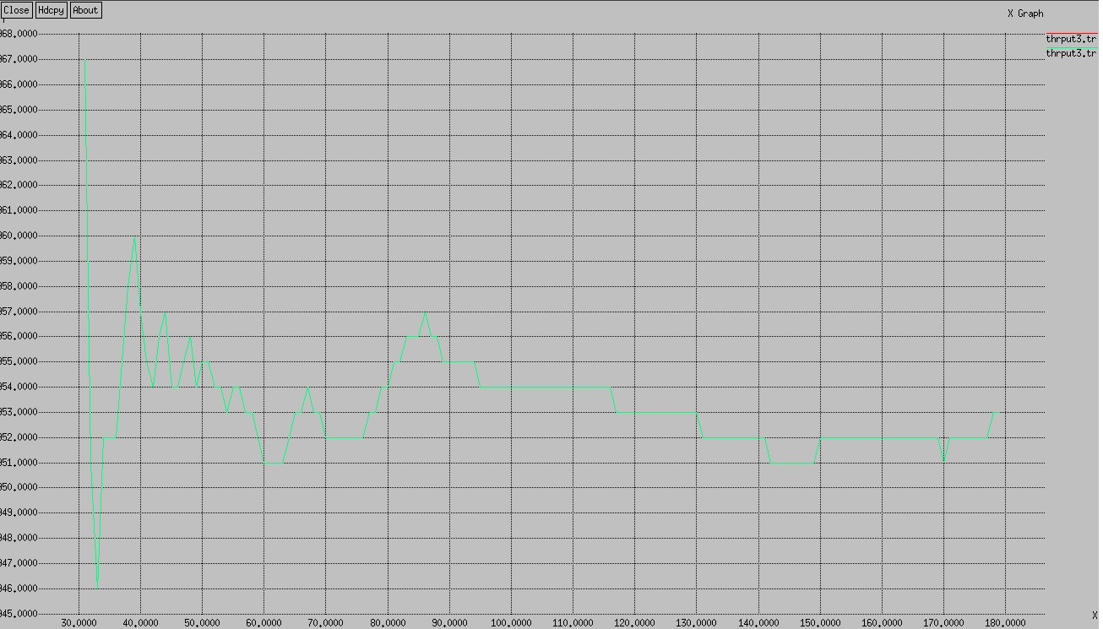

Average throughput of the link H5-H6

**Simulation Result for Case2 with the use of DropTail Queue Buffer:**

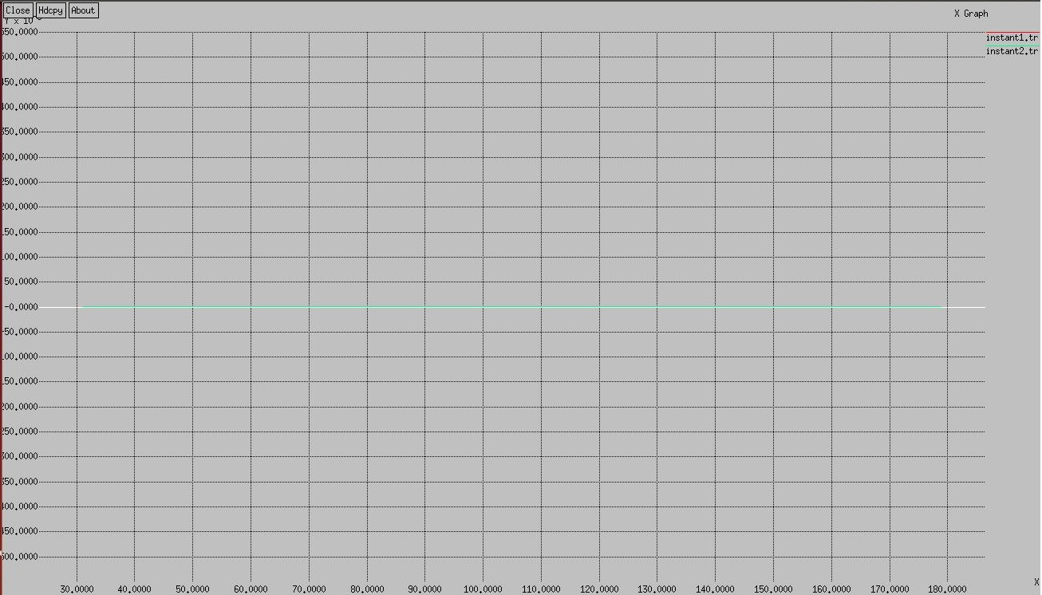

Instantaneous throughput of the link H1-H3 and H2-H4

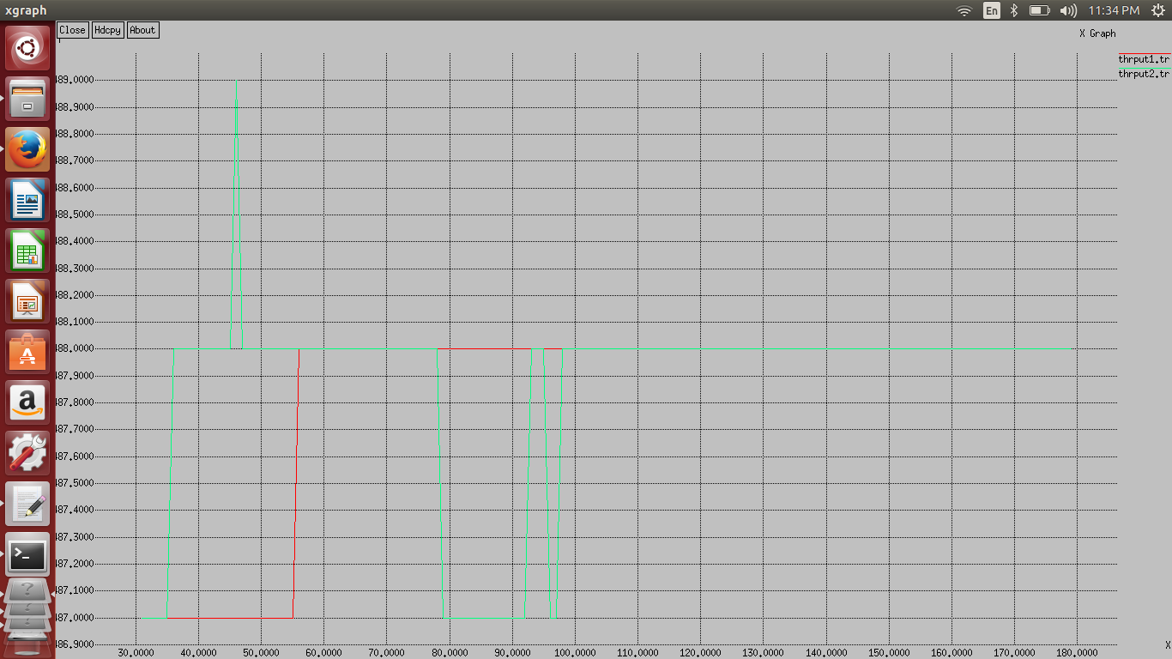

Average throughput of the link H1-H3 and H2-H4

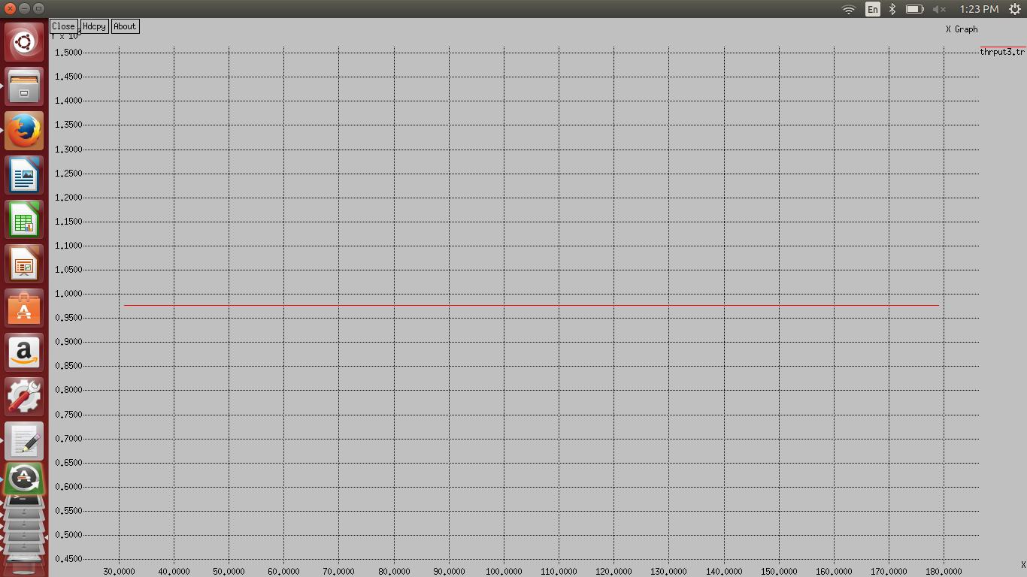

Average throughput of the link H5-H6