***D. Password-change phase***

The proposed scheme allows a legitimated embedded device $(SM_{i})$ to change the password periodically, thereby ensuring security. To change the password, the smart meter ($SM_{i}$) first perform authentication and authorization and prove their genuineness (See Fig. 1). The details of the password change are as follows:

***Step 1. ${SM}_{i}→SP$*** : $<I_{i}^{*}, P_{ke}^{*}>.$ The authorized legitimated embedded device $(SM_{i})$ selects a new password ${Psw}_{i}^{*}$ and then recomputes the hashed identity $(I_{i}^{*}=H(ID_{i} |\left|{Psw}_{i}^{*} \right))$ and public key ($P_{ke}^{*}$ = ${Psw}_{i}^{*}.G)$. Subsequently, it sends the updated < $I_{i}^{*}, P_{ke}^{*}>$ to SP through a trusted public channel by using the session key $S_{K}$.

***Step 2***. ${SP→ SM}_{i}$: $<{CID}_{i}^{*},{CK}^{'*}>.$ Furthermore, SP receive updated parameters < $I_{i}^{*}, P_{ke}^{*}>$ and then SP selects a random number $R^{*}$ and then recomputes all parameters ( ${CID_{i}}^{*}$ =h(R||||s ) $⊕$ s, ${CID_{i}}^{'*}={CID_{i}}^{*}.G$, ${CK}^{*}=h(R^{*}|\left|s\right||E_{t}||{CID_{i}}^{*})$, ${CK}^{*^{'}}={CK}^{*}.G$, *T= $R^{*}⊕$ h*(*||||s* ) $,$*A= $T⊕I_{i}^{*}⊕{CK}^{*^{'}},$ $t^{'}=T⊕{CID_{i}}^{*}⊕ s⊕{ID}_{TS} , a^{'}=A⊕ {CID_{i}}^{*}⊕s⊕ {ID}_{TS}, and{ e}_{t}^{'} = E_{t}⊕{CID_{i}}^{*}⊕ s⊕{ID}_{TS})$*  which are mentioned in registration Subsection III*.B*. Subsequently, *TS* stores the parameters < $t^{'},a^{'}, { e}_{t}^{'}$ > in the server database and sends the updated $<{CID_{i}}^{*}, {CK}^{*'}>$ to the server *TS* through an open trusted channel by using the session key $(S_{K})$.

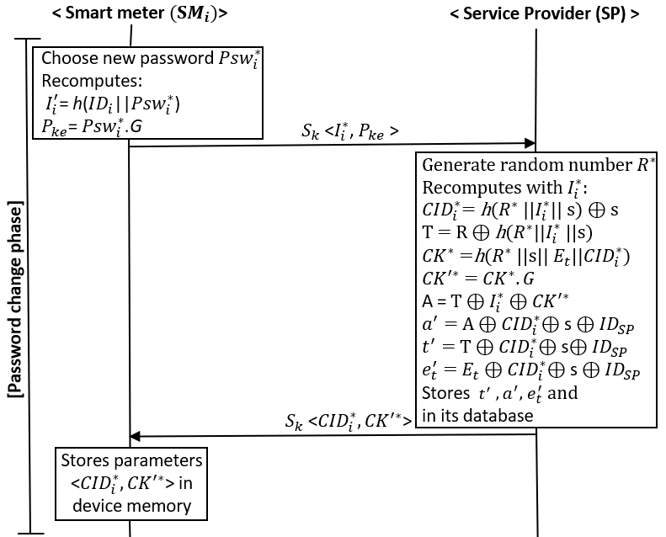

Fig.1. Password-change phase