

**CSE-326**

**Project: -INDIAN ELECTRICITY SYSTEM**

**FINAL REPORT**

|  |  |  |  |  |
| --- | --- | --- | --- | --- |
| S.No | Group Member  Sec:-K19PB  Group:-- | Registration Number | Roll No. |  |
| 1. | **Abhijeet Srivastava** | **11915988** | **31** |  |
| 2. | **Ponthangi *Naga Sai Mahesh*** | **11915103** | **32** |  |
| 3. | **Aryan Singh** | **11912727** | **33** |  |
|  |  |  |  |  |

**Submitted to: Ms. Shabnam**

**CONTENTS**

* **ABSTRACT OF PROJECT**
* **INTRODUCTION**
* **WEBSITE DESIGNING**
* **CONCLUSION**
* **REFERENCES AND LINKS**

**ABSTRACT OF PROJECT**

This website is designed to in order to compliance with section 3 of the Electricity Act 2003 the Central Government hereby notifies the National Electricity Policy.

Electricity is an essential requirement for all facets of our life. It has been recognized as a basic human need. It is a critical infrastructure on which the socio-economic development of the country depends. Supply of electricity at reasonable rate to rural India is essential for its overall development. Equally important is availability of reliable and quality power at competitive rates to Indian industry to make it globally competitive and to enable it to exploit the tremendous potential of employment generation. Services sector has made significant contribution to the growth of our economy. Availability of quality supply of electricity is very crucial to sustained growth of this segment.

Recognizing that electricity is one of the key drivers for rapid economic growth and poverty alleviation, the nation has set itself the target of providing access to all households in next five years. As per Census 2001, about 44% of the households do not have access to electricity. Hence meeting the target of providing universal access is a daunting task requiring significant addition to generation capacity and expansion of the transmission and distribution network.

**INTRODUCTION**

Indian Power sector is witnessing major changes. Growth of Power Sector in India since its Independence has been noteworthy. However, the demand for power has been outstripping the growth of availability. Substantial peak and energy shortages prevail in the country. This is due to inadequacies in generation, transmission & distribution as well as inefficient use of electricity. Very high level of technical and commercial losses and lack of commercial approach in management of utilities has led to unsustainable financial operations. Cross-subsidies have risen to unsustainable levels. Inadequacies in distribution networks has been one of the major reasons for poor quality of supply.

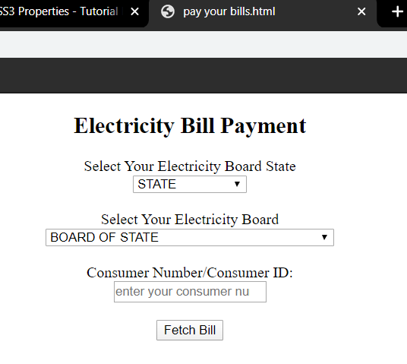

Electricity industry is capital-intensive having long gestation period. Resources of power generation are unevenly dispersed across the country. Electricity is a commodity that can not be stored in the grid where demand and supply have to be continuously balanced.

Electricity Act, 2003 provides an enabling framework for accelerated and more efficient development of the power sector. The Act seeks to encourage competition with appropriate regulatory intervention. Competition is expected to yield efficiency gains and in turn result in availability of quality supply of electricity to consumers at competitive rates.

**WEBSITE DESIGNING**

1. **HTML :-** *It provides a means to create structured documents by denoting structural semantics for text such as Headings, paragraphs, lists, link, Quotes and other items****.***

(Home Page)

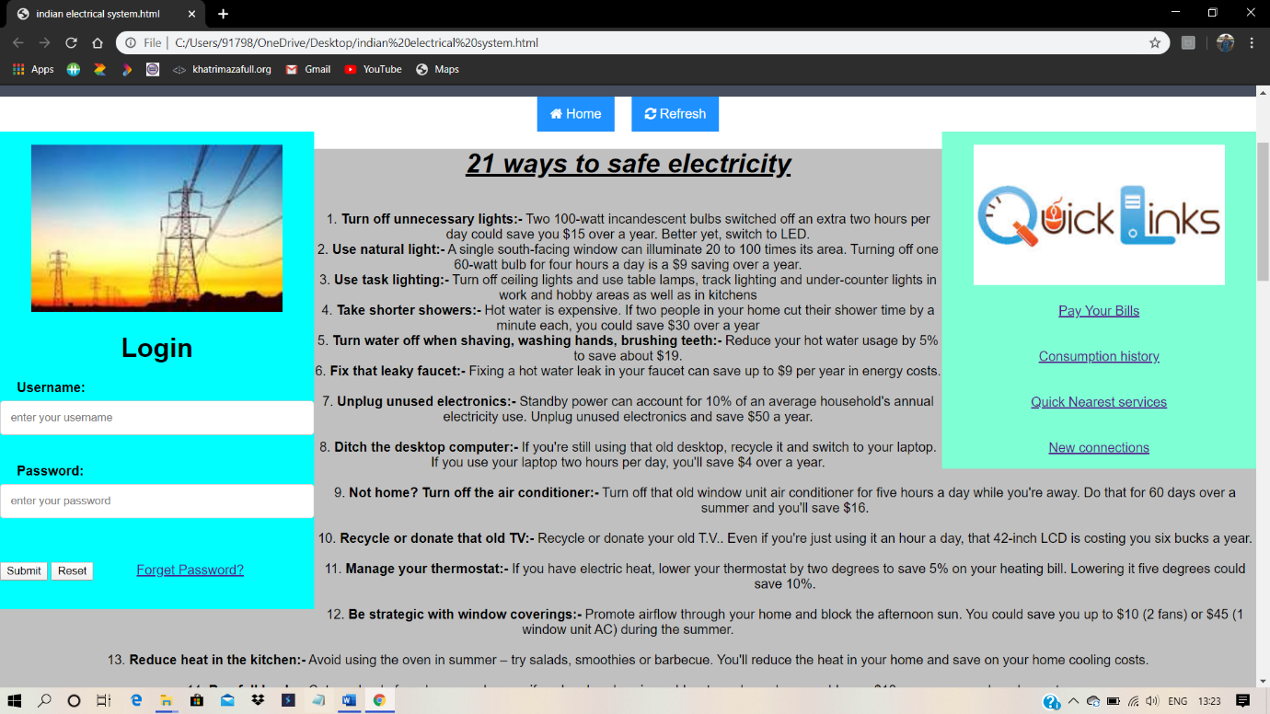

***(Responsibility by-Abhijeet srivastava)***

***Different HTML Tags Used in Designing***

|  |  |  |  |
| --- | --- | --- | --- |
| **Serial No** | **Opening tag** | **Closing tag** | **Structure Specified** |
| **1.** | **<p>** | **</p>** | **Paragraph text** |
| **2.** | **<h1>** | **</h1>** | **Main heading** |
| **3.** | **<h2>** | **</h2>** | **Sub heading** |
| **4.** | **<a href=”URL”>** | **</a>** | **Hyperlink** |
| **5.** | **<li>** | **</li>** | **List item** |
| **6.** | **<ul>** | **</ul>** | **Bulleted list(unordered)** |
| **7.** | **<ol>** | **</ol>** | **Numbered list(ordered)** |
| **8.** | **<img src=”url”>** | **None** | **Image** |
| **9.** | **<a>** | **</a>** | **Anchor tag** |
| **10.** | **<abbr>** | **</abbr>** | **Abbreviation tag** |
| **11.** | **<b>** | **</b>** | **Bold tag** |
| **12.** | **<i>** | **</i>** | **Italic text** |
| **13.** | **<br>** | **None** | **Line break** |
| **14.** | **<big>** | **</big>** | **Larger than the usual** |
| **15.** | **<small>** | **</small>** | **Smaller than the usual** |
| **16.** | **<form>** | **</form>** | **It is used to create form** |
| **17.** | **<table>** | **</table>** | **For table** |
| **18.** | **<col>** | **</col>** | **Used to create column** |
| **19.** | **<td>** | **</td>** | **Used to make cell** |
| **20.** | **<tr>** | **</tr>** | **Table row** |
| **21.** | **<blockquote>** | **</blockquote>** | **Special quote** |

1. **CSS:-***It is style sheet language used for describing the presentation of a document written in HTML.*

(Showing different color **,in HOME Button as well as in Refresh button ,you see Below**)

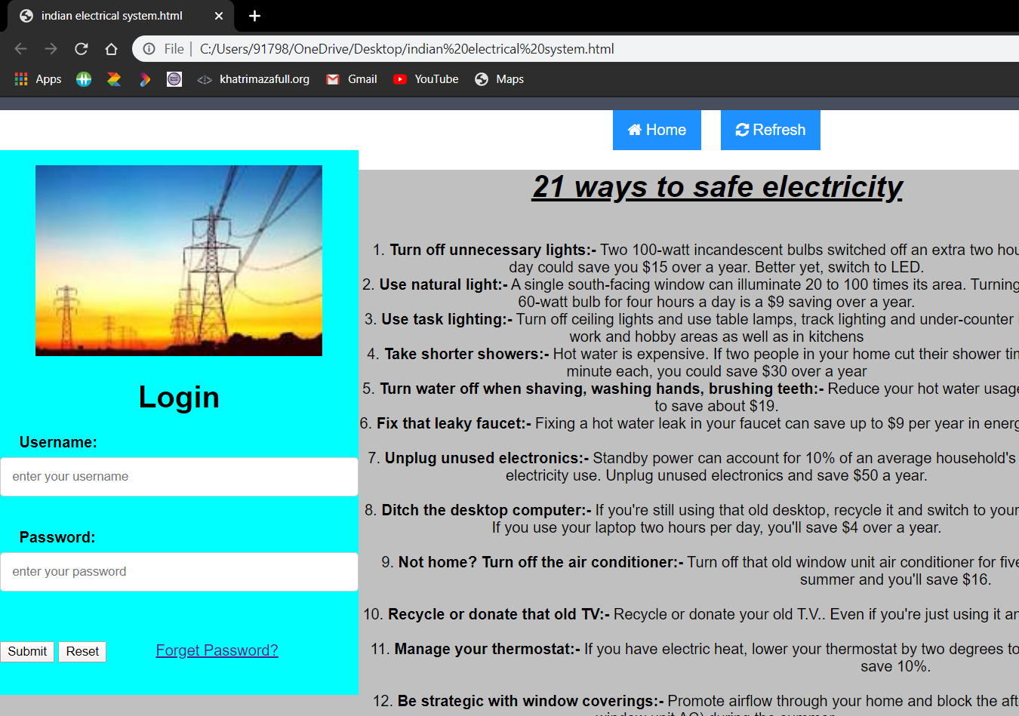

***(Responsibility by- Aryan Singh)***

***Different CSS Attributes Used in Designing***

|  |  |
| --- | --- |
| *Property* | *Description* |
| align-content | Specifies the alignment of flexible containers items within the flex containers. |
| Background-color | *Define an always background color* |
| Background-image | *define an element background image* |
| Background-size | *Specifies the size of background image* |
| Border-image-source | *Specifies the location of image where border is used* |
| font | *Defines a variety of font properties within one declaration.* |
| Padding-left | *Sets the padding to the left side of the element* |
| Padding-right | Sets the padding to the right side of an element. |
| Text-align | Sets the horizontal alignment of inline content. |
| Word-spacing | Set the space between words. |
| Max-height | Specify the maximum height of an element. |
| Font-size | Defines the font size for the text. |
| height | Specify the height of an element. |
| left | Specify the location of the left edge of the positioned element. |
| margin | Sets the margin on all four sides of the element. |
| resize | Specifies whether element is resizable or not |
| Vertical-align | Sets the vertical positioning of an element relative to the current text baseline. |

1. **JAVA SCRIPT:-***It is a high level, often in just time compile and multi paradigm bracket syntax dynamic type, prototype based object orientation and first class functions.*

**(Minimizing the Window, shows, how this page is responsive)**

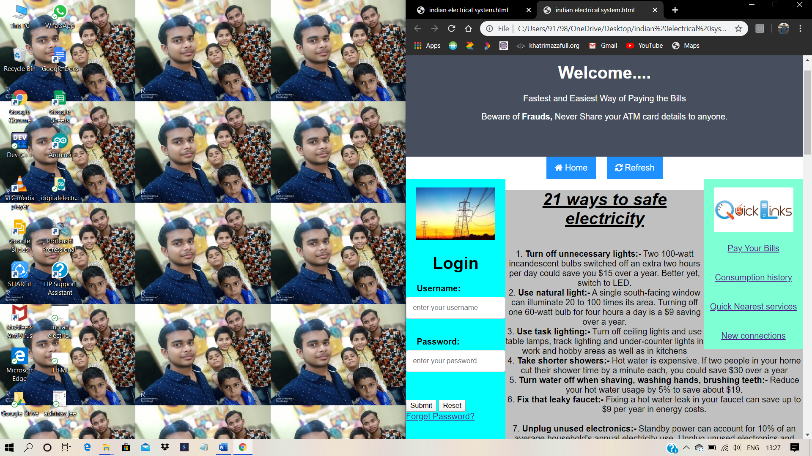

*(Responsibility by-* ***Naga Sai Mahesh****)*

**CONCLUSION**

*The project is to bring the real estate fastest and easiest way of paying the Electricity Bills Online, in Safe and Secure manner. Site acts as an interface between Individuals and electricity board of their state. Here the user can Pay bills, by sitting from home only.*

**REFRENCES**

*BOOKS:*

*HTML 5 (BLACK BOOK)*

*WEBSITES: -*

[*WWW.W3SCHOOLS.COM*](http://WWW.W3SCHOOLS.COM)

**…*Thank You***