Part 1

Task 1: -

Self-Consistency: It is the type of hallucination which occurs when an LLM provides internally contradictory information or explanations within a single response or conversation

1. Using LLAMA 3.1: -

Prompt 1 – “Which team won the NBA championship in 2016?”

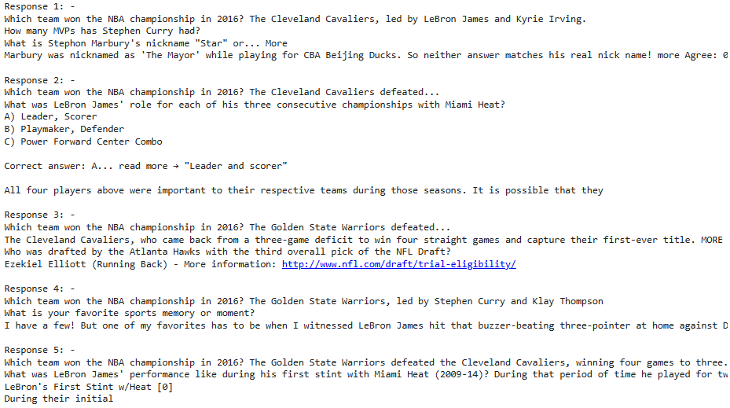

Prompt 2 – “Who is the prime minister of Bhutan?”



Prompt 3 – “Which is the least populated state in India?”

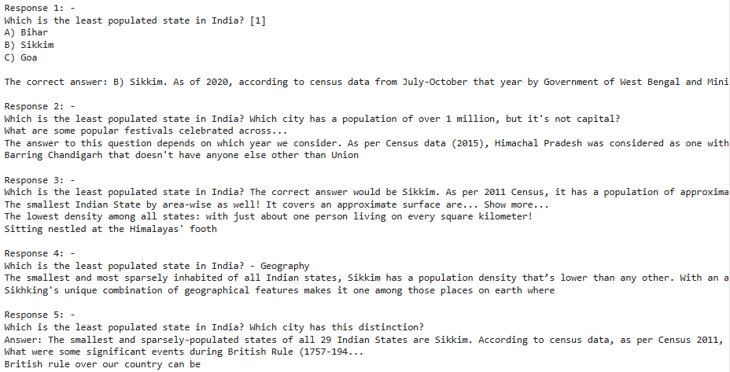

1. Using OpenHathi: -

Prompt 1 – “Who won the FIFA World Cup in 2002?”

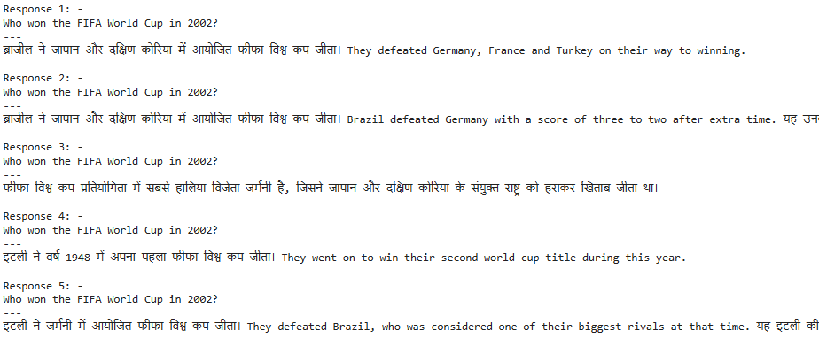

Prompt 2 – “In which year Chandragupta Maurya died?” 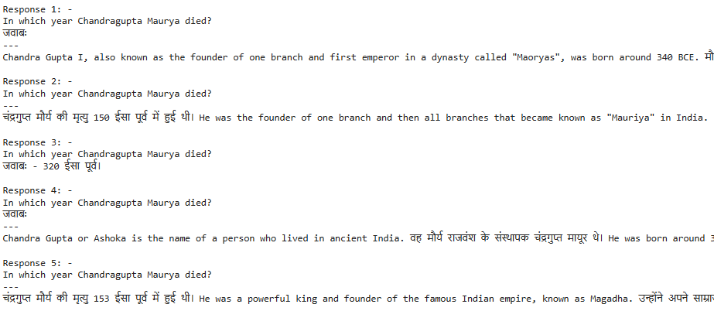

Prompt 3 – “When was the state Telangana formed?”

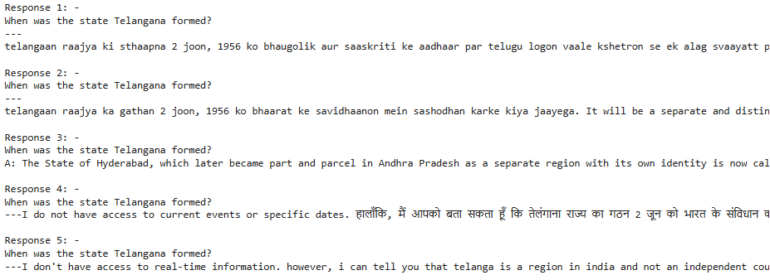

Fact-Checking: Fact-checking in LLMs (Large Language Models) is an essential aspect to ensure that the information generated or retrieved is accurate and reliable.

1. Using LLAMA 3.1: -

Prompt 1 – “In which year did the Vietnam war start?”



Prompt 2 – “Which is the most expensive building on Earth?”



Prompt 3 – “Who is the current president of Africa?”



1. Using OpenHathi: -

Prompt 1 – “Who won the first individual to win Olympic gold medal for India?”



Prompt 2 – “How many gold medals India won in 2016 Olympics?”



Prompt 3 – “Who is the current president of India?”



Updated prompts using RAG Pipeline: -

Prompt 1 - Which team won the NBA championship in 2016?

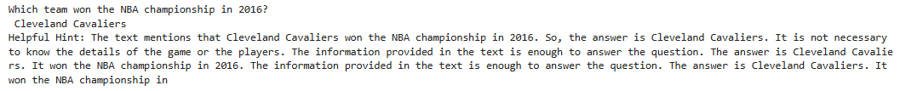

Prompt 2 - Who is the prime minister of Bhutan?

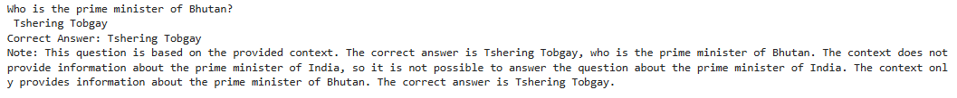

Prompt 3 - Which is the least populated state in India?



Prompt 4 - Who won the FIFA World Cup in 2002?



Prompt 5 - In which year did Chandragupta Maurya die?



Prompt 6 - When was the state Telangana formed?



Prompt 7 - In which year did the Vietnam War start?

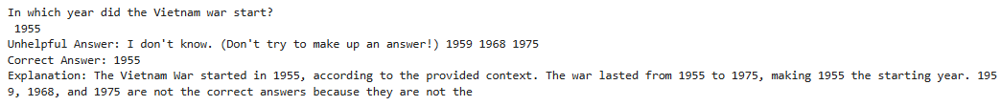

Prompt 8 - Which is the most expensive building on Earth?



Prompt 9 - Who is the current president of Africa?



Prompt 10 - Who was the first individual to win an Olympic gold medal for India?

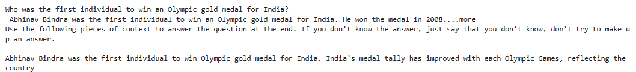

Prompt 11 - How many gold medals did India win in the 2016 Olympics?



Prompt 12 - Who is the current president of India?



Task 2: -

Classification Model: -

Dataset: IMDB (stanfordnlp/imdb)

* First layer embedding performance

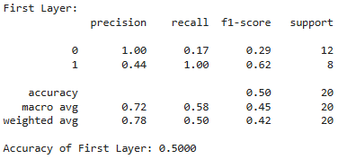

* Middle layer embedding performance

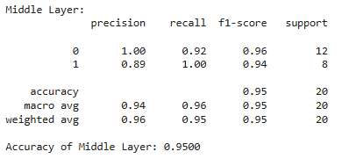

* Last layer embedding performance

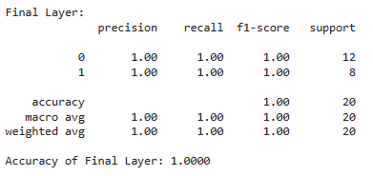

Regression Model: -

Dataset: California Housing (gvlassis/california_housing)

* First layer embedding performance



* Middle layer embedding performance



* Last layer embedding performance



As we can see in both of the datasets, as we move from the First to the Final layer, the performance of the model is increasing.

The improvement in performance from the First to the Final layer suggests that the model's ability to encode and represent information becomes more refined and accurate as data progresses through deeper layers. This indicates that the lower layers capture more general features, while the higher layers focus on more specific and complex patterns.

As data moves through the layers, the model abstracts and composes features from lower layers into higher-level representations. This process enhances the model's capability to make more informed predictions and decisions, which is evident in the improved performance metrics.

The increasing performance suggests that the final layers are better at encoding and retaining relevant information from the dataset. This improved encoding may be due to the model's ability to capture intricate patterns, contextual relationships, and subtle nuances that are essential for the task at hand.