

**BHARATI VIDYAPEETH’S**

**INSTITUTE OF COMPUTER APPLICATIONS & MANAGEMENT**

(Affiliated to Guru Gobind Singh Indraprastha University, Approved by AICTE, New Delhi)

Artificial Intelligence and Machine Learning

**(MCA- 263)**

**Practical File**

**Submitted To: Submitted By:**

Dr. Rakhee Sharma Vishal Nain (07411604422)

(Associate Professor) MCA 3rd Sem Section-2

**INDEX**

|  |  |
| --- | --- |
| **S. No.** | **Problem Description** |
| P1 | Create a solution to solve the Graph Traversal using BFS? |
| P2 | Given a snake and ladder board, find the minimum number of dice throws toreach the destination cell starting from the source using BFS? |
| P3 | Create a solution to solve the graph traversal using DFS? |
| P4 | Create a solution to solve the following Sudoku using DFS? |
| P5 | **The Towers of Hanoi**  Three vertical pegs (henceforth “towers”) stand tall. We will label them A, B,and C.  Doughnut-shaped discs are around tower A. The widest disc is at the bottom, and we will call it disc 1. The rest of the discs above disc 1 are labelled with increasing numerals and get progressively narrower. For instance, if we were to work with three discs, the widest disc, the one on thebottom, would be 1. The next widest disc, disc 2, would sit on top of disc 1. And finally, the narrowest disc, disc 3, would sit on top of disc 2.  **Our goal is to move all of the discs from tower A to tower C**.  Given the following constraints: Only one disc can be moved at a time. Thetopmost disc of any tower is the only one available for moving. A wider disc |

|  |  |
| --- | --- |
|  | can never be atop a narrower disc.Solve this problem |
| P6 | Given an initial state of a 8-puzzle problem and final state to be reached- |

|  |  |
| --- | --- |
|  | Find the most cost-effective path to reach the final state from initial state using A* Algorithm. F(n)=g(n)+h(n). Consider g(n) = Depth of node and h(n) =  Number of misplaced tiles. |
| P7 | Consider the following graph    The numbers written on edges represent the distance between the nodes.The numbers written on nodes represent the heuristic value. Find the mostcost-effective path to reach from start state A to final state J using A*  Algorithm. |

|  |  |
| --- | --- |
| P8 | Create a solution to load the IRIS dataset from the following URL: "https://archive.ics.uci.edu/ml/machine-learning-databases/iris/iris.data". Prepare the data, evaluate the algorithms and present the results throughsuitable visualizations? |
| P9 | Clean the Iris Dataset of Question P8 of duplicate values and repeat your analysis. Which algorithm performs better now? |
| P10 | Clean the Oil Spill dataset from the following URL: https://github.com/jbrownlee/Datasets/blob/master/oilspill.csv. Clean the data of duplicate data, single value columns and low variance columns. Oncethe data is prepared, evaluate it on the classification algorithms in CP1 and present the result through suitable visualizations. |
| P11 | Clean the Heart Disease Database to create a classifier that can help diagnose patients |
| P12 | Load the Boston housing dataset directly via URL and split it into train and test sets, then estimates the mean squared error (MSE) for a linear regression as well as the bias and variance for the model error over 200 bootstrap samples. Estimate the bias and variance for the regression model? |
| P13 | Using linear regression predict the relationship between the experience ofan individual and his salary. Predict the variance and bias for the same? |
| P14 | Predict the CO2 emission of a car based on the size of the engine, but use multiple regression so we can throw in more variables, like the weight of thecar? |
| P15 | Plot the CO2 emission values wrt engine size using multiple linearregression? |
| P16 | You have the following client list and some additional sales information stored in a CSV file (where the file name is ‘Clients ‘):  Person Name Country Product Purchase Price  Jon Japan Computer $800  Bill US Tablet $450  Maria Canada Printer $150  Rita Brazil Laptop $1,200  Jack UK Monitor $300  Ron Spain Laptop $1,200  Jeff China Laptop $1,200  Carrie Italy Computer $800  Marry Peru Computer $800  Ben Russia Printer $150  Implement and demonstrate the FIND-S algorithm for finding the most specific hypothesis based on a given set of training data samples. Read the training data from a .CSV file. FIND-S Algorithm 1. Initialize h to the most specific hypothesis in H  1. For each positive training instance x  2. For each attribute constraint ai in h If the constraint ai is satisfied by x Then do nothing  3. Else replace ai in h by the next more general constraint that is satisfied by x Output hypothesis h |
| P17 | Apply Linear Regression and build a model that studies the relationship between the head size and the brain weight of an individual? Evaluate by using least square regression method where RMSE (root mean squared  error) and R-squared/R2 will be the model evaluation parameters |

|  |  |
| --- | --- |
| P18 | Apply logistic regression on userdata.csv dataset to predict the users whomay be potential customers to purchase a SUV car? Also generate the  confusion matrix to evaluate your model? |
| P19 | Apply logistic regression on handwritten digits dataset to classify the digits.Evaluate your model too? |
| P20 | Create a mall_customer_dataset.csv dataset and apply the K-means on thesame after deciding the number of clusters using the elbow method to uncover the patterns? |
| P21 | Use the Pima Indian diabetes database to perform ensemble predictionsusing the following bagging classifiers: Bagged Decision Trees, Random Forest Classifier and Extra trees? |
| P22 | Implement a simple neural network with:   * 2 inputs * A hidden layer with 2 neurons (h1, h2) * An output layer with 1 neuron (o1) |
| P23 | Build a simplified clone of IMDB Top 250 movies using metadata collectionfrom IMDB. The following are the steps involved: -Decide on the metric or score to rate movies on -Calculate the score for every movie -Sort the  movies based on the score and output the top results. -Use the Full MovieLens Dataset. |

# P1. Create a solution to solve the Graph Traversal using BFS?

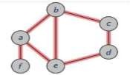

graph = {

'a' : ['b','e','f'],

'b' : ['a', 'e','c'],

'c' : ['b','d'],

'd' : ['c','e'],

'e' : ['a','b','d'], 'f' : ['a']

}

visited = [] queue = []

def bfs(visited, graph, node): visited.append(node) queue.append(node) while queue:

m = queue.pop(0) print (m, end = " ")

for neighbour in graph[m]:

if neighbour not in visited: visited.append(neighbour) queue.append(neighbour)

print("The Breadth-First Search Traversal(starting from b):") bfs(visited, graph, 'b')

# OUTPUT

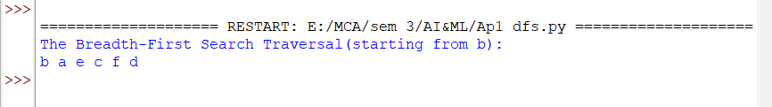

**P2. Given a snake and ladder board, find the minimum number of dice throws to reach the destination cell starting from the source using BFS?**

class QueueEntry(object):

def init (self, v=0, dist=0): self.v = v

self.dist = dist

def getMinDiceThrows(move, N): visited = [False] * N

queue = [] visited[0] = True

queue.append(QueueEntry(0, 0)) qe = QueueEntry()

while queue:

qe = queue.pop(0) v = qe.v

if v == N - 1:

break

j = v + 1

while j <= v + 6 and j < N:

if visited[j] is False:

a = QueueEntry() a.dist = qe.dist + 1 visited[j] = True

a.v = move[j] if move[j] != -1 else j queue.append(a)

j += 1

return qe.dist

N = 30

moves = [-1] * N moves[2] = 21 #Ladder moves[4] = 7 #Ladder

moves[10] = 25 #Ladder moves[19] = 28 #Ladder moves[26] = 0 #Snake moves[20] = 8 #Snake

moves[16] = 3 #Snake moves[18] = 6 #Snake

print("Mininum dice throws required is {0}".format(getMinDiceThrows(moves, N)))

# OUTPUT



**P3. Create a solution to solve the Graph Traversal using DFS?**



graph = {

'a' : ['b','e','f'],

'b' : ['a', 'c','e'],

'c' : ['b','d'],

'd' : ['c','e'],

'e' : ['a','b','d'], 'f' : ['a']

}

visited = set()

def dfs(visited, graph, node): if node not in visited:

print(node, end=" ") visited.add(node)

for neighbour in graph[node]: dfs(visited,graph,neighbour)

print("The Depth-First Search Traversal(starting from b):") dfs(visited, graph, 'b')

# OUTPUT

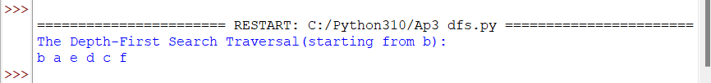

**P4. Create a solution to solve the following Sudoku using DFS?**

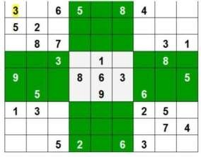

N = 9

def printing(arr):

for i in range(N):

for j in range(N):

print(arr[i][j], end = " ")

print()

def isSafe(grid, row, col, num): for x in range(9):

if grid[row][x] == num:

return False for x in range(9):

if grid[x][col] == num:

return False startRow = row - row % 3 startCol = col - col % 3

for i in range(3):

for j in range(3):

if grid[i + startRow][j + startCol] == num: return False

return True

def solveSudoku(grid, row, col):

if (row == N - 1 and col == N): return True

if col == N:

row += 1

col = 0

if grid[row][col] > 0:

return solveSudoku(grid, row, col + 1) for num in range(1, N + 1, 1):

if isSafe(grid, row, col, num): grid[row][col] = num

if solveSudoku(grid, row, col + 1): return True

grid[row][col] = 0 return False

grid = [[3, 0, 6, 5, 0, 8, 4, 0, 0],

[5, 2, 0, 0, 0, 0, 0, 0, 0],

[0, 8, 7, 0, 0, 0, 0, 3, 1],

[0, 0, 3, 0, 1, 0, 0, 8, 0],

[9, 0, 0, 8, 6, 3, 0, 0, 5],

[0, 5, 0, 0, 9, 0, 6, 0, 0],

[1, 3, 0, 0, 0, 0, 2, 5, 0],

[0, 0, 0, 0, 0, 0, 0, 7, 4],

[0, 0, 5, 2, 0, 6, 3, 0, 0]]

if (solveSudoku(grid, 0, 0)):

printing(grid)

else:

print("no solution exists ")

# OUTPUT

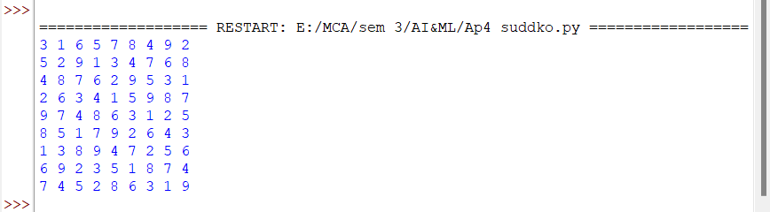

**P5. The Towers of Hanoi**

# Three vertical pegs (henceforth “towers”) stand tall. We will label them A, B, and C. Doughnut- shaped discs are around tower A. The widest disc is at the bottom, and we will call it disc 1.

**The rest of the discs above disc 1 are labelled with increasing numerals and get progressively narrower. For instance, if we were to work with three discs, the widest disc, the one on the bottom, would be 1. The next widest disc, disc 2, would sit on top of disc 1. And finally, the narrowest disc, disc 3, would sit on top of disc 2.**

# Our goal is to move all of the discs from tower A to tower C.

**Given the following constraints: Only one disc can be moved at a time. The topmost disc of any tower is the only one available for moving. A wider disc can never be atop a narrower disc.**

# Solve this problem

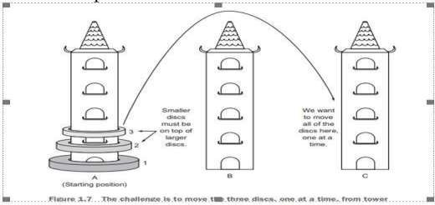

def tower_of_hanoi(disks, source, auxiliary, target): if(disks == 1):

print('Move disk 1 from tower {} to tower {}.'.format(source, target)) return

tower_of_hanoi(disks - 1, source, target, auxiliary)

print('Move disk {} from tower {} to tower {}.'.format(disks, source, target)) tower_of_hanoi(disks - 1, auxiliary, source, target)

disks = int(input('Enter the number of disks: \n')) tower_of_hanoi(disks, 'A', 'B', 'C')

# OUTPUT

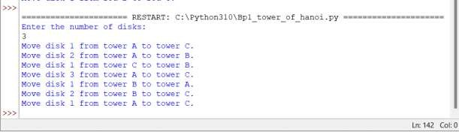

**P6. Given an initial state of 8-puzzle problem and final state to be reached-**

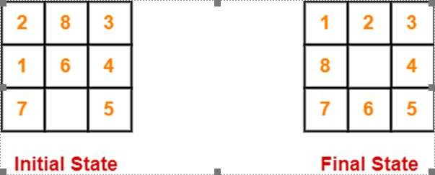

# Find the most cost-effective path to reach the final state from initial state using A* Algorithm. f(n)=g(n)+h(n). Consider g(n) = Depth of node and h(n) = Number of misplaced tiles.

class Node:

def init (self,data,level,fval):

self.data = data self.level = level self.fval = fval

def generate_child(self):

x,y = self.find(self.data,'_')

val_list = [[x,y-1],[x,y+1],[x-1,y],[x+1,y]] children = []

for i in val_list:

child = self.shuffle(self.data,x,y,i[0],i[1]) if child is not None:

child_node = Node(child,self.level+1,0) children.append(child_node)

return children

def shuffle(self,puz,x1,y1,x2,y2):

if x2 >= 0 and x2 < len(self.data) and y2 >= 0 and y2 < len(self.data): temp_puz = []

temp_puz = self.copy(puz) temp = temp_puz[x2][y2]

temp_puz[x2][y2] = temp_puz[x1][y1] temp_puz[x1][y1] = temp

return temp_puz else:

return None

def copy(self,root): temp = []

for i in root: t = []

for j in i:

t.append(j) temp.append(t)

return temp

def find(self,puz,x):

for i in range(0,len(self.data)): for j in range(0,len(self.data)):

if puz[i][j] == x:

return i,j

class Puzzle:

def init (self,size):

self.n = size self.open = [] self.closed = []

def accept(self):

puz = []

for i in range(0,self.n):

temp = input().split(" ") puz.append(temp)

return puz

def f(self,initial,final):

return self.h(initial.data,final)+initial.level

def h(self,initial,final):

temp = 0

for i in range(0,self.n): for j in range(0,self.n):

if initial[i][j] != final[i][j] and initial[i][j] != '_':

temp += 1 return temp

def process(self):

print("Enter the initial state matrix \n") initial = self.accept()

print("Enter the final state matrix \n") final = self.accept()

initial = Node(initial,0,0) initial.fval = self.f(initial,final) self.open.append(initial)

print("\nThe most cost-effective path to reach the final state from initial state using A* Algorithm:

\n")

while True:

cur = self.open[0] print("")

print(" | ")

print(" | ")

print(" \\\'/ \n")

for i in cur.data:

for j in i: print(j,end=" ")

print("") if(self.h(cur.data,final) == 0):

break

for i in cur.generate_child():

i.fval = self.f(i,final) self.open.append(i) self.closed.append(cur)

del self.open[0]

self.open.sort(key = lambda x:x.fval,reverse=False)

puz = Puzzle(3) puz.process() **OUTPUT**

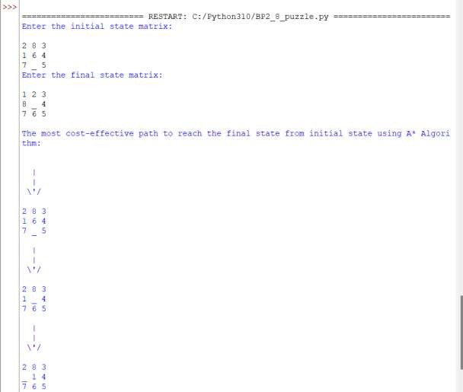

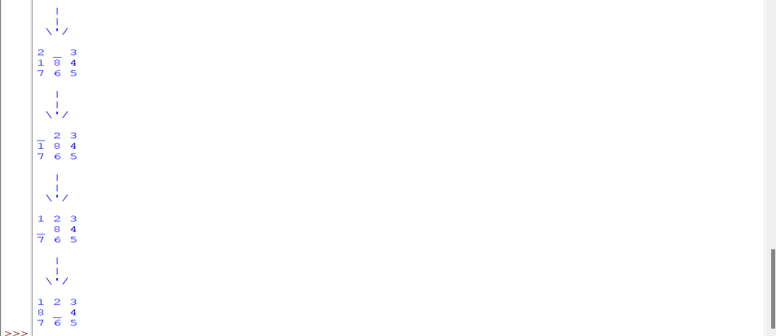

# P7. Consider the following graph

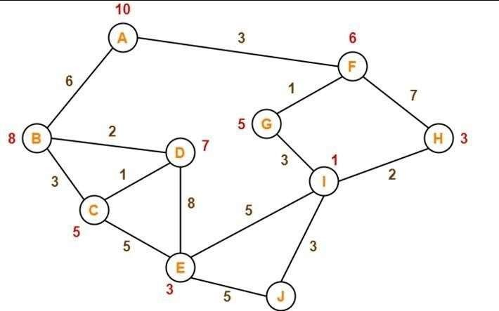

**The numbers written on edges represent the distance between the nodes. The numbers written on nodes represent the heuristic value. Find the most cost-effective path to reach from start state A to final state J using A* Algorithm.**

def aStarAlgo(start_state, final_state):

open_set = set(start_state) closed_set = set()

g = {}

parents = {} g[start_state] = 0

parents[start_state] = start_state while len(open_set) > 0:

n = None

for v in open_set:

if n == None or g[v] + heuristic(v) < g[n] + heuristic(n): n = v

if n == final_state or Graph_nodes[n] == None: pass

else:

for (m, weight) in get_neighbors(n):

if m not in open_set and m not in closed_set: open_set.add(m)

parents[m] = n g[m] = g[n] + weight

else:

if g[m] > g[n] + weight: g[m] = g[n] + weight parents[m] = n

if m in closed_set:

closed_set.remove(m) open_set.add(m)

if n == None:

print('Path does not exist!') return None

if n == final_state: path = []

while parents[n] != n: path.append(n)

n = parents[n] path.append(start_state) path.reverse()

print(' The most cost-effective path to reach from start state A to final state J using A* Algorithm:

{}'.format(path))

return path open_set.remove(n) closed_set.add(n)

print('Path does not exist!') return None

def get_neighbors(v): if v in Graph_nodes:

return Graph_nodes[v] else:

return None

def heuristic(n): H_dist = {

'A': 10,

'B': 8,

'C': 5,

'D': 7,

'E': 3,

'F': 6,

'G': 5,

'H': 3,

'I': 1,

'J': 0

}

return H_dist[n]

Graph_nodes = {

'A': [('B', 6), ('F', 3)],

'B': [('A', 6), ('C', 3), ('D', 2)],

'C': [('B', 3), ('D', 1), ('E', 5)],

'D': [('B', 2), ('C', 1), ('E', 8)],

'E': [('C', 5), ('D', 8), ('I', 5), ('J', 5)],

'F': [('A', 3), ('G', 1), ('H', 7)],

'G': [('F', 1), ('I', 3)],

'H': [('F', 7), ('I', 2)],

'I': [('E', 5), ('G', 3), ('H', 2), ('J', 3)],

}

aStarAlgo('A', 'J')

# OUTPUT

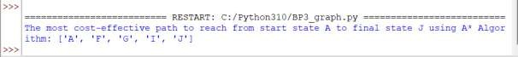

**P8. Create a solution to load the IRIS dataset from the following URL: "https://archive.ics.uci.edu/ml/machine-learning-databases/iris/iris.data". Prepare the data, evaluate the algorithms and present the results through suitable visualizations?**

#Load Libraries

from pandas import read_csv

from pandas.plotting import scatter_matrix from pandas import set_option

from pandas import DataFrame from pandas import concat from matplotlib import pyplot

from sklearn.model_selection import train_test_split from sklearn.model_selection import cross_val_score from sklearn.model_selection import StratifiedKFold from sklearn.metrics import classification_report from sklearn.metrics import confusion_matrix

from sklearn.metrics import accuracy_score

from sklearn.linear_model import LogisticRegression from sklearn.tree import DecisionTreeClassifier from sklearn.neighbors import KNeighborsClassifier

from sklearn.discriminant_analysis import LinearDiscriminantAnalysis from sklearn.naive_bayes import GaussianNB

from sklearn.svm import SVC

# Load dataset

#url = "https://raw.githubusercontent.com/jbrownlee/Datasets/master/iris.cs v"

url = "https://archive.ics.uci.edu/ml/machine-learning- databases/iris/iris.data"

names = ['sepal-length', 'sepal-width', 'petal-length', 'petal- width', 'class']

dataset = read_csv(url, names=names)

# locate rows of duplicate data # calculate duplicates

dups = dataset.duplicated()

# report if there are any duplicates print(dups.any())

# list all duplicate rows print(dataset[dups])



# delete rows of duplicate data from the dataset print(dataset.shape)

# delete duplicate rows

dataset.drop_duplicates(inplace=True) print(dataset.shape)



# head, peek your dataset, see first 10 rows print(dataset.head(10))

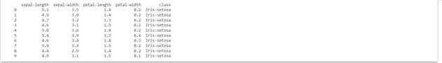

# Split-out validation dataset array = dataset.values

X = array[:,0:4]

y = array[:,4]

X_train, X_validation, Y_train, Y_validation = train_test_split(X, y, test_ size=0.20, random_state=1)

# Spot Check Algorithms models = []

models.append(('LR', LogisticRegression(solver='liblinear', multi_class='ov r')))

models.append(('LDA', LinearDiscriminantAnalysis())) models.append(('KNN', KNeighborsClassifier())) models.append(('CART', DecisionTreeClassifier())) models.append(('NB', GaussianNB())) models.append(('SVM', SVC(gamma='auto')))

# evaluate each model in turn results = []

names = []

for name, model in models:

kfold = StratifiedKFold(n_splits=10, random_state=1, shuffle=True) cv_results = cross_val_score(model, X_train, Y_train, cv=kfold, scoring='

accuracy') results.append(cv_results) names.append(name)

print('%s: %f (%f)' % (name, cv_results.mean(), cv_results.std()))



# Compare Algorithms

pyplot.boxplot(results, labels=names) pyplot.title('Algorithm Comparison') pyplot.show()

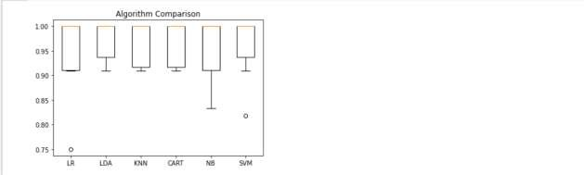

#PCA is effected by scale so you need to scale the features in your data be fore applying PCA. Use StandardScaler to help you st

#the dataset’s features onto unit scale (mean = 0 and variance = 1) which i s a requirement for the optimal performance of many machine learning algori thms.

from sklearn.preprocessing import StandardScaler

features = ['sepal-length', 'sepal-width', 'petal-length', 'petal-width'] # Separating out the features

x = dataset.loc[:, features].values # Separating out the target

y = dataset.loc[:,['class']].values # Standardizing the features

x = StandardScaler().fit_transform(x)

from sklearn.decomposition import PCA pca = PCA(n_components=2)

principalComponents = pca.fit_transform(x) principalDf = DataFrame(data = principalComponents

, columns = ['principal component 1', 'principal component 2']

)

#Concatenating DataFrame along axis = 1. finalDf is the final DataFrame bef ore plotting the data

finalDf = concat([principalDf, dataset[['class']]], axis = 1)

fig = pyplot.figure(figsize = (8,8)) ax = fig.add_subplot(1,1,1)

ax.set_xlabel('Principal Component 1', fontsize = 15)

ax.set_ylabel('Principal Component 2', fontsize = 15) ax.set_title('2 component PCA', fontsize = 20)

targets = ['Iris-setosa', 'Iris-versicolor', 'Iris-virginica'] colors = ['r', 'g', 'b']

for target, color in zip(targets,colors): indicesToKeep = finalDf['class'] == target

ax.scatter(finalDf.loc[indicesToKeep, 'principal component 1']

, finalDf.loc[indicesToKeep, 'principal component 2']

, c = color

, s = 50)

ax.legend(targets) ax.grid()

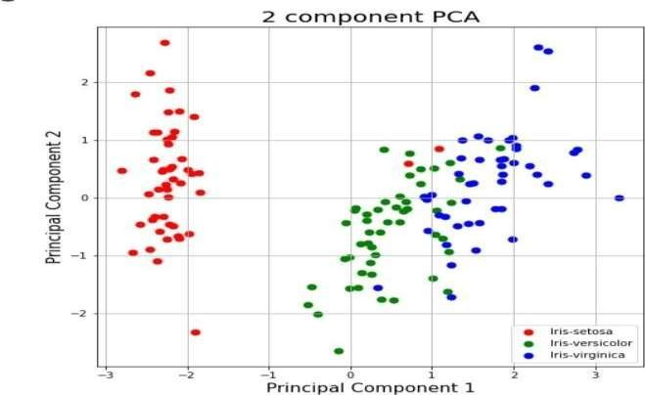

pca.explained_variance_ratio_



# P9.Clean the Iris Dataset of Question P8 of duplicate values and repeat your analysis. Which algorithm performs better now?

# import pandas as pd

# # Load the dataset

# iris_data = pd.read_csv('iris.csv')

# # Remove duplicate rows

# iris_data = iris_data.drop_duplicates()

# P10. Clean the Oil Spill dataset from the following URL: https://github.com/jbrownlee/Datasets/blob/master/oilspill.csv. Clean the data of duplicate data, single value columns and low variance columns. Once the data is prepared, evaluate it on the classification algorithms in CP1 and present the result through suitable visualizations

import pandas as pd import numpy as np ## for plotting

import matplotlib.pyplot as plt import seaborn as sns

## for statistical tests import scipy

import statsmodels.formula.api as smf import statsmodels.api as sm

## for machine learning

from sklearn import preprocessing, feature_selection, ensemble, decompositi on

from sklearn.model_selection import train_test_split from sklearn.linear_model import LogisticRegression from sklearn.metrics import accuracy_score

from sklearn.feature_selection import VarianceThreshold from sklearn.model_selection import cross_val_score from sklearn.model_selection import StratifiedKFold from sklearn.metrics import classification_report

from sklearn.metrics import confusion_matrix from sklearn.metrics import accuracy_score

from sklearn.linear_model import LogisticRegression from sklearn.tree import DecisionTreeClassifier from sklearn.neighbors import KNeighborsClassifier

from sklearn.discriminant_analysis import LinearDiscriminantAnalysis from sklearn.naive_bayes import GaussianNB

from sklearn.svm import SVC

from google.colab import drive drive.mount('/content/drive')

# read the data into a pandas Dataframe

dtf = pd.read_csv('/content/drive/My Drive/Colab Notebooks/titanic_data.csv ')

dtf.head()

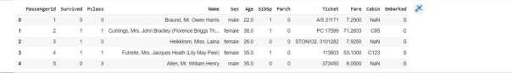

#let’s check how many cells are left empty in the table. dtf.isnull().sum()

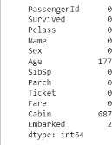

#Dropping the “Cabin” column from the data frame as it won’t be of much imp ortance

dtf=dtf.drop(columns='Cabin', axis=1)

#Replacing the missing values in the “Age” column with the mean value dtf['Age'].fillna(dtf['Age'].mean(), inplace=True)

#Finding the mode value of the “Embarked” column as it will have occurred t he maximum number of times

#Replacing the missing values in the “Embarked” column with mode value print(dtf['Embarked'].mode()) dtf['Embarked'].fillna(dtf['Embarked'].mode()[0], inplace=True)

#convert string type values into numerical dtf.replace({'Sex':{'male':0,'female':1}, 'Embarked':{'S':0,'C':1,'Q':2}}, inplace=True)

#cleaning data of duplicate data # calculate duplicates

dups = dtf.duplicated()

# report if there are any duplicates print(dups.any())

# list all duplicate rows print(dtf[dups]) print(dtf.shape)

# delete duplicate rows dtf.drop_duplicates(inplace=True) print(dtf.shape)



#cleaning data of single value column print(dtf.shape)

# get number of unique values for each column counts = dtf.nunique()

# record columns to delete

to_del = [i for i,v in enumerate(counts) if v == 1] print(to_del)

# drop useless columns dtf.drop(to_del, axis=1, inplace=True) print(dtf.shape)



#to implement ml split data in target and feature variables

# X is the feature variable, containing all the features like Pclass, Age, Sex, Embarked, etc. excluding the Survived column

X = dtf.drop(columns = ['PassengerId','Name','Ticket','Survived'],axis=1)

#Y, on the other hand, is the target variable, as that is the result that w e want to determine,i.e, whether a person is alive.

Y =dtf['Survived']

#cleaning data of low variance

var_thr = VarianceThreshold(threshold = 0.1) var_thr.fit(X)

concol = [column for column in X.columns

if column not in X.columns[var_thr.get_support()]]

for features in concol: print(features)

X.drop(concol,axis=1)

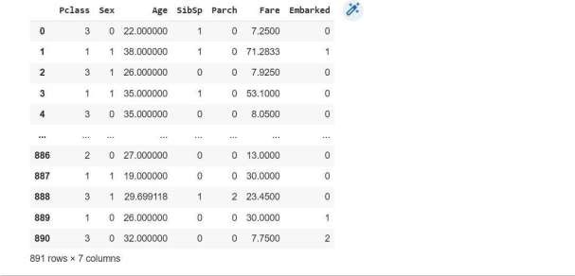

#split the data into four variables, namely, X_train, Y_train, X_test, Y_te st

X_train, X_test, Y_train, Y_test = train_test_split(X,Y, test_size=0.2, ran dom_state=2)

# Spot Check Algorithms models = []

models.append(('LR', LogisticRegression(solver='liblinear', multi_class='ov r')))

models.append(('LDA', LinearDiscriminantAnalysis())) models.append(('KNN', KNeighborsClassifier())) models.append(('CART', DecisionTreeClassifier())) models.append(('NB', GaussianNB())) models.append(('SVM', SVC(gamma='auto')))

# evaluate each model in turn results = []

names = []

for name, model in models:

kfold = StratifiedKFold(n_splits=10, random_state=1, shuffle=True) cv_results = cross_val_score(model, X_train, Y_train, cv=kfold, scoring='

accuracy') results.append(cv_results) names.append(name)

print('%s: %f (%f)' % (name, cv_results.mean(), cv_results.std()))

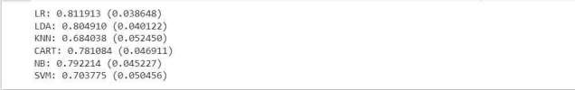

# Compare Algorithms plt.boxplot(results, labels=names) plt.title('Algorithm Comparison') plt.show()

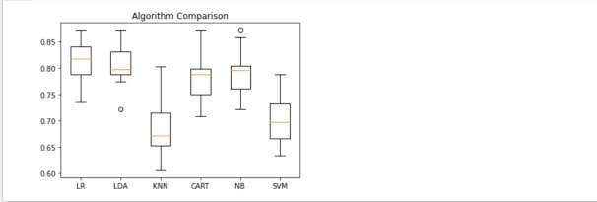

# P11. Clean the Heart Disease Database to create a classifier that can help diagnose patients

# import pandas as pd

# from sklearn.model_selection import train_test_split

# from sklearn.ensemble import RandomForestClassifier

# from sklearn.metrics import accuracy_score, classification_report, confusion_matrix

# import matplotlib.pyplot as plt

# # Load the dataset (make sure to replace 'heart_disease_dataset.csv' with your actual dataset file)

# data = pd.read_csv('heart_disease_dataset.csv')

# # Data preprocessing: handle missing values, encode categorical variables if needed

# # Example: data = data.dropna()

# # Split the data into features (X) and the target (y)

# X = data.drop('target', axis=1)

# y = data['target']

# # Split the data into training and testing sets

# X_train, X_test, y_train, y_test = train_test_split(X, y, test_size=0.2, random_state=42)

# # Initialize and train a classifier (Random Forest in this example)

# clf = RandomForestClassifier(n_estimators=100, random_state=42)

# clf.fit(X_train, y_train)

# # Make predictions on the test data

# y_pred = clf.predict(X_test)

# # Evaluate the classifier

# accuracy = accuracy_score(y_test, y_pred)

# print(f'Accuracy: {accuracy:.2f}')

# # Print a classification report and confusion matrix

# print(classification_report(y_test, y_pred))

# print('Confusion Matrix:')

# print(confusion_matrix(y_test, y_pred))

# # Visualize feature importances (for RandomForest)

# feature_importances = clf.feature_importances_

# plt.figure(figsize=(10, 6))

# plt.barh(X.columns, feature_importances)

# plt.xlabel('Feature Importance')

# plt.title('Feature Importance for Heart Disease Prediction')

# plt.show()

# P12. Load the Boston housing dataset directly via URL and split it into train and test sets, then estimate the mean squared error (MSE) for a linear regression model. Estimate the bias and variance for the linear regression model?

from pandas import read_csv

from sklearn.model_selection import train_test_split from sklearn.linear_model import LinearRegression from mlxtend.evaluate import bias_variance_decomp

# load dataset

url = 'https://raw.githubusercontent.com/jbrownlee/Datasets/master/housing. csv'

dataframe = read_csv(url, header=None)

# separate into inputs and outputs data = dataframe.values

X, y = data[:, :-1], data[:, -1]

# split the data

X_train, X_test, y_train, y_test = train_test_split(X, y, test_size=0.33, r andom_state=1)

# define the model

model = LinearRegression()

# estimate bias and variance

mse, bias, var = bias_variance_decomp(model, X_train, y_train, X_test, y_te st, loss='mse', num_rounds=200, random_seed=1)

# summarize results print('MSE: %.3f' % mse) print('Bias: %.3f' % bias) print('Variance: %.3f' % var)

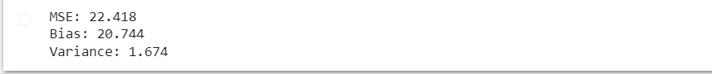

# P13. Using linear regression predict the relationship between the experience of an individual and his salary. Predict the variance and bias for the same?

import mlxtend.evaluate import pandas as pd import numpy as np

import matplotlib.pyplot as plt import seaborn as sns

from sklearn.model_selection import train_test_split from sklearn.linear_model import LinearRegression from mlxtend.evaluate import bias_variance_decomp

from google.colab import drive drive.mount('/content/drive')

dtf = pd.read_csv('/content/drive/My Drive/Colab Notebooks/Salary_Data.csv'

)

dtf.head()

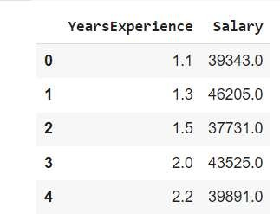

data = dtf.values

X, y = data[:, :-1], data[:, -1] # split the data

X_train, X_test, y_train, y_test = train_test_split(X, y, test_size=0.3, ra ndom_state=1)

model = LinearRegression() model.fit(X_train, y_train) y_train_pred = model.predict(X_train)

plt.figure()

plt.scatter(X_train, y_train, color='blue', label="True Value") plt.plot(X_train, y_train_pred, color='black', linewidth=2, label="Predicti on")

plt.xlabel("Years of Experiences") plt.ylabel("Salary")

plt.title('Prediction Result of Training Data') plt.legend()

plt.show()

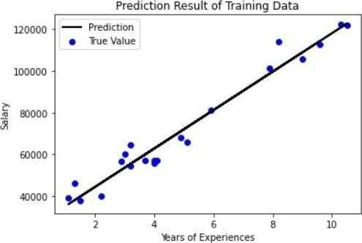

# estimate bias and variance

_, bias, var = bias_variance_decomp(model, X_train, y_train, X_test, y_test

, loss='mse', num_rounds=200, random_seed=1) # summarize results

print('Bias: %.3f' % bias) print('Variance: %.3f' % var)



# P14. Predict the CO2 emission of a car based on the size of the engine, but use multiple regression so we can throw in more variables, like the weight of the car?

import pandas as pd import numpy as np

import matplotlib.pyplot as plt import seaborn as sns

from sklearn.model_selection import train_test_split from sklearn.linear_model import LinearRegression

from google.colab import drive drive.mount('/content/drive')

dtf = pd.read_csv('/content/drive/My Drive/Colab Notebooks/FuelConsumptionC o2.csv')

data = dtf.values

X = np.asanyarray(dtf[['ENGINESIZE','CYLINDERS','FUELCONSUMPTION_CITY','FUE LCONSUMPTION_HWY','FUELCONSUMPTION_COMB']])

y = np.asanyarray(dtf[['CO2EMISSIONS']]) # split the data

X_train, X_test, y_train, y_test = train_test_split(X, y, test_size=0.3, ra ndom_state=1)

model = LinearRegression() model.fit(X_train, y_train)

y_train_pred = model.predict(X_train)

plt.figure()

plt.scatter(X_train[:,:1], y_train, color='blue', label="True Value") plt.scatter(X_train[:,:1], y_train_pred, color='red', linewidth=2, label="P rediction")

plt.xlabel("Engine Size") plt.ylabel("CO2 emission")

plt.title('Prediction Result of Training Data') plt.legend()

plt.show()

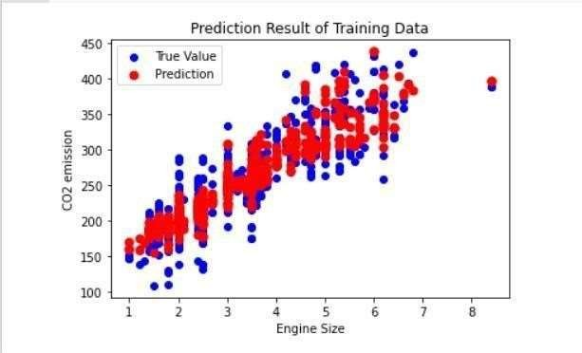

# P15. Plot the CO2 emission values wrt engine size using multiple linear regression?

import pandas as pd import numpy as np

import matplotlib.pyplot as plt import seaborn as sns

from sklearn.model_selection import train_test_split from sklearn.linear_model import LinearRegression

from google.colab import drive drive.mount('/content/drive')

dtf = pd.read_csv('/content/drive/My Drive/Colab Notebooks/FuelConsumptionC o2.csv')

data = dtf.values

X = np.asanyarray(dtf[['ENGINESIZE','CYLINDERS','FUELCONSUMPTION_CITY','FUE LCONSUMPTION_HWY','FUELCONSUMPTION_COMB']])

y = np.asanyarray(dtf[['CO2EMISSIONS']]) # split the data

X_train, X_test, y_train, y_test = train_test_split(X, y, test_size=0.3, ra ndom_state=1)

model = LinearRegression() model.fit(X_train, y_train)

y_train_pred = model.predict(X_train)

plt.figure()

plt.scatter(X_train[:,:1], y_train, color='blue', label="True Value") plt.scatter(X_train[:,:1], y_train_pred, color='red', linewidth=2, label="P rediction")

plt.xlabel("Engine Size") plt.ylabel("CO2 emission")

plt.title('Prediction Result of Training Data') plt.legend()

plt.show()



y_test_pred = model.predict(X_test)

plt.figure()

plt.scatter(X_test[:,:1], y_test, color='green', label='True Value') plt.scatter(X_test[:,:1], y_test_pred, color='red', linewidth=2, label='Pre diction')

plt.xlabel("CO2 Emission") plt.ylabel("Engine Size") plt.title('Prediction Result of Test data') plt.legend()

plt.show()

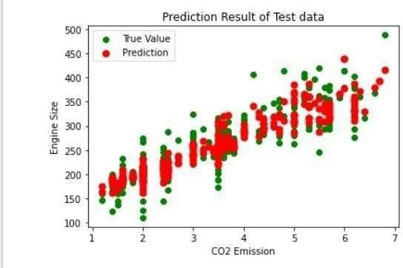

**P16. You have the following client list and some additional sales information stored in a CSV file (where the file name is ‘Clients ‘):**

Person Name Country Product Purchase Price

Jon Japan Computer $800

Bill US Tablet $450

Maria Canada Printer $150

Rita Brazil Laptop $1,200

Jack UK Monitor $300

Ron Spain Laptop $1,200

Jeff China Laptop $1,200

Carrie Italy Computer $800

Marry Peru Computer $800

Ben Russia Printer $150

Implement and demonstrate the FIND-S algorithm for finding the most specific hypothesis based on a given set of training data samples. Read the training data from a .CSV file. FIND-S Algorithm 1. Initialize h to the most specific hypothesis in H

1. For each positive training instance x

2. For each attribute constraint ai in h If the constraint ai is satisfied by x Then do nothing

# 3. Else replace ai in h by the next more general constraint that is satisfied by x Output hypothesis h

# Solution:

# import pandas as pd

# # Load the training data from the 'Clients' CSV file

# data = pd.read_csv('Clients.csv')

# # Initialize h to the most specific hypothesis in H

# hypothesis = ["?"] * (len(data.columns) - 1)

# # Iterate through the positive training instances in the dataset

# for index, row in data.iterrows():

# if row['Purchase Price'] == "$1,200":

# for i, value in enumerate(row[:-1]):

# if hypothesis[i] == "?":

# hypothesis[i] = value

# elif hypothesis[i] != value:

# hypothesis[i] = "?"

# # Output hypothesis h

# print("The most specific hypothesis h is:", hypothesis)

# P17. Apply Linear Regression and build a model that studies the relationship between the head size and the brain weight of an individual? Evaluate by using least square regression method where RMSE (root mean squared error) and R-squared/R2 will be the model evaluation parameters.

import pandas as pd import numpy as np

import matplotlib.pyplot as plt

from sklearn.model_selection import train_test_split from sklearn.linear_model import LinearRegression from sklearn.metrics import mean_squared_error

from sklearn.metrics import r2_score

from google.colab import drive drive.mount('/content/drive')

dtf = pd.read_csv('/content/drive/My Drive/Colab Notebooks/headbrain.csv') dtf.head()

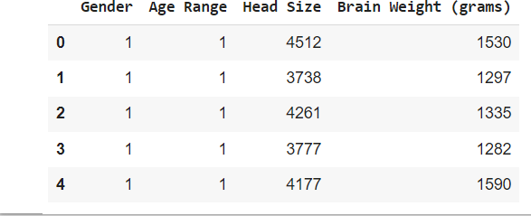

X = dtf['Head Size'].values

Y = dtf['Brain Weight (grams)'].values

# Mean X and Y mean_x = np.mean(X) mean_y = np.mean(Y)

# Total number of values n = len(X)

# Using the formula to calculate 'm' and 'c' numer = 0

denom = 0

for i in range(n):

numer += (X[i] - mean_x) * (Y[i] - mean_y) denom += (X[i] - mean_x) ** 2

m = numer / denom

c = mean_y - (m * mean_x)

# Printing coefficients print("Coefficients") print(m, c)



# Plotting Values and Regression Line max_x = np.max(X) + 100

min_x = np.min(X) - 100

# Calculating line values x and y x = np.linspace(min_x, max_x, 1000) y = c + m * x

# Ploting Line

plt.plot(x, y, color='#58b970', label='Regression Line') # Ploting Scatter Points

plt.scatter(X, Y, c='#ef5423', label='Scatter Plot')

plt.xlabel('Head Size in cm3') plt.ylabel('Brain Weight in grams') plt.legend()

plt.show()

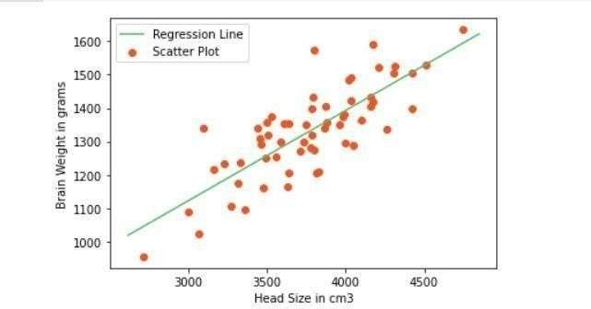

# Calculating Root Mean Squares Error rmse = 0

for i in range(n): y_pred = c + m * X[i]

rmse += (Y[i] - y_pred) ** 2

rmse = np.sqrt(rmse/n) print("RMSE: ",rmse)



# Calculating R2 Score ss_tot = 0

ss_res = 0

for i in range(n): y_pred = c + m * X[i]

ss_tot += (Y[i] - mean_y) ** 2 ss_res += (Y[i] - y_pred) ** 2

r2 = 1 - (ss_res/ss_tot) print("R2 Score: ",r2)



# P18. Apply logistic regression on userdata.csv dataset to predict the users who may be potential customers to purchase a SUV car? Also generate the confusion matrix to evaluate your model?

import numpy as np import pandas as pd

import matplotlib.pyplot as plt import seaborn as sns

from sklearn.model_selection import train_test_split from sklearn.preprocessing import StandardScaler from sklearn.linear_model import LogisticRegression from sklearn import metrics

from google.colab import drive drive.mount('/content/drive')

dtf = pd.read_csv('/content/drive/My Drive/Colab Notebooks/User_Data.csv') dtf.head()

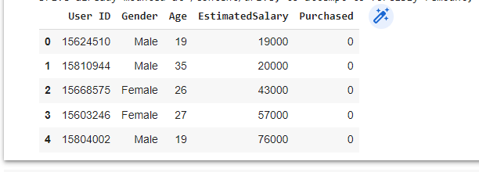

data = dtf.values

X, y = data[:, [2,3]], data[:, 4] # split the data

X_train, X_test, y_train, y_test = train_test_split(X, y, test_size=0.3, ra ndom_state=1)

sc = StandardScaler()

X_train = sc.fit_transform(X_train) X_test = sc.transform(X_test)

classifier = LogisticRegression() classifier.fit(X_train, y_train)

y_pred = classifier.predict(X_test)

print('Accuracy score of test data : ',metrics.accuracy_score(y_test,y_pred

))



cm = metrics.confusion_matrix(y_test, y_pred) print('Confision matrix: ')

print(cm)

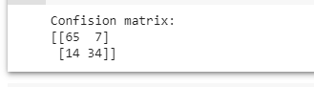

# P19. Apply logistic regression on handwritten digits dataset to classify the digits. Evaluate your model too?

import numpy as np

from sklearn.datasets import fetch_openml

from sklearn.linear_model import LogisticRegression from sklearn.model_selection import train_test_split from sklearn.preprocessing import StandardScaler from sklearn.utils import check_random_state

import matplotlib.pyplot as plt

X, y = fetch_openml('mnist_784', version=1, return_X_y=True, as_frame=False

)

# Print to show there are 1797 images (8 by 8 images for a dimensionality o f 64)

print("Image Data Shape" , X.shape)

# Print to show there are 1797 labels (integers from 0-9) print("Label Data Shape", y.shape)



train_img, test_img, train_lbl, test_lbl = train_test_split(X, y, test_size

=1/7.0, random_state=0)

plt.figure(figsize=(20,4))

for index, (image, label) in enumerate(zip(train_img[0:5], train_lbl[0:5]))

:

plt.subplot(1, 5, index + 1)

plt.imshow(np.reshape(image, (28,28)), cmap=plt.cm.gray) plt.title('Training: %s\n' % label, fontsize = 20)

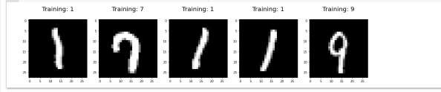

logisticRegr = LogisticRegression(solver = 'lbfgs') logisticRegr.fit(train_img, train_lbl)

# Make predictions on entire test data predictions = logisticRegr.predict(test_img)

plt.figure(figsize=(20,4)) for i in range(0,5):

plt.subplot(1, 5, i + 1)

plt.imshow(np.reshape(test_img[i], (28,28)), cmap=plt.cm.gray) plt.title('Predicted: {}, Actual: {}'.format(predictions[i], test_lbl[i

]), fontsize = 15)

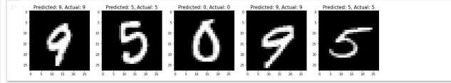

score = logisticRegr.score(test_img, test_lbl) print(score)



# P20. Create a mall_customer_dataset.csv dataset and apply the K-means on the same after deciding the number of clusters using the elbow method to uncover the patterns?

#import libraries import numpy as nm

import matplotlib.pyplot as mtp import pandas as pd

from google.colab import drive drive.mount('/content/drive')

dataset=pd.read_csv('/content/drive/My Drive/Colab Notebooks/Mall_Customers

_data.csv')

#extract the independent variables x=dataset.iloc[:,[3,4]].values

#finding optimal number of clusters using elbow method from sklearn.cluster import KMeans wcss_list=[]#initializing the list for the values of WCSS for i in range(1,11):

kmeans=KMeans(n_clusters=i, init='k-means++', random_state=42) kmeans.fit(x)

wcss_list.append(kmeans.inertia_) mtp.plot(range(1,11), wcss_list) mtp.title('The elbow method graph') mtp.xlabel('Number of cluster (k)') mtp.ylabel('wcss_list')

mtp.show()

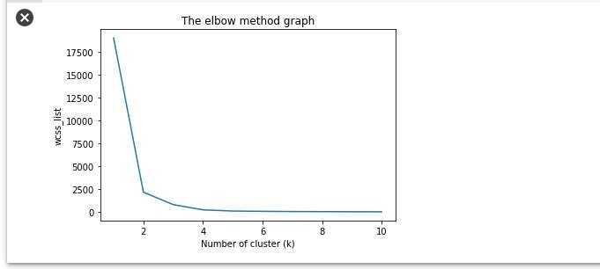

#training the K-mean model on a dataset kmeans=KMeans(n_clusters=2,init='k-means++',random_state=42) y_predict=kmeans.fit_predict(x)

#visualize the clusters

mtp.scatter(x[y_predict == 0,0],x[y_predict ==0,1], s=100, c='blue',label=' Cluster 1')

mtp.scatter(x[y_predict == 1,0],x[y_predict ==1,1], s=100, c='green',label= 'Cluster 2') mtp.scatter(kmeans.cluster_centers_[:,0],kmeans.cluster_centers_[:,1],s=300

,c='yellow')

mtp.title('Clusters of customers') mtp.xlabel('Annual Income (k$)') mtp.ylabel('Spending Score(1-100)') mtp.legend()

mtp.show()

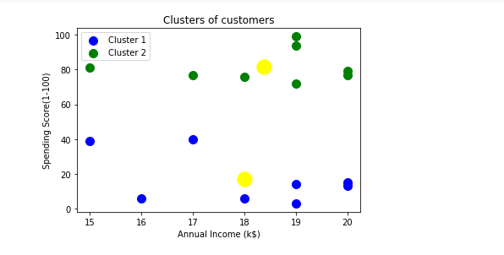

# P21. Use the Pima Indian diabetes database to perform ensemble predictions using the following bagging classifiers: Bagged Decision Trees, Random Forest Classifier and Extra trees?

import pandas

from sklearn import model_selection

from sklearn.ensemble import BaggingClassifier from sklearn.tree import DecisionTreeClassifier

url = "https://raw.githubusercontent.com/jbrownlee/Datasets/master/pima- indians-diabetes.data.csv"

names = ['preg', 'plas', 'pres', 'skin', 'test', 'mass', 'pedi', 'age', 'cl ass']

dataframe = pandas.read_csv(url, names=names) array = dataframe.values

X = array[:,0:8]

Y = array[:,8] seed = 7

kfold = model_selection.KFold(n_splits=10, random_state=seed , shuffle=True

)

# Bagged Decision Trees for Classification cart = DecisionTreeClassifier()

num_trees = 100

model = BaggingClassifier(base_estimator=cart, n_estimators=num_trees, rand om_state=seed)

results = model_selection.cross_val_score(model, X, Y, cv=kfold) print(results.mean())



# Random Forest Classification

from sklearn.ensemble import RandomForestClassifier max_features=3

model = RandomForestClassifier(n_estimators=num_trees, max_features=max_fea tures)

results = model_selection.cross_val_score(model, X, Y, cv=kfold) print(results.mean())



# Extra Trees Classification

from sklearn.ensemble import ExtraTreesClassifier num_trees = 100

max_features = 7

model = ExtraTreesClassifier(n_estimators=num_trees, max_features=max_featu res)

results = model_selection.cross_val_score(model, X, Y, cv=kfold) print(results.mean())



# P22. Implement a simple neural network with:

* **2 inputs**

# A hidden layer with 2 neurons (h1, h2)

* **An output layer with 1 neuron (o1)**

import numpy as np def sigmoid(x):

# Sigmoid activation function: f(x) = 1 / (1 + e^(-x)) return 1 / (1 + np.exp(-x))

def deriv_sigmoid(x):

# Derivative of sigmoid: f'(x) = f(x) * (1 - f(x)) fx = sigmoid(x)

return fx * (1 - fx)

def mse_loss(y_true, y_pred):

# y_true and y_pred are numpy arrays of the same length. return ((y_true - y_pred) ** 2).mean()

class OurNeuralNetwork:

def init (self): # Weights

self.w1 = np.random.normal() self.w2 = np.random.normal() self.w3 = np.random.normal() self.w4 = np.random.normal() self.w5 = np.random.normal() self.w6 = np.random.normal()

# Biases

self.b1 = np.random.normal() self.b2 = np.random.normal() self.b3 = np.random.normal()

def feedforward(self, x):

# x is a numpy array with 2 elements.

h1 = sigmoid(self.w1 * x[0] + self.w2 * x[1] + self.b1) h2 = sigmoid(self.w3 * x[0] + self.w4 * x[1] + self.b2) o1 = sigmoid(self.w5 * h1 + self.w6 * h2 + self.b3) return o1

def train(self, data, all_y_trues):

learn_rate = 0.1

epochs = 1000 # number of times to loop through the entire dataset

for epoch in range(epochs):

for x, y_true in zip(data, all_y_trues):

# --- Do a feedforward (we'll need these values later) sum_h1 = self.w1 * x[0] + self.w2 * x[1] + self.b1

h1 = sigmoid(sum_h1)

sum_h2 = self.w3 * x[0] + self.w4 * x[1] + self.b2 h2 = sigmoid(sum_h2)

sum_o1 = self.w5 * h1 + self.w6 * h2 + self.b3 o1 = sigmoid(sum_o1)

y_pred = o1

# --- Calculate partial derivatives.

# --- Naming: d_L_d_w1 represents "partial L / partial w1" d_L_d_ypred = -2 * (y_true - y_pred)

# Neuron o1

d_ypred_d_w5 = h1 * deriv_sigmoid(sum_o1) d_ypred_d_w6 = h2 * deriv_sigmoid(sum_o1) d_ypred_d_b3 = deriv_sigmoid(sum_o1)

d_ypred_d_h1 = self.w5 * deriv_sigmoid(sum_o1) d_ypred_d_h2 = self.w6 * deriv_sigmoid(sum_o1)

# Neuron h1

d_h1_d_w1 = x[0] * deriv_sigmoid(sum_h1) d_h1_d_w2 = x[1] * deriv_sigmoid(sum_h1) d_h1_d_b1 = deriv_sigmoid(sum_h1)

# Neuron h2

d_h2_d_w3 = x[0] * deriv_sigmoid(sum_h2) d_h2_d_w4 = x[1] * deriv_sigmoid(sum_h2) d_h2_d_b2 = deriv_sigmoid(sum_h2)

# --- Update weights and biases # Neuron h1

self.w1 -= learn_rate * d_L_d_ypred * d_ypred_d_h1 * d_h1_d_w1 self.w2 -= learn_rate * d_L_d_ypred * d_ypred_d_h1 * d_h1_d_w2 self.b1 -= learn_rate * d_L_d_ypred * d_ypred_d_h1 * d_h1_d_b1

# Neuron h2

self.w3 -= learn_rate * d_L_d_ypred * d_ypred_d_h2 * d_h2_d_w3 self.w4 -= learn_rate * d_L_d_ypred * d_ypred_d_h2 * d_h2_d_w4 self.b2 -= learn_rate * d_L_d_ypred * d_ypred_d_h2 * d_h2_d_b2

# Neuron o1

self.w5 -= learn_rate * d_L_d_ypred * d_ypred_d_w5

self.w6 -= learn_rate * d_L_d_ypred * d_ypred_d_w6 self.b3 -= learn_rate * d_L_d_ypred * d_ypred_d_b3

# --- Calculate total loss at the end of each epoch if epoch % 10 == 0:

y_preds = np.apply_along_axis(self.feedforward, 1, data) loss = mse_loss(all_y_trues, y_preds)

print("Epoch %d loss: %.3f" % (epoch, loss))

# Define dataset data = np.array([

|  |  |  |  |
| --- | --- | --- | --- |
| [-2, | -1], | # | Alice |
| [25, | 6], | # | Bob |
| [17, | 4], | # | Charlie |
| [-15, | -6], | # | Diana |

])

all_y_trues = np.array([ 1, # Alice

0, # Bob

0, # Charlie

1, # Diana

])

# Train our neural network! network = OurNeuralNetwork() network.train(data, all_y_trues)

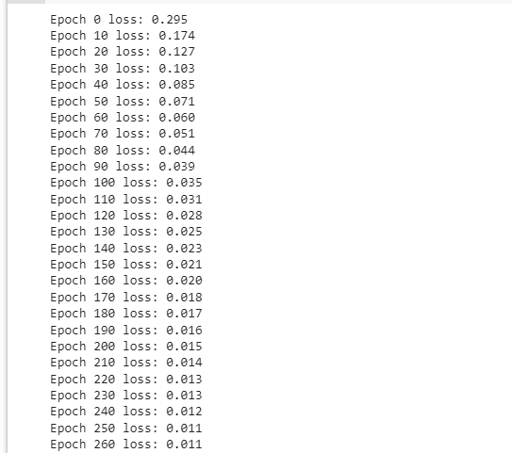

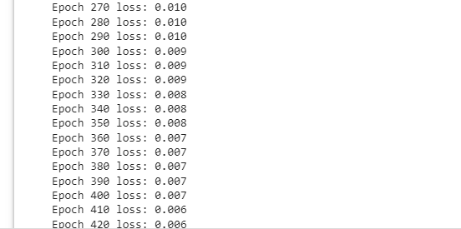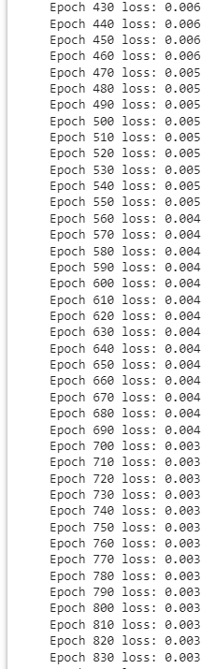

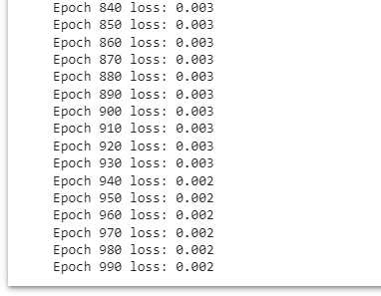

# Make some predictions

emily = np.array([-7, -3]) # 128 pounds, 63 inches

frank = np.array([20, 2]) # 155 pounds, 68 inches print("Emily: %.3f" % network.feedforward(emily)) # 0.951 - F print("Frank: %.3f" % network.feedforward(frank)) # 0.039 - M



# P23. Build a simplified clone of IMDB Top 250 movies using metadata collection from IMDB. The following are the steps involved: -Decide on the metric or score to rate movies on - Calculate the score for every movie -Sort the movies based on the score and output the top results. -Use the Full Movie Lens Dataset.

#Importing relevant libraries import pandas as pd

from google.colab import drive drive.mount('/content/drive')

# Load Movies Metadata

metadata = pd.read_csv('/content/drive/My Drive/Colab Notebooks/movies_meta data.csv', low_memory=False)

# Print the first three rows metadata.head(3)

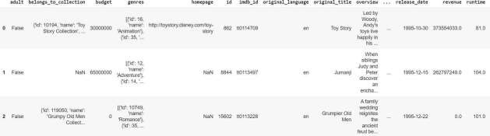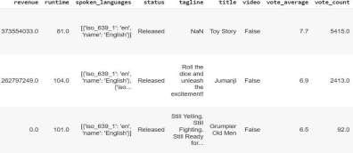

# Calculate mean of vote average column C = metadata['vote_average'].mean() print(C)



# Calculate the minimum number of votes required to be in the chart, m m = metadata['vote_count'].quantile(0.90)

print(m)



# Filter out all qualified movies into a new DataFrame q_movies = metadata.copy().loc[metadata['vote_count'] >= m] q_movies.shape



metadata.shape



# Function that computes the weighted rating of each movie def weighted_rating(x, m=m, C=C):

v = x['vote_count'] R = x['vote_average']

# Calculation based on the IMDB formula return (v/(v+m) * R) + (m/(m+v) * C)

# Define a new feature 'score' and calculate its value with `weighted_ratin g()`

q_movies['score'] = q_movies.apply(weighted_rating, axis=1)

#Sort movies based on score calculated above

q_movies = q_movies.sort_values('score', ascending=False)

#Print the top 20 movies

q_movies[['title', 'vote_count', 'vote_average', 'score']].head(20)

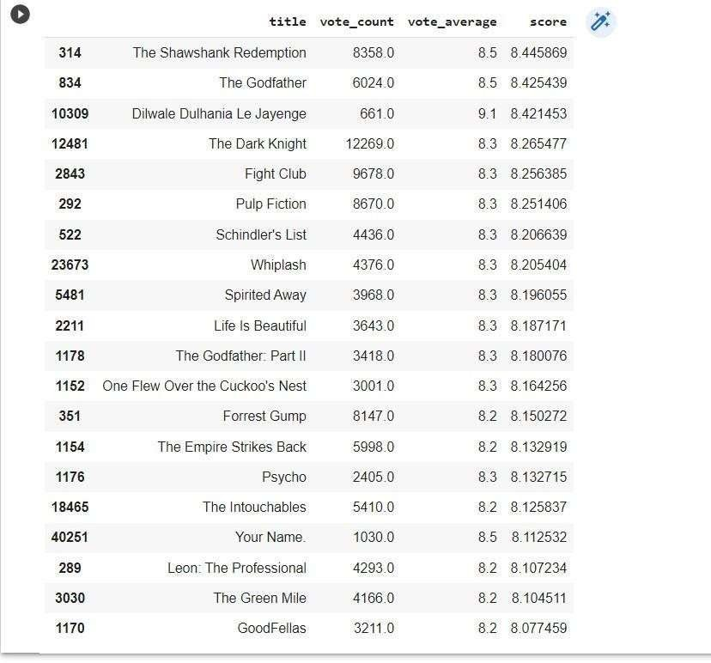

# P24. Build a system that recommends movies that are similar to a particular movie. Compute pairwise cosine similarity scores for all movies based on that similarity score threshold. The plot description is available to you as the overview feature in your metadata dataset.

#Importing relevant libraries import pandas as pd

from google.colab import drive drive.mount('/content/drive')

# Load Movies Metadata

metadata = pd.read_csv('/content/drive/My Drive/Colab Notebooks/movies_meta data.csv', low_memory=False)

#Print plot overviews of the first 5 movies. metadata['overview'].head()

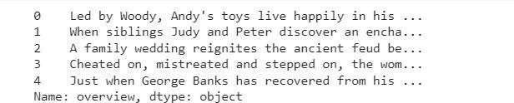

#Import TfIdfVectorizer from scikit-learn

from sklearn.feature_extraction.text import TfidfVectorizer

#Define a TF-

IDF Vectorizer Object. Remove all english stop words such as 'the', 'a' tfidf = TfidfVectorizer(stop_words='english')

#Replace NaN with an empty string metadata['overview'] = metadata['overview'].fillna('')

#Construct the required TF-IDF matrix by fitting and transforming the data tfidf_matrix = tfidf.fit_transform(metadata['overview'])

#Output the shape of tfidf_matrix tfidf_matrix.shape



#Array mapping from feature integer indices to feature name. tfidf.get_feature_names()[5000:5010]

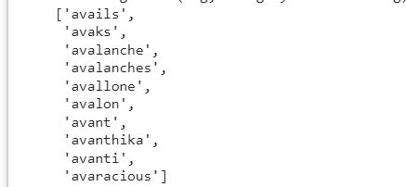

# Import linear_kernel

from sklearn.metrics.pairwise import linear_kernel

# Compute the cosine similarity matrix

cosine_sim = linear_kernel(tfidf_matrix, tfidf_matrix)

#Construct a reverse map of indices and movie titles

indices = pd.Series(metadata.index, index=metadata['title']).drop_duplicate s()

indices[:10]

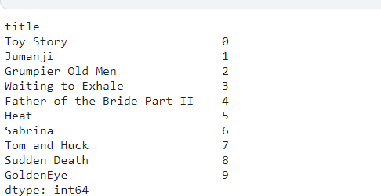

# Function that takes in movie title as input and outputs most similar movi es

def get_recommendations(title, cosine_sim=cosine_sim): # Get the index of the movie that matches the title idx = indices[title]

# Get the pairwsie similarity scores of all movies with that movie sim_scores = list(enumerate(cosine_sim[idx]))

# Sort the movies based on the similarity scores

sim_scores = sorted(sim_scores, key=lambda x: x[1], reverse=True)

# Get the scores of the 10 most similar movies sim_scores = sim_scores[1:11]

# Get the movie indices

movie_indices = [i[0] for i in sim_scores]

# Return the top 10 most similar movies return metadata['title'].iloc[movie_indices]

get_recommendations('The Dark Knight Rises')

