Before writing the code, we first have to check the analog value an IR sensor records when an obstacle ( in this case a car ) is put in front of it. For that, we will make the value it records, print on the screen via Arduino. Use the following code for the same.

void setup()

{

Serial.begin(9600);

}

void loop()

{

int sensorValue=analogRead(A0);

Serial.println(sensorValue);

delay(1);

}

After compiling the code, click on the Serial monitor button on the Arduino ide

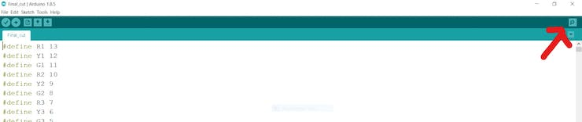

In for my ir sensors, I found this value to be around 500. So any analog value above 500(reported by the sensor, in any lane ) was treated as high density for that lane by the programme.

There being 4 lanes and each lane may have either

1. high density traffic or

2. Low density traffic.

Therefore will be 2^4=16 cases we will have to consider while writing the code.