

## BHARATI VIDYAPEETH’S

**INSTITUTE OF COMPUTER APPLICATIONS & MANAGEMENT**

(Affiliated to Guru Gobind Singh Indraprastha University, Approved by AICTE, New Delhi)

**Database Management**

**Systems (MCA-165)**

**Practical File**

## Submitted To: Submitted By:

Dr. Vaishali Joshi Sachin Rana (02511604421) (Assistant Professor) MCA 1st Sem, Sec 1

**INDEX**

|  |  |  |
| --- | --- | --- |
|  | **LAB ASSIGNMENT** | **PAGE NO.** |
| **I** | LAB ASSIGNMENT I | **3** |
| **II** | LAB ASSIGNMENT II | **10** |
| **III** | LAB ASSIGNMENT III (JOINS) | **17** |
| LAB ASSIGNMENT III (JOINS) (Part2) | **24** |
| **IV** | LAB ASSIGNMENT IV | **29** |
| **V** | LAB ASSIGNMENT V (PL/SQL) | **36** |
| LAB ASSIGNMENT V (Use of Cursors) | **42** |
| LAB ASSIGNMENT V (Cursor and Error Handling) | **46** |
| LAB ASSIGNMENT V (Procedures and Functions) | **48** |
| LAB ASSIGNMENT V (Trigger) | **52** |

# LAB ASSIGNMENT – I

#### Table : Book

|  |  |  |  |
| --- | --- | --- | --- |
| **Field Name** | **Data type** | **Size** | **Constraint** |
| Book_Code | Varchar2 | 5 | Primary Key |
| ISBN No. | Varchar2 | 8 | Not Null/ |
| Book Name | Varchar2 | 14 | Unique |
| Publisher | Varchar2 | 10 |  |
| Price | Number | 5,2 | >=100 |
| Author Name | Varchar2 | 14 |  |
| Date_of_Launch | Date |  |  |

***Table Creation Query-***

CREATE TABLE Book(

Book_Code VARCHAR2(5) PRIMARY KEY, ISBN_No VARCHAR(8) NOT NULL, Book_Name VARCHAR2(14) UNIQUE,

Publisher VARCHAR2(10),

Price NUMBER(5,2) CHECK (Price>=100),

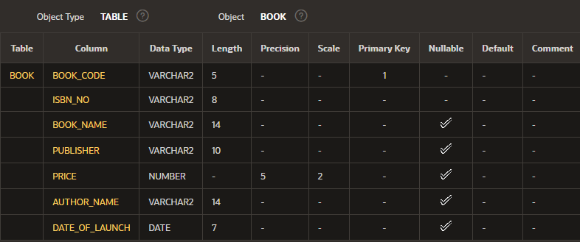Author_Name VARCHAR2(14), Date_of_Launch DATE);

**Write queries to perform the following:**

#### 1. Insert a few records in it.

***Sql Query-***

INSERT INTO Book VALUES ('M138', 'IB0013', 'Intro to C#', 'TMH', 500.00, 'Yashwant K', '04/25/2003');

INSERT INTO Book VALUES ('M272', 'IB1045', 'Graphics with C', 'PHI', 650.00, 'F Campbell', '09/20/2006');

INSERT INTO Book VALUES ('M106', 'IB0024', 'JAVA Basics', 'TMH', 920.50, 'Brie Avant', '01/15/1999');

INSERT INTO Book VALUES ('M210', 'IB1048', 'Kotlin Guide', 'PHI', 200.00, 'Mason G Tam', '06/30/2015');

INSERT INTO Book VALUES ('M167', 'IB0061', 'CPP Coding', 'Pearson', 750.25, 'Jean Arrot', '07/13/1998');

INSERT INTO Book VALUES ('M236', 'IB1031', 'JAVA with VS', 'BPB', 800.55, 'Brie Avant', '03/15/2008');

INSERT INTO Book VALUES ('M123', 'IB0032', 'Graphics in C#', 'Pearson', 750.25, 'K Dibiasky', '02/14/2005');

INSERT INTO Book VALUES ('M242', 'IB1074', 'Python', 'BPB', 980.55, 'Juon Orlean', '09/27/2007');

INSERT INTO Book VALUES ('M119', 'IB0038', 'SQL Basics', 'TMH', 800.00, 'Yule Drask', '06/26/2003');

INSERT INTO Book VALUES ('M289', 'IB1027', 'Database Guide', 'Pearson', 475.25, 'Yule Drask', '05/21/2010');

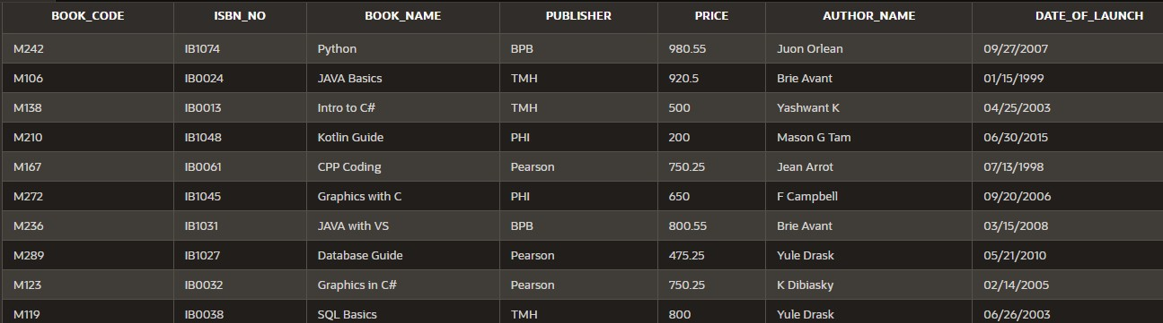***Results-***

#### —----------------------------------

**Q2. Increase the size of the Book_Name field to 16 characters.**

***Sql Query-***

ALTER TABLE Book

MODIFY Book_Name VARCHAR2(16);

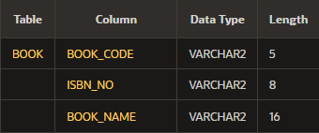***Results-***

#### —----------------------------------

**Q3. Display the total price of all the books of “TMH’ publishing house.**

***Sql Query-***

SELECT SUM(Price)

FROM Book

WHERE Publisher = 'TMH';

***Results-***

#### —----------------------------------

**Q4. Display the details of all the books of author “Yashwant Kanetkar” and “Yule Drask”.**

***Sql Query-***

SELECT * FROM Book

WHERE Author_Name IN ('Yashwant K','Yule Drask');

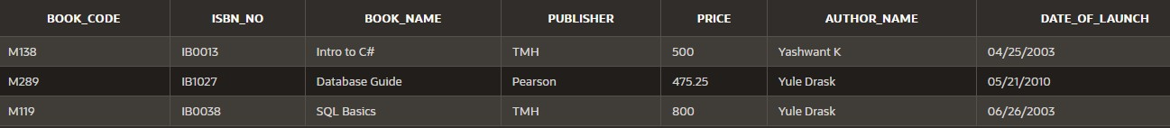***Results-***

#### —----------------------------------

**Q5. Delete all the books belonging to “PHI” publisher.**

***Sql Query-***

DELETE FROM Book

WHERE Publisher = 'PHI';

***Results-***

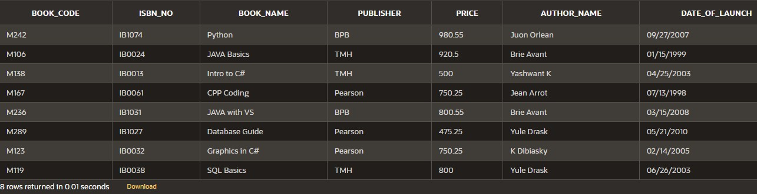

#### —----------------------------------

**Q6. Update the price of books by 5% which belong to ‘BPB’ publishers.**

***Sql Query-***

UPDATE Book

SET Price = ((0.05*Price) + Price) WHERE Publisher = 'BPB';

***Results-***

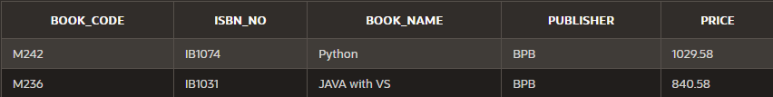

#### —----------------------------------

**Q7. Create a new table “Author” with author details such as author id (primary key), name of the author, subject, contact details, research area etc.**

***Sql Query-***

CREATE TABLE Author(

Author_ID NUMBER(3) PRIMARY KEY,

Author_Name VARCHAR2(14), Subject VARCHAR(8) NOT NULL,

Contact_Details VARCHAR2(14), Research_Area VARCHAR2(30));

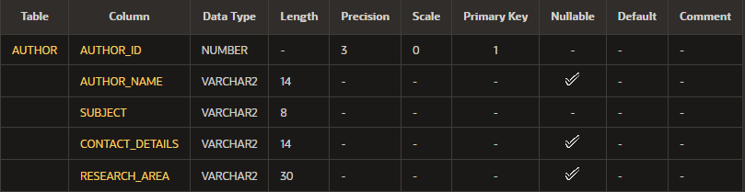***Results-***

#### —----------------------------------

***Inertion in Author Table-***

INSERT INTO Author VALUES(992, 'Yashwant K.', 'C#', '9999999999', 'Web Mining');

INSERT INTO Author VALUES(125, 'Juan Orlean', 'Python', 'xyz@gmail.com', 'Web Mining'); INSERT INTO Author VALUES(325, 'Brie Avant', 'JAVA', 'brav@yahoo', 'Numerical Applications');

INSERT INTO Author VALUES(777, 'Yule Drask', 'DBMS', 'yuld@mail.com', 'Data Mining'); INSERT INTO Author VALUES(623, 'K Dibiasky', 'C#', 'kdbs@ggle', 'Web Mining');

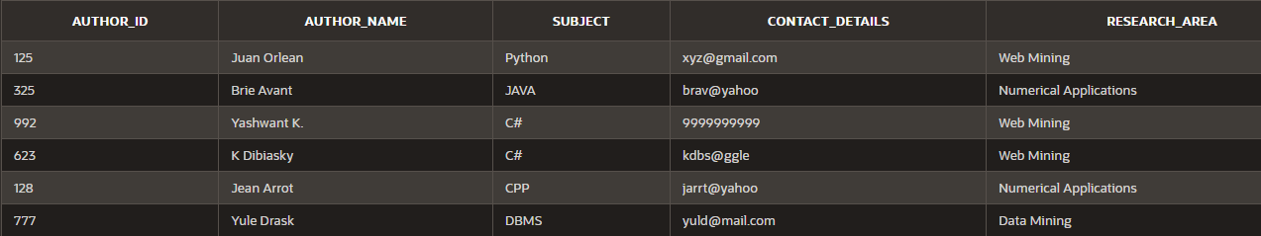INSERT INTO Author VALUES(128, 'Jean Arrot', 'CPP', 'jarrt@yahoo', 'Numerical Applications');

#### Q8. Insert records in it and display the records of those authors who have ‘Web mining’ as their research area.

***Sql Query-***

SELECT * FROM Author

WHERE Research_Area = 'Web Mining';

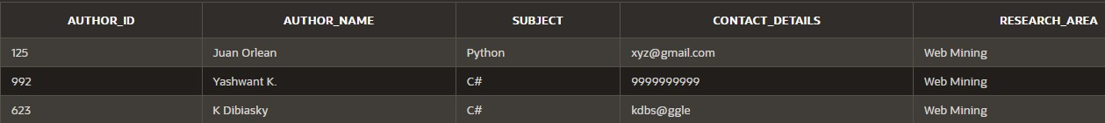***Results-***

#### —----------------------------------

**Q9. Add a new column “Author_Id” in “Book” table and make it a foreign key on “author id” of “Author” table.**

***Sql Query-***

ALTER TABLE Book

ADD Author_ID REFERENCES Author(Author_ID); SELECT * FROM Book;

***Results-***

#### —----------------------------------

**Q10. Update all the previous records of Book table to add information of author id (newly added column)**

***Sql Query-***

UPDATE Book SET Author_ID = 992 WHERE Author_Name = 'Yashwant K'; UPDATE Book SET Author_ID = 125 WHERE Author_Name = 'Juon Orlean'; UPDATE Book SET Author_ID = 325 WHERE Author_Name = 'Brie Avant'; UPDATE Book SET Author_ID = 623 WHERE Author_Name = 'K Dibiasky'; UPDATE Book SET Author_ID = 128 WHERE Author_Name = 'Jean Arrot'; UPDATE Book SET Author_ID = 777 WHERE Author_Name = 'Yule Drask'; UPDATE Book SET Author_ID = 992 WHERE Author_Name = 'Yashwant K';

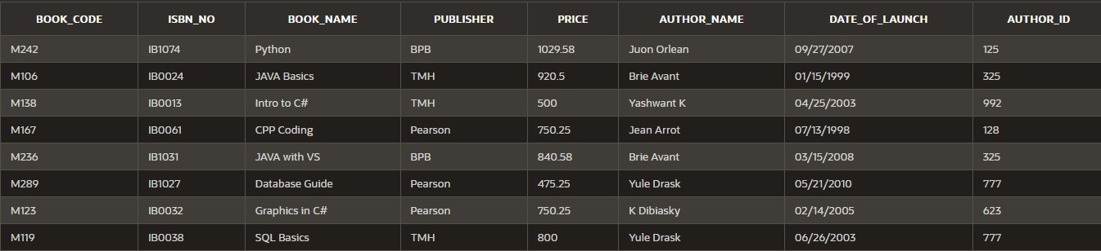***Results-***

#### —----------------------------------

**Q11. Display the records of the books where book name starts with ‘C’ or ‘G’ or ‘I’.**

***Sql Query-***

SELECT * FROM Book

WHERE Book_Name LIKE 'C%' OR Book_Name LIKE 'G%'

OR Book_Name LIKE 'I%';

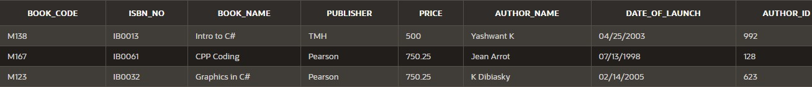***Results-***

#### —----------------------------------

**Q12. Create a view for the user to access Book Code, Name and Price of books which are published by ‘Pearson Education’**

***Sql Query-***

CREATE VIEW PearsonV AS

SELECT Book_Code, Book_Name, Price FROM Book

WHERE Publisher = 'Pearson';

SELECT * FROM PearsonV;

***Results-***

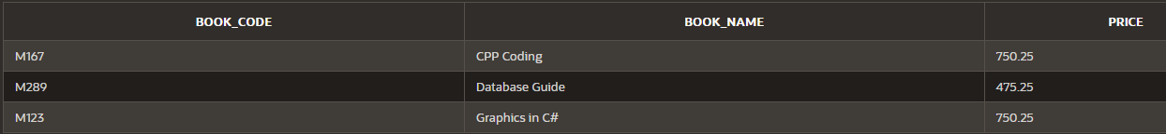

**—----------------------------------**

# LAB ASSIGNMENT – II

#### Table : Student

|  |  |  |  |
| --- | --- | --- | --- |
| **Field Name** | **Data type** | **Size** | **Constraint** |
| Roll_No | Number | 2 | Primary Key |
| SName | Varchar2 | 20 | Not Null |
| Address | Varchar2 | 50 |  |
| City | Varchar2 | 30 |  |
| Marks_Sub1 | Number | 5,2 | >=0 and <=100 |
| Marks_Sub2 | Number | 5,2 | >=0 and <=100 |
| Marks_Sub3 | Number | 5,2 | >=0 and <=100 |
| Total | Number | 5,2 | >=0 and <=300 |

***Table Creation Query-***

CREATE TABLE Student(

Roll_No NUMBER(2) PRIMARY KEY, SName VARCHAR2(20) NOT NULL, Address VARCHAR2(50),

City VARCHAR2(30),

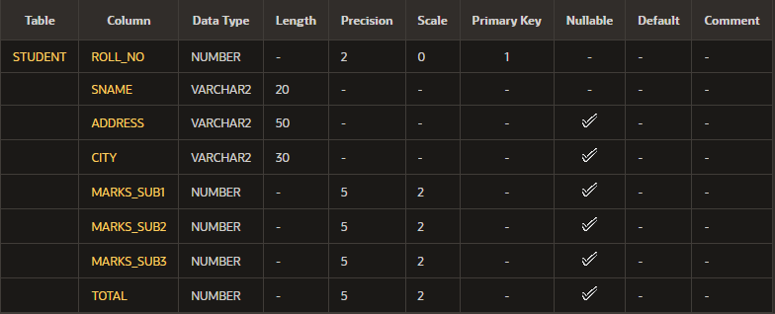Marks_Sub1 NUMBER(5,2) CHECK (Marks_Sub1>=0 AND Marks_Sub1<=100), Marks_Sub2 NUMBER(5,2) CHECK (Marks_Sub2>=0 AND Marks_Sub2<=100), Marks_Sub3 NUMBER(5,2) CHECK (Marks_Sub3>=0 AND Marks_Sub3<=100), Total NUMBER(5,2) CHECK (Total>=0 AND Total<=300));

**Write SQL queries for :**

#### Q1. Insert few records except total marks.

***SQL Query-***

INSERT INTO Student(Roll_No, SName, Address, City, Marks_Sub1, Marks_Sub2, Marks_Sub3) VALUES (12, 'Sachin', 'Flat No 324 ABC Apartment', 'New Delhi', 89, 90.50,

95.25);

INSERT INTO Student(Roll_No, SName, Address, City, Marks_Sub1, Marks_Sub2, Marks_Sub3) VALUES (30, 'Akriti', 'Flat No 23 DD Apartments', 'New Delhi', 95, 70.50, 85); INSERT INTO Student(Roll_No, SName, Address, City, Marks_Sub1, Marks_Sub2, Marks_Sub3) VALUES (9, 'Nishant', 'Flat No 324 ABC Apartment', 'Gurgaon', 70, 90.50, 95.25); INSERT INTO Student(Roll_No, SName, Address, City, Marks_Sub1, Marks_Sub2, Marks_Sub3) VALUES (15, 'Rajesh', 'Flat No 324 ABC Apartment', 'New Delhi', 39, 30.50,

35.25);

INSERT INTO Student(Roll_No, SName, Address, City, Marks_Sub1, Marks_Sub2, Marks_Sub3) VALUES (33, 'Suman', 'Flat No 324 ABC Apartment', 'Mumbai', 49, 90.50, 95.25); INSERT INTO Student(Roll_No, SName, Address, City, Marks_Sub1, Marks_Sub2, Marks_Sub3) VALUES (22, 'Aman', 'Flat No 324 ABC Apartment', 'Gurgaon', 29, 90.50, 95.25); INSERT INTO Student(Roll_No, SName, Address, City, Marks_Sub1, Marks_Sub2, Marks_Sub3) VALUES (39, 'Geeta', 'Flat No 324 ABC Apartment', 'Lucknow', 59, 90.50, 95.25); INSERT INTO Student(Roll_No, SName, Address, City, Marks_Sub1, Marks_Sub2, Marks_Sub3) VALUES (25, 'Satyam', 'Flat No 324 ABC Apartment', 'Lucknow', 97, 41.50, 37); INSERT INTO Student(Roll_No, SName, Address, City, Marks_Sub1, Marks_Sub2, Marks_Sub3) VALUES (40, 'Kiran', 'Flat No 324 ABC Apartment', 'Mumbai', 85, 90.50, 95.25); INSERT INTO Student(Roll_No, SName, Address, City, Marks_Sub1, Marks_Sub2, Marks_Sub3) VALUES (1, 'Suman', 'Flat No 424 ABC Apartment', 'New Delhi', 99, 96.50,

95.25);

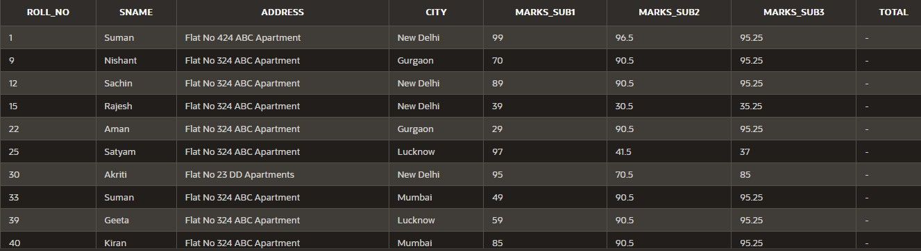***Results-***

#### —----------------------------------

**Q2. Calculate total marks of each student and save it.**

***SQL Query-***

UPDATE Student

SET Total = (Marks_Sub1 + Marks_Sub2 + Marks_Sub3);

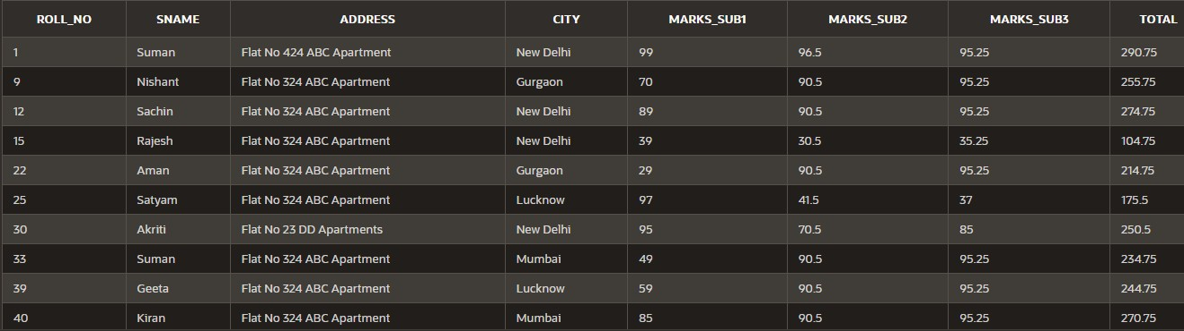***Results-***

#### —----------------------------------

**Q3. Display the name of the student who has got the highest marks.**

***SQL Query-***

SELECT SName

FROM Student WHERE Total=(

SELECT MAX(Total)

FROM Student);

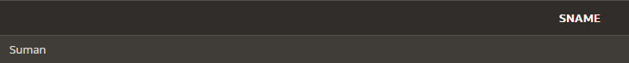***Results-***

#### —----------------------------------

**Q4. Display the records of those students who have got marks more than the marks of ‘Kiran’.**

***SQL Query-***

SELECT * FROM Student WHERE Total >(

SELECT Total FROM Student WHERE SName='Kiran');

***Results-***

#### —----------------------------------

**Q5. Display the percentage of all the students with their names.**

***SQL Query-***

SELECT SName, (Total/3) AS Percentage FROM Student;

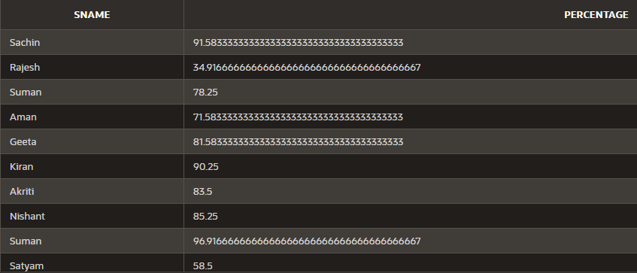***Results-***

#### —----------------------------------

**Q6. Display the names of those students who have got maximum marks in sub1 and more than 50 in sub2 and sub3.**

***SQL Query-***

SELECT SName

FROM Student WHERE (

Marks_Sub1 = (

SELECT MAX(Marks_Sub1) FROM Student WHERE (Marks_Sub2>50 AND Marks_Sub3>50)

)

);

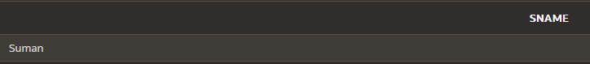***Results-***

#### —----------------------------------

**Q7. Update the marks of all those students who failed, with grace marks 5. (fail means less than 40).**//Check if failed in any 1 sub or more. Add grace marks in total

***SQL Query-*** UPDATE Student SET Total = (Total+5)

WHERE (Marks_Sub1<40) OR (Marks_Sub2<40) OR (Marks_Sub3<40);

***Results-***

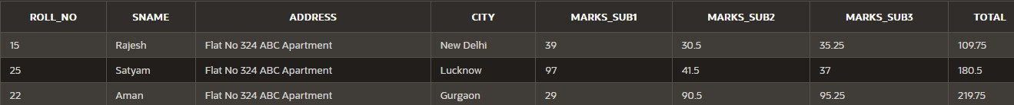

#### —----------------------------------

**Q8. Delete the records of those students who are fail in all three subjects.**

***SQL Query-***

DELETE FROM Student WHERE ((Marks_Sub1<40)

AND (Marks_Sub1<40) AND (Marks_Sub1<40)

);

***Results-***

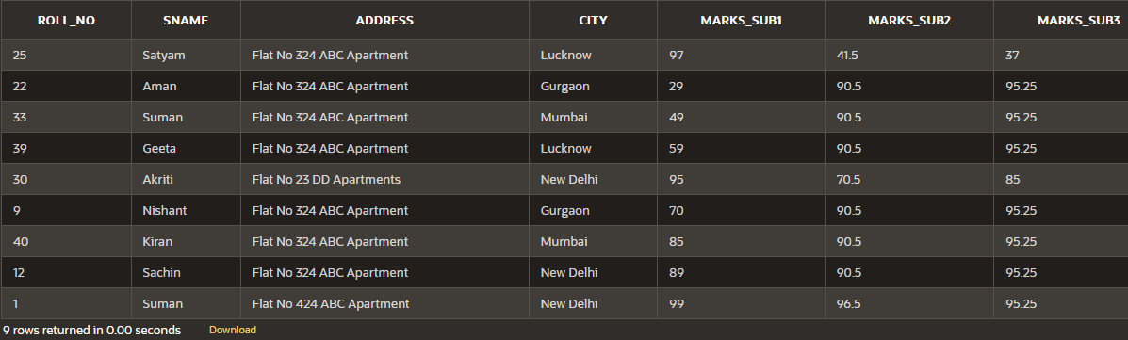

#### —----------------------------------

**Q9. Display the average total marks of all the students city wise excluding the students of ‘Gurgaon’.**

***SQL Query-***

SELECT City, AVG(Total) FROM Student

WHERE City <> 'Gurgaon' GROUP BY City;

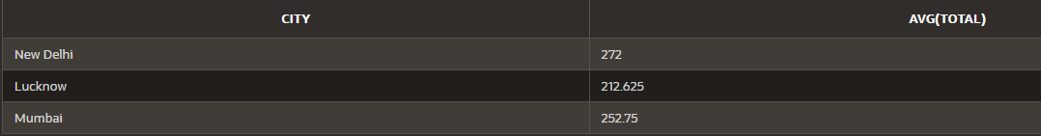***Results-***

#### —----------------------------------

**Q10. Get the names of students with Roll_no less than 30 and whose total marks is more than the total marks of at least one student with Roll_no greater than or equal to 30.**

***SQL Query-***

SELECT SName

FROM Student WHERE(

(Roll_No < 30) AND

(Total > (SELECT MIN(Total) FROM Student WHERE Roll_No >=30)

)

);

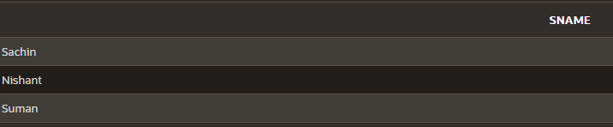***Results-***

#### —----------------------------------

**Q11. Create a composite index on Student table.**

***SQL Query-***

CREATE INDEX StudentI

ON Student (Roll_No, SName);

***Results-***

#### —----------------------------------

**Q12. Create a view on the table to access roll no, name (in capitals), Marks of all 3 subjects and Percentage of all the students.**

***SQL Query-***

CREATE VIEW PercentageV AS

SELECT Roll_No, UPPER(SName) AS SName, Marks_Sub1, Marks_Sub2, Marks_Sub3, (Total/3) AS Percentage

FROM Student;

SELECT * FROM PercentageV;

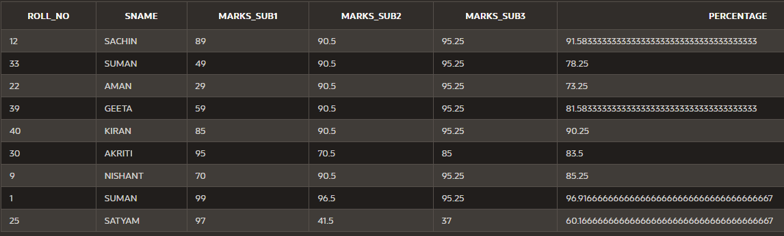***Results-***

**—----------------------------------**

# LAB ASSIGNMENT – III (Joins)

#### (Part 1)

**Consider the following three relations:**

#### Employee (Eid#, EName, Address, DateOfJoining, Department) Project (Pid#, PName, StartDate, TerminationDate)

**AssignedTo (Eid, Pid)**

***Table Creation Query-***

CREATE TABLE Employee(

Eid NUMBER(3) PRIMARY KEY, EName VARCHAR2(20),

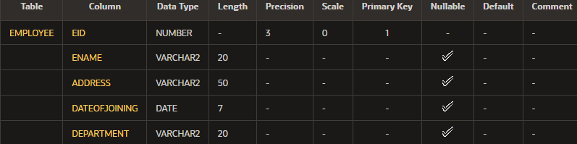Address VARCHAR2(50), DateOfJoining DATE, Department VARCHAR2(20));

***Table Creation Query-***

CREATE TABLE Projects(

Pid NUMBER(3) PRIMARY KEY, PName VARCHAR2(20),

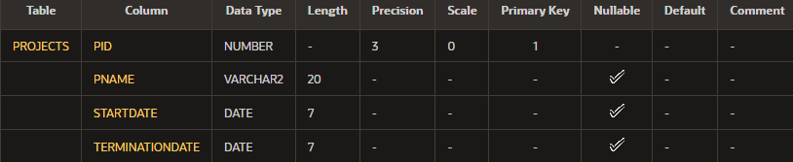StartDate DATE, TerminationDate DATE);

***Table Creation Query-***

CREATE TABLE AssignedTo(

Eid REFERENCES Employee(Eid),

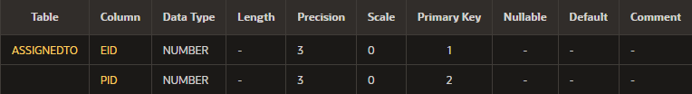Pid REFERENCES Projects(Pid), PRIMARY KEY(Eid,Pid));

***Insertion in Table Employee-***

INSERT INTO Employee VALUES(101, 'Jai Prakkash', 'Delhi', '2/15/2021', 'D01'); INSERT INTO Employee VALUES(102, 'Rajesh', 'Mumbai', '1/11/2021', 'D02');

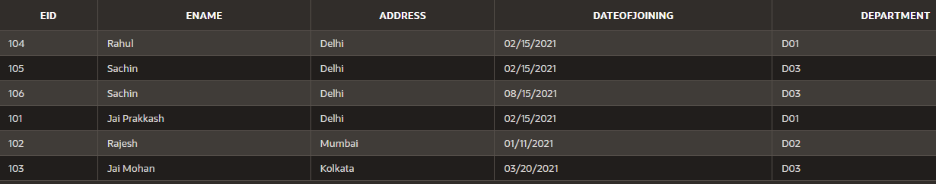INSERT INTO Employee VALUES(103, 'Jai Mohan', 'Kolkata', '3/20/2021', 'D03'); INSERT INTO Employee VALUES(104, 'Rahul', 'Delhi', '2/15/2021', 'D01'); INSERT INTO Employee VALUES(105, 'Sachin', 'Delhi', '2/15/2021', 'D03'); INSERT INTO Employee VALUES(106, 'Sachin', 'Delhi', '8/15/2021', 'D03');

***Insertion in Table Projects-***

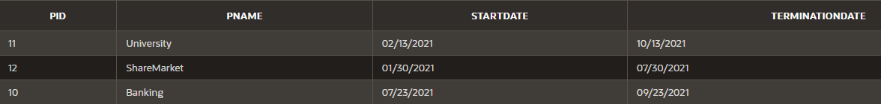INSERT INTO Projects VALUES(10, 'Banking', '7/23/2021', '9/23/2021'); INSERT INTO Projects VALUES(11, 'University', '2/13/2021', '10/13/2021'); INSERT INTO Projects VALUES(12, 'ShareMarket', '1/30/2021', '7/30/2021');

***Insertion in AssignedTo-***

INSERT INTO AssignedTo VALUES(101, 10); INSERT INTO AssignedTo VALUES(103, 10); INSERT INTO AssignedTo VALUES(105, 10); INSERT INTO AssignedTo VALUES(102, 11); INSERT INTO AssignedTo VALUES(103, 11); INSERT INTO AssignedTo VALUES(104, 11); INSERT INTO AssignedTo VALUES(105, 12); INSERT INTO AssignedTo VALUES(103, 12);

**Now write queries for the following in relational algebra as well as in SQL:**

#### Q1. Find the employees working on ‘Banking’ project.

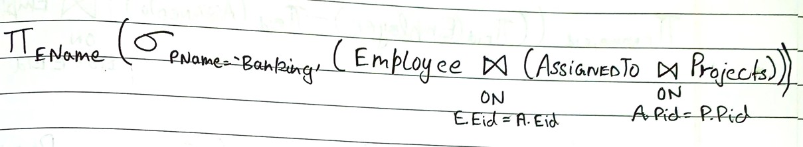***Relational Algebra-***

***SQL Query-***

SELECT EName

FROM Employee JOIN AssignedTo

ON AssignedTo.Eid=Employee.Eid JOIN Projects

ON Projects.Pid= AssignedTo.Pid WHERE PName='Banking';

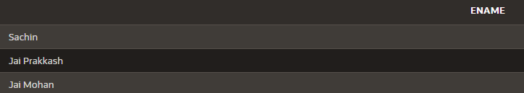***Results-***

#### —----------------------------------

**Q2. Find the projects assigned to the employees of D01 or D02.**

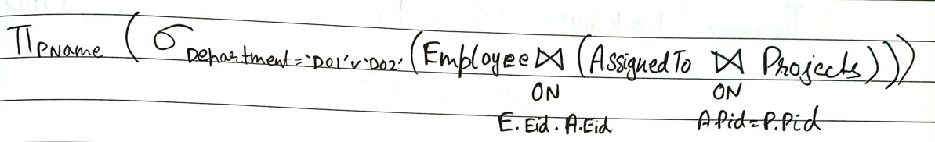***Relational Algebra-***

***SQL Query-***

SELECT DISTINCT PName

FROM Projects JOIN AssignedTo

ON AssignedTo.Pid=Projects.Pid JOIN Employee

ON Employee.Eid= AssignedTo.Eid WHERE Department='D01';

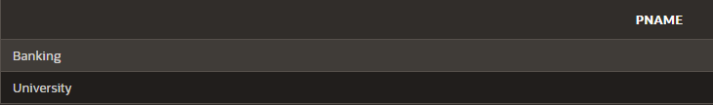***Results-***

#### —----------------------------------

**Q3. Find the employees who belong to Delhi and work on either ‘University’ project or ‘ShareMarket’ project**

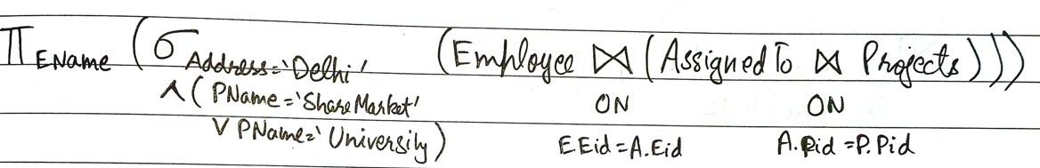***Relational Algebra-***

***SQL Query-***

SELECT EName

FROM Employee JOIN AssignedTo

ON AssignedTo.Eid=Employee.Eid JOIN Projects

ON Projects.Pid= AssignedTo.Pid

WHERE (PName='ShareMarket' OR PName='University') AND Address='Delhi';

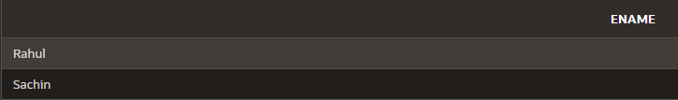***Results-***

#### —----------------------------------

**Q4. Find the employees who do not work on ‘University’ project.**

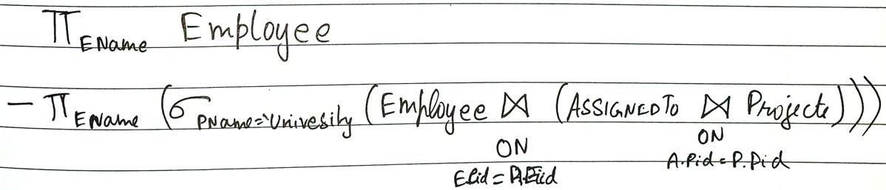***Relational Algebra-***

***SQL Query-***

SELECT Ename FROM Employee MINUS

SELECT Employee.EName FROM Employee

JOIN AssignedTo ON Employee.Eid=AssignedTo.Eid JOIN PROJECTS ON AssignedTo.Pid=Projects.Pid WHERE Projects.PName ='University';

***Results-***

#### —----------------------------------

**Q5. Find the employees who work on all projects.**

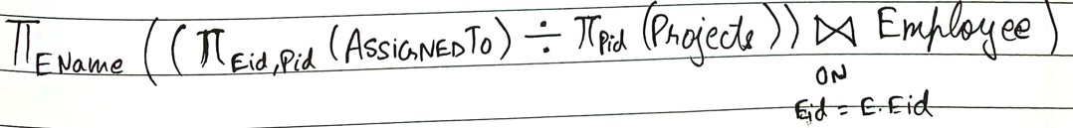***Relational Algebra-***

***SQL Query-***

SELECT EName FROM Employee WHERE Eid IN(SELECT Eid

FROM AssignedTo GROUP BY Eid

HAVING COUNT(Pid)= (SELECT COUNT(Pid) FROM Projects));

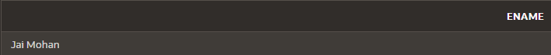***Results-***

#### —----------------------------------

**Q6. List the employees who have not been assigned any project.**

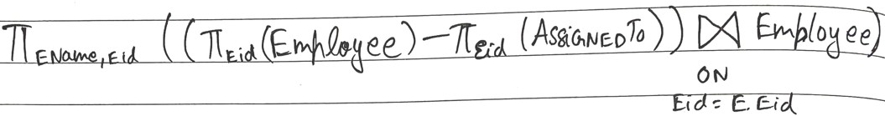***Relational Algebra-***

***SQL Query-*** SELECT Eid, EName FROM Employee

WHERE Eid NOT IN (SELECT Eid FROM AssignedTo);

***Results-***

#### —----------------------------------

**Q7. Find the employees who joined the department after the commencement of ‘Banking’ project.**

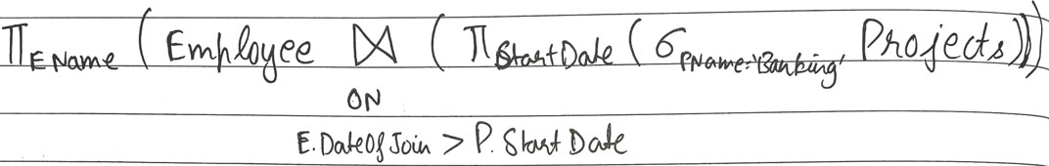***Relational Algebra-***

***SQL Query-***

SELECT * FROM Employee

Where Employee.DateOfJoining > (SELECT StartDate from Projects WHERE Pname = 'Banking');

***Results-***

#### —----------------------------------

**Q8. Display the start and termination date of projects which are allotted to ‘Jai Prakkash’.**

***Relational Algebra-***

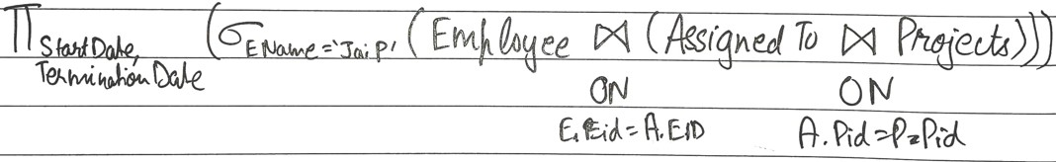

***SQL Query-***

SELECT StartDate, TerminationDate FROM Projects JOIN AssignedTo

ON AssignedTo.Pid = Projects.Pid JOIN Employee

ON AssignedTo.Eid = Employee.Eid WHERE Ename = 'Jai Prakkash';

***Results-***

#### —----------------------------------

**LAB ASSIGNMENT – III (Joins)*(Part 2)***

#### Consider the following relations:

**Students (Roll#, SName, City, Age, Gender) Course (Cid#, CName, Semester, Credits, Fee) Enrollment (Roll#, Cid#, DateOfReg)**

***Table Creation Query-***

CREATE TABLE Students(

Roll NUMBER(2) PRIMARY KEY,

SName VARCHAR2(20), City VARCHAR2(20),

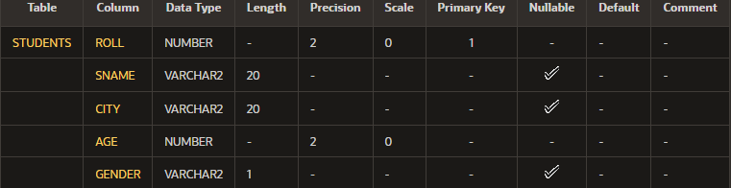Age NUMBER(2) NOT NULL, Gender VARCHAR2(1));

***Table Creation Query-***

CREATE TABLE Course(

Cid NUMBER(3) PRIMARY KEY,

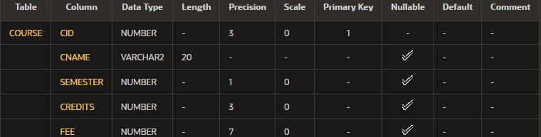CName VARCHAR2(20), Semester NUMBER(1), Credits NUMBER(3), Fee NUMBER(7));

***Table Creation Query-***

CREATE TABLE Enrollment(

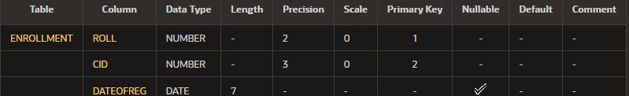Roll REFERENCES Students(Roll), Cid REFERENCES Course(Cid), PRIMARY KEY(Roll,Cid), DateOfReg DATE);

***Insertion in Table Students-***

INSERT INTO Students VALUES(12, 'Sachin', 'Delhi', 21, 'M'); INSERT INTO Students VALUES(13, 'Anita', 'Delhi', 20, 'F');

INSERT INTO Students VALUES(10, 'Kunal', 'Mumbai', 21, 'M'); INSERT INTO Students VALUES(7, 'Nia', 'Kolkata', 22, 'F');

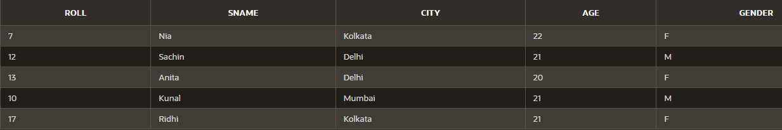INSERT INTO Students VALUES(17, 'Ridhi', 'Kolkata', 21, 'F');

***Insertion in Table Course-***

INSERT INTO Course VALUES(101, 'MCA', 4, 120, 10000);

INSERT INTO Course VALUES(102, 'MBA', 4, 100, 10000);

INSERT INTO Course VALUES(103, 'BTech', 8, 160, 30000);

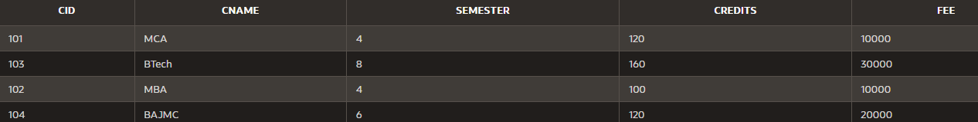INSERT INTO Course VALUES(104, 'BAJMC', 6, 120, 20000);

***Insertion in Table Enrollment-***

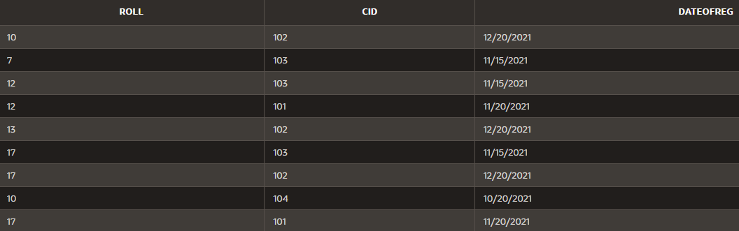INSERT INTO Enrollment VALUES(12, 101, '11/20/2021'); INSERT INTO Enrollment VALUES(13, 102, '12/20/2021'); INSERT INTO Enrollment VALUES(10, 102, '12/20/2021'); INSERT INTO Enrollment VALUES(7, 103, '11/15/2021'); INSERT INTO Enrollment VALUES(17, 103, '11/15/2021'); INSERT INTO Enrollment VALUES(12, 103, '11/15/2021'); INSERT INTO Enrollment VALUES(10, 104, '10/20/2021'); INSERT INTO Enrollment VALUES(17, 102, '12/20/2021'); INSERT INTO Enrollment VALUES(17, 101, '11/20/2021');

### Now write SQL queries for the following:

#### Q1.Find the details of students registered in MCA course.

***SQL Query-***

SELECT * FROM Students JOIN Enrollment

ON Enrollment.Roll= Students.Roll JOIN Course

ON Course.Cid= Enrollment.Cid WHERE CName = 'MCA';

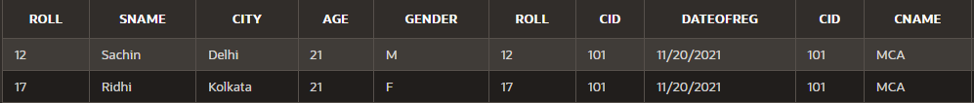***Results-***

#### —----------------------------------

**Q2.Display the total number of students enrolled in MBA.**

***SQL Query-***

SELECT COUNT(*) FROM(

SELECT * FROM Students JOIN Enrollment

ON Enrollment.Roll= Students.Roll JOIN Course

ON Course.Cid= Enrollment.Cid) WHERE CName='MBA';

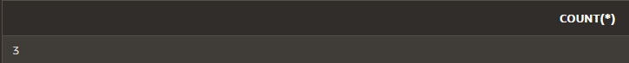***Results-***

#### —----------------------------------

**Q3.Display the names of students who are enrolled in the course in which “Anita” is registered.**

***SQL Query-***

SELECT * FROM Students JOIN Enrollment

ON Enrollment.Roll= Students.Roll JOIN Course

ON Course.Cid= Enrollment.Cid WHERE CName IN

(SELECT CName FROM Course

JOIN Enrollment ON Enrollment.Cid= Course.Cid JOIN Students ON Students.Roll= Enrollment.Roll WHERE SName='Anita');

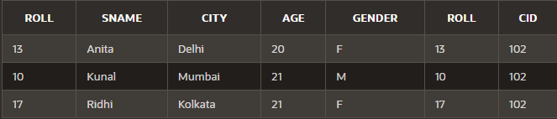***Results-***

#### —----------------------------------

**Q4.Display the names of all the students with their date of enrollment in the courses.**

***SQL Query-***

SELECT Sname,DateOfReg FROM Students

JOIN Enrollment ON Enrollment.Roll= Students.Roll;

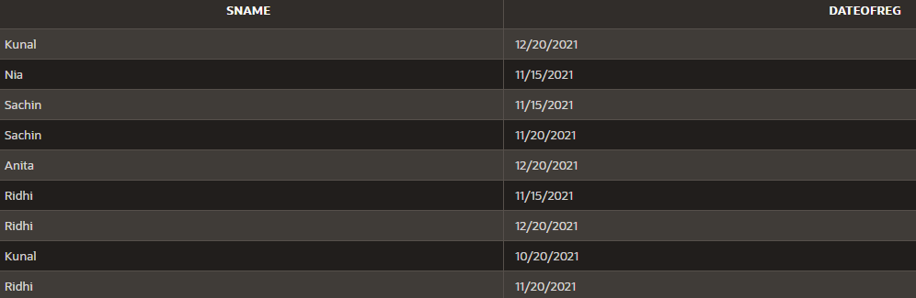***Results-***

#### —----------------------------------

**Q5.Display the name of the course in which “Kunal” is registered.**

***SQL Query-***

SELECT CName FROM Course

JOIN Enrollment ON Enrollment.Cid= Course.Cid JOIN Students ON Students.Roll= Enrollment.Roll WHERE SName='Kunal';

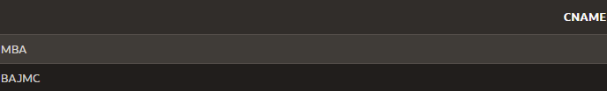***Results-***

#### —----------------------------------

**Q6.Display the names of boys-students enrolled in MCA.**

***SQL Query-***

SELECT Sname FROM Students

JOIN Enrollment ON Enrollment.Roll= Students.Roll JOIN Course ON Course.Cid= Enrollment.Cid WHERE CName = 'MCA' AND Gender = 'M';

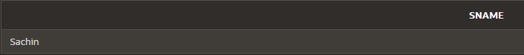***Results-***

#### —----------------------------------

**Q7.Display the number of students registered in MCA course who live outside Delhi**

***SQL Query-***

SELECT COUNT(*) FROM( SELECT * FROM Students

JOIN Enrollment ON Enrollment.Roll= Students.Roll JOIN Course ON Course.Cid= Enrollment.Cid) WHERE CName='MCA' AND City<>'Delhi';

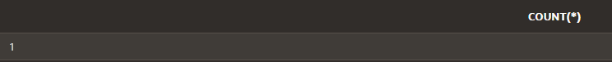***Results-***

**—----------------------------------**

# LAB ASSIGNMENT – IV

### Write an example of the following functions :

#### SQRT()

This function in SQL is used to return the square root of a specified positive number.

***Sql Query-***

SELECT SQRT(625) FROM DUAL;

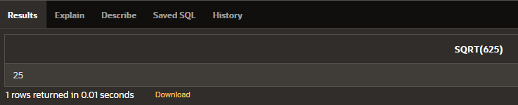***Results-***

#### —----------------------------------

**POWER()**

The POWER() function returns the value of a number raised to the power of another number.

***Sql Query-***

SELECT POWER(7, 3), POWER(5, 4) FROM DUAL;

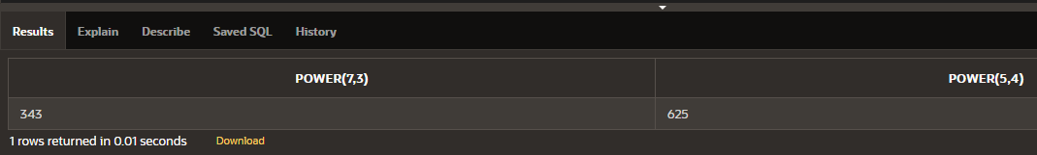***Results-***

#### —----------------------------------

**CEIL()**

The CEIL() function returns the smallest integer value that is bigger than or equal to a number.

***SQL Query-***

SELECT CEIL(5.6), CEIL(11.2) FROM DUAL;

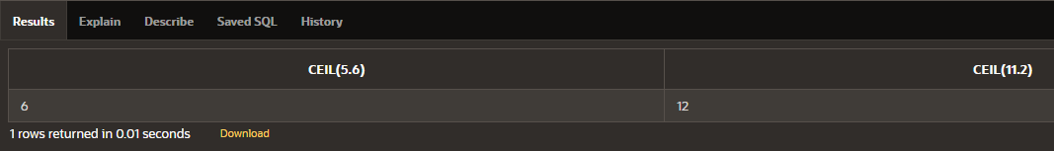***Results-***

#### —----------------------------------

**SUBSTR()**

The SUBSTR() function extracts a substring from a string (starting at any position).

***SQL Query-***

SELECT SUBSTR('I am Sachin Rana', 6, 6) FROM DUAL;

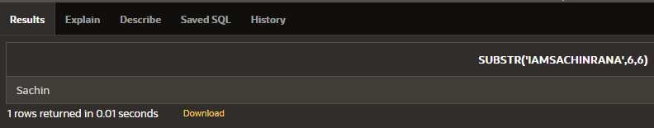***Results-***

#### —----------------------------------

**ROUND()**

The ROUND() function rounds a number to a specified number of decimal places.

***SQL Query-***

SELECT ROUND(22.2301, 2), ROUND(4.99211, 3) FROM DUAL;

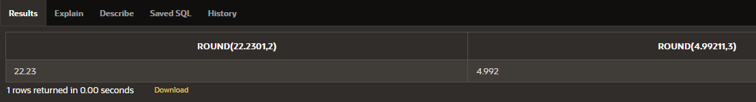***Results-***

#### —----------------------------------

**LENGTH()**

The LENGTH() function returns the length of a string (in bytes).

***SQL Query-***

SELECT LENGTH('sachin'), LENGTH('MCA DMBS_LAB') FROM DUAL;

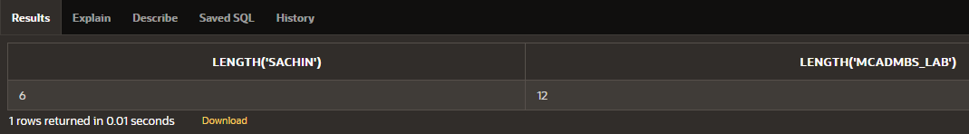***Results-***

#### —----------------------------------

**EXP()**

The EXP() function returns e raised to the power of the specified number.

***SQL Query-***

SELECT EXP(1), EXP(7) FROM DUAL;

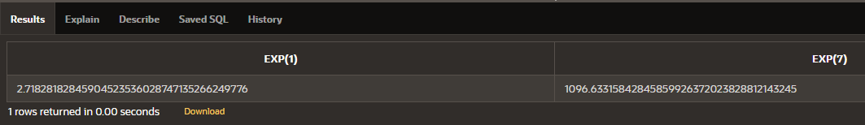***Results-***

#### —----------------------------------

**MOD()**

The MOD() function returns the remainder of a number divided by another number.

***SQL Query-***

SELECT MOD(27,5), MOD(3,2) FROM DUAL;

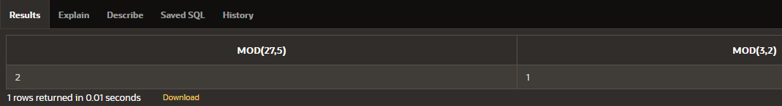***Results-***

#### —----------------------------------

**LOWER()**

The LOWER() function converts a string to lower-case.

***SQL Query-***

SELECT LOWER('Sachin DBMS FILE') FROM DUAL;

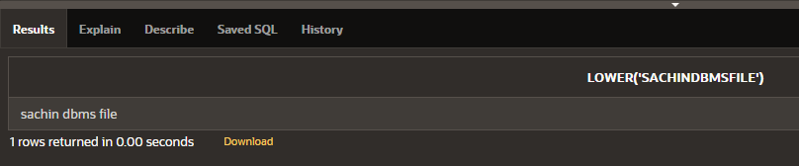***Results-***

#### —----------------------------------

**INITCAP()**

INITCAP() Function return capitalize string/char (capitalize first letter of each word).

***SQL Query-***

SELECT INITCAP('my name is sachin') FROM DUAL;

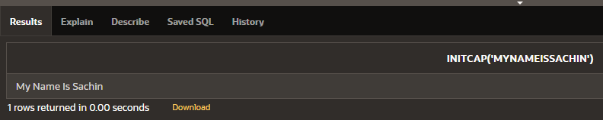***Results-***

#### —----------------------------------

**INSTR()**

The INSTR() function returns the position of the first occurrence of a string in another string.This function performs a case-insensitive search.

***SQL Query-***

SELECT INSTR('my name is sachin', 's') FROM DUAL;

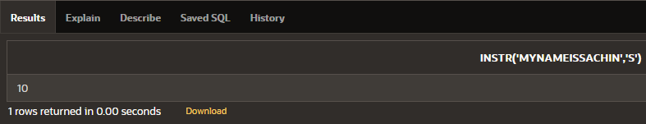***Results-***

#### —----------------------------------

**MONTHS_BETWEEN()**

The MONTHS_BETWEEN() function is used to get the number of months between dates (date1, date2).

***SQL Query-***

SELECT MONTHS_BETWEEN ('01-23-2022', '03-23-2020')FROM DUAL;

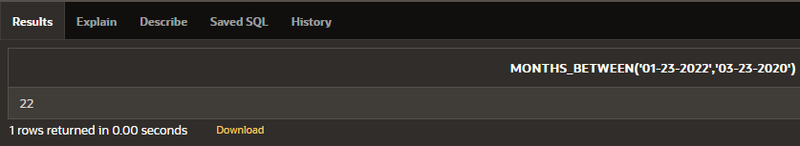***Results-***

#### —----------------------------------

**Table Used for Following 6 Functions (max(), min(), avg(), count(), to_date(), to_char())**

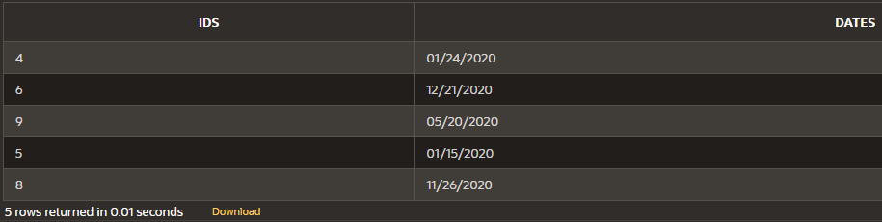CREATE TABLE Sample4 (Ids NUMBER(2) PRIMARY KEY, Dates DATE);

#### MAX()

The MAX() function returns the maximum value in a set of values.

***SQL Query-***

SELECT MAX(Ids) FROM Sample4

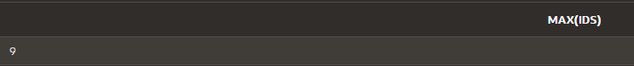***Results-***

#### —----------------------------------

**MIN()**

The MIN() function returns the minimum value in a set of values.

***SQL Query-***

SELECT MIN(Ids) FROM Sample4

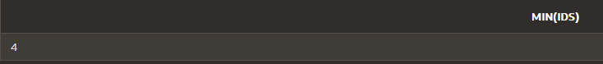***Results-***

#### —----------------------------------

**AVG()**

The AVG() function returns the average value of a numeric column.

***SQL Query-***

SELECT AVG(Ids) FROM Sample4

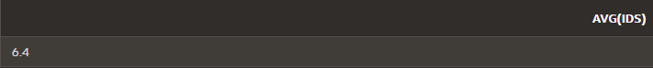***Results-***

#### —----------------------------------

**COUNT()**

The COUNT() function returns the number of rows that matches a specified criterion.

***SQL Query-***

SELECT COUNT(Ids) FROM Sample4 WHERE Ids>5

***Results-***

#### —----------------------------------

**TO_DATE()**

The TO_DATE() function converts date strings in various formats to a date integer value, with data type DATE in the format specified.

***SQL Query-***

*–converts the given date string into date/month/year format*

INSERT INTO Sample4 VALUES (5, TO_DATE('15/01/2020', 'DD/MM/YYYY')); INSERT INTO Sample4 VALUES (9, TO_DATE('20/05/2020', 'DD/MM/YYYY'));

*–converts the given date string into date/month/year format*

INSERT INTO Sample4 VALUES (8, TO_DATE('11/26/2020', 'MM/DD/YYYY')); INSERT INTO Sample4 VALUES (6, TO_DATE('12/21/2020', 'MM/DD/YYYY'));

***Results-***

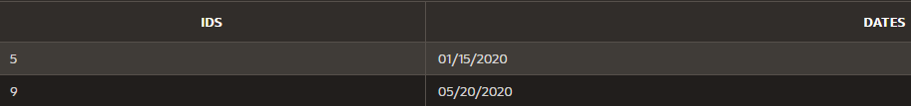*–considers 15/01/2020 and 20/05/2020 in date/month/year format*

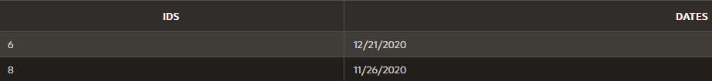*–considers 11/26/2020 and 12/21/2020 in month/date/year format*

#### —----------------------------------

**TO_CHAR()**

TO_CHAR converts a date of DATE datatype to a value of VARCHAR2 datatype in the format specified by the date format.

***SQL Query-***

*–to display date in date/month/year format*

SELECT TO_CHAR(Dates, 'DD/MM/YYYY') FROM Sample4

*–to display date in month/date/year format*

SELECT TO_CHAR(Dates, 'YYYY/MM/DD') FROM Sample4

***Results-***

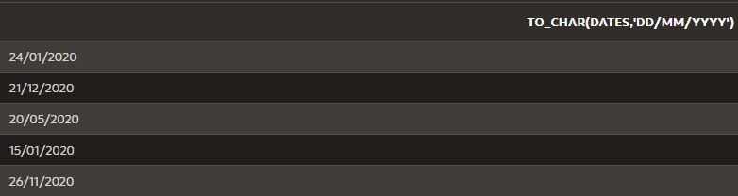*–displaying dates in date/month/year format*

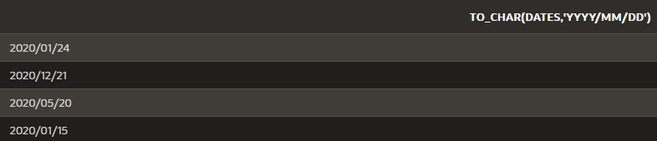*–displaying dates in year/month/date format*

**—----------------------------------**

**LAB ASSIGNMENT – V**

### PL/SQL:

#### Q1. Write a PL/SQL code that accepts the account number from the user and check the users balance. If it is greater than 1000 , only then deduct Rs. 200/- from the balance . The process is fired on the Acct_Mstr table.

**Solution-**

CREATE TABLE Acct_Mstr (Acc_No NUMBER(4) PRIMARY KEY, CustomerName VARCHAR2(20), Balance NUMBER(10), Address VARCHAR2(20));

INSERT INTO Acct_Mstr VALUES(2312, 'Sachin Rana', 10000, 'Delhi'); INSERT INTO Acct_Mstr VALUES(9234, 'Mukesh', 1000, 'Agra');

INSERT INTO Acct_Mstr VALUES(8234, 'Mahesh', 800, 'Chennai'); INSERT INTO Acct_Mstr VALUES(1242, 'Raju', 500, 'Mumbai');

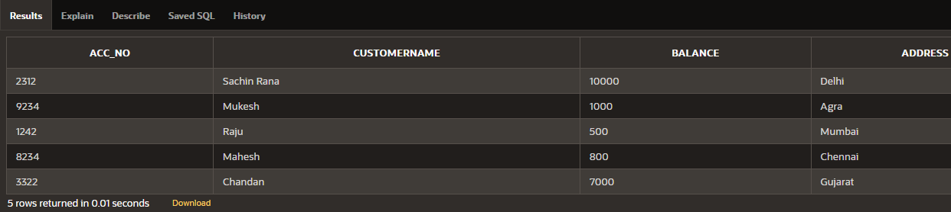INSERT INTO Acct_Mstr VALUES(3322, 'Chandan', 7000, 'Gujarat'); SELECT * FROM Acct_Mstr;

***--PL/SQL***

#### DECLARE

V_Acc_No Acct_Mstr.Acc_No %Type; V_CustomerName Acct_Mstr.CustomerName %Type; V_Balance Acct_Mstr.Balance %Type;

V_Address Acct_Mstr.Address %Type;

#### BEGIN

V_Acc_No:=:V_Acc_No;

SELECT Acc_No, CustomerName, Balance, Address INTO V_Acc_No, V_CustomerName, V_Balance, V_Address

FROM Acct_Mstr

WHERE Acc_No=V_Acc_No;

DBMS_OUTPUT.PUT_LINE('Before:');

DBMS_OUTPUT.PUT_LINE('Acc No= '||V_Acc_No||' Customer Name= '||V_CustomerName||' Balance= '||V_Balance||' Address= '||V_Address);

IF(V_Balance>1000) THEN V_Balance := V_Balance - 200; UPDATE Acct_Mstr

SET Balance = Balance - 200 WHERE Acc_No = V_Acc_No;

END IF; DBMS_OUTPUT.PUT_LINE('After:');

DBMS_OUTPUT.PUT_LINE('Acc No= '||V_Acc_No||' Customer Name= '||V_CustomerName||' Balance= '||V_Balance||' Address= '||V_Address);

#### END;

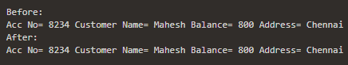



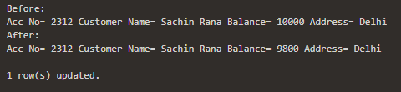

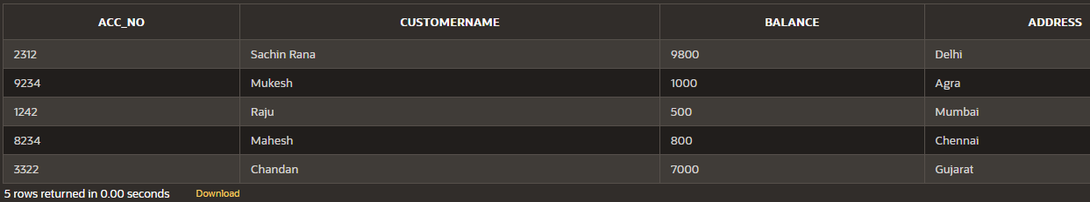

**Q2. Write a PL/SQL code to calculate the area of a circle for a value of radius varying from 3 to 7. Store the radius and the corresponding values of calculated area in an empty table named Areas , consisting of two columns Radius and Area.**

#### Solution-

CREATE TABLE Areas (Radius NUMBER(1) PRIMARY KEY, Area NUMBER(5,2));

***--PL/SQL***

#### DECLARE

V_Radius NUMBER;

V_pi constant NUMBER:=3.14; V_Area NUMBER(5,2);

#### BEGIN

FOR i IN 3..7 LOOP

V_Radius := i;

V_Area:=V_pi * V_Radius * V_Radius; DBMS_OUTPUT.PUT_LINE('Radius= '||V_Radius||' || Area= '||' '||V_Area); INSERT INTO Areas VALUES(V_Radius, V_Area);

END LOOP;

#### END;

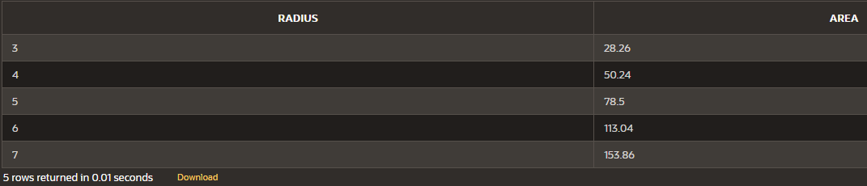SELECT * FROM Areas;

#### Q3. Write a PL/SQL code that first withdraws an amount of Rs. 1500/-. Then deposits an amount of Rs. 50,000.Update the current balance . Then check to see that the sum of the current balance of all the accounts in the bank does not exceed Rs. 60,00,000. If the balance exceeds Rs 60,00,000 then undo the deposit just made.

**Solution-**

CREATE TABLE Accounts (Acc_No NUMBER(4) PRIMARY KEY, CustomerName VARCHAR2(20), Balance NUMBER(10));

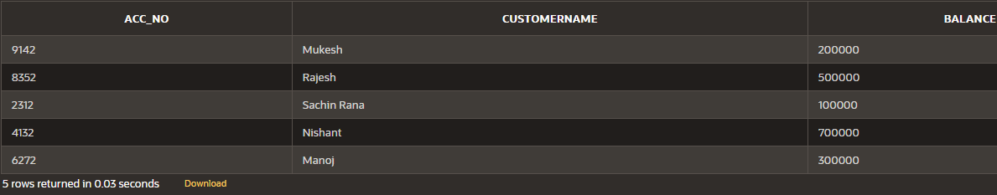INSERT INTO Accounts VALUES(2312, 'Sachin Rana', 100000); INSERT INTO Accounts VALUES(9142, 'Mukesh', 200000); INSERT INTO Accounts VALUES(8352, 'Rajesh', 500000); INSERT INTO Accounts VALUES(6272, 'Manoj', 300000); INSERT INTO Accounts VALUES(4132, 'Nishant', 700000);

***--PL/SQL***

#### DECLARE

V_Sum NUMBER(10) := 0;

#### BEGIN

UPDATE Accounts

SET Accounts.Balance = Accounts.Balance - 1500; UPDATE Accounts

SET Accounts.Balance = Accounts.Balance + 50000; SELECT SUM(Accounts.Balance) INTO V_Sum FROM Accounts;

IF(V_Sum > 6000000) THEN

UPDATE Accounts

SET Accounts.Balance = Accounts.Balance - 50000; END IF;

#### END;

***(When Sum exceeds 60,00,000)***

CREATE TABLE Accounts (Acc_No NUMBER(4) PRIMARY KEY, CustomerName VARCHAR2(20), Balance NUMBER(10));

INSERT INTO Accounts VALUES(2312, 'Sachin Rana', 1000000); INSERT INTO Accounts VALUES(9142, 'Mukesh', 200000); INSERT INTO Accounts VALUES(8352, 'Rajesh', 5000000); INSERT INTO Accounts VALUES(6272, 'Manoj', 300000); INSERT INTO Accounts VALUES(4132, 'Nishant', 700000);

SELECT * FROM Accounts;

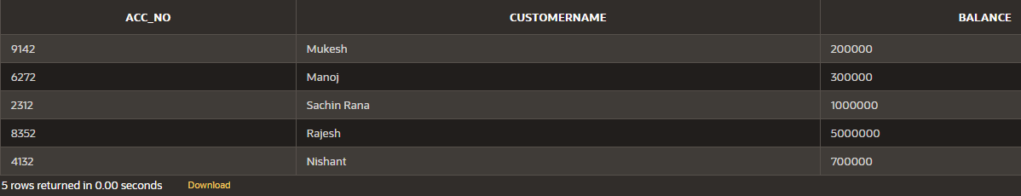

***(After PL/SQL)***

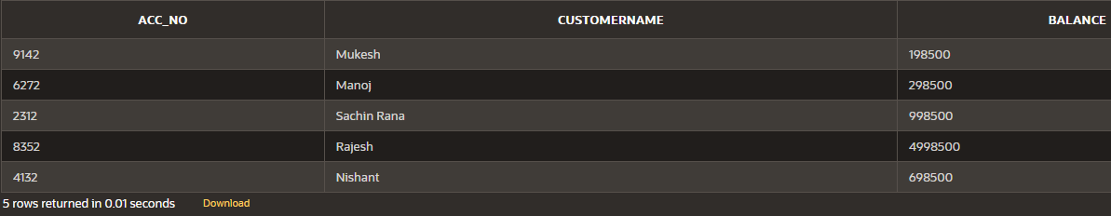

#### Q4. Write a PL/SQL code that will reverse a given number like 12345 to 54321 Solution-

**DECLARE**

V_Num NUMBER;

V_Result NUMBER := 0;

#### BEGIN

V_Num:=:V_Num;

DBMS_OUTPUT.PUT_LINE('Given Number: '||V_Num); WHILE V_Num>0 LOOP

V_Result := (V_Result*10) + MOD(V_Num,10); V_Num := FLOOR(V_Num/10);

END LOOP;

DBMS_OUTPUT.PUT_LINE('Reverse of Given Number: '||V_Result);

**END;**

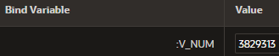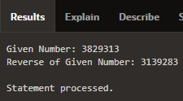

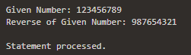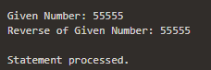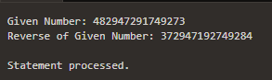

## LAB ASSIGNMENT – V

### Use of Cursors :

#### Q1. The bank manager of Delhi branch decides to mark the status of all those accounts as ‘Inactive’ on which there are no transactions performed in the last 6 months.

**Whenever any such update takes place the corresponding record is inserted in another table ‘InactiveAccounts’ with the name and account no of the account holder and his balance.**

#### (Table : Account (AccNo, Name, Address, PANNo, TDate, Status) Solution-

***--Creating Accounts Table***

CREATE TABLE AccountsPL (

AccNo NUMBER(3) PRIMARY KEY, CName VARCHAR2(20),

PANNo VARCHAR2(10),

Balance NUMBER(8,2), TDate DATE,

Status VARCHAR2(10));

***--Inserting Values***

INSERT INTO AccountsPL VALUES (101, 'Sachin', 'D4371', 10000.00, '01/19/2021', 'Active'); INSERT INTO AccountsPL VALUES (102, 'Rahul', 'D1831', 20000.00, '07/26/2021', 'Active'); INSERT INTO AccountsPL VALUES (103, 'Aman', 'D9121', 35000.00, '04/23/2021', 'Active'); INSERT INTO AccountsPL VALUES (104, 'Karan', 'D2936', 19000.00, '05/28/2021', 'Active'); INSERT INTO AccountsPL VALUES (105, 'Prateek', 'D9128', 16000.00, '08/15/2021', 'Active'); INSERT INTO AccountsPL VALUES (106, 'Rohan', 'D0192', 26000.00, '11/17/2021', 'Active'); INSERT INTO AccountsPL VALUES (107, 'Manan', 'D4571', 35000.00, '10/23/2021', 'Active'); INSERT INTO AccountsPL VALUES (108, 'Kartik', 'D9157', 84000.00, '09/28/2021', 'Active'); INSERT INTO AccountsPL VALUES (109, 'Sagar', 'D0192', 52000.00, '12/30/2021', 'Active');

***--Displaying Values***

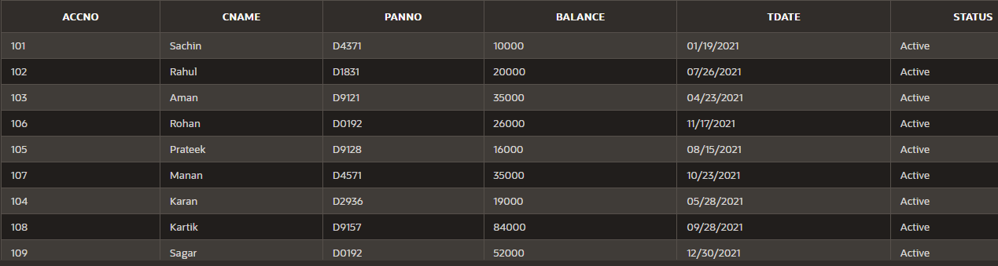SELECT * FROM AccountsPL;

***--Creating Inactive Accounts Table***

CREATE TABLE InactiveAccounts (AccNo NUMBER(3) PRIMARY KEY, CName VARCHAR2(20), Balance NUMBER(8,2));

***--Displaying Values***

SELECT * FROM InactiveAccounts;

***--PL/SQL***

#### DECLARE

V_AccNo AccountsPL.AccNo%TYPE; V_CName AccountsPL.CName%TYPE; V_Balance AccountsPL.Balance%TYPE; CURSOR C_InAccounts IS

SELECT AccNo, CName, Balance FROM AccountsPL WHERE ((SYSDATE-TDate) > 180);

#### BEGIN

OPEN C_InAccounts; LOOP

FETCH C_InAccounts INTO V_AccNo, V_CName, V_Balance; EXIT WHEN C_InAccounts%notfound;

UPDATE AccountsPL SET Status = 'Inactive';

INSERT INTO InactiveAccounts VALUES (V_AccNo, V_CName, V_Balance); END LOOP;

CLOSE C_InAccounts;

#### END;

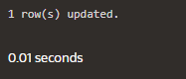

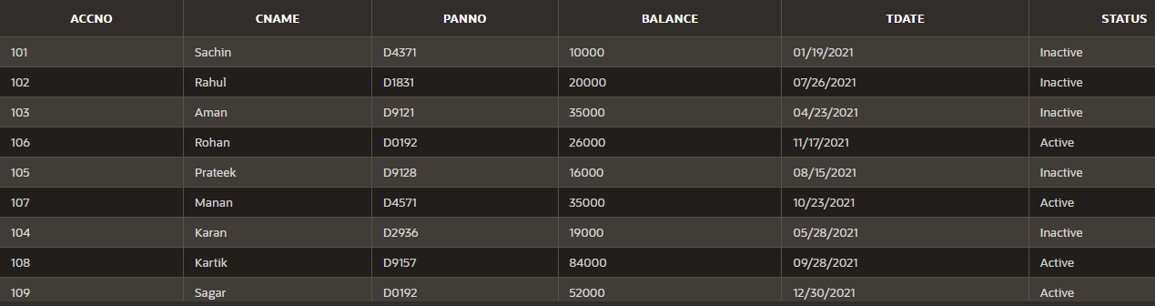***--Displaying AccountsPL Table***

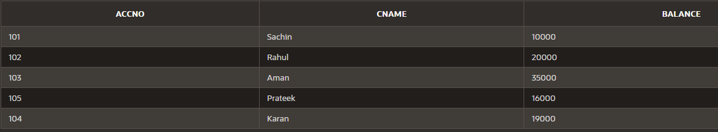***--Displaying InactiveAccounts***

#### Q2. Write a PL/SQL code that updates the balance of the account holder of ‘delhi’ branch active accounts and displays the number of records updated. (Use implicit cursor).

**Solution-**

***(Using Table From Above Question)***

#### DECLARE

V_NoOfRecord NUMBER(2);

#### BEGIN

UPDATE AccountsPL

SET Balance = Balance + 1000 WHERE Status = 'Active'; V_NoOfRecord := SQL%ROWCOUNT;

DBMS_OUTPUT.PUT_LINE('Total Number of Rows Updated = ' || V_NoOfRecord);

#### END;

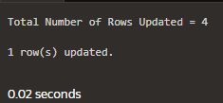

***Before-***

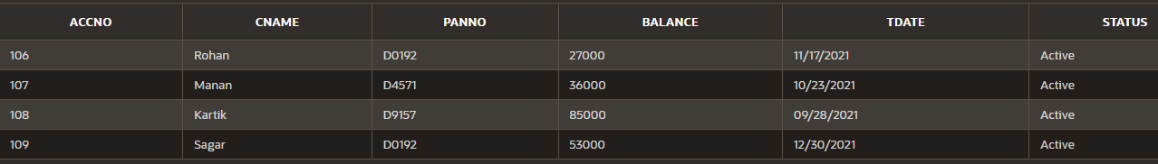***After (Updated 4 Active Records)-***

## LAB ASSIGNMENT – V

### Cursor and Error Handing

#### Q1. Write a Cursor( PL/SQL code) to display the Employee_name, DateOfBirth , Designation whose basic salary is greater than 15000, if not found then show the proper error message. (Use Exception handling)

**Solution-**

***--Creating EmployeeError Table***

CREATE TABLE EmployeeError (

EID NUMBER(3) PRIMARY KEY, EName VARCHAR2(20), DOB DATE,

Designation VARCHAR2(20), BasicSalary NUMBER(10)

);

***--Inserting Values***

INSERT INTO EmployeeError VALUES(1, 'Sachin', '09/12/2000', 'Junior Developer', 10000); INSERT INTO EmployeeError VALUES(2, 'Aman', '04/19/1990', 'Senior Developer', 12000); INSERT INTO EmployeeError VALUES(3, 'Rahul', '03/26/1995', 'Junior Developer', 10000); INSERT INTO EmployeeError VALUES(4, 'Sachin', '11/22/1999', 'Manager', 13000);

INSERT INTO EmployeeError VALUES(5, 'Sachin', '07/17/2000', 'Associate Developer', 11000);

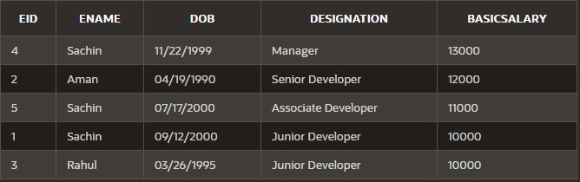***--Displaying Values***

***--PL/SQL***

#### DECLARE

V_EName EmployeeError.EName%type; V_DOB EmployeeError.DOB%type;

V_Designation EmployeeError.Designation%type; V_BasicSalary EmployeeError.BasicSalary%type; temp NUMBER:= 0;

CURSOR C_Employee IS

SELECT EName, DOB, Designation, BasicSalary FROM EmployeeError;

#### BEGIN

OPEN C_Employee; LOOP

FETCH C_Employee INTO V_EName, V_DOB, V_Designation, V_BasicSalary; EXIT WHEN C_Employee%NOTFOUND;

IF V_BasicSalary>15000 THEN

DBMS_OUTPUT.PUT_LINE(V_EName || ' ' || V_DOB || ' '|| V_Designation || ' ' || V_BasicSalary || ' > 15000');

temp:= 1; END IF;

END LOOP;

IF temp<=0 THEN

RAISE NO_DATA_FOUND; END IF;

EXCEPTION

WHEN NO_DATA_FOUND THEN DBMS_OUTPUT.PUT_LINE('ERROR: No Data Found');

DBMS_OUTPUT.PUT_LINE('No Record with BasicSalary greater than 15000'); CLOSE C_Employee;

#### END;

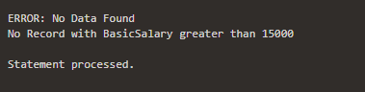***--Output when no such record***

***--Inserting records with salary greater than 15000***

INSERT INTO EmployeeError VALUES(6, 'Suraj', '07/18/2000', 'Associate Developer', 16000); INSERT INTO EmployeeError VALUES(7, 'Mohit', '06/14/2000', 'Senior Developer', 17000);

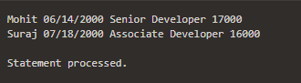***--Output when there are such records***

## LAB ASSIGNMENT – V

### Procedures and Functions

#### Q1. Create a procedure that accepts the emp id from the calling procedure and displays his/her record.

**Solution-**

#### (Using following table for this question)

***--PL/SQL***

**CREATE OR REPLACE PROCEDURE** EmpID_Q1 ( V_SearchID IN EmployeePF.EID%type) **IS**

V_EID EmployeePF.EID%type; V_EName EmployeePF.EName%type; V_EAge EmployeePF.EAge%type;

CURSOR C_EmployeePF IS SELECT EID, EName, EAge FROM EmployeePF;

#### BEGIN

OPEN C_EmployeePF; LOOP

FETCH C_EmployeePF INTO V_EID, V_EName, V_EAge; EXIT WHEN C_EmployeePF%NOTFOUND;

IF V_EID = V_SearchID THEN DBMS_OUTPUT.PUT_LINE('Employee ID: ' || V_EID);

DBMS_OUTPUT.PUT_LINE('Employee Name: ' || V_EName); DBMS_OUTPUT.PUT_LINE('Employee Age: ' || V_EAge); END IF;

END LOOP;

CLOSE C_EmployeePF;

#### END;

***--Calling Procedure with EID as parameter***

BEGIN

EmpID_Q1(3); ***--EmpID_Q1(2);***

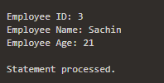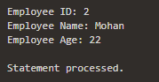END;

#### Q2. Create a function that accepts emp id from the calling procedure and returns his age.

**Solution-**

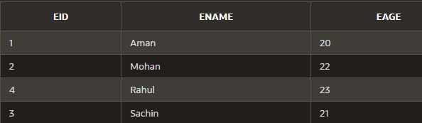***--(Using Table)***

***--PL/SQL***

**CREATE OR REPLACE FUNCTION** EmpID_Q2 ( V_SearchID IN EmployeePF.EID%type) RETURN EmployeePF.EAge%type

IS

V_ReturnAge EmployeePF.EAge%type;

#### BEGIN

SELECT EAge INTO V_ReturnAge FROM EmployeePF WHERE EID = V_SearchID; RETURN V_ReturnAge;

#### END;

***--Calling Function with EID as parameter and storing returned value***

DECLARE

V_GetAge EmployeePF.EAge%type; BEGIN

V_GetAge := EmpID_Q2(2);

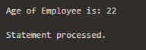DBMS_OUTPUT.PUT_LINE('Age of Employee is: ' || V_GetAge); END;

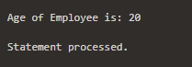***--with EID = 1***

#### Q3. Write a PL/SQL function ODDEVEN to return value TRUE if the number passed to it is EVEN else will return FALSE.

**Solution-**

***--PL/SQL***

**CREATE OR REPLACE FUNCTION** ODDEVEN ( V_Num IN NUMBER) RETURN BOOLEAN

IS

V_Even BOOLEAN;

#### BEGIN

IF MOD(V_Num,2) = 0 THEN RETURN TRUE;

ELSE

RETURN FALSE; END IF;

#### END;

***--Calling Function with a odd number as parameter***

#### DECLARE

V_IsEven BOOLEAN;

#### BEGIN

V_IsEven := ODDEVEN(87);

IF V_IsEven THEN

DBMS_OUTPUT.PUT_LINE('The Number passed is Even'); ELSE

DBMS_OUTPUT.PUT_LINE('The Number passed is Odd'); END IF;

#### END;

***--Calling Function with an even number as parameter***

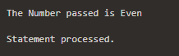***--V_IsEven := ODDEVEN(56);***

#### Q4. Write a PL/SQL procedure called MULTI_TABLE that takes two numbers as parameters and displays the multiplication of the first parameter till the second parameter.

**Solution-**

**CREATE OR REPLACE PROCEDURE** MULTI_TABLE ( V_Num1 IN NUMBER, V_Num2 IN NUMBER)

IS

#### BEGIN

DBMS_OUTPUT.PUT_LINE('Multiplication of first parameter till second parameter:-'); FOR i IN 1..V_Num2

LOOP

DBMS_OUTPUT.PUT_LINE( V_Num1 ||' x '|| i ||' = '|| V_Num1*i ); END LOOP;

#### END;

***--Calling the procedure MULTI_TABLE***

#### BEGIN

MULTI_TABLE(5, 10);

**END;**

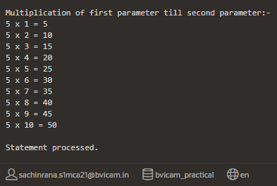

## LAB ASSIGNMENT – V

### Trigger

#### Q1. Create a Trigger in PL/SQL which will work before deletion or updation in employee_master table and inserts a duplicate copy of the record in another table for future reference.

**Solution-**

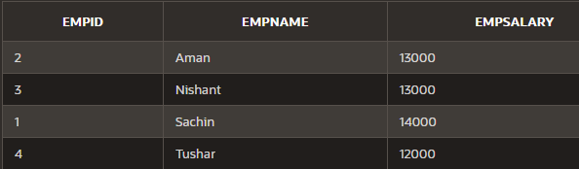***--Employee_Master Table***

***--Employee_Master_Backup***



***--Creating Trigger***

**CREATE OR REPLACE TRIGGER** Before_Delete_Update BEFORE DELETE OR UPDATE ON Employee_Master FOR EACH ROW

#### BEGIN

INSERT INTO Employee_Master_Backup VALUES (:old.EmpID, :old.EmpName,

:old.EmpSalary);

#### END;

***--Deleting a record from Employee_Master Table***

DELETE FROM Employee_Master WHERE EmpID = 3

***--Updating a record from Employee_Master Table***

UPDATE Employee_Master SET EmpSalary = 20000 WHERE EmpID = 1

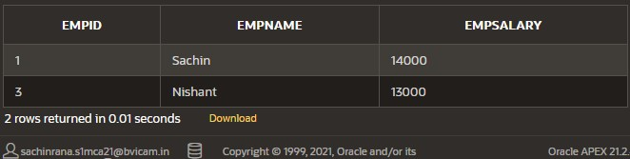***--Employee_Master_Backup Table***

#### Q2. Create a Trigger in PL/SQL which will work after update or delete on employee_master and store the old data and deleted data in a table named as backup_employee_master .

**Solution-**

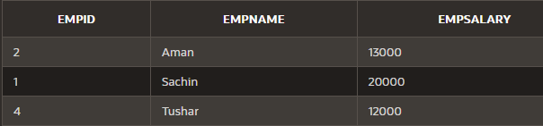***--Employee_Master Table***

***--Backup_Employee_Master Table***



***--Creating Trigger***

**CREATE OR REPLACE TRIGGER** After_Delete_Update AFTER DELETE OR UPDATE ON Employee_Master FOR EACH ROW

#### BEGIN

INSERT INTO Employee_Master_Backup VALUES (:old.EmpID, :old.EmpName,

:old.EmpSalary);

#### END;

***--Deleting a record from Employee_Master Table***

DELETE FROM Employee_Master WHERE EmpID= 4;

***--Updating a record from Employee_Master Table***

UPDATE Employee_Master SET EmpName = 'Amann' WHERE EmpID = 2;

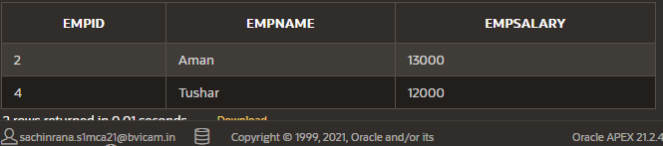***--Backup_Employee_Master Table***