**DATA**

**Mining**

**PRACTICAL**

**FILE :-**

Submitted By :-

Name: ABHIJEET RANA

Roll Number: 2k18/CS/82

University Roll Number : 18013570001

Course: B.Sc (H) Computer Science

Semester : 6th

**Practical 1**

[**Create a file “people.txt” with the following data:**](https://www.tutorialsduniya.com/programs/du/csh/data-mining-in-r/program1)

|  |  |  |  |  |
| --- | --- | --- | --- | --- |
| **Age** | **Age Group** | **Height** | **Status** | **Years Married** |
| **21** | **adult** | **6.0** | **single** | **-1** |
| **2** | **child** | **3** | **married** | **0** |
| **18** | **adult** | **5.7** | **married** | **20** |
| **221** | **elderly** | **5** | **widowed** | **2** |
| **34** | **child** | **-7** | **married** | **3** |

**i) Read the data from the file “people.txt”.  
ii) Create a rule set E that contain rules to check for the following conditions :**

1. **The age should be in the range 0-150.**
2. **The age should be greater than years married.**
3. **The status should be married or single or widowed.**
4. **If age is less than 18 the age group should be child, if age is between 18 and 65 the age group should be adult, if age is more than 65 the age group should be elderly.**

**iii) Check whether rule set E is violated by the data in the file people.txt.  
iv) Summarize the results obtained in part(iii)  
v) Visualize the results obtained in part(iii)**

**library**(editrules)

## Loading required package: igraph

##

## Attaching package: ’igraph’

## The following objects are masked from ’package:stats’:

##

## decompose, spectrum

## The following object is masked from ’package:base’:

##

## union

##

## Attaching package: ’editrules’

## The following objects are masked from ’package:igraph’:

##

## blocks, normalize

df <- **read.table**("practical1/people.txt", header=TRUE)

**attach**(df)

E <- **editset**(**expression**(

age **>=** 0,

age **<=** 150,

age **>=** yearsmarried,

status **%in% c**("married", "single", "widowed"),

**if** (age **<=** 18) agegroup **%in% c**("child"),

**if** (age **>=** 19 **&&** age **<=** 64) agegroup **%in% c**("adult"),

**if** (age **>=** 65) agegroup **%in% c**("elderly")

))

sm <- **violatedEdits**(E, df)

**summary**(sm)

## Edit violations, 5 observations, 0 completely missing (0%):

##

## editname freq rel

## num2 1 20%

## num3 1 20%

## mix4 1 20%

## mix5 1 20%

##

## Edit violations per record:

##

## errors freq rel

## 0 2 40%

## 1 2 40%

## 2 1 20%

**plot**(sm)

**Edit violation frequency of top 8 edits**

Edit

Count

num1 num2

0.00 0.05 0.10 0.15 0.20

Frequency

**Edit violations per record**

2 records with no violations

1.0 1.2 1.4 1.6 1.8 2.0

1.0 2.0

Number of violations

**Practical 2**

[**Perform the following preprocessing tasks on the dirty_iris dataset.  
i) Calculate the number and percentage of observations that are complete.  
ii) Replace all the special values in data with NA.  
iii) Define these rules in a separate text file and read them.  
(Use editfile function in R (package editrules). Use similar function in Python).  
Print the resulting constraint object.  
– Species should be one of the following values: setosa, versicolor or virginica.  
– All measured numerical properties of an iris should be positive.  
– The petal length of an iris is atleast 2 times its petal width.  
– The sepal length of an iris cannot exceed 30cm.  
– The sepals of an iris are longer than its petals.  
iv) Determine how often each rule is broken (violatedEdits). Also summarize and plot the result.  
v) Find outliers in sepal length using boxplot and boxplot.stats**](https://www.tutorialsduniya.com/programs/du/csh/data-mining-in-r/program2)

**library**(editrules)

df <- **read.csv**("./practical2/dirty_iris.csv") df.complete <- df[**complete.cases**(df), ] **print**(**paste**(

"Complete cases are: ",

**nrow**(df.complete),

" and their percentage: ",

**nrow**(df.complete) **/ nrow**(df) **\*** 100,

"%",

sep = ""

))

## [1] "Complete cases are: 96 and their percentage: 64%"

**attach**(df.complete)

E <- **editfile**("practical2/rules.txt")

violations <- **violatedEdits**(E, df.complete)

**summary**(violations)

## Edit violations, 96 observations, 0 completely missing (0%):

##

## editname freq rel

## num5 2 2.1%

## num2 1 1%

## num6 1 1%

## num7 1 1%

##

## Edit violations per record:

##

## errors freq rel

## 0 91 94.8%

## 1 5 5.2%

**plot**(violations)

**Edit violation frequency of top 8 edits**

num1 num5

Edit

0.000 0.005 0.010 0.015 0.020

6

Frequency

**Edit violations per record**

3

91 records with no violations

0.6 0.8 1.0 1.2 1.4

Count

**boxplot**(df.complete**$**Sepal.Length)

Number of violations

50

**Practical 3**

10

20

30

40

[**Load the data from wine dataset. Check whether all attributes are standardized or not (mean is 0 and standard deviation is 1). If not, standardize the attributes. Do the same with Iris dataset.**](https://www.tutorialsduniya.com/programs/du/csh/data-mining-in-r/program3)

df <- **read.csv**(file = "practical3/wine.csv", sep = ";")

isNormalized <- **function**(df) {

normalized <- TRUE

**for**(i **in** 1**:length**(df)) {

**if** (**floor**(**mean**(df[, i])) **!=** 0 **&& sd**(df[, i]) **!=**1) {

normalized <- FALSE

}

}

**return**(normalized)

}

normalizeTransformation <- **function**(x) {

**return** ((x**-mean**(x))**/sd**(x))

}

**if**(**isNormalized**(df[, -12])) {

**cat**("Dataset is normalized")

} **else** {

**cat**("Dataset is not normalized")

**cat**("\nNormalizing now")

df.normalized <- **data.frame**(**sapply**(df[, -12], normalizeTransformation))

df.normalized**$**quality <- df[, 12]

**if**(**isNormalized**(df.normalized[, -12])) {

**cat**("\nDataset is now normalized")

} **else** {

**cat**("\nNormalization failed")

}

}

## Dataset is not normalized

## Normalizing now

## Dataset is now normalized

**Practical 4**

**Run Apriori algorithm to find frequent itemsets and association rules  
 4.1 Use minimum support as 50% and minimum confidence as 75%  
 4.2 Use minimum support as 60% and minimum confidence as 60%**

**library**(arules)

## Loading required package: Matrix

##

## Attaching package: ’arules’

## The following objects are masked from ’package:base’:

##

## abbreviate, write

**data**(Adult)

rules <- **apriori**(Adult, parameter = **list**(supp = 0.5, conf = .75, target = "rules"))

## Apriori

##

## Parameter specification:

## confidence minval smax arem aval originalSupport maxtime support minlen

## 0.75 0.1 1 none FALSE TRUE 5 0.5 1

## maxlen target ext

## 10 rules TRUE

##

## Algorithmic control:

## filter tree heap memopt load sort verbose

## 0.1 TRUE TRUE FALSE TRUE 2 TRUE

##

## Absolute minimum support count: 24421

##

## set item appearances ...[0 item(s)] done [0.00s].

## set transactions ...[115 item(s), 48842 transaction(s)] done [0.05s].

## sorting and recoding items ... [9 item(s)] done [0.00s].

## creating transaction tree ... done [0.03s].

## checking subsets of size 1 2 3 4 done [0.00s].

## writing ... [84 rule(s)] done [0.00s].

## creating S4 object ... done [0.00s].

**summary**(rules)

## set of 84 rules

##

## rule length distribution (lhs + rhs):sizes

## 1 2 3 4

## 4 23 38 19

##

## Min. 1st Qu. Median Mean 3rd Qu. Max.

## 1.000 2.000 3.000 2.857 3.000 4.000

##

## summary of quality measures:

## support confidence coverage lift

## Min. :0.5084 Min. :0.8504 Min. :0.5406 Min. :0.9789

## 1st Qu.:0.5415 1st Qu.:0.8888 1st Qu.:0.5931 1st Qu.:0.9943

## Median :0.5897 Median :0.9132 Median :0.6640 Median :0.9988

## Mean :0.6433 Mean :0.9110 Mean :0.7070 Mean :1.0034

## 3rd Qu.:0.7490 3rd Qu.:0.9422 3rd Qu.:0.8220 3rd Qu.:1.0077

## Max. :0.9533 Max. :0.9583 Max. :1.0000 Max. :1.0586

## count

## Min. :24832

## 1st Qu.:26447

## Median :28803

## Mean :31422

## 3rd Qu.:36585

## Max. :46560

##

## mining info:

## data ntransactions support confidence

## Adult 48842 0.5 0.75

**inspect**(**head**(rules))

## lhs rhs support confidence coverage

## [1] {} => {race=White} 0.8550428 0.8550428 1.0000000 1.00

## [2] {} => {native-country=United-States} 0.8974243 0.8974243 1.0000000 1.00

## [3] {} => {capital-gain=None} 0.9173867 0.9173867 1.0000000 1.00

## [4] {} => {capital-loss=None} 0.9532779 0.9532779 1.0000000 1.00

## [5] {hours-per-week=Full-time} => {native-country=United-States} 0.5179559 0.8852574 0.5850907 0.98

## [6] {hours-per-week=Full-time} => {capital-gain=None} 0.5435895 0.9290688 0.5850907 1.01

**Practical 5**

[**Use Naive bayes, K-nearest, and Decision tree classification algorithms and build classifiers. Divide the data set in to training and test set. Compare the accuracy of the different classifiers under the following situations:  
5.1 a) Training set = 75% Test set = 25%  
5.1 b) Training set = 66.6% (2/3rd of total), Test set = 33.3%  
5.2 Training set is chosen by i)hold out method ii)Random sub sampling iii)Cross-Validation. Compare the accuracy of the classifiers obtained.  
5.3 Data is scaled to standard format.**](https://www.tutorialsduniya.com/programs/du/csh/data-mining-in-r/program5)

**library**(rpart)

**library**(caret)

## Loading required package: lattice

## Loading required package: ggplot2

**library**(e1071)

**library**(class)

##

## Attaching package: ’class’

## The following object is masked from ’package:igraph’:

##

## knn

**data**(iris)

*#Holdout method*

smp_size <- **floor**(0.75 **\* nrow**(iris))

train <- iris[1**:**smp_size, ]

test <- iris[**-**(1**:**smp_size), ]

model <- **naiveBayes**(Species **~** ., data = train) prediction <- **predict**(model, test) **confusionMatrix**(prediction, test[,5])

## Confusion Matrix and Statistics

##

## Reference

## Prediction setosa versicolor virginica

## setosa 0 0 0

## versicolor 0 0 5

## virginica 0 0 33

##

## Overall Statistics

##

## Accuracy : 0.8684

## 95% CI : (0.7191, 0.9559)

## No Information Rate : 1

## P-Value [Acc > NIR] : 1

##

## Kappa : 0

##

## Mcnemar’s Test P-Value : NA

##

## Statistics by Class:

##

## Class: setosa Class: versicolor Class: virginica

## Sensitivity NA NA 0.8684

## Specificity 1 0.8684 NA

## Pos Pred Value NA NA NA

## Neg Pred Value NA NA NA

## Prevalence 0 0.0000 1.0000

## Detection Rate 0 0.0000 0.8684

## Detection Prevalence 0 0.1316 0.8684

## Balanced Accuracy NA NA NA

model <- **rpart**(Species **~** ., data = train) prediction <- **predict**(model, test, type = "class") **confusionMatrix**(prediction, test[,5])

## Confusion Matrix and Statistics

##

## Reference

## Prediction setosa versicolor virginica

## setosa 0 0 0

## versicolor 0 0 4

## virginica 0 0 34

##

## Overall Statistics

##

## Accuracy : 0.8947

## 95% CI : (0.752, 0.9706)

## No Information Rate : 1

## P-Value [Acc > NIR] : 1

##

## Kappa : 0

##

## Mcnemar’s Test P-Value : NA

##

## Statistics by Class:

##

## Class: setosa Class: versicolor Class: virginica

## Sensitivity NA NA 0.8947

## Specificity 1 0.8947 NA

## Pos Pred Value NA NA NA

## Neg Pred Value NA NA NA

## Prevalence 0 0.0000 1.0000

## Detection Rate 0 0.0000 0.8947

## Detection Prevalence 0 0.1053 0.8947

## Balanced Accuracy NA NA NA

prediction = **knn**(train[,**-**5], test[,**-**5], **factor**(train[,5]), k = 10)

**confusionMatrix**(prediction, test[,5])

## Confusion Matrix and Statistics

##

## Reference

## Prediction setosa versicolor virginica

## setosa 0 0 0

## versicolor 0 0 15

## virginica 0 0 23

##

## Overall Statistics

##

## Accuracy : 0.6053

## 95% CI : (0.4339, 0.7596)

## No Information Rate : 1

## P-Value [Acc > NIR] : 1

##

## Kappa : 0

##

## Mcnemar’s Test P-Value : NA

##

## Statistics by Class:

##

## Class: setosa Class: versicolor Class: virginica

## Sensitivity NA NA 0.6053

## Specificity 1 0.6053 NA

## Pos Pred Value NA NA NA

## Neg Pred Value NA NA NA

## Prevalence 0 0.0000 1.0000

## Detection Rate 0 0.0000 0.6053

## Detection Prevalence 0 0.3947 0.6053

## Balanced Accuracy NA NA NA

*#Random Subsampling*

smp_size <- **floor**(0.75 **\* nrow**(iris))

**set.seed**(123)

train_ind <- **sample**(**nrow**(iris), size = smp_size)

train <- iris[train_ind, ]

test <- iris[**-**train_ind, ]

model <- **naiveBayes**(Species **~** ., data = train) prediction <- **predict**(model, test) **confusionMatrix**(prediction, test[,5])

## Confusion Matrix and Statistics

##

## Reference

## Prediction setosa versicolor virginica

## setosa 12 0 0

## versicolor 0 17 0

## virginica 0 0 9

##

## Overall Statistics

##

## Accuracy : 1

## 95% CI : (0.9075, 1)

## No Information Rate : 0.4474

## P-Value [Acc > NIR] : 5.312e-14

##

## Kappa : 1

##

## Mcnemar’s Test P-Value : NA

##

## Statistics by Class:

##

## Class: setosa Class: versicolor Class: virginica

## Sensitivity 1.0000 1.0000 1.0000

## Specificity 1.0000 1.0000 1.0000

## Pos Pred Value 1.0000 1.0000 1.0000

## Neg Pred Value 1.0000 1.0000 1.0000

## Prevalence 0.3158 0.4474 0.2368

## Detection Rate 0.3158 0.4474 0.2368

## Detection Prevalence 0.3158 0.4474 0.2368

## Balanced Accuracy 1.0000 1.0000 1.0000 model <- **rpart**(Species **~** ., data = train)

prediction <- **predict**(model, test, type = "class")

**confusionMatrix**(prediction, test[,5])

## Confusion Matrix and Statistics

##

## Reference

## Prediction setosa versicolor virginica

## setosa 12 0 0

## versicolor 0 17 1

## virginica 0 0 8

##

## Overall Statistics

##

## Accuracy : 0.9737

## 95% CI : (0.8619, 0.9993)

## No Information Rate : 0.4474

## P-Value [Acc > NIR] : 2.547e-12

##

## Kappa : 0.9588

##

## Mcnemar’s Test P-Value : NA

##

## Statistics by Class:

##

## Class: setosa Class: versicolor Class: virginica

## Sensitivity 1.0000 1.0000 0.8889

## Specificity 1.0000 0.9524 1.0000

## Pos Pred Value 1.0000 0.9444 1.0000

## Neg Pred Value 1.0000 1.0000 0.9667

## Prevalence 0.3158 0.4474 0.2368

## Detection Rate 0.3158 0.4474 0.2105

## Detection Prevalence 0.3158 0.4737 0.2105

## Balanced Accuracy 1.0000 0.9762 0.9444

prediction = **knn**(train[,**-**5], test[,**-**5], **factor**(train[,5]), k = 10)

**confusionMatrix**(prediction, test[,5])

## Confusion Matrix and Statistics

##

## Reference

## Prediction setosa versicolor virginica

## setosa 12 0 0

## versicolor 0 16 0

## virginica 0 1 9

##

## Overall Statistics

##

## Accuracy : 0.9737

## 95% CI : (0.8619, 0.9993)

## No Information Rate : 0.4474

## P-Value [Acc > NIR] : 2.547e-12

##

## Kappa : 0.9595

##

## Mcnemar’s Test P-Value : NA

##

## Statistics by Class:

##

## Class: setosa Class: versicolor Class: virginica

## Sensitivity 1.0000 0.9412 1.0000

## Specificity 1.0000 1.0000 0.9655

## Pos Pred Value 1.0000 1.0000 0.9000

## Neg Pred Value 1.0000 0.9545 1.0000

## Prevalence 0.3158 0.4474 0.2368

## Detection Rate 0.3158 0.4211 0.2368

## Detection Prevalence 0.3158 0.4211 0.2632

## Balanced Accuracy 1.0000 0.9706 0.9828

train_control <- **trainControl**(method="cv", number=10)

model <- **train**(Species**~**., data=iris, trControl=train_control, method="nb")

prediction <- **predict**(model, test)

**confusionMatrix**(prediction, test[,5])

## Confusion Matrix and Statistics

##

## Reference

## Prediction setosa versicolor virginica

## setosa 12 0 0

## versicolor 0 17 0

## virginica 0 0 9

##

## Overall Statistics

##

## Accuracy : 1

## 95% CI : (0.9075, 1)

## No Information Rate : 0.4474

## P-Value [Acc > NIR] : 5.312e-14

##

## Kappa : 1

##

## Mcnemar’s Test P-Value : NA

##

## Statistics by Class:

##

## Class: setosa Class: versicolor Class: virginica

## Sensitivity 1.0000 1.0000 1.0000

## Specificity 1.0000 1.0000 1.0000

## Pos Pred Value 1.0000 1.0000 1.0000

## Neg Pred Value 1.0000 1.0000 1.0000

## Prevalence 0.3158 0.4474 0.2368

## Detection Rate 0.3158 0.4474 0.2368

## Detection Prevalence 0.3158 0.4474 0.2368

## Balanced Accuracy 1.0000 1.0000 1.0000

train_control <- **trainControl**(method="cv", number=10)

model <- **train**(Species**~**., data=iris, trControl=train_control, method="rpart")

prediction <- **predict**(model, test)

**confusionMatrix**(prediction, test[,5])**$**table

## Reference

## Prediction setosa versicolor virginica

## setosa 12 0 0

## versicolor 0 17 1

## virginica 0 0 8

train_control <- **trainControl**(method="cv", number=10)

model <- **train**(Species**~**., data=iris, trControl=train_control, method="knn")

prediction <- **predict**(model, test)

**confusionMatrix**(prediction, test[,5])

## Confusion Matrix and Statistics

##

## Reference

## Prediction setosa versicolor virginica

## setosa 12 0 0

## versicolor 0 16 0

## virginica 0 1 9

##

## Overall Statistics

##

## Accuracy : 0.9737

## 95% CI : (0.8619, 0.9993)

## No Information Rate : 0.4474

## P-Value [Acc > NIR] : 2.547e-12

##

## Kappa : 0.9595

##

## Mcnemar’s Test P-Value : NA

##

## Statistics by Class:

##

## Class: setosa Class: versicolor Class: virginica

## Sensitivity 1.0000 0.9412 1.0000

## Specificity 1.0000 1.0000 0.9655

## Pos Pred Value 1.0000 1.0000 0.9000

## Neg Pred Value 1.0000 0.9545 1.0000

## Prevalence 0.3158 0.4474 0.2368

## Detection Rate 0.3158 0.4211 0.2368

## Detection Prevalence 0.3158 0.4211 0.2632

## Balanced Accuracy 1.0000 0.9706 0.9828

**Practical 6**

[**Use Simple Kmeans, DBScan, Hierachical clustering algorithms for clustering. Compare the performance of clusters by changing the parameters involved in the algorithms.**](https://www.tutorialsduniya.com/programs/du/csh/data-mining-in-r/program6)

**library**(dbscan)

**str**(iris)

## ’data.frame’: 150 obs. of 5 variables:

## $ Sepal.Length: num 5.1 4.9 4.7 4.6 5 5.4 4.6 5 4.4 4.9 ...

## $ Sepal.Width : num 3.5 3 3.2 3.1 3.6 3.9 3.4 3.4 2.9 3.1 ...

## $ Petal.Length: num 1.4 1.4 1.3 1.5 1.4 1.7 1.4 1.5 1.4 1.5 ...

## $ Petal.Width : num 0.2 0.2 0.2 0.2 0.2 0.4 0.3 0.2 0.2 0.1 ...

## $ Species : Factor w/ 3 levels "setosa","versicolor",..: 1 1 1 1 1 1 1 1 1 1 ...

*#kmeans*

cl <- **kmeans**(iris[,**-**5], 3)

**plot**(iris[,**-**5], col = cl**$**cluster)

**points**(cl**$**centers, col = 1**:**3, pch = 8)

Sepal.Length

1.5

2.0

3.0

4.0

2.0 3.0 4.0

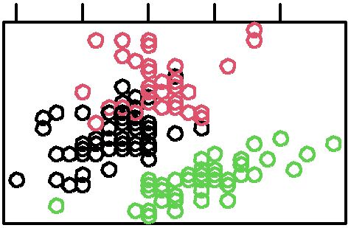

Sepal.Width

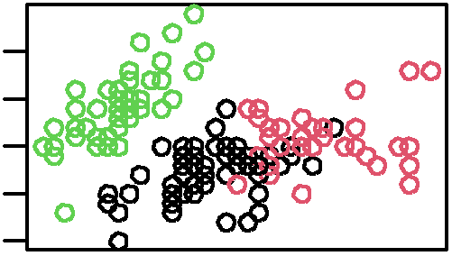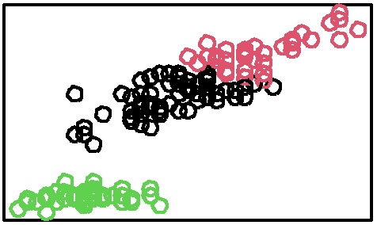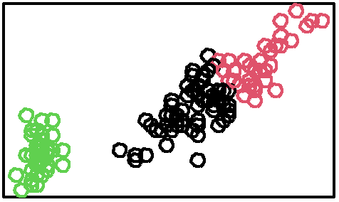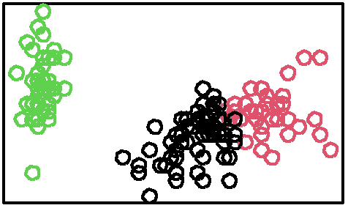

Petal.Length

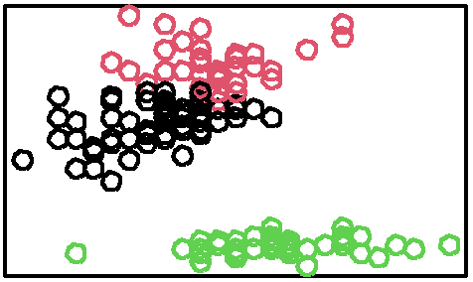

0.5 1.5 2.5

4.5 6.0 7.5

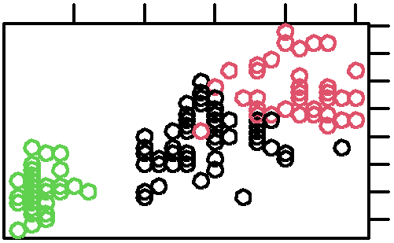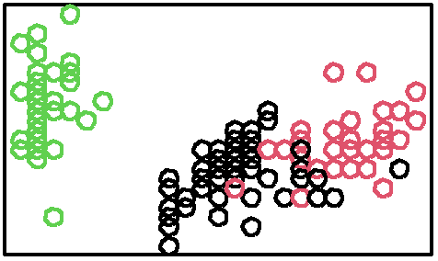

1

3

5

7

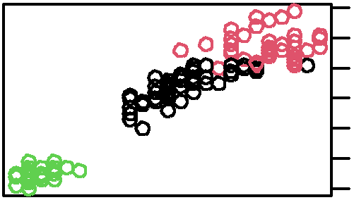

Petal.Width

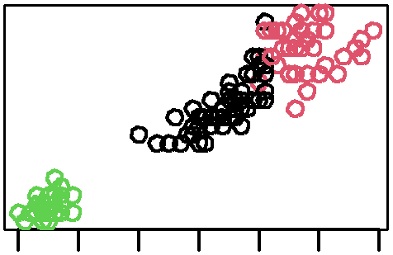

4.5 5.5 6.5 7.5

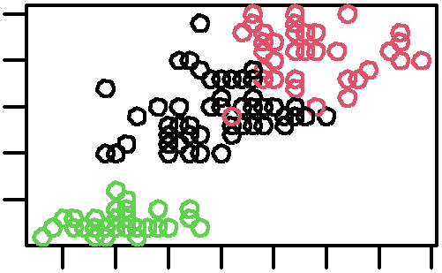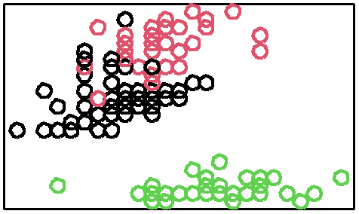

0.5

*#heirarchical*

2.5

clusters <- **hclust**(**dist**(iris[, -5]))

**plot**(clusters)

1 2 3 4 5 6 7

**Cluster Dendrogram**

4

6

11375310

14181

4483

166

197

2

*#DBScan*

Height

0

2

1312

1143

dist(iris[, −5])

hclust (*, "complete")

1141796

11440

11230985

1110124

138743

5798

5876

697429

9647

8

782

89935

967563

8320 42

31523

322

43723

3147

143

244

cl <- **dbscan**(iris[,**-**5], eps = .5, minPts = 5)

813

1131609

1142155

**plot**(iris[,**-**5], col = cl**$**cluster)

1411401

1319815

1124477

67767

797584

107

6

132016

Sepal.Length

1130

111017409

2.0

3.0

4.0

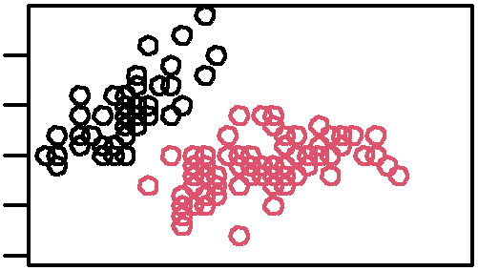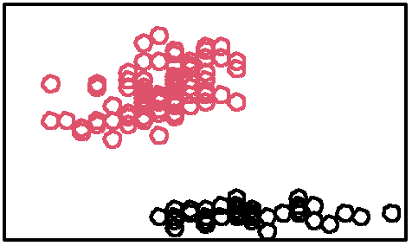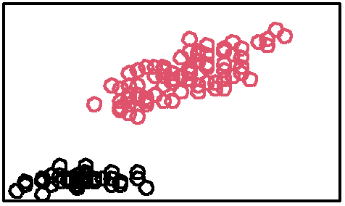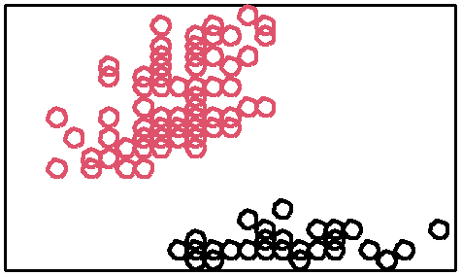

0.5

1.5

2.5

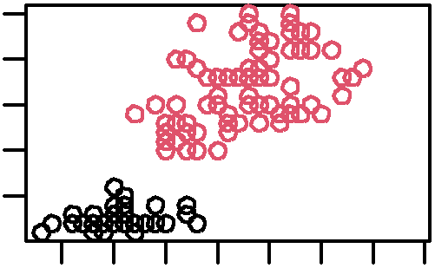

4.5 5.5 6.5 7.5

2.0 3.0 4.0

1121638

141311235

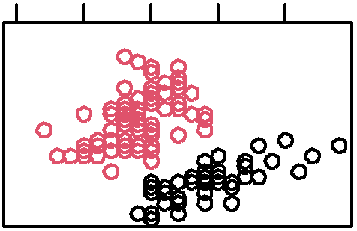

Sepal.Width

6819820

584600

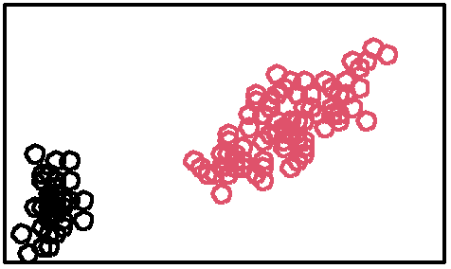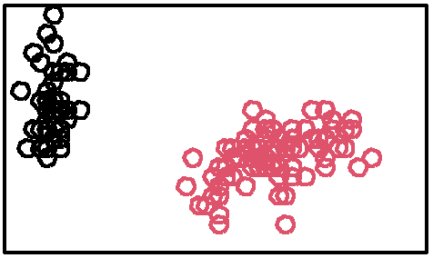

Petal.Length

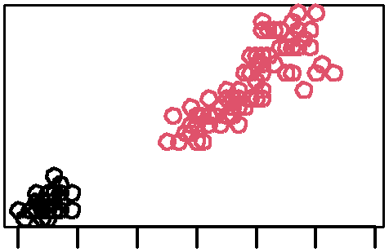

1 2 3 4 5 6 7

0.5 1.5 2.5

5837

598691

95

1908609

89710

43566

45800

3194

32119

244075

27

4.5 6.0 7.5

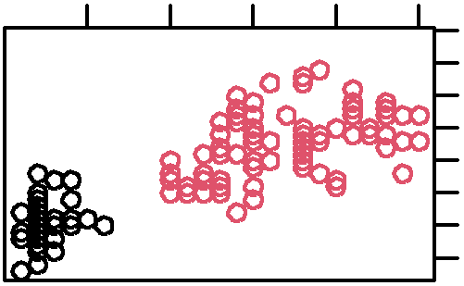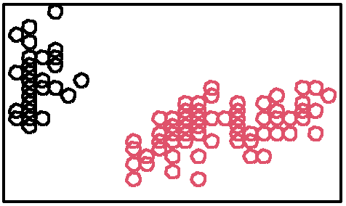

1

3

5

7

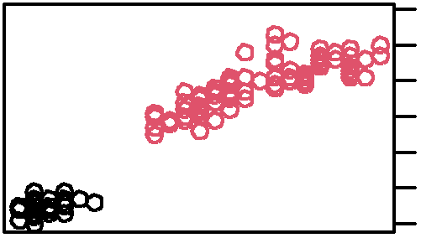

Petal.Width