**ARTIFICIAL**

**INTELLIGENCE**

**PRACTICAL**

**FILE :-**

**Submitted By :-**

**Name: ABHIJEET RANA**

**Roll Number: 2k18/CS/82**

**University Roll Number : 18013570001**

**Course: B.Sc (H) Computer Science**

**UPC: 32341601**

**S/W LAB BASED ON ARTIFICIAL INTELLIGENCE**

**Semester : 6th**

Q1 -

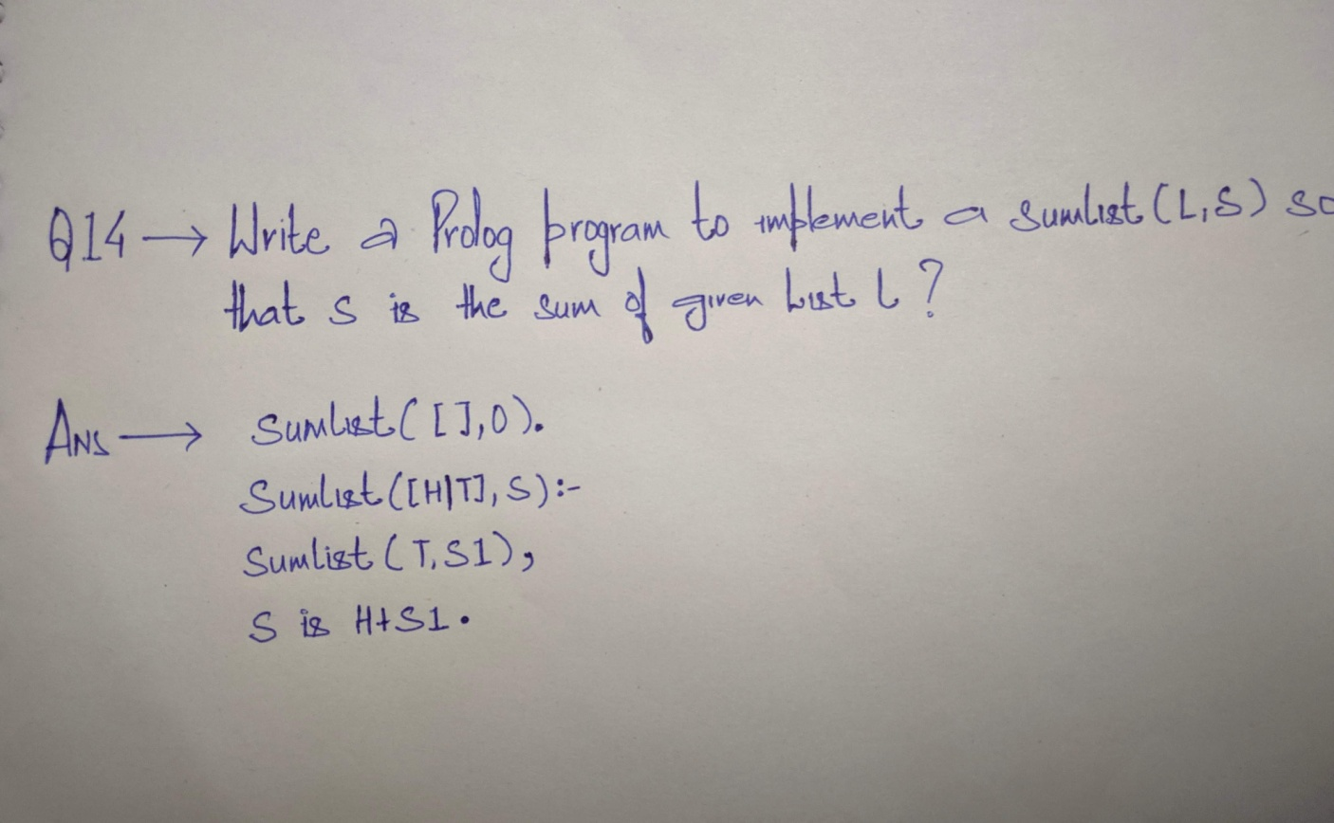

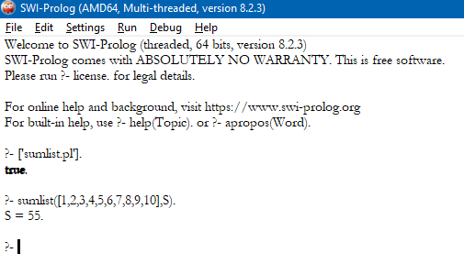

Q2 -

