**Assignment 1**

**Bubble Sort Pseudocode:**

Step 1: function bubbleSort(arr)

Step 2: n = length of arr

Step 3: for i from 0 to n-1

Step 4: for j from 0 to n-i-1

Step 5: if arr[j] > arr[j+1]

Step 6: swap arr[j] and arr[j+1]

**Bubble Sort Flowchart:**

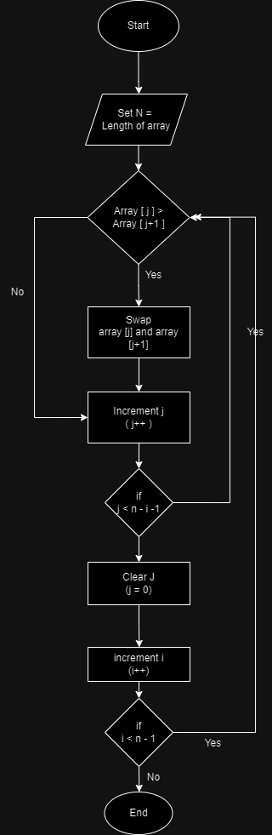

**Bubble sort explanation:**

Bubble Sort works by repeatedly swapping adjacent elements if they are in the wrong order. It starts by comparing the first two elements, swapping them, if necessary, then moves to compare the next two elements, and so on. This process continues until the entire array is sorted.