alu_uvm_env: UVM Verification Environment for a Parameterised ALU
Design document - executed on Verilator 5.052 with the Accellera UVM library

A. Project overview

A.1 Purpose
alu_uvm_env is a UVM 1.2-style verification environment for a small, parameterised ALU (ADD, SUB, AND, OR, XOR, with a registered result and carry and an operand width set at compile time). It's a verification project. The design under test is tiny on purpose, so that the environment itself (sequences, driver, monitor, scoreboard, covergroup, configuration) is what's being looked at.
The portfolio copy adds one thing the original didn't have: it was run. My original repository says the environment "was written and reviewed without execution", because I had no UVM-capable simulator then. Here it's compiled and run with Verilator 5.052 and the Accellera UVM library (the uvm-verilator kit), the scoreboard results and functional coverage are measured, and the environment is checked with an injected-bug campaign.

A.2 Problem statement and motivation
A verification environment is only believable once it has been shown to catch bugs. A scoreboard that never fails proves nothing, and a covergroup that was never sampled reports nothing. So the aim was to take an environment that only existed on paper and give it evidence: a run with real transaction counts, a coverage figure computed from real bin hits, and a measured answer to "which design bugs would it miss?".

A.3 Scope and requirements
ID | Requirement | Status
R1 | Self-checking UVM environment: sequence, sequencer, driver, monitor, scoreboard, coverage subscriber, config object, virtual interface | implemented in the original; executed here
R2 | The scoreboard's reference model is independent of the DUT's implementation (it must not copy the shared-adder trick) | implemented (native +/-, carry = a >= b)
R3 | Correct handling of the DUT's one-cycle latency by re-pairing each result with the instruction that produced it | implemented (monitor)
R4 | Functional coverage: opcode, operand value classes, carry, opcode x operands, opcode x carry | implemented as a covergroup; measured from the simulator's bin data
R5 | Run at WIDTH 8 (exhaustive) and a wider width (random) | measured (8 and 16)
R6 | Show what the environment cannot catch | injected-bug campaign, with the gaps reported and one of them closed

Out of scope: a UVM register model, multiple agents, random stimulus that relies on the constraint solver (see the tool limitations in section G), and assertions on the DUT (the ALU is combinational logic plus one register, so the checks live in the scoreboard).

A.4 Target application and concepts
It applies to any block with an input transaction and a registered output. Building it covers UVM phases and the factory, uvm_sequence / uvm_sequencer / uvm_driver, virtual interfaces and the config DB, analysis ports and uvm_subscriber, independent reference modelling, coverage-driven random stimulus, cross coverage and mutation analysis.

A.5 Key features and measurable objectives
- Exhaustive verification at WIDTH = 8: 5 opcodes x 256 x 256 operand pairs = 327,680 transactions, plus directed corner cases.
- One analysis port that feeds both the scoreboard and the coverage subscriber.
- Objective: zero scoreboard failures, zero UVM errors, 100 % of the counted covergroup bins hit, and a measured list of the injected bugs that survive.

B. Architecture and block diagram

B.1 Overview
The testbench top (alu_tb_top) generates the clock and reset, instantiates the DUT and the interface alu_if, puts the virtual interface in the config DB and calls run_test("test"). The test builds an env with an agent (sequencer, driver, monitor), a scoreboard and a coverage subscriber, and starts the sequences on the agent's sequencer.

B.2 Components and responsibilities
Component | File | Responsibility
transaction | transaction.sv | uvm_sequence_item: rand opcode, num1, num2; result and carry filled by the monitor; constraint legal_opcode (the five opcodes)
sequences | sequence.sv | corner_case_seq (directed corners and reserved opcodes), exhaustive_seq (all pairs, WIDTH <= 8), random_seq (coverage-driven, WIDTH > 8)
driver | driver.sv | get_next_item, drives opcode/num1/num2 through the virtual interface on a clock edge, item_done
monitor | monitor.sv | samples the interface; pairs each result with the instruction driven one cycle earlier; ignores everything until one clock after reset is released; checks the output for X/Z
scoreboard | scoreboard.sv | uvm_analysis_imp; independent expected-value model; counts pass and fail; reports in report_phase
coverage | coverage.sv | uvm_subscriber; covergroup cg with op_cp, num1_cp, num2_cp, carry_cp, op_x_operands, op_x_carry
agent, env, test, alu_config, alu_pkg, alu_if | agent.sv, env.sv, test.sv, config.sv, alu_pkg.sv, interface.sv | structure, configuration (is_active), the WIDTH parameter and opcode constants, the signal bundle

B.3 Interfaces
alu_if carries clk, rst_n, opcode[2:0], num1[WIDTH-1:0], num2[WIDTH-1:0], result[WIDTH-1:0] and carry_out. The DUT, alu #(WIDTH), has the same ports. There's one agent and one analysis port.

B.4 Data and control paths
Stimulus path: sequence -> sequencer -> driver -> alu_if -> DUT. Observation path: DUT -> alu_if -> monitor -> analysis port -> scoreboard and coverage. Control: the test raises the objection before the sequences and drops it after them, and the monitor gates itself on reset.

C. Draw.io architecture diagram
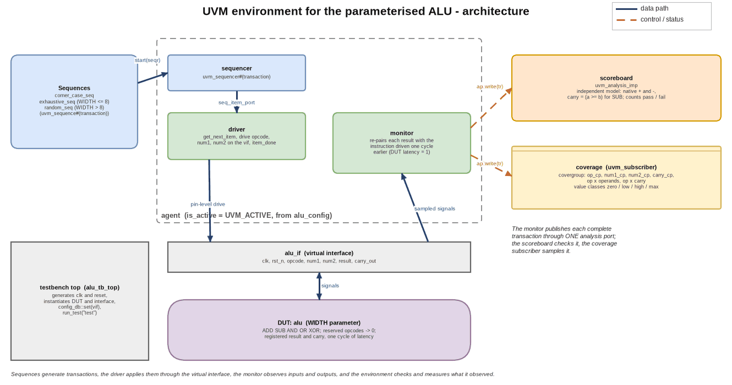
Figure C.1 - UVM environment architecture (stimulus path solid blue, analysis path dashed orange)
The diagram files are in docs/portfolio/diagrams/: alu_uvm_architecture.drawio (editable), .png and .svg, plus alu_uvm_flowchart.* and alu_uvm_toolchain.*. dgm.py, next to the diagram script, draws them from the same specification that writes the .drawio, so they aren't exports from draw.io.

D. Design flowchart
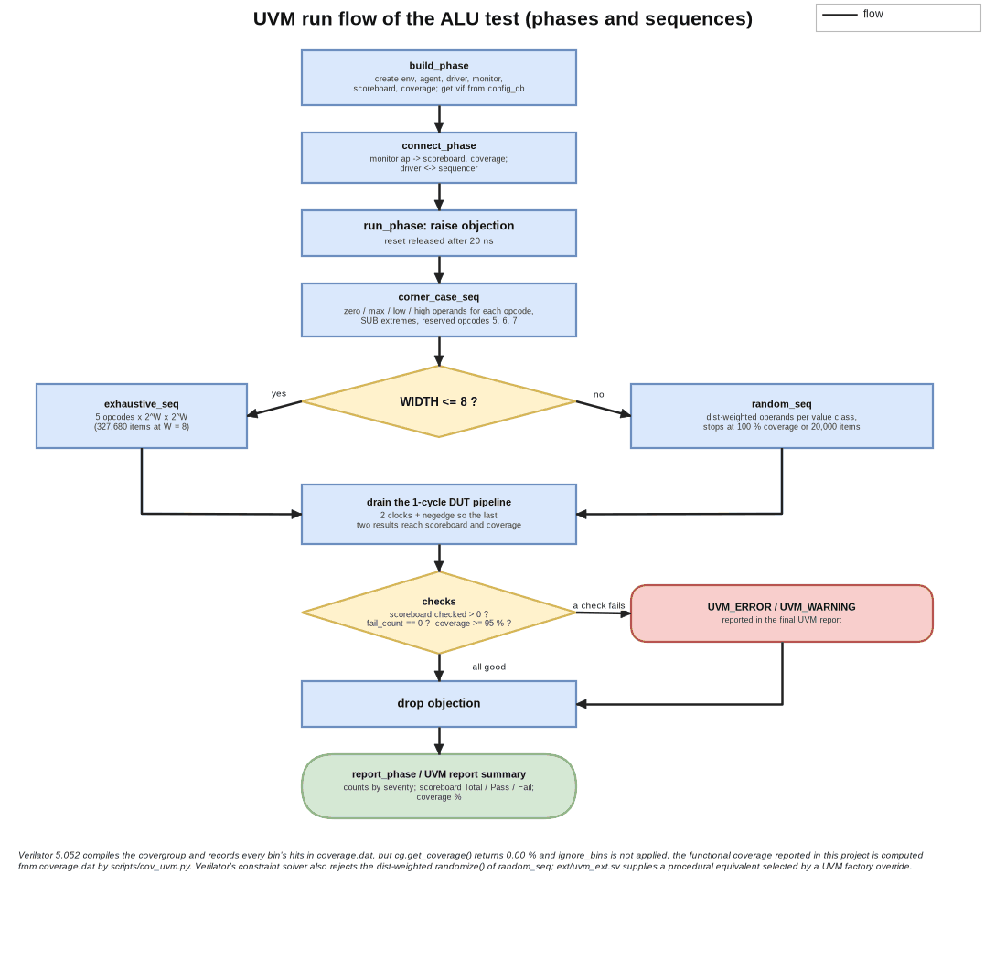
Figure D.1 - UVM run flow: phases, sequences, drain, checks and report
The run starts with the UVM build and connect phases, raises an objection, runs corner_case_seq, and then runs either exhaustive_seq (WIDTH <= 8) or random_seq. It then waits two clocks and a falling edge, so that the last two results reach the scoreboard and the coverage subscriber (the DUT has one cycle of latency and the monitor publishes one cycle after that). Finally it checks that the scoreboard saw transactions and no failures and that coverage meets the goal, drops the objection and prints the UVM report.
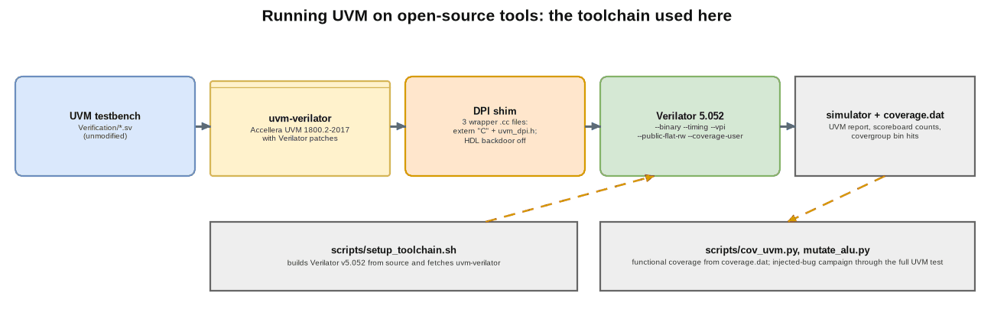
Figure D.2 - The open-source toolchain used to run UVM here

E. Detailed design explanation

E.1 The DUT
alu #(WIDTH) decodes opcode 000 as ADD, 001 SUB, 010 AND, 011 OR and 100 XOR; 101 to 111 are reserved and return 0 with carry 0. ADD and SUB share one adder (num2 is conditionally inverted and the subtract is fed in as carry-in). The result and carry are registered, which gives one cycle of latency, with an asynchronous active-low reset.

E.2 The latency problem and the monitor
The result lags the instruction by a cycle, so a monitor that sampled a single clock edge would pair each result with the next instruction. Instead the monitor keeps the previous cycle's instruction and publishes a transaction made of that instruction and the current result. It only sets have_prev after the first edge after reset and clears it while reset is asserted, so the first output, which is the reset value, never becomes a transaction. It also checks the output for X/Z before the two-state transaction fields can quietly turn it into 0.

E.3 The scoreboard's reference model
The model deliberately does not reuse the DUT's shared-adder implementation. ADD is {1'b0, a} + {1'b0, b}, SUB is the native subtraction with carry defined as a >= b (no borrow), the logic operations are bitwise, and reserved opcodes expect 0. So a bug in the DUT's invert-and-carry-in trick can't be reproduced by the checker without anyone noticing.

E.4 Coverage model
The value classes are relative to the width (zero, max, low = 1 to 2^(W-1)-1, high = 2^(W-1) to max-1), so the model stays meaningful at any WIDTH. op_cp has bins for the five opcodes and a reserved[] bin set. op_x_operands crosses the opcode with both operand classes and ignores the reserved opcodes, and op_x_carry crosses the opcode with the carry value and ignores AND, OR, XOR and the reserved opcodes, whose carry is always 0.

E.5 Reset, latency, throughput, back-pressure and errors
Reset is released after 20 ns. The DUT takes one instruction per clock with no handshake, so there's no back-pressure, and results come one cycle late. Errors are reported with uvm_error, by the scoreboard for a mismatch and by the monitor for X/Z.

E.6 Design decisions and trade-offs
Decision | Alternative | Reason / cost
Exhaustive stimulus for WIDTH <= 8 | random only | complete evidence for the exact configuration; does not scale beyond about 10 bits
Coverage-driven random above 8 bits | exhaustive | the only option at 16 bits and above
Independent reference model | reuse RTL expressions | catches bugs in the implementation trick
One analysis port for scoreboard and coverage | two monitors | one source of truth for what was observed
Original sources left unmodified; additions in ext/ selected by factory override | edit the sources | the original remains exactly what was written; the additions are separable and documented

F. Interface and timing details
The interface is a plain synchronous bundle on clk. The driver changes opcode, num1 and num2 with non-blocking assignments after a clock edge, the DUT registers its result on the following edge, and the monitor samples on every rising edge. A transaction is therefore (instruction at edge k, result at edge k+1). It supports any WIDTH that fits the packages (alu_pkg::WIDTH, default 8; the run script rewrites it in a copy for other widths), one clock and synchronous stimulus.

G. Verification and testing

G.1 Execution evidence
run W sequence txns pass fail UVM_ERROR UVM_FATAL wall [s]
------------------------------------------------------------------------------------------------
w8 8 exhaustive_seq 327705 327705 0 0 0 21.775
w16_original 16 random_seq (original) 20025 20025 0 20000 0 2.001
w16 16 random_seq_vl 20025 20025 0 0 0 0.998

simulator: Verilator 5.052 2026-09-05, one thread, seed 1; 'txns' = scoreboard Total (corner_case_seq 25 + main sequence).
note: the 'w16_original' run drives the unmodified random_seq; every one of its 20,000 randomize() calls fails on this simulator (UVM_ERROR),
which is why the run is reported but not counted as a verification result (see section G.4).

G.2 Functional coverage
Verilator 5.052 compiles the covergroup and records each bin's hit count in coverage.dat, but get_coverage() returns 0.00 % and ignore_bins isn't applied. So scripts/cov_uvm.py reads the bin data and leaves out exactly the bins that coverage.sv declares ignored.
WIDTH = 8 (exhaustive):
coverpoint bins ignored counted hit zero
carry_cp 2 0 2 2 0
num1_cp 4 0 4 4 0
num2_cp 4 0 4 4 0
op_cp 8 0 8 8 0
op_x_carry 16 12 4 4 0
op_x_operands 128 48 80 80 0

raw (Verilator data as is, ignore_bins NOT applied) : 111 / 162 bins hit = 68.52 %
with the declared ignore_bins removed (60 bins) : 102 / 102 bins hit = 100.00 %
counted bins never hit: none

WIDTH = 16 (20,000 procedurally generated random transactions plus the corner cases):
coverpoint bins ignored counted hit zero
carry_cp 2 0 2 2 0
num1_cp 4 0 4 4 0
num2_cp 4 0 4 4 0
op_cp 8 0 8 8 0
op_x_carry 16 12 4 4 0
op_x_operands 128 48 80 80 0

raw (Verilator data as is, ignore_bins NOT applied) : 111 / 162 bins hit = 68.52 %
with the declared ignore_bins removed (60 bins) : 102 / 102 bins hit = 100.00 %
counted bins never hit: none

G.3 Checking the environment: injected bugs
Each of 14 one-line edits of the ALU is run through the complete UVM test at WIDTH = 8 (scripts/mutate_alu.py). With the original sources:
mutants run: 14, killed 10, survived 4
environment: ORIGINAL sources, unmodified
survivors are annotated: A07 is an equivalent mutant (OR does not use the adder, so its output cannot change); A08 and A14 change only the
reset value of a register, which this environment never samples (the monitor discards everything until one clock after reset is released): a gap, not an equivalent;
A06 (reserved opcodes return num1) survives the original environment because corner_case_seq sends reserved opcodes only with zero operands: a stimulus gap, closed by the extension.
PROBLEMS: none (every outcome matched its expectation)

A01 KILLED SUB without the carry-in (a - b computed as a + ~b) scoreboard fail 65542 of 327705, UVM_ERROR 65543 [expected: killed]
A02 KILLED result LSB forced to 0 for ADD/SUB scoreboard fail 65542 of 327705, UVM_ERROR 65543 [expected: killed]
A03 KILLED ADD/SUB carry taken from the wrong adder bit scoreboard fail 98308 of 327705, UVM_ERROR 98309 [expected: killed]
A04 KILLED AND implemented as OR scoreboard fail 65282 of 327705, UVM_ERROR 65283 [expected: killed]
A05 KILLED XOR implemented as AND scoreboard fail 65538 of 327705, UVM_ERROR 65539 [expected: killed]
A06 SURVIVED reserved opcodes return num1 instead of 0 scoreboard fail 0 of 327705, UVM_ERROR 0 [expected: gap]
A07 SURVIVED subtract also asserted for OR (the adder is not used by OR) scoreboard fail 0 of 327705, UVM_ERROR 0 [expected: equivalent]
A08 SURVIVED result register resets to all-ones instead of 0 scoreboard fail 0 of 327705, UVM_ERROR 0 [expected: gap]
A09 KILLED carry_out register stuck at 0 scoreboard fail 65541 of 327705, UVM_ERROR 65542 [expected: killed]
A10 KILLED SUB carry has the wrong sense scoreboard fail 65542 of 327705, UVM_ERROR 65543 [expected: killed]
A11 KILLED OR implemented as XOR scoreboard fail 58976 of 327705, UVM_ERROR 58977 [expected: killed]
A12 KILLED XOR implemented as OR scoreboard fail 58976 of 327705, UVM_ERROR 58977 [expected: killed]
A13 KILLED operand 2 not inverted for SUB scoreboard fail 65542 of 327705, UVM_ERROR 65543 [expected: killed]
A14 SURVIVED carry_out register resets to 1 scoreboard fail 0 of 327705, UVM_ERROR 0 [expected: gap]

With the extension that closes the reserved-opcode gap (ext/uvm_ext.sv, a corner_case_seq subclass selected with +uvm_set_type_override):
mutants run: 14, killed 11, survived 3
environment: ORIGINAL sources + ext/uvm_ext.sv (corner-case extension)
survivors are annotated: A07 is an equivalent mutant (OR does not use the adder, so its output cannot change); A08 and A14 change only the
reset value of a register, which this environment never samples (the monitor discards everything until one clock after reset is released): a gap, not an equivalent;
A06 (reserved opcodes return num1) survives the original environment because corner_case_seq sends reserved opcodes only with zero operands: a stimulus gap, closed by the extension.
PROBLEMS: none (every outcome matched its expectation)

A01 KILLED SUB without the carry-in (a - b computed as a + ~b) scoreboard fail 65542 of 327723, UVM_ERROR 65543 [expected: killed]
A02 KILLED result LSB forced to 0 for ADD/SUB scoreboard fail 65542 of 327723, UVM_ERROR 65543 [expected: killed]
A03 KILLED ADD/SUB carry taken from the wrong adder bit scoreboard fail 98308 of 327723, UVM_ERROR 98309 [expected: killed]
A04 KILLED AND implemented as OR scoreboard fail 65282 of 327723, UVM_ERROR 65283 [expected: killed]
A05 KILLED XOR implemented as AND scoreboard fail 65538 of 327723, UVM_ERROR 65539 [expected: killed]
A06 KILLED reserved opcodes return num1 instead of 0 scoreboard fail 15 of 327723, UVM_ERROR 16 [expected: killed]
A07 SURVIVED subtract also asserted for OR (the adder is not used by OR) scoreboard fail 0 of 327723, UVM_ERROR 0 [expected: equivalent]
A08 SURVIVED result register resets to all-ones instead of 0 scoreboard fail 0 of 327723, UVM_ERROR 0 [expected: gap]
A09 KILLED carry_out register stuck at 0 scoreboard fail 65541 of 327723, UVM_ERROR 65542 [expected: killed]
A10 KILLED SUB carry has the wrong sense scoreboard fail 65542 of 327723, UVM_ERROR 65543 [expected: killed]
A11 KILLED OR implemented as XOR scoreboard fail 58976 of 327723, UVM_ERROR 58977 [expected: killed]
A12 KILLED XOR implemented as OR scoreboard fail 58976 of 327723, UVM_ERROR 58977 [expected: killed]
A13 KILLED operand 2 not inverted for SUB scoreboard fail 65542 of 327723, UVM_ERROR 65543 [expected: killed]
A14 SURVIVED carry_out register resets to 1 scoreboard fail 0 of 327723, UVM_ERROR 0 [expected: gap]

The scoreboard catches every arithmetic and logic bug. Mutant A06 (reserved opcodes return num1) survives the original environment, because corner_case_seq only drives the reserved opcodes with zero operands, where the buggy and correct outputs are the same. Only the injected-bug campaign showed that stimulus gap, and the extension closes it. Mutants A08 and A14 (a register's reset value) survive because the monitor ignores everything until one clock after reset is released, so the reset value is never observed. That's a known blind spot rather than an equivalent mutant. A07 really is equivalent, because OR doesn't use the adder.

G.4 Tool limitations met and how they were handled
Limitation (Verilator 5.052) | Handling
covergroup.get_coverage() returns 0.00 % | coverage computed from coverage.dat by cov_uvm.py
ignore_bins not applied to the recorded bins | the script excludes the declared ignore bins and also prints the raw figure
the constraint solver rejects dist weights and a constraint over package parameters (randomize() returns 0) | ext/uvm_ext.sv: random_seq_vl (procedural operand classes and opcode table), selected by factory override
the stock uvm_dpi.cc needs a vendor HDL backdoor (uvm_hdl.c) | three small wrapper files (scripts/dpi_wrappers/) compile the command-line, regex and report helpers; HDL backdoor access is compiled off
the UVM test's coverage-goal check (>= 95 %) reads get_coverage() | a UVM_WARNING is printed; the real figure is in section G.2

G.5 Simulation commands and tool requirements
scripts/setup_toolchain.sh # builds Verilator v5.052 + fetches uvm-verilator (one time)
scripts/run_uvm.sh build/w8 # WIDTH 8, exhaustive
scripts/run_uvm.sh build/w16 --width 16 --ext ext/uvm_ext.sv --plus +uvm_set_type_override=random_seq,random_seq_vl
python3 scripts/cov_uvm.py build/w8/coverage.dat
python3 scripts/mutate_alu.py [--with-ext]

G.6 Known failures
None in the delivered runs: zero scoreboard failures and zero UVM_ERROR. The known gaps are that reset values aren't observed, that the original random sequence can't run on this simulator (random_seq_vl replaces it), and that the test's 95 % coverage-goal check can't work on this simulator.

H. Synthesis, timing and performance results
This doesn't apply here. The project is a UVM environment around a small RTL block, and I didn't run synthesis, timing or power analysis on the ALU, so those are NOT MEASURED (the alu_fifo and rv32i_5stage_core projects have synthesis and timing results for ALU-class logic). For reference, the simulation speed (Verilator-reported, one thread, section G.1): the exhaustive WIDTH = 8 run of 327,705 transactions took 21.8 s of wall time, and the 20,025-transaction WIDTH = 16 run 1.0 s.

I. Results, limitations and future improvements

I.1 Summary
A UVM environment that had been written but never run now runs: 327,705 transactions at WIDTH 8 and 20,025 at WIDTH 16 with zero failures, 100 % of the counted covergroup bins hit at both widths, and a measured injected-bug campaign that found one stimulus gap (closed) and one blind spot (reset values).

I.2 Most meaningful outcomes
- Getting a real UVM library and covergroups to compile and run on open-source Verilator, with a setup script that reproduces it and a straight list of what the tool can't do.
- A coverage figure computed from the raw bin data when the tool's own figure is wrong.
- Mutation analysis of a verification environment, which found a concrete hole (reserved opcodes only tested at zero) that coverage alone didn't show, because the cross ignores reserved opcodes by design.

I.3 Limitations
The open-source tool limits (section G.4); a tiny DUT; no assertions; no register model; no multi-agent topology; reset values aren't observed; and the original random_seq can't run on this tool.

I.4 Future improvements
SVA bound to the DUT (reset values, latency); a reset-value check in the monitor; formal equivalence of the ALU against a reference; porting the environment to a commercial simulator to run random_seq with its constraint solver and the built-in coverage report; and a second agent and scoreboard topology (for example an ALU behind a FIFO).

I.5 Interview talking points
- How the monitor deals with a DUT that has one cycle of latency, and why it gates on reset.
- Why the scoreboard's model has to be independent of the RTL's structure.
- What ignore_bins does, why Verilator's raw coverage differs from the intended number, and how I got the right number back.
- How a mutant survived (reserved opcodes at zero operands) while coverage said 100 %, and what that says about coverage models.
- The factory override I used to add stimulus without changing the original sources.

J. References and reproducibility
- IEEE 1800.2 (UVM); Accellera UVM; Antmicro uvm-verilator; Verilator manual (--binary, --timing, --vpi, --coverage-user).
- The original specification: docs/superpowers/specs/2026-09-28-parameterized-alu-uvm-design.md (the working plan I built the environment from isn't kept in this folder).
- Directory structure: Design/alu.v, Verification/*.sv (original, unmodified), ext/uvm_ext.sv, scripts/ (setup_toolchain.sh, run_uvm.sh, cov_uvm.py, mutate_alu.py, dpi_wrappers/), results/, docs/portfolio/.
- To reproduce, use the commands in section G.5. The toolchain directory (../../_toolchain) isn't part of the deliverable; setup_toolchain.sh recreates it. The source is at https://github.com/AbhijeetJ-512/alu-uvm-env.

