mlc_cache_controller: Three-Level Cache Hierarchy Controller
Design document - L1 / L2 / L3 with AXI4 memory interface, simulated, synthesised and timed on Sky130 HD

A. Project overview

A.1 Purpose
mlc_cache_controller is a parameterised cache hierarchy controller in SystemVerilog, with three levels (L1 / L2 / L3) and a single requester. Split L1 instruction and data caches (direct mapped, write-through) share one unified L2 (set associative, write-back, tree-PLRU) through an arbiter. A 2:1 line-size adapter connects L2 to an L3 (set associative, write-back, tree-PLRU, with twice the line size), and an AXI4 fill engine turns each L3 miss or dirty eviction into one burst on a memory-side AXI4 master. It's a memory-subsystem design, and what I cared about was making a different trade-off at each level, getting the boundary logic between levels right, and having evidence that each piece works.

A.2 Problem statement and motivation
A cache hierarchy is a handful of simple ideas (tag compare, victim choice, write policy) joined by interface contracts that are easy to get subtly wrong. A hit and its response have to be one event, a fill request has to stay valid until it's answered, a posted write must never get a response, and two requesters have to share one lower port without losing a response. I built the project around writing those contracts down explicitly, testing the boundaries where they meet, and measuring what the resulting hardware costs.

A.3 Scope and requirements (as implemented)
ID | Requirement | Status
R1 | L1-I and L1-D: 4 KiB, 32 B lines, direct mapped, write-through, no dirty bit, same-cycle hit response | implemented, simulated (unit tests and the system test)
R2 | L2: 32 KiB, 32 B lines, 4-way, write-back, tree-PLRU, write-allocate, unified | implemented, simulated
R3 | L3: 256 KiB (default), 64 B lines, 8-way, write-back, tree-PLRU; one controller shared with L2 at different parameters | implemented, simulated (system test uses the default size)
R4 | l2_l3_width_adapter: 32 B to 64 B line adaptation, half select by address bit 5, write-back as a posted half-line write | implemented, simulated
R5 | l1_l2_arbiter: one L2 port for two L1s, round-robin, response routed to the owner | implemented, simulated
R6 | axi4_fill_engine: one INCR burst per line, 16 beats of 32 bits at the defaults, one transaction in flight, sticky mem_err | implemented, simulated against an AXI4 memory model that checks the burst shape
R7 | Parameter guards at elaboration (power-of-two sizes, 2:1 line ratio, burst length) | implemented, simulated (make elab: accepted and rejected sets under Icarus and Yosys)
R8 | Synthesis to Sky130HD and static timing of every unit | done for every unit except the default 256 KiB L3 (out of memory; measured to 32 KiB) and the top (wiring only)
R9 | UVM environment, formal properties, place and route, whole-hierarchy timing | NOT DONE / NOT MEASURED (UVM needs an external simulator; the other items are not attempted)

Left out by design: a coherence protocol and an inclusion policy (there's one requester, so neither is needed; the hierarchy is non-inclusive non-exclusive), virtual memory, non-blocking misses (blocking misses keep the verification matrix manageable, and I list them as a limitation), write buffers and prefetch.

A.4 Target application and concepts
A memory subsystem between one CPU (an instruction fetch port plus a load/store port) and an AXI4 memory. Building it covers address partitioning derived from parameters, tag, valid and dirty state, write-through against write-back, write allocation, tree pseudo-LRU, eviction and fill sequencing, line-size adaptation, posted writes, arbitration, burst generation, and interface contracts that avoid deadlock.

A.5 Key features and measurable objectives
- A different trade-off at each level: L1 is direct mapped and write-through (no way mux, no eviction state), L2 and L3 are set associative and write-back (fewer conflict misses and less downstream traffic).
- At every level a hit completes in the cycle it's accepted.
- L2 and L3 share one controller, and the adapter is the only place where the two line sizes meet.
- Measured: unit synthesis area and cell counts, the minimum clock period of each unit with its limiting class of path (section H), and a system-level data-integrity test over the whole hierarchy with an injected-bug campaign (section G).

B. Architecture and block diagram

B.1 Overview
mlc_cache_top is purely structural. The two L1 controllers present the same request / response interface to the CPU and the same downstream interface to the arbiter. L2 has a single upstream port and doesn't know which L1 a request came from. The adapter has no clock and no state. L3 is the L2 controller module instantiated with L3 parameters and with its write width set to one L2 line, so an L2 write-back arrives as one posted half-line write. The fill engine is the only block that knows about AXI4.

B.2 Blocks and responsibilities
Block | File | Responsibility
l1_cache_ctrl (L1-I, L1-D wrappers) | rtl/l1/ | direct-mapped tag / data array, hit path, 3-state miss FSM, one-entry write-forward skid, write-through forward
l1_l2_arbiter | rtl/arbiter/ | picks one L1 request (round-robin on a tie), holds the other, remembers the owner of an outstanding read and routes its response; three state bits
l2_cache_ctrl | rtl/l2/ | set-associative write-back controller with 5-state miss FSM, victim register, merge of write data, dirty tracking; reused as L3
plru_tree | rtl/replace/ | tree pseudo-LRU for any power-of-two way count
l2_l3_width_adapter | rtl/adapter/ | combinational: request pass-through, half select of the 64 B response by address bit 5, L2 write-back to L3 write data with all strobes set
l3_cache_ctrl | rtl/l3/ | l2_cache_ctrl at the L3 parameters
axi4_fill_engine | rtl/mem_if/ | 6-state AXI4 master (IDLE, AR, R, RESP, WR, B) generating one fixed-length INCR burst per line request
reset_sync | rtl/common/ | asynchronous assert, synchronous de-assert, applied once in the top
mlc_pkg | rtl/common/ | the parameters; each level derives its tag / index / offset widths from them with $clog2

B.3 Interfaces
On the CPU side (one instance per L1) the signals are req_valid/ready, req_addr, req_we, req_wdata, req_wstrb, resp_valid/ready and resp_rdata; the fetch port has no req_we. The links between levels have the same shape plus a full-line response (resp_line) and a full-line write-back payload (req_line). The memory side is a full AXI4 master (m_axi_*, no IDs, constant sideband values as parameters) plus a sticky mem_err.
Three contracts bind everything together:
- The CPU must not derive resp_ready from resp_valid, because an L1 hit only raises resp_valid in a cycle in which it's also accepting the request.
- A fill request's req_valid stays high for the whole fill, so a level further down has to hold req_ready low until it has answered.
- Writes on the links between levels are posted, so no level ever answers a write.

B.4 Data and control paths
A read hit does the tag compare and the data read in the cycle of the request. On a read miss, L1 ALLOC_FILL asks L2 for a 32 B line through the arbiter. L2 either hits, or evicts a victim (writing it back through the adapter if it's dirty), fills from L3 (the adapter selects the requested 32 B half of an L3 line) and returns the line. L3 in turn either hits, or evicts and fills through one AXI4 burst. On a store, an L1 hit updates L1 and forwards the store to L2 (write-through, posted), and L2 merges it into its line and marks it dirty. A dirty line only reaches L3 when it's evicted, and only reaches memory when L3 evicts it.

C. Draw.io architecture diagram
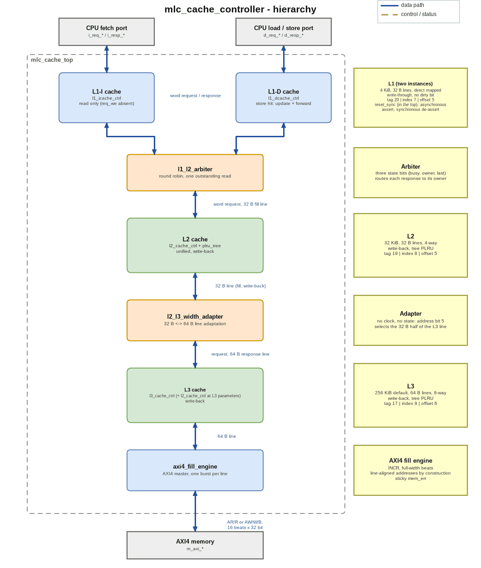
Figure C.1 - mlc_cache_controller hierarchy
The diagram files are in docs/portfolio/diagrams/: mlc_architecture.drawio (editable), .png and .svg, and the same three for mlc_flowchart and mlc_fsm. make_diagrams.py writes all of them from one specification, so the .drawio is generated rather than exported from draw.io.

D. Design flowchart
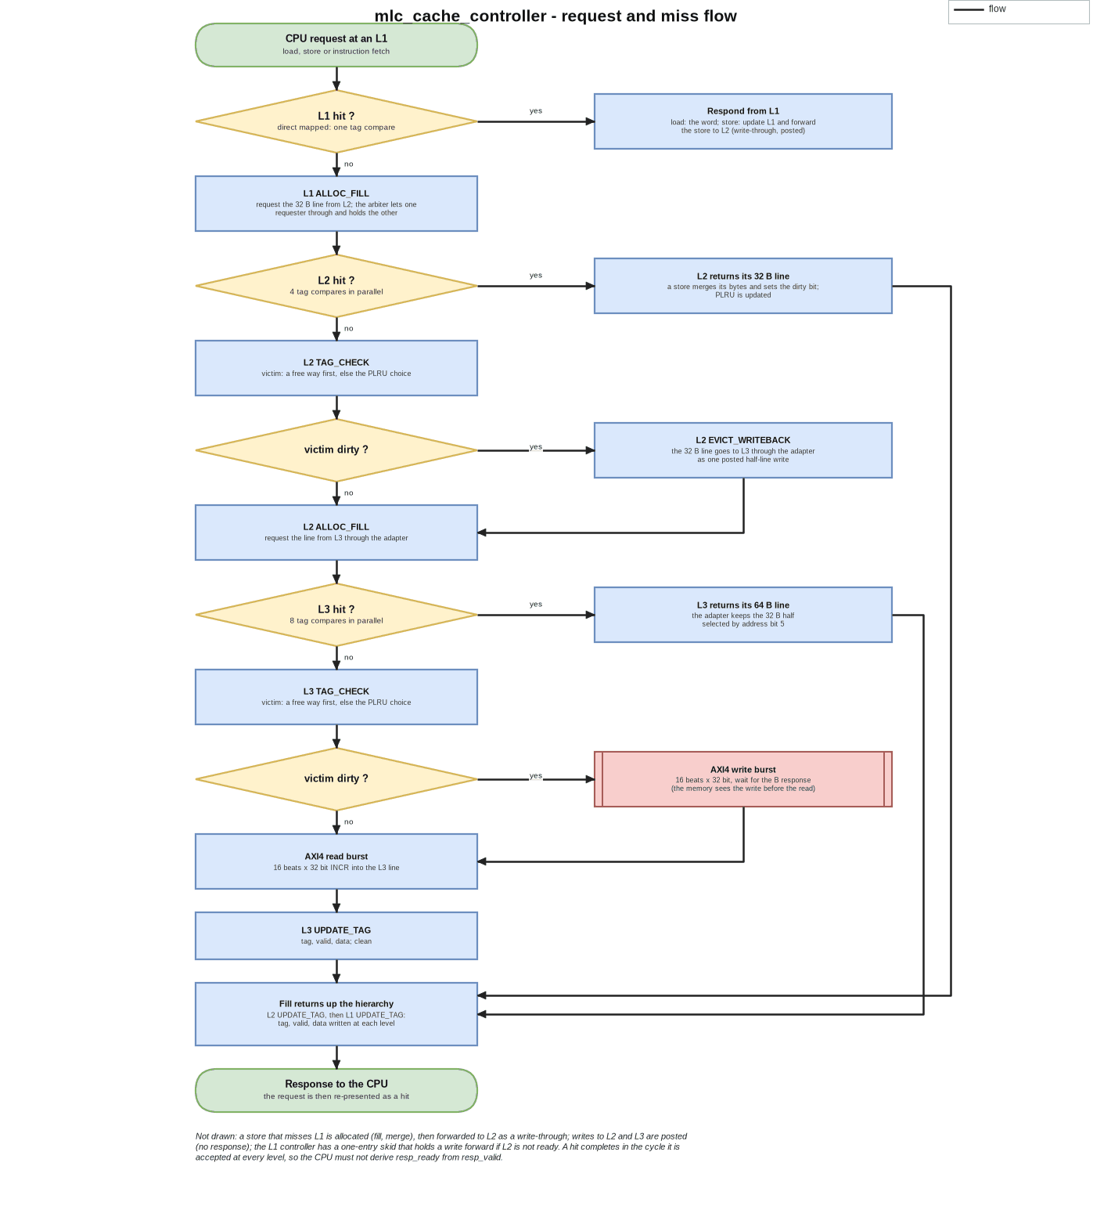
Figure D.1 - What happens to one request: hit and miss paths through the three levels
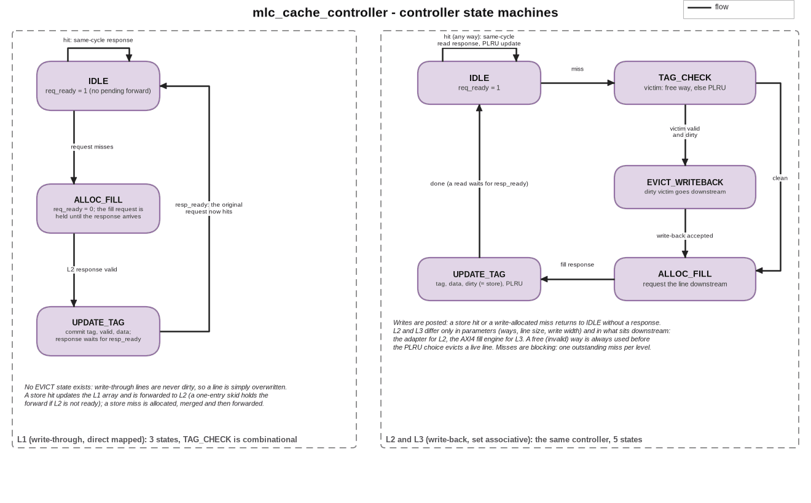
Figure D.2 - The two controller state machines: L1 (3 states) and L2 / L3 (5 states)

E. Detailed design explanation

E.1 Address partitioning
Each level splits the 32-bit address into tag, index and offset with widths derived from its own parameters, and an elaboration-time check requires sets x ways x line = capacity. L1 uses tag 20, index 7 and offset 5 (128 lines), L2 tag 19, index 8 and offset 5 (256 sets x 4 ways), and L3 tag 17, index 9 and offset 6 (512 sets x 8 ways). L3's index sits at different bit positions from L2's for the same address bits. That's correct: each level indexes by its own line size, and the only thing the adapter needs the two levels to agree on is which L2 line lies in which half of an L3 line.

E.2 L1: write-through, direct mapped
The hit path is one tag compare and one data read, with no way multiplexer. There's no dirty bit and no eviction state: a write-through line is never dirty, so a replaced line is simply overwritten in UPDATE_TAG. A store hit updates the array and forwards the store downstream in the same cycle. If L2 can't take it, a one-entry skid register holds the forward and req_ready stays low until it drains. A store miss is allocated (the line is fetched and the store merged) and then forwarded. req_ready stays low for the whole miss, and the original request is presented again as a hit after UPDATE_TAG.

E.3 L2 and L3: write-back, set associative
On a miss the controller latches the line-aligned address and picks a victim, a free way if there is one and otherwise the PLRU tree's choice. If the victim is valid and dirty it writes it back (EVICT_WRITEBACK), then fetches the new line (ALLOC_FILL) and commits the tag, data, dirty bit (set when the request was a store) and PLRU state (UPDATE_TAG). Writes from above are posted: a store hit or a write-allocated miss goes back to IDLE without a response. A free way is always used before a live line is evicted, because hits can steer the tree towards a live way while an invalid way is still free. Arrays that need no reset (tag, dirty, data) are kept in a reset-free block so synthesis infers memories, and only the valid array and the FSM are reset.

E.4 Tree-PLRU
Each set has WAYS - 1 bits forming a binary tree. An access sets the bits on the path away from the accessed way, and the victim is found by following the bits. The module is parameterised on the way count (3 state bits per set for L2's 4 ways, 7 for L3's 8 ways) and has its own tests over several way counts.

E.5 Line-size adapter and write-back path
An L2 request is answered with exactly the 32 B half it asked for, selected by address bit 5, and the other half is never pushed into L2 speculatively (the hierarchy is non-inclusive). L3 is elaborated with a write width equal to one L2 line, so an L2 write-back is a merge into a two-slot line, with the slot taken from address bit 5 and all strobes set. It sets the L3 dirty bit without needing the other half to be present or dirty.

E.6 AXI4 fill engine
There are two triggers, and each produces one burst of L3_LINE_B / AXI_DATA_W beats (16 at the defaults): an L3 miss (AR, then R) and an L3 dirty eviction (AW and W together, then B). Addresses are line-aligned by construction, because the shared controller latches the miss address with its offset bits cleared, so the engine has no alignment logic. A write completes (B received) before the fill read that follows it, so memory sees an eviction before the line that replaced it. mem_err is sticky. It's set by an error response, or by an RLAST that disagrees with the beat count. The engine counts beats and has no timeout, so mem_err is a diagnostic, not a way to recover.

E.7 Reset, ordering and errors
Reset is asserted asynchronously and released synchronously in the top. The valid arrays and the FSMs clear; the data and tag arrays don't. Misses block and there's one requester at each boundary, so no response can overtake another and at most one read is outstanding at the arbiter. There are no software-visible registers and no error response towards the CPU; memory errors are only reported on mem_err.

E.8 Design decisions and trade-offs
Decision | Alternative | Reason / cost
L1 direct mapped, write-through | set associative, write-back | no way mux, no eviction state, shorter critical path and FSM; costs write traffic to L2 and conflict misses
L2 / L3 write-back, PLRU | LRU, write-through | less downstream traffic and conflict misses, cheaper than true LRU; costs dirty state and an eviction state
L3 line twice L2's | same line size | amortises burst overhead nearest to memory; costs the adapter and the half-line write path
One controller for L2 and L3 | two modules | one implementation to verify; the two bugs recorded as D-021 lived on boundaries, not inside a controller
No coherence, NINE | inclusive hierarchy, MESI | exists to bound multi-agent snoop traffic, a problem a single requester does not have
Blocking misses | MSHRs, hit-under-miss | tractable verification matrix; limits miss-level parallelism
Posted writes on inter-level links | write responses | a response would deadlock against L1's skid register and could hand L1 a stale line
Register-array storage, no macros | SRAM macros | the flow has no macro generator; every stored bit is a flip-flop plus multiplexing (section H)

F. Interface and timing details
The CPU side uses valid / ready in both directions. A hit completes in the cycle it's accepted: resp_valid goes up together with req_ready, and req_ready for a hit requires resp_ready, so a CPU that derives resp_ready from resp_valid deadlocks (the first contract in B.3). A miss holds req_ready low until UPDATE_TAG, and its response is held there until resp_ready. The exact miss latencies depend on the configuration, so they aren't fixed numbers. Between levels, the fill request is held for the whole fill, writes are posted (they complete when req_ready accepts them), and everything a level sends downstream is line-aligned. The memory side is AXI4 with INCR bursts of full-width beats, one outstanding transaction and no IDs. The memory model used in simulation checks burst length, size, type, alignment, WSTRB, the position of WLAST and payload stability.
Operating assumptions: one clock with no clock-domain crossing, physical addresses, word-aligned CPU accesses (the low two address bits are assumed to be zero), and no writes to the fetch port.

G. Verification and testing

G.1 Verification environment
The testbenches are plain, class-free SystemVerilog on Icarus Verilog 12, directed, with one testbench per unit plus three boundary tests. make check also runs the parameter-guard cases, a structural check of the top (every port connected by name, one driver per signal, only wires and instances), the Yosys elaboration check, an RTL coding-rule check and the self-tests of the synthesis and timing flows. The testbenches use stubs and an AXI4 memory model that checks the protocol.

G.2 Unit and boundary tests
In the original repository, make sim (with logs checked in under sim/logs/) runs 13 testbenches with 594 checks in total: reset_sync (4), L1-I (4), L1-D (91), PLRU (23), PLRU over way counts (98), L2 (120), adapter (41), AXI4 fill engine (50), L3 (47), arbiter (45), and three boundary-contract tests: L1 to L2 (11), both L1s through the arbiter to L2 (41), and L2 to adapter to L3 to the fill engine (19). The L1-I test only has 4 checks, but the system test below fetches through it 4,000 times. The portfolio copy adds the system test (5 checks) and, from the assertion work in G.5, 5 checks to the fill engine test (now 55) and 3 to the arbiter test (now 48). That makes 14 testbenches and 607 checks.

G.3 System-level test of the integrated hierarchy (added in this portfolio copy)
The original project says the integrated top "elaborates cleanly but has not been simulated" and leaves its behaviour to the UVM tier, which needs a simulator that isn't installed. sim/tb_mlc_top.sv closes that gap for data integrity without UVM. It instantiates mlc_cache_top at its default sizes with the AXI4 memory model and drives the instruction and data ports at the same time: first directed sweeps of conflicting addresses that overflow each level, then a constrained-random load/store mix with partial byte strobes and idle gaps, then a read-back sweep. It compares every load and fetch with a flat reference memory that has no cache in it. The data region (384 KiB) is larger than the L3 (256 KiB), so lines get evicted at every level and dirty lines are written all the way back.
PASS: 11051 D loads, all equal to the flat reference memory (0 mismatches)
PASS: 4000 instruction fetches (L1-I), all equal to the reference (0 mismatches)
INFO: 6105 D stores issued
INFO: AXI traffic: 7044 read bursts (112704 beats), 1139 write bursts (18224 beats)
PASS: the AXI4 memory model saw no protocol error from the master
PASS: mem_err stayed low
PASS: dirty lines were evicted all the way to memory (1139 write bursts)
tb_mlc_top: ALL CHECKS PASSED

What this test doesn't do: run on its own under Icarus it has no functional coverage and no assertions (the bound checkers of G.5 run on it under Verilator). It doesn't check performance (hit rates, latency, replacement quality). The fetch port reads a region that the data port never writes, because the project has no coherence between the two L1s. And it runs one seed.

G.4 Does the system test notice bugs? Injected-bug campaign
Each of 23 one-line edits of the RTL (L1 store paths, L2 / L3 dirty and write-back logic, the strobe merge, the adapter, the arbiter, the AXI4 engine) is compiled into a copy and run through the full system test (scripts/mutate_top.py):
mutants run: 23, killed 20, survived 3, invalid 0 (each through the full system test sim/tb_mlc_top.sv)
a survivor is expected where the edit changes only replacement quality or fairness: the test checks data integrity, not performance.
PROBLEMS: none (every outcome matched its expectation)

M01 KILLED L1: a store hit does not update the L1 data array [expected: killed] FAIL: load 0x0000020c returned 0xc0de0083, reference 0xc0350083
M02 KILLED L1: the write-through forward of a store hit ignores the byte strobes [expected: killed] FAIL: load 0x00000378 returned 0x4aa01822, reference 0xc0de0022
M03 KILLED L1: a store miss is not forwarded to L2 [expected: killed] FAIL: load 0x00000040 returned 0xc0de0010, reference 0xa5a50000
M04 KILLED L1: a store miss does not merge the store into the filled line [expected: killed] FAIL: load 0x00000670 returned 0xc0de019c, reference 0x7467c86f
M05 KILLED L1: a hit returns the neighbouring word [expected: killed] FAIL: fetch 0x00071824 returned 0xc0dfc608, expected 0xc0dfc609
M06 KILLED L2/L3: a store hit does not set the dirty bit [expected: killed] FAIL: load 0x00000040 returned 0xc0de0010, reference 0xa5a50000
M07 KILLED L2/L3: a write-allocated line is not marked dirty [expected: killed] FAIL: load 0x00028040 returned 0xa5a52005, reference 0xa5a52105
M08 KILLED L2/L3: a write-back goes to the address of the incoming line [expected: killed] FAIL: load 0x00000040 returned 0xa5a50006, reference 0xa5a50000
M09 KILLED L2/L3: a write-back sends way 0's data instead of the victim's [expected: killed] FAIL: load 0x00001040 returned 0xa5a50003, reference 0xa5a50001
M10 KILLED L2/L3: the byte-strobe merge ignores the strobes [expected: killed] FAIL: load 0x00000378 returned 0x4aa01822, reference 0xc0de0022
M11 KILLED L2/L3: a write-allocate miss drops the store [expected: killed] FAIL: load 0x00028040 returned 0xa5a52005, reference 0xa5a52105
M12 KILLED L2/L3: a store hit is not written [expected: killed] FAIL: load 0x00000040 returned 0xc0de0010, reference 0xa5a50000
M13 SURVIVED L2/L3: the eviction does not wait for the write-back to be accepted [expected: survives: equivalent in this integration (the downstream is always ready when L2 evicts: one requester, blocking misses); tb_l2 with a stalling stub kills it]
M14 KILLED L2/L3: a filled line is never marked valid [expected: killed] FAIL: load 0x00000040 returned 0xc0de0010, reference 0xa5a50000
M15 SURVIVED L2/L3: the PLRU tree is ignored, a full set always evicts way 0 [expected: survives: replacement quality is not data-visible]
M16 KILLED adapter: the half-line select is inverted [expected: killed] FAIL: load 0x00000000 returned 0xc0de0008, reference 0xc0de0000
M17 KILLED adapter: write-backs to L3 carry no strobes [expected: killed] FAIL: load 0x00000040 returned 0xc0de0010, reference 0xa5a50000
M18 KILLED arbiter: a miss response goes to the other requester [expected: killed] FAIL: fetch 0x00071820 returned 0xc0de0000, expected 0xc0dfc608
M19 SURVIVED arbiter: round-robin removed, L1-I wins every tie [expected: survives: fairness is not data-visible]
M20 KILLED AXI engine: write beats carry no strobes [expected: killed] AXI PROTO: WSTRB 0x0, expected all ones (t=0)
M21 KILLED AXI engine: write bursts go to the neighbouring line [expected: killed] FAIL: load 0x00000040 returned 0xc0de0010, reference 0xa5a52000
M22 KILLED AXI engine: read bursts are one beat short [expected: killed] AXI PROTO: ARLEN 14, expected 15 (t=0)
M23 KILLED AXI engine: WLAST on the second-to-last beat [expected: killed] AXI PROTO: WLAST 1 on beat 14 of 16 (t=0)

How to read the survivors: M15 (the PLRU tree ignored) and M19 (round-robin removed) change replacement quality and fairness, which a data-integrity test can't see by design. M13 (an eviction that doesn't wait for its write-back to be accepted) is equivalent in this integration: with one requester and blocking misses, the level below is always ready at that point. The unit test tb_l2, whose stub can stall, does catch it (9 failing checks, run separately). That's the argument for keeping both tiers.

G.5 Bound assertions, cover points and a second injected-bug campaign
verif/mlc_checkers.sv holds assertions (a_*), cover points (c_*) and a few procedural checks (sb_*). verif/mlc_binds.sv binds them into both instances of the L1 controller, the L2 / L3 controller (which the L3 controller instantiates), the L1 to L2 arbiter, the PLRU tree, the AXI4 fill engine and the L2 to L3 width adapter, so the RTL is untouched and every testbench that instantiates a module runs its checker.
The rules come from docs/04_interfaces.md and the microarchitecture tables. A hit completes in its accept cycle and only then (PF-01), and it's only accepted when the CPU can take the response. Misses block (FR-05), and the miss sequence is checked arc by arc. The fill request is held with a stable address for the whole fill, with the response channel open only then. Writes are posted (D-021). Write-backs only happen for a valid dirty victim, to its own line and never to the line being fetched. The arbiter's one-at-a-time and routing rules and its round robin are checked (D-033), and so is the tree-PLRU property that the way just used is never the next victim. Then there are the AXI4 master rules: a channel holds its payload until it's accepted, the burst shape, the 4 KB window, WLAST, one transaction at a time, error flagging, and scoreboards for the beats read and written. As in the FIR accelerator, every conditional assertion gets an automatically generated cover of its antecedent (scripts/gen_vacuity.py), so an assertion that passed vacuously gets reported.
I reused the repository's own Icarus testbenches, with the additions listed below. Twelve of the fourteen run under Verilator 5.052: tb_l3 hits an internal fault in that simulator, and tb_reset_sync contains no module a checker binds to. (L3 is the same module as L2 with other parameters, and the L2-to-L3 chain test and the system test exercise it.) State is zero-initialised, because with random power-up state the testbenches themselves report spurious forwards counted before reset (Icarus's X values hide them). The result on the unmodified RTL (scripts/sva_run.py):
mlc_cache_controller: bound checkers under Verilator 5.052 on the repository's own testbenches (12 runs, unmodified RTL)
runs : 12 testbenches, all passed and no checker fired: yes
assertions defined : 106 labelled (103 concurrent, 3 procedural checks)
conditional assertions : 85, antecedent reached in at least one run: 85
cover bins : 59, hit: 59, zero: 0 (excluded with a reason: 0)
note : gen_vacuity: 85 conditional assertions got an antecedent cover; 12 unconditional (never vacuous): a_resp_ready_def, a_one_hit, a_l2_resp_ready_def, a_plru_event, a_one_ready, a_unselected_wait, a_victim_range, a_wlast_def, a_one_txn, a_ready_def, a_rready_def, a_bready_def
problems : none

Writing the covers showed one situation that no test produced: a new request presented to the AXI4 fill engine in the cycle right after the previous response was taken. I added a directed scenario for it to sim/tb_axi4_fill_engine.sv. The campaign below turned up two more (see the end of this section), and both are in the testbenches now.
Checking the checks. scripts/sva_mutants.py runs the 23 mutants of G.4 again, this time against every testbench that contains the edited file (unit, boundary and system tests) with the checkers bound, and adds 83 new ones in two groups. The 31 N mutants target the interface contracts and protocol rules that a data-integrity test can't see: a phantom response, a hit accepted without the response being takeable, a dropped forwarded store, a response channel that's always open, an arbiter that shows L2 a request while a read is outstanding, a PLRU that updates towards the way just used, an AXI engine that abandons a channel without its ready, and so on. I wrote the 52 P mutants afterwards, one for each assertion that none of the first 54 had made fire, because a campaign that never makes an assertion fire hasn't shown that the assertion can fail. A run counts as "caught by the tests" only when a testbench check failed (a FAIL / ERROR / FATAL / AXI PROTO line, one of its own asserts, a timeout, or an exit without its verdict). A run that the checkers stopped themselves (the simulator's error limit) counts as caught by an assertion. A run is killed after 300 s with its whole process group, and no run in this campaign needed that. The result (results/sva/mutants.txt, first lines):
mutants: 106, caught 106 (by tests 96, by an assertion only 10), survived 0, invalid 0
caught ONLY by an assertion (the testbenches missed them): N04, N13, N31, P02, P07, P09, P22, P41, P42, P43
survivors (each with its reason): none
assertions defined: 106; fired in at least one mutant run: 105
assertions that fired in no run: none
assertions no RTL edit can violate (reason in verif/sva_unviolable.txt): a_victim_range
mutants whose expected assertion did not fire (another one did): none
PROBLEMS: none

What the P mutants added to the testbenches:
- P28 (the arbiter tells requester 1 "accepted" while a read is outstanding) survived, and no assertion fired. The L2 model in tb_arbiter is, like the real L2, never ready at that point, so the arbiter's own refusal was never exercised. tb_arbiter now has a phase with an L2 that claims to be ready the whole time one of its reads is outstanding. The arbiter still mustn't pass the request on, and the write offered in the meantime has to reach L2 afterwards.
- P42 (RREADY waits for RVALID, which is legal AXI) couldn't be told apart from the engine's own rule, because the memory model answers the first beat at once. The model now has a switch (first_gap_en, set from the testbench), and tb_axi4_fill_engine reads a line whose first beat is four cycles late.
One assertion, a_victim_range, can't be violated by any edit: the victim index is a $clog2(WAYS)-bit value and WAYS has to be a power of two. It's listed with that reason in verif/sva_unviolable.txt and reported separately from the 105 that were shown to fire. Ten mutants are caught only by an assertion (N04, N13, N31, P02, P07, P09, P22, P41, P42, P43). Each is a protocol or timing fault that leaves every testbench passing, for example a request accepted a cycle early, a response channel left open, or a signal that changes in the cycle a response arrives.
One observation that isn't a defect: the L1 controller latches the CPU's request address as its fill address, word offset included, while docs/04_interfaces.md says every request a level sends downstream is line-aligned. L2 derives index, tag and slot from the full address and doesn't depend on alignment, and L2 and L3 do send aligned addresses (the assertion a_l2_fill_request checks this for them), so the document is stricter than the design needs for L1.

G.6 Simulation commands and tool requirements
make check # parameter guards, top check, every testbench (now 14), Yosys lint, flow self-tests
make sva # the testbenches under Verilator 5.052 with the bound checkers (53 s from a cold start with 7 jobs)
make sva-mutants # the second injected-bug campaign, 106 mutants (1126 s with `scripts/sva_mutants.py --jobs 7` on 8 cores; the target uses 4 jobs)
make test-tb_mlc_top # the system test only
python3 scripts/mutate_top.py --jobs 3 # the injected-bug campaign for the system test
python3 scripts/doc_snippets.py # regenerate the result tables quoted in this document

Tools: Icarus Verilog 12, Yosys 0.33, Python 3 and OpenSTA 2.7.0. make sva and make sva-mutants also need Verilator 5.052 built from source (the system package is 5.020, which has no sequence delays), which they find through VERILATOR_5052 (default ../../_toolchain/verilator-5.052, relative to the project folder).

G.7 Known gaps
The UVM tier, a UVM-style functional-coverage model and formal properties don't exist; assertions and cover points do (G.5), and they're only checked in simulation. Four units have testbenches that read internal state, so they have no gate-level evidence (L1-D, L2, L3, the AXI4 engine). The system test uses one seed and one configuration. Non-word-aligned accesses, memory errors and slave back-pressure on the integrated top aren't exercised at system level, although the memory model supports stalls and error injection in the unit tests.

H. Synthesis, timing and performance results

H.1 Method
Yosys 0.33 synthesises each unit on its own to Sky130HD (typical corner, vendored liberty) and flattens it. The default flow uses abc -fast, with no buffering or sizing, and a second, timing-driven mapping (buffering and sizing for delay) is used for timing. OpenSTA 2.7.0 analyses each netlist alone on one ideal clock, with a 0.35 ns input delay, a 0.15 ns output delay, an inv_2 driving every input and 0.033 pF on every output, and no wire parasitics. "Minimum period" is the base period minus the worst setup slack, confirmed by re-running 2 % above (no violation) and 2 % below (a violation). Paths from the reset port are false paths in the main figure and are reported separately.

H.2 Area (synthesis)
Synthesis, default configuration (Yosys 0.33, Sky130HD typical corner, abc -fast; from build/reports/summary.md):
point | parameters | area (um^2) | cells | flip-flops | flip-flop area
reset_sync | defaults | 54 | 3 | 2 | 93%
l1_icache | defaults | 1,455,566 | 162,596 | 35,491 | 49%
l1_dcache | defaults | 1,496,114 | 166,059 | 35,596 | 48%
l2_default | defaults | 15,047,108 | 2,249,289 | 284,763 | 38%
adapter | defaults | 3,323 | 800 | 0
arbiter | defaults | 1,026 | 108 | 3 | 7%
axi4_engine | defaults | 36,102 | 5,511 | 554 | 31%
l3_32k_w8 | CAPACITY_B=32768 WAYS=8 | 14,710,293 | 2,189,987 | 274,710 | 37%

There are no memory macros in this flow, so every stored bit is a flip-flop plus multiplexing. The flip-flop count equals the stored bits plus a few hundred control flip-flops, and flip-flops are 37 to 49 % of the area. The default 256 KiB L3 didn't complete (it ran out of memory under a 12,000,000 KiB cap after 252 s), so its area is NOT MEASURED; L3 is measured up to 32 KiB. I don't claim an area for the whole hierarchy.

H.3 Timing (static timing, per unit)
Static timing, timing-driven mapping, one unit at a time (OpenSTA 2.7.0; from build/reports/timing_summary.md):
point | cells | area (um^2) | min period (ns) | Fmax (MHz) | limiting class | depth | worst hold slack (ns)
reset_sync_speed | 3 | 54 | 0.638 | 1567.4 | reg2out | 0 | 0.331
arbiter_speed | 95 | 1,041 | 1.859 | 537.9 | reg2out | 4 | 0.517
adapter_speed | 316 | 3,332 | 1.446 | 691.6 | in2out | 3 | 0.553
axi4_engine_speed | 3,791 | 35,425 | 2.495 | 400.8 | reg2reg | 7 | 0.481
l1_icache_speed | 128,692 | 1,514,111 | 4.171 | 239.8 | reg2out | 16 | 0.431
l1_dcache_speed | 132,737 | 1,548,375 | 5.929 | 168.7 | in2reg | 23 | 0.427
l2_default_speed | 887,109 | 13,679,955 | 9.028 | 110.8 | in2reg | 34 | 0.416
l3_32k_w8_speed | 1,146,921 | 12,663,505 | 8.274 | 120.9 | in2reg | 32 | 0.418

Same flow at 8 KiB (the comparison the microarchitecture document predicted):
point | cells | area (um^2) | min period (ns) | Fmax (MHz) | limiting class | depth | in2reg | req2resp
l1_dcache_8k_speed | 260,514 | 3,066,431 | 5.545 | 180.3 | in2reg | 25 | 5.545 | 4.292
l2_8k_w4_speed | 226,336 | 3,474,946 | 8.514 | 117.5 | in2reg | 28 | 8.514 | 7.172
l3_8k_w4_speed | 293,374 | 3,212,237 | 7.052 | 141.8 | in2reg | 27 | 7.052 | 6.040
l3_8k_w8_speed | 293,500 | 3,222,235 | 7.220 | 138.5 | in2reg | 29 | 7.220 | 6.317

Every figure is an upper bound on frequency: ideal clock, no wires, each unit on its own. I don't claim a frequency for the integrated hierarchy. The 8 KiB comparison shows that my prediction (that the 8-way L3 compare would be the longest path) was only half right. The direct-mapped L1 is the fastest, as predicted, but the 4-way L2 is slower than either L3 at the same capacity. It has twice the sets of the 4-way L3 and takes word-sized forwards where the L3 takes half-lines, and the project didn't separate those effects. The limiting path of L1-D, L2 and L3 is an input-to-register path from a low bit of the request address, not the hit path. About half of it is fan-out buffers, and the flip-flop names in the netlists are anonymous, so which register it ends in is NOT MEASURED.

H.4 Not measured
Place and route, any timing across units, the hit latency in cycles under load, hit rates, throughput and power. (OpenSTA's static power estimate is reported in the repository, but it isn't a design figure.) Gate-level simulation only covers the four units whose testbenches use ports alone.

I. Results, limitations and future improvements

I.1 Summary
This is a complete three-level cache hierarchy in which every unit is built, unit-tested and boundary-tested, synthesised and timed on its own, and which is now also simulated as a whole: 11,051 loads and 4,000 fetches through the integrated top compared with a reference memory, with no mismatch, and a 23-mutant campaign showing which classes of bug that test does and doesn't detect. Revision 3 added 106 bound assertions and 59 cover points, and a 106-mutant campaign shows that they can fail (G.5).

I.2 Most meaningful outcomes
- Boundary-contract tests that found two real bugs no single-module test could see, because both lived on a boundary.
- A system-level data-integrity test for a hierarchy whose own documents had left the integrated top unsimulated, checked with injected bugs (20 of 23 caught, and the survivors explained).
- Honest per-unit synthesis and timing results, including the unit that didn't fit (the default L3) and a timing prediction that I measured and that turned out partly wrong.
- Interface contracts (the resp_ready rule, held fill requests, posted writes) written down because each one prevents a specific deadlock, and then turned into bound assertions that an injected-bug campaign shows can fail (G.5).

I.3 Limitations
A single requester, no coherence, blocking misses, no write buffer and no prefetch; physical addresses only; no UVM, no UVM-style functional-coverage model and no formal proof (the assertions are only checked in simulation); no place and route; timing is per unit and pre-layout; the default L3 wasn't synthesised; the integrated test has one seed and no performance checks; and there's an I/D data-coherence hazard by design (an L1-I line can go stale if the data port writes instruction memory).

I.4 Future improvements
A seeded, multi-configuration version of the system test with hit-rate and latency counters; formal proofs of the contracts that G.5 states as assertions; the UVM tier, either on a class-capable simulator (the repository's tb_uvm plan) or on Verilator as in the alu_uvm_env project; non-blocking misses (MSHRs); an SRAM-macro mapping; place and route and cross-unit timing; and a PLRU-quality metric to go with the data-integrity checks.

I.5 Interview talking points
- Why L1 is write-through and direct mapped while L2 and L3 are write-back and set associative.
- The resp_ready independence rule and the deadlock it prevents.
- Why writes between levels are posted, and the stale-line bug that a write response would cause.
- The line-size adapter: why the half select needs no state, and how an L2 write-back becomes a half-line write.
- What an injected-bug campaign tells you about a data-integrity test (and why M13 survives it but dies in a unit test), and which bugs only an interface assertion sees.
- The timing prediction that was wrong: what I measured, and what I didn't separate.

J. References and reproducibility
- AMBA AXI and ACE Protocol Specification (AXI4), Arm; Hennessy and Patterson, Computer Architecture: A Quantitative Approach (cache organisation, write policies); Yosys, OpenSTA and Icarus Verilog documentation; SkyWater SKY130 sky130_fd_sc_hd liberty.
- The original project documents, unchanged: docs/00_project_plan.md, 01_requirements.md, 02_architecture.md, 03_microarchitecture.md, 04_interfaces.md and engineering_log.md (decisions D-001 onward, 43 entries), and the checked-in tool reports build/reports/summary.md and timing_summary.md.
- Directory structure: rtl/ (one directory per block), sim/ (testbenches, stubs, the AXI4 memory model, logs), scripts/ (synthesis and timing flows, structural checks, mutate_top.py, doc_snippets.py), constraints/, sky130hd/, build/reports/, results/, docs/.
- To reproduce, use the commands in G.6, and for synthesis and timing (tens of minutes to hours; the largest point needs 9.4 GiB) make synth, make synth-timing and make sta. There's no source-repository link for this portfolio copy because it hasn't been published, and the original repository is private.

