# Walchand College of Engineering, Sangli Department of Computer Science and Engineering



**Mini Project – 1**

# Project Guide

**Prof. A. R. Surve Sir**

**Team Members**

|  |  |  |
| --- | --- | --- |
| **PRN** | **Name** | **Contact No.** |
| 2020BTECS00095 | Sairaje Sanjay Jadhav | 8999890822 |
| 2020BTECS00111 | Shubhada Dinkar Kamble | 9356401180 |
| 2020BTECS00010 | Abhijeet Chaitanya Kamalekar | 9529512659 |

## Shortlisted Topics:

1. Traffic noise management using IOT Device.
2. Color Detection.
3. Asset Management System.

## Selected Topic: Asset Management System

**Table of content:**

|  |  |  |
| --- | --- | --- |
| Sr.No. | Title | Page No. |
| 1 | **Introduction** |  |
| 2 | **Objectives** |  |
| 3 | **Requirements** |  |
| 4 | **Technology Stack** |  |
| 5 | **SDLC Methodology** |  |
| 6 | **Flow Diagram** |  |
| 7 | **Gantt Chart** |  |
| 8 | **Conclusion** |  |

**Introduction:**

The management of physical assets is like any other evolving management discipline. Implementing e-asset management in college enables college asset managers, administrators, and teachers to ensure the availability of assets to each student and member of staff. By choosing the right asset management tool, schools and colleges are able to maximize the usability of assets that are crucial for day-to-day operations.

**Objective:**

To develop Web-based system to assist the staff in record management as well as utilise resources in efficient manner by increasing their productivity through automation

To manage and track all the information regarding any asset.

To provide searching facilities based on various factors such as price, VR number, active status etc.

To generate a filtered report on assets and export in the form of of pdf.

To improve the control and performance by coping up with issues and problems of current asset management system.

To minimize the overall cost of maintenance by less implementation of human efforts to manage data.

**Requirement:**

**Technology Stack:**

HTML

CSS

Bootstrap

Django

Firebase

**SDLC Methodology:**

AGILE METHODOLOGY: The Agile methodology is a way to manage a project by breaking it up into several phases. It involves constant collaboration with stakeholders and continuous improvement at every stage. Once the work begins, team cycle through a process of planning, executing, and evaluating.

**Flow Diagram:**

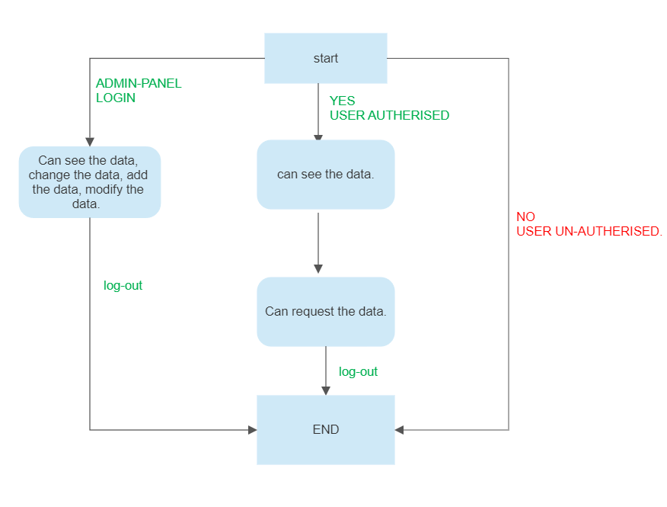

**Gannt Chart:**

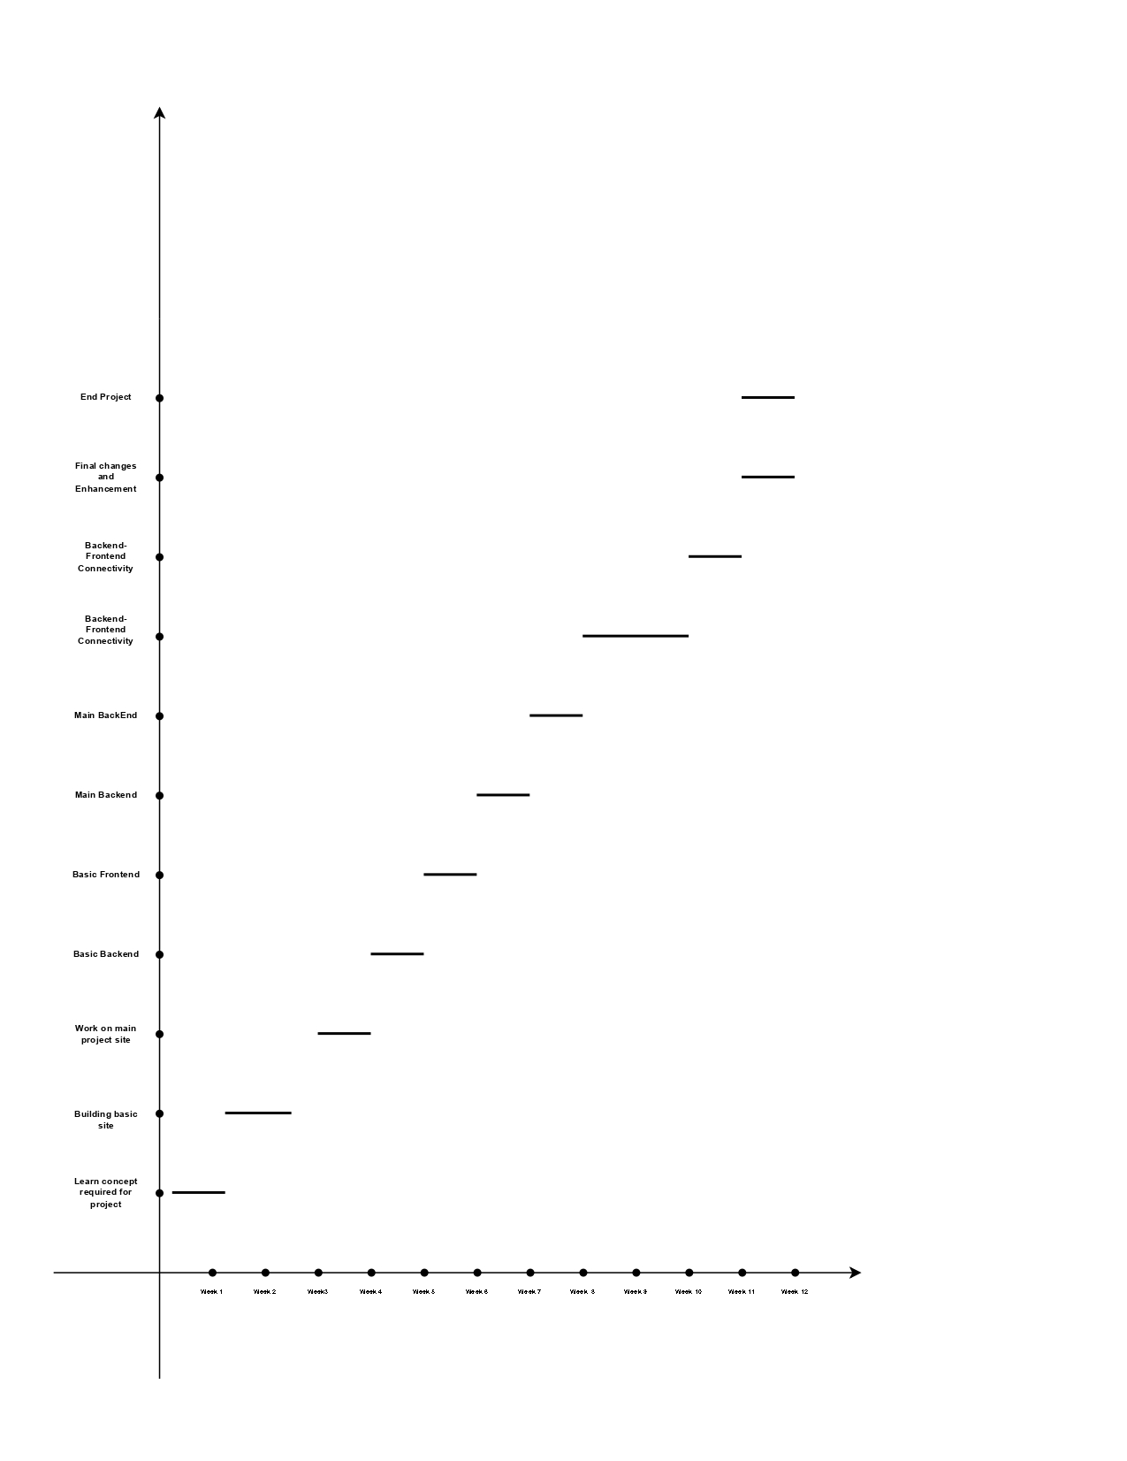

**Conclusion:**