VAN Network Issue Prediction Using Machine Learning
Technical Prototype Document
Goal: Predict possible VAN/network issues from current network and vehicle conditions, then show risk level in a dashboard.

1. Executive Summary
This prototype predicts network issues from vehicle and network-health parameters. The problem is treated as binary classification: 0 = Normal and 1 = Network Issue. Logistic Regression and Random Forest were compared. Random Forest was selected. FastAPI exposes the prediction service and Streamlit provides the user interface.

2. Problem Definition
VAN conditions change quickly. High latency, packet loss, bandwidth utilization, interference, resource usage and vehicle density can reduce communication quality. The objective is to identify a possible issue early from network telemetry.

3. Dataset
- 10,000 records and 20 columns
- 7,200 Normal and 2,800 Network Issue records
- Target: Network_Issue — 0 = Normal, 1 = Network Issue
- Synthetic dataset created for the prototype; real labelled telemetry is required for production.

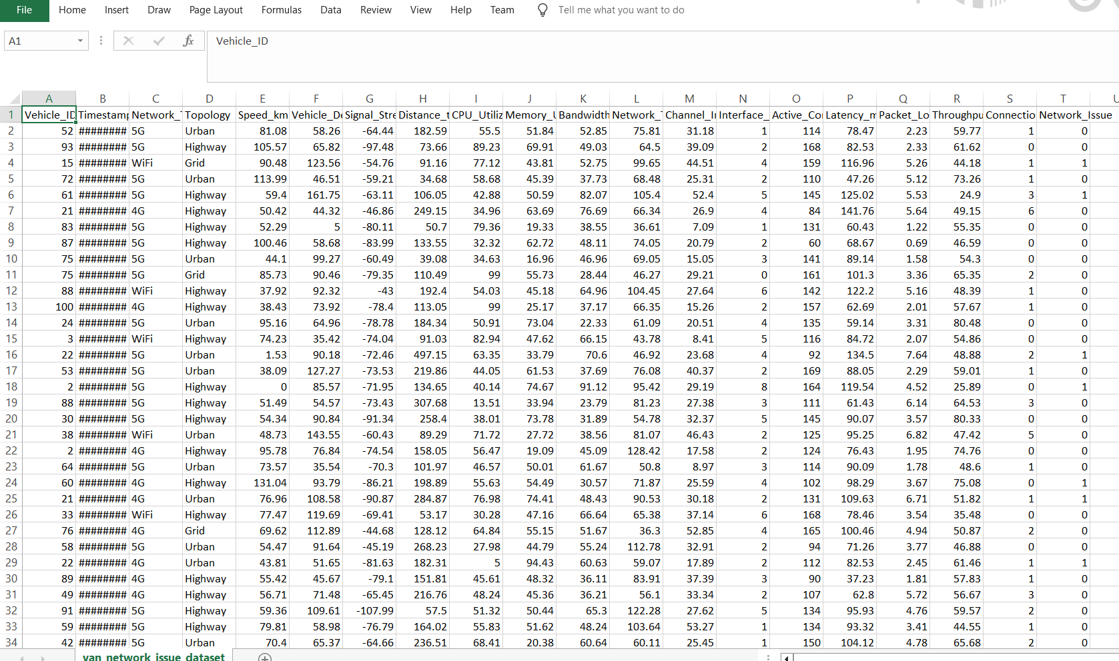

4. Main Features
Feature | Purpose
CPU Utilization | System resource load
Memory Utilization | Memory pressure
Latency | Communication delay
Packet Loss | Lost packets
Bandwidth Utilization | Network saturation
Throughput | Data transfer performance
Interface Errors | Link/interface problems
Signal Strength | Wireless quality
Channel Interference | Wireless interference
Vehicle Density | Traffic/network load
Active Connections | Connection load
Connection Drops | Connectivity instability

5. Solution Architecture
VAN / Network Data
↓
Preprocessing
↓
ML Model
↓
FastAPI /predict
↓
Streamlit Dashboard
↓
Prediction + Probability + Risk Level

The trained model is stored using Joblib. FastAPI calls the prediction layer. Streamlit sends metrics to the API and displays the result.

6. ML Workflow
Load Data → Check Data → Preprocess → Train/Test Split → Train Models → Evaluate → Select Model → Save Model

- Missing numerical values: median imputation
- Missing categorical values: most-frequent imputation
- Categorical values: One-Hot Encoding
- Numerical values: StandardScaler
- Train/Test split: 80/20
- Models: Logistic Regression and Random Forest

7. Model Evaluation
Accuracy, precision, recall, F1 score and ROC-AUC are used. F1 is useful because both false positives and false negatives matter.
Model | Accuracy | Precision | Recall | F1 | ROC-AUC
Logistic Regression | 79.3% | 60.0% | 78.0% | 67.9% | 87.8%
Random Forest | 82.6% | 69.7% | 66.6% | 68.1% | 88.6%
Random Forest was selected because it gave the best overall recorded performance and the highest ROC-AUC. A 0.45 decision threshold was tested for issue detection.

8. Prediction Output
{
"prediction": 1,
"status": "NETWORK ISSUE",
"probability": 0.9778,
"risk_percentage": 97.78,
"risk_level": "HIGH",
"threshold": 0.45
}

Risk level: LOW below 40%, MEDIUM from 40–70%, HIGH above 70%.

9. API Design
Method | Endpoint | Purpose
GET | / | Service information
GET | /health | Health check
POST | /predict | Network issue prediction

10. Event-Driven Workflow
Telemetry Event → Validate → Predict → Calculate Risk → High Risk? → Alert / Dashboard Update

In production, telemetry can come continuously from vehicles, RSUs or network monitoring systems. High-risk predictions can trigger an operator alert.

11. Security & Monitoring
- Pydantic validation checks API input values.
- Production API should use authentication, authorization and HTTPS along with JWT or OAuth.
- Log API errors, response time and prediction activity.
- Monitor data drift and model performance.
- Flash message or notification for High Risk alerts.
- Protect model and telemetry data using access control.

12. Streamlit Dashboard
Network Information | Vehicle/Mobility | System Resources | Network Performance | Prediction Result

The dashboard lets an operator enter network metrics and receive a prediction without manually calling the API.

13. Key Code Snippets

Preprocessing
numeric_pipeline = Pipeline([
("imputer", SimpleImputer(strategy="median")),
("scaler", StandardScaler())
])
categorical_pipeline = Pipeline([
("imputer", SimpleImputer(strategy="most_frequent")),
("onehot", OneHotEncoder(handle_unknown="ignore"))
])

Random Forest
random_forest_model = Pipeline([
("preprocessor", rf_preprocessor),
("model", RandomForestClassifier(
n_estimators=250,
max_depth=12,
class_weight="balanced",
random_state=42
))
])
random_forest_model.fit(X_train, y_train)

FastAPI
@app.post("/predict")
def predict_network(data: NetworkData):
input_data = data.model_dump()
result = predict_network_issue(input_data)
return result

14. Project Structure
VAN-Network-Issue-Prediction/
├── api/
│ └── main.py
├── dashboard/
│ └── app.py
├── data/
│ └── van_network_issue_dataset.csv
├── model/
│ ├── van_network_issue_model.joblib
│ └── model_metadata.joblib
├── src/
│ ├── preprocessing.py
│ ├── train_model.py
│ └── prediction.py
├── venv/
└── requirements.txt

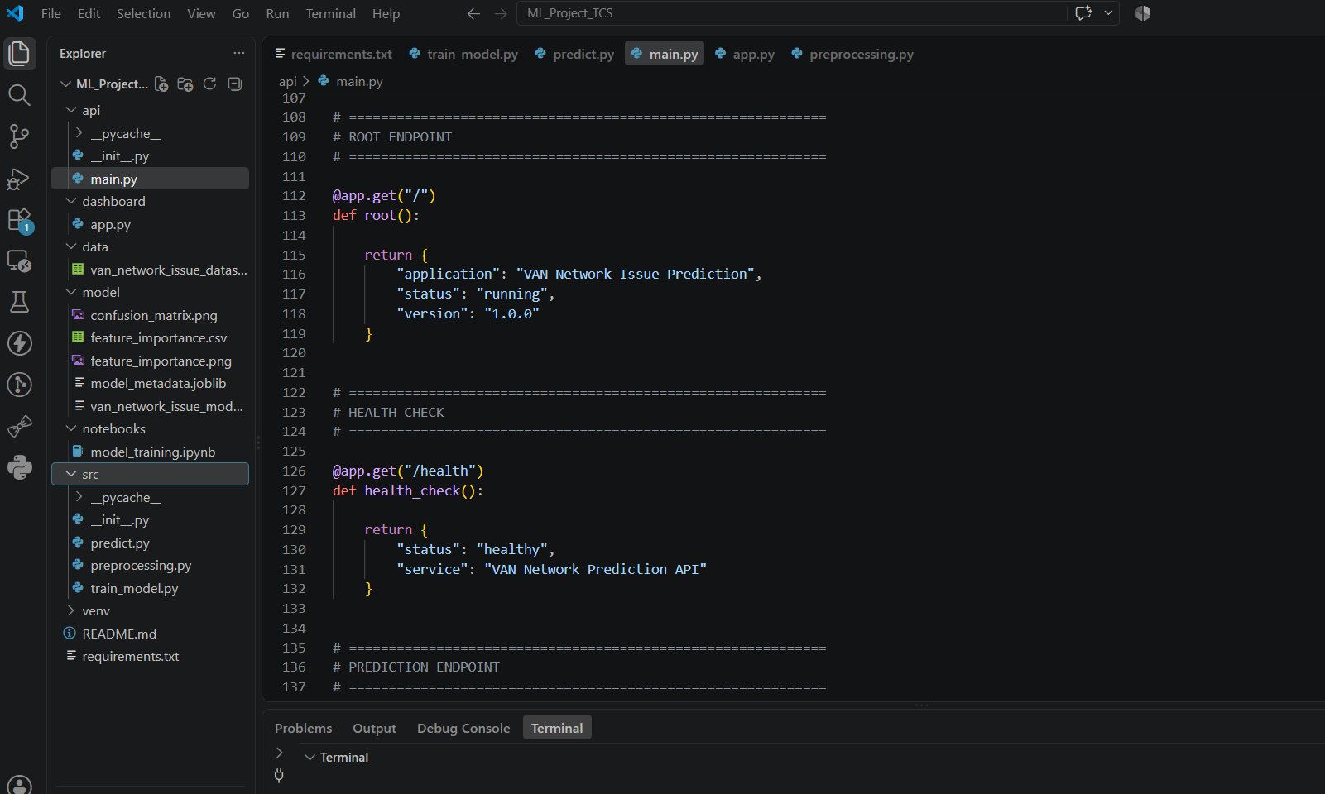

15. Demo Result
Example Test
Prediction: NETWORK ISSUE
Probability: 94.76%
Risk Level: HIGH

The high-risk test used high latency, packet loss, bandwidth utilization, interference, CPU/memory utilization and vehicle density.
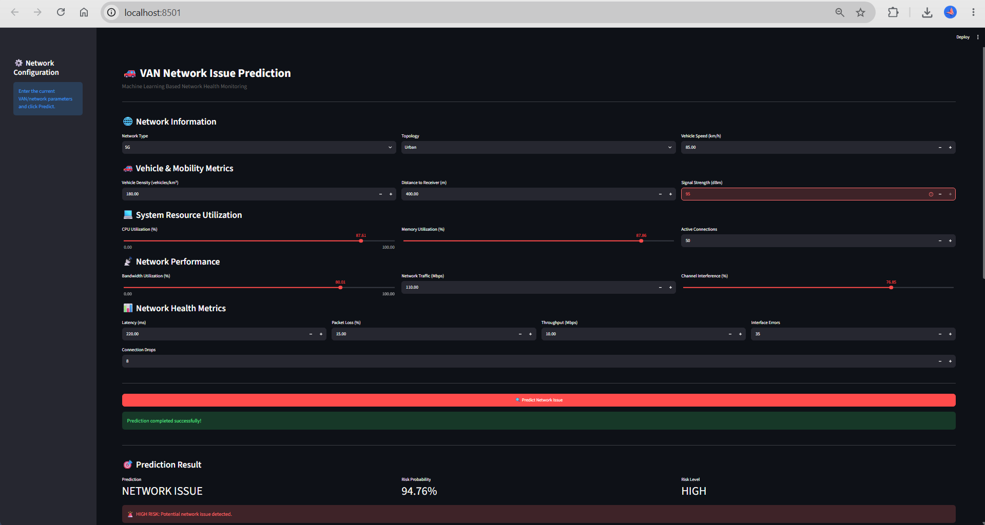
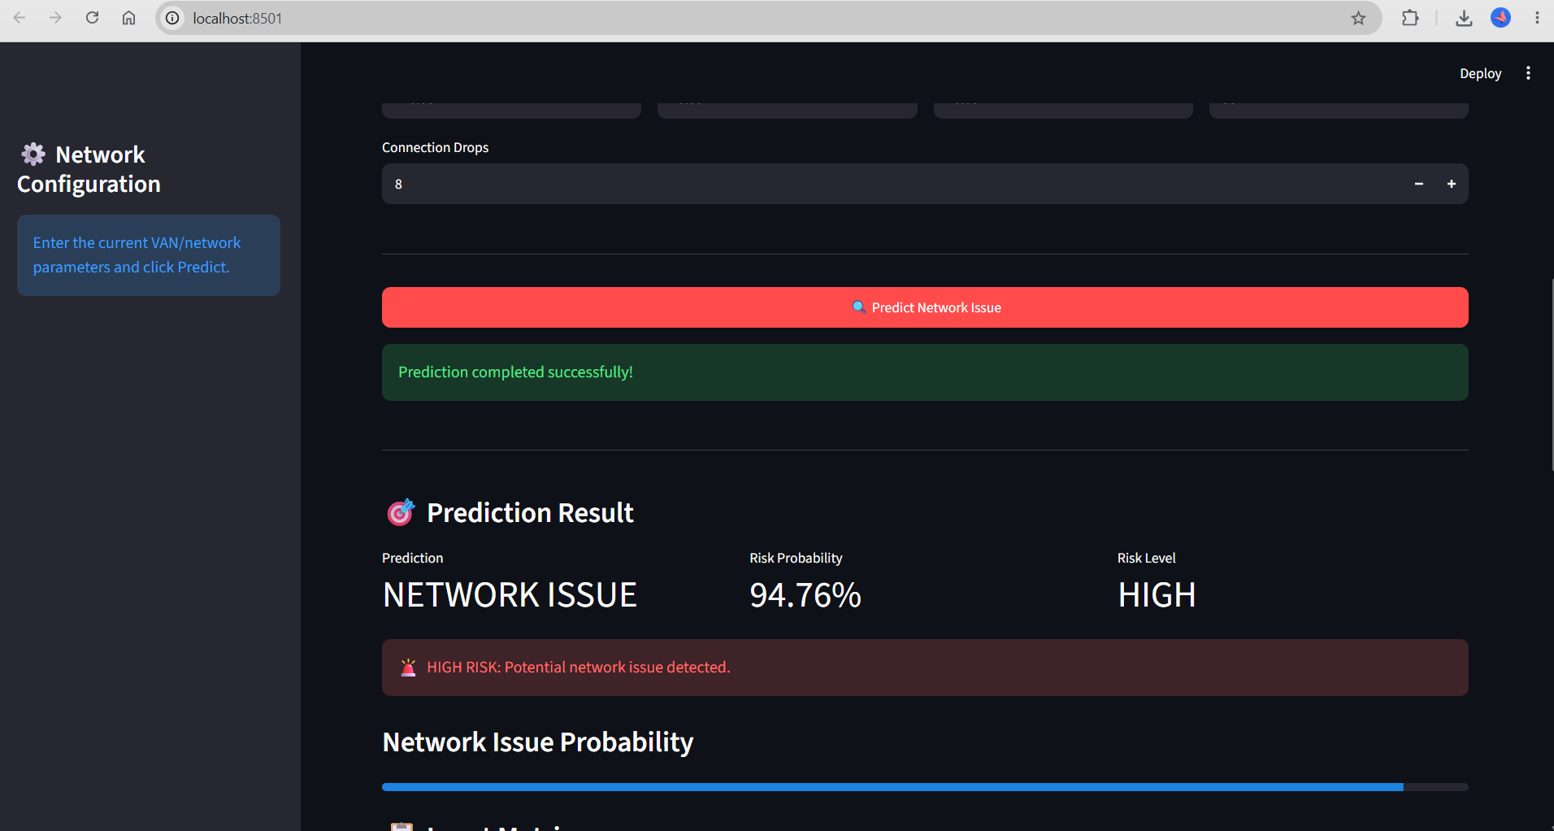

16. Limitations
- Synthetic data is used in the current prototype.
- Real-world validation is required.
- Real-time telemetry integration is not included.
- False positives and false negatives must be measured using real incident labels.

17. Future Enhancements
- Integrate real VAN/5G telemetry.
- Add real-time streaming using Kafka or MQTT.
- Add alerting and incident-management integration.
- Add model monitoring and automatic retraining.
- Deploy the API/dashboard using containers or cloud infrastructure.
- Add authentication and role-based access.

18. Technology Selection
Technology | Reason
Python | Fast development and ML ecosystem
Pandas / NumPy | Data processing
Scikit-learn | ML and evaluation
Random Forest | Strong tabular baseline and feature importance
FastAPI | Lightweight REST API and automatic docs
Pydantic | Input validation
Streamlit | Interactive ML dashboard
Joblib | Model persistence

19. Conclusion
The prototype demonstrates an end-to-end VAN network issue prediction solution:
telemetry features → preprocessing → machine learning → REST API → dashboard.
The next production step is validation with real labelled network telemetry. And then it can be deployed on AWS.

Additional Images:

- Swagger UI
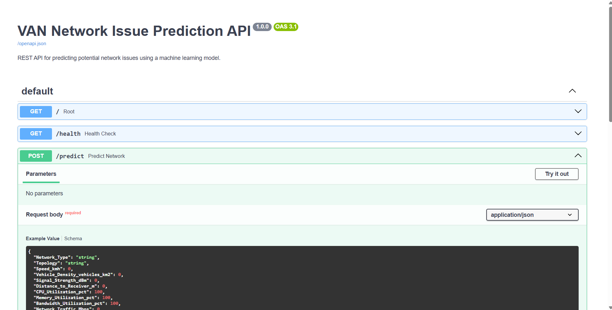
- Streamlit UI
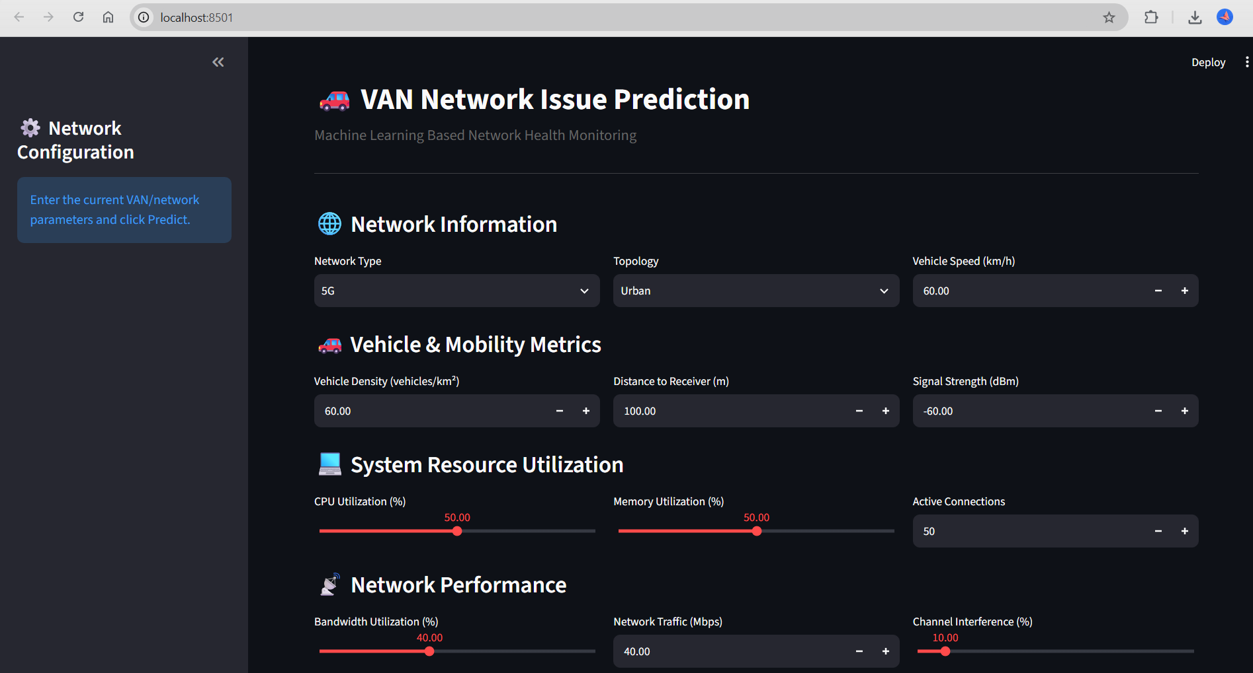
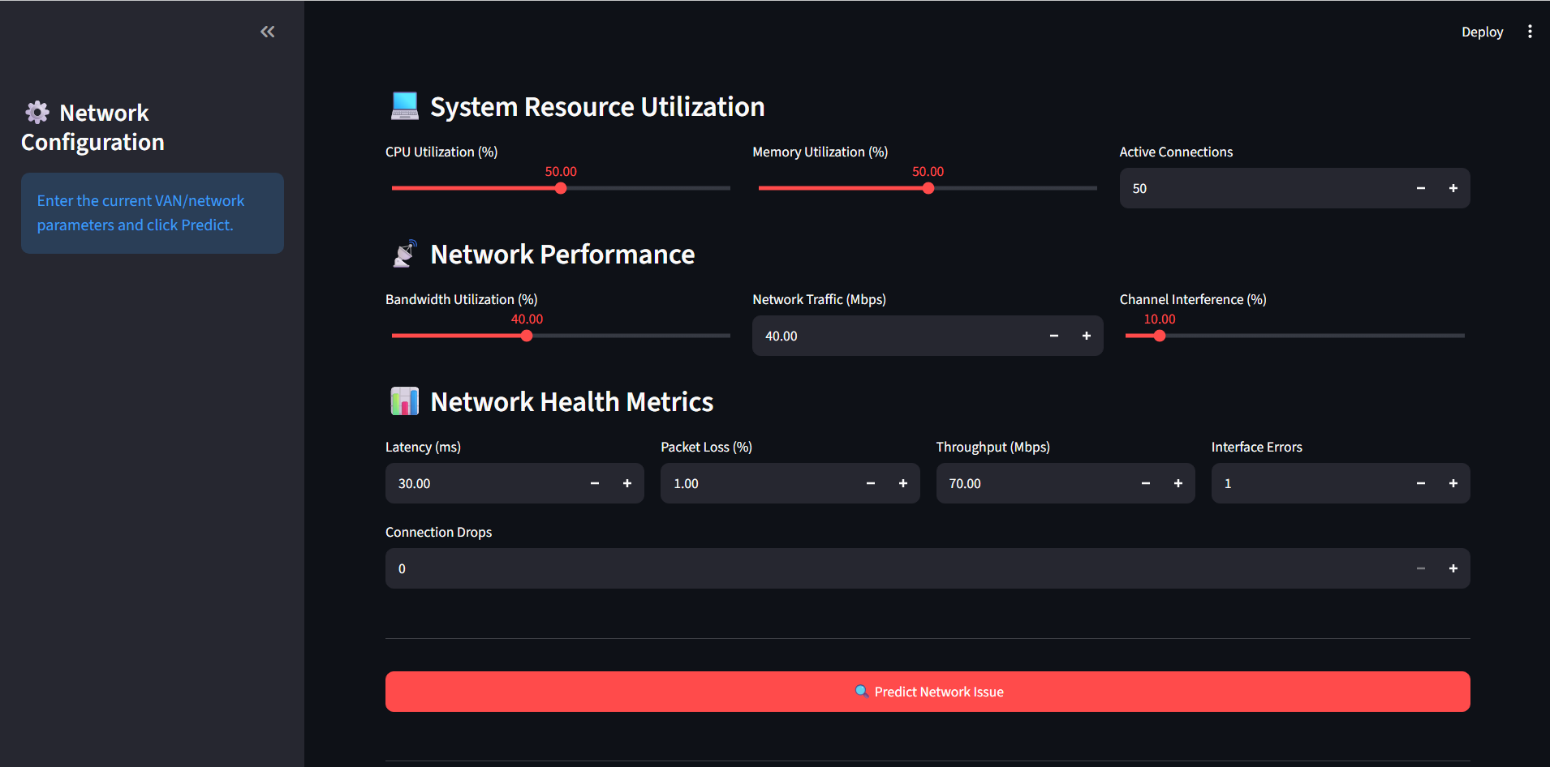
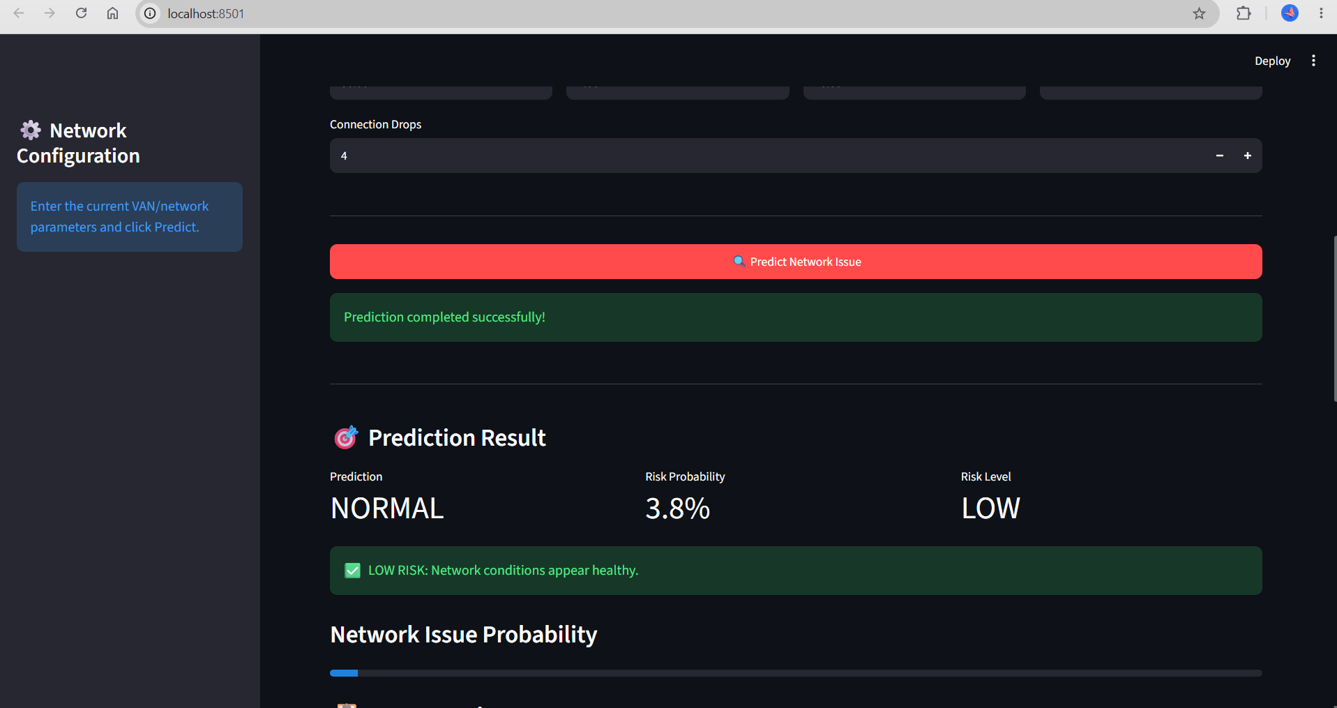
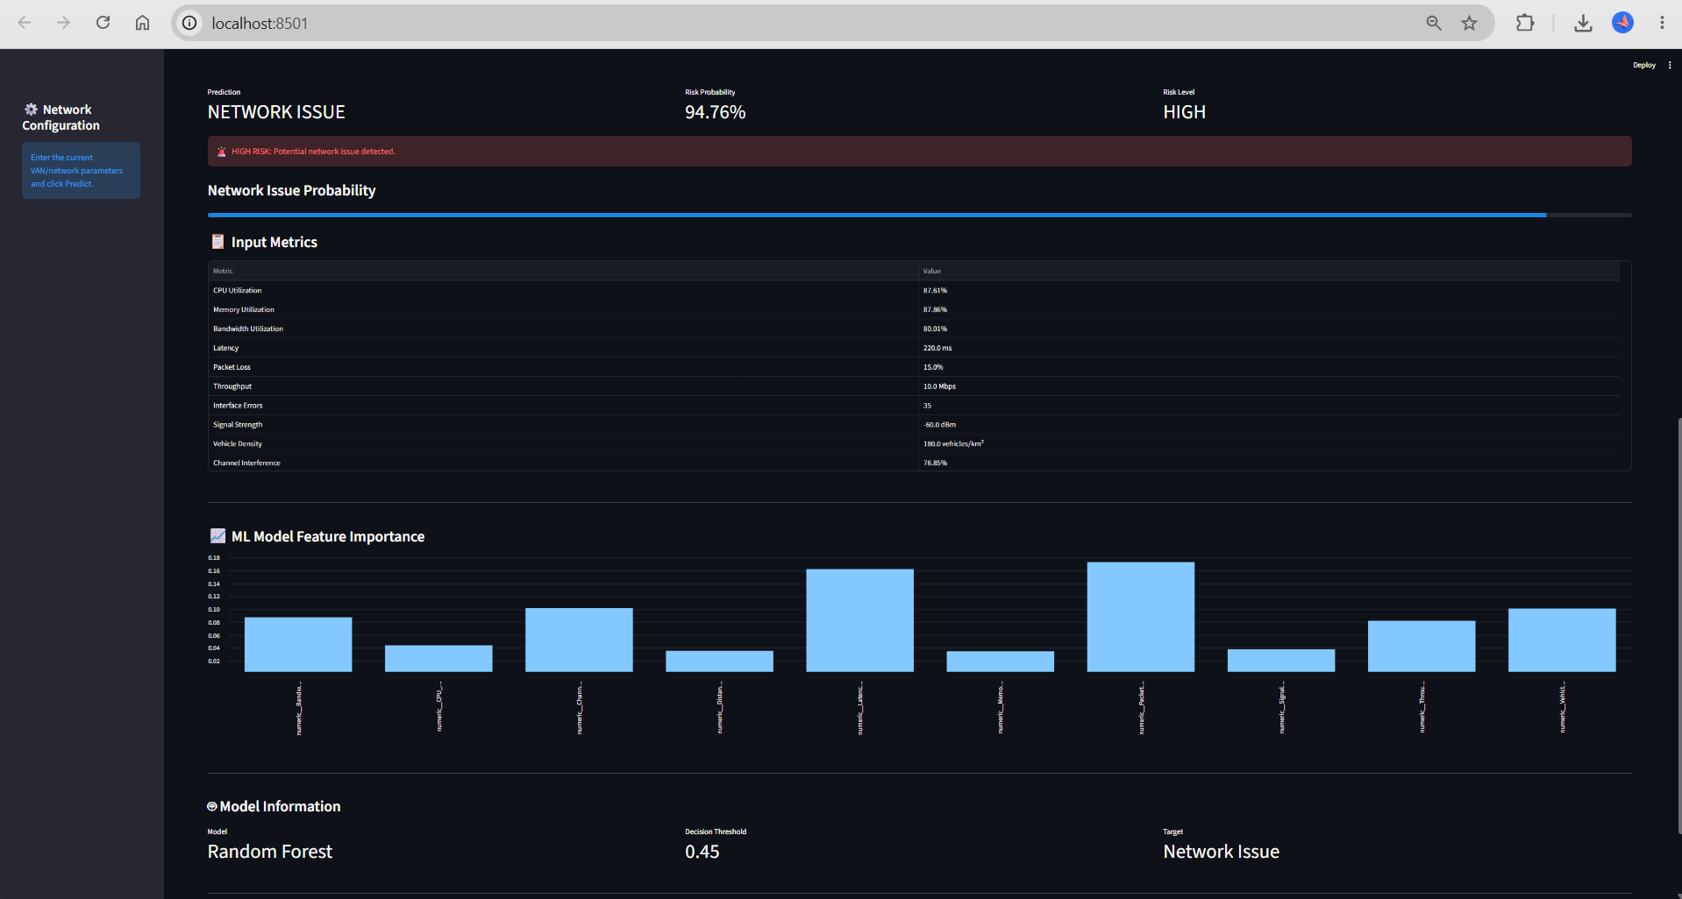

End Points Status
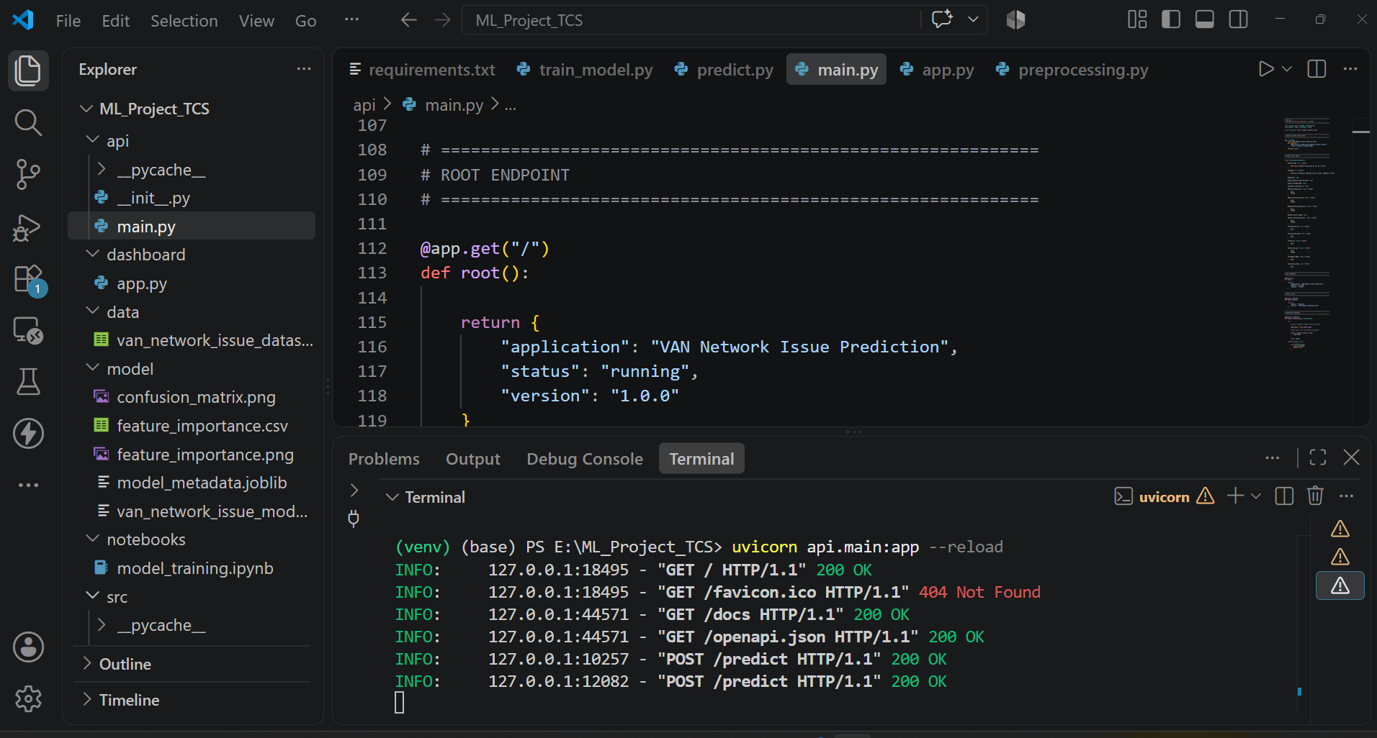

StreamLit UI run
