Ship
From Wikipedia, the free encyclopedia
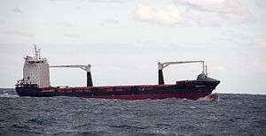
A ship is a large watercraft that travels the world's oceans and other sufficiently deep waterways, carrying goods or passengers, or in support of specialized missions, such as defense, research, and fishing. Ships are generally distinguished from boats, based on size, shape, load capacity, and purpose. In the Age of Sail a "ship" was a sailing vessel defined by its sail plan of at least three square rigged masts and a full bowsprit.

Ships have supported exploration, trade, warfare, migration, colonization, imperialism, and science. After the 15th century, new crops that had come from and to the Americas via the European seafarers significantly contributed to the world population growth. Ship transport is responsible for the largest portion of world commerce.

As of 2016, there were more than 49,000 merchant ships, totaling almost 1.8 billion dead weight tons. Of these 28% were oil tankers, 43% were bulk carriers, and 13% were container ships.

