Van
From Wikipedia, the free encyclopedia
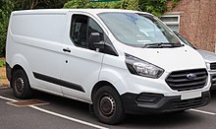
A Ford Transit Custom low roof van
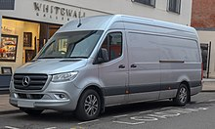
Mercedes-Benz Sprinter high roof van
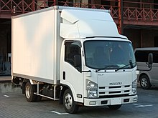
A box van (also referred to as a box truck)
A van is a type of road vehicle used for transporting goods or people. Depending on the type of van, it can be bigger or smaller than a truck and SUV, and bigger than a common car. There is some varying in the scope of the word across the different English-speaking countries. The smallest vans, microvans, are used for transporting either goods or people in tiny quantities. Mini MPVs, compact MPVs, and MPVs are all small vans usually used for transporting people in small quantities. Larger vans with passenger seats are used for institutional purposes, such as transporting students. Larger vans with only front seats are often used for business purposes, to carry goods and equipment. Specially-equipped vans are used by television stations as mobile studios. Postal services and courier companies use large step vans to deliver packages.

