Jet aircraft
From Wikipedia, the free encyclopedia
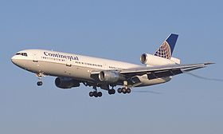
McDonnell Douglas DC-10 of Continental Airlines is an example of a Trijet configuration
A jet aircraft (or simply jet) is an aircraft (nearly always a fixed-wing aircraft) propelled by jet engines.

Whereas the engines in propeller-powered aircraft generally achieve their maximum efficiency at much lower speeds and altitudes, jet engines achieve maximum efficiency at speeds close to or even well above the speed of sound. Jet aircraft generally cruise most efficiently at about Mach 0.8 (981 km/h (610 mph)) and at altitudes around 10,000–15,000 m (33,000–49,000 ft) or more.

The idea of the jet engine was not new, but the technical problems involved could not begin to be solved until the 1930s. Frank Whittle, an English inventor and RAF officer, began development of a viable jet engine in 1928,[1] and Hans von Ohain in Germany began work independently in the early 1930s. In August 1939 the turbojet powered Heinkel He 178, the world's first jet aircraft, made its first flight. A wide range of different types jet aircraft exist, both for civilian and military purposes.

