**ARCHITECTURE FOR PAINT APPLICATION**

1. **FLOWCHART**

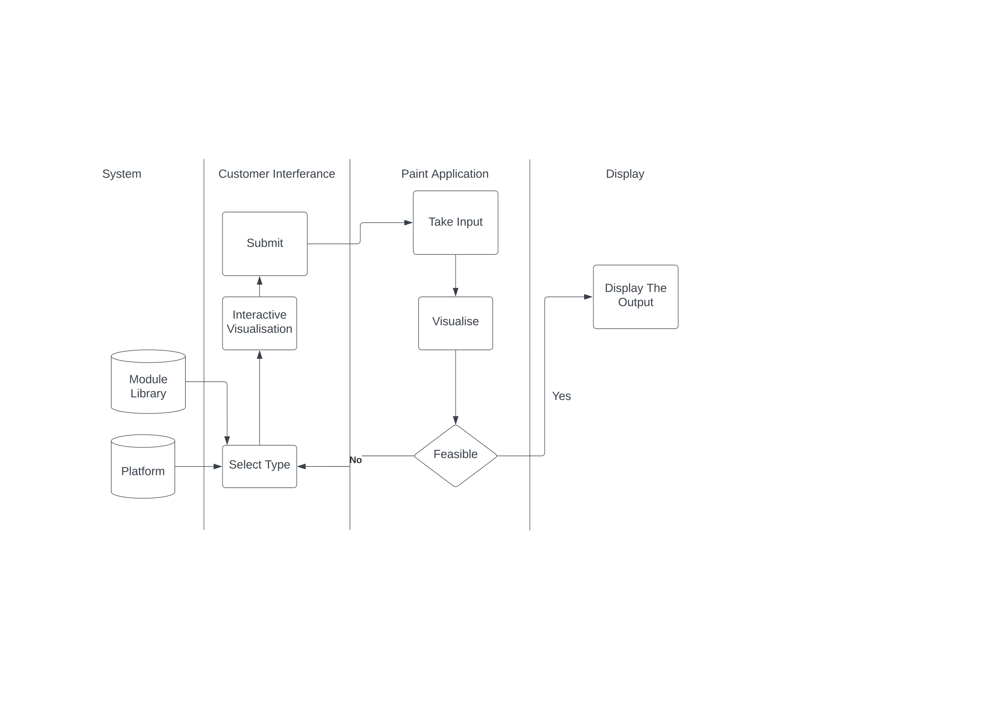

The system has the module libraries and the platform, for now it is a Desktop application. When we select the module libraries begin to work in the background, and whenever the user selects any component like the paint brush and shape, it begins to start the interactive visualization, after submitting the choice, the choice will start to take input and it will begin to visualize the shape or line. If the design made is feasible it will display the output, and if not, it will again ask for the type and the process will be iterative.

1. **CLASS DIAGRAM**

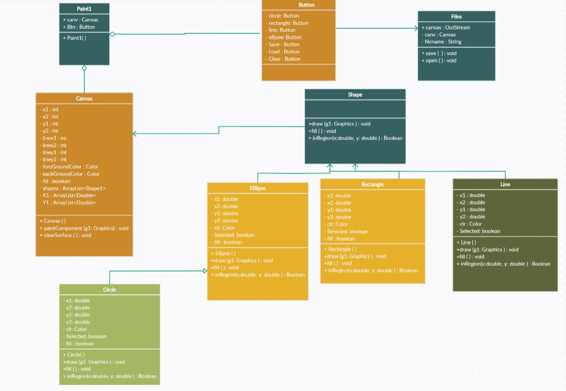

We have one class Paint1, which has the buttons and canvas. The buttons have buttons like circle, rectangle, line, ellipse, save, and clear button. The buttons class is associated with another class file which is for storing, and opening of the files we store. The canvas class is associated with shape class which contains three main classes for now, which are rectangle, line, and ellipse, which is further associated with circle class. All the classes have functions as shown in the image above.