1. Create a keypair,   
     
   using AWS CLI,   
   aws ec2 create-key-pair –key-name ‘Seclore-test-30-01-2020’ –query ‘KeyMaterial’ –output text > Seclore-test-30-01-2020.pem
2. Create stack using the seclore-test-infra.yaml cloudformation template,   
     
   using AWS CLI,

aws cloudformation create-stack –stack-name seclore-test-infra –template-body file:///$(pwd)/seclore-test-infra.yaml

once complete – following will be the output:

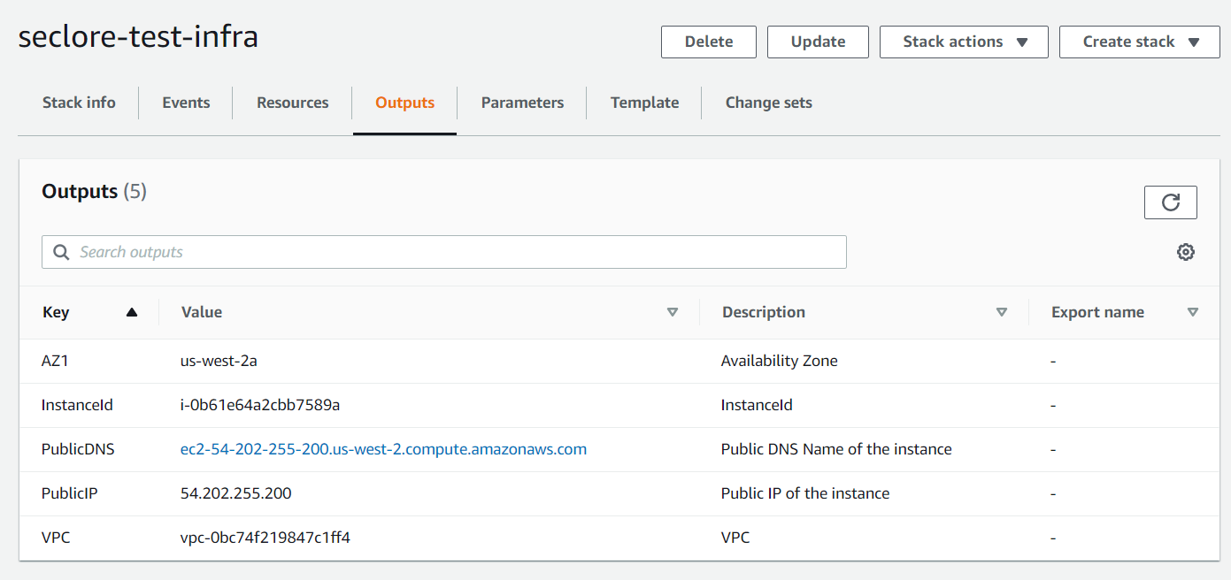

1. Connect using the private key created earlier:

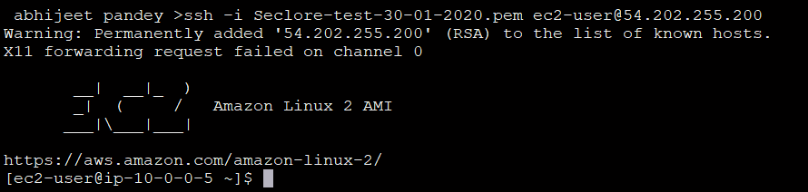

1. Open the url using publicIp in chrome or curl:

