**2.PROBLEM DEFINITION**

The main aim of designing and developing this banking System PYTHON primarily based Engineering project is to provide secure and efficient banking facilities to the banking customers .text documents are use to store the account details of customers.Tkinter library of python used to develop this bank web application where banking customers can login through the secured web page by their account login id and password. Users will have all options and features in that application like cashcreadit, debit, balance enquiry and create account of customers by simply adding login information.

**3.MOTIVATION**

Bank Account Management System keeps the day by day tally record as a

complete banking system. It can keep the information of Account type, account opening form, Deposit fund, Withdrawal, and Searching the transaction, Transaction reports, Individual account opening form, Group Account. The existing part of this project is; it displays Transaction reports, Statistical Summary of Account details.

**4.SOFTWARE REQUIREMENTS SPECIFICATION**

The objective of the project is to design and develop Secure Banking Application using Python.

Some customers avoidDigital banking as they perceive it as being too vulnerable to fraud. The security measures employed by most banks are never 100% safe, but in practice the number of fraud victims due to banking is very small. Indeed, conventional banking practices may be more prone to abuse by fraudsters than Digital banking. Credit card fraud, signature forgery and identity theft are far more widespread "offline" crimes than malicious hacking. Bank transactions are generally traceable and criminal penalties for bank fraud are high. Digital banking can be more insecure if users are careless, gullible or computer illiterate. An increasingly popular criminal practice to gain access to a user's finances is phishing, whereby the user is in some way persuaded to hand over their password(s) to the fraudster.

**4.1 INTRODUCTION**

The “Banking System” project is a model Internet Banking Site. This site enables the customers to perform the basic banking transactions by sitting at their office or at homes through PC or laptop. The system provides the access to the customer to create an account, deposit/withdraw the cash from his account, also to view reports of all accounts present. The customers can access the banks website for viewing their Account details and perform the transactions on account as per their requirements. With Internet Banking, the brick and mortar structure of the traditional banking gets converted into a click and portal model, thereby giving a concept of virtual banking a real shape. Thus today's banking is no longer confined to branches. E-banking facilitates banking transactions by customers round the clock globally.

The primary aim of this “Online Banking System” is to provide an improved design methodology, which envisages the future expansion, and modification, which is necessary for a core sector like banking. This necessitates the design to be expandable and modifiable and so a modular approach is used in developing the application software. To create an account in bank he has to fill a form with his personal details and Account Number.

Bank is the place where customers feel the sense of safety for their property. In the bank, customers deposit and withdraw their money. Transaction of money also is a part where customer takes shelter of the bank. Now to keep the belief and trust of customers, there is the positive need for management of the bank, which can handle all this with comfort and ease. Smooth and efficient management affects the satisfaction of the customers and staff members, indirectly.

Now a day’s, managing a bank is tedious job up to certain limit. So software that reduces the work is essential. Also today’s world is a genuine computer world and is getting faster and faster day-by-day. Thus, considering above necessities, the software for bank management has became necessary which would be useful in managing the bank more efficiently. All transactions are carried out online by transferring from accounts in the same Bank or international bank. The software is meant to overcome the drawbacks of the manual system

.

**4.1.1 MAIN PURPOSE :**

* The Traditional way of maintaining details of a user in a bank was to enter the details and record them. Every time the user needs to perform some transactions he has to go to bank and perform the necessary actions, which may not be so feasible all the time. It may be a hardhitting task for the users and the bankers too. The project gives real life understanding of Banking System and activities performed by various roles in the supply chain. Here, we provide automation for banking system through Internet. Banking System project captures activities performed by different roles in real life banking which provides enhanced techniques for maintaining the required information up-to-date, which results in efficiency. The project gives real life understanding of Banking System and activities performed by various roles in the supply chain.

**4.1.2 FEATURES:**

* User registration for online banking if not register.
* Adding Beneficiary account by customer.
* Transferring amount to the local customer account number.
* Admin must approve the user account activation before it can be used and transferring funds, view statement history.
* Customer gets to know his last login date and time each time he logs in.
* Customer can check all transactions made with their account.
* Customer can check their account statement within a date range.
* Admin can add/edit/delete customer account’s.
* All two of them (customer & admin) can change their password.
* Admin Login pages are hidden from customer for security purpose.
* Passwords are stored as encrypted hashes with an additional random salt for added security.

**4.1.3 GOALS AND OBJECTIVES**

**1. Main Goals:**

* Our motto is to develop a software program for managing the entire bank process related to Administration accounts customer accounts and to keep each every track about their property and their various transaction processes efficiently.
* Hereby, our main objective is the customer’s satisfaction considering today’s faster in the world.

**2. Customer Satisfaction:**

* Client can do his operations comfortably without any risk or losing of his privacy.
* Our software will perform and fulfill all the tasks that any customer would desire.

**3. Saving Customer Time:**

* Client doesn't need to go to the bank to do small operation.

**4. Protecting The Customer:**

* It helps the customer to be satisfied and comfortable in his choices, this protection contains customer’s account, money and his privacy.

**5. Transferring Money:**

* Help client transferring money to/or another bank or country.

**4.1.4.Modules Description:**

The Modules description of Bank Account Management System project. These modules will be developed in Python source code and Tkinter library of python.

* Name
* Account No
* pin

**Bank Account**

AA

**Account**

**Account Holder**

**BANK ACCOUNT**

* Credit
* Debit
* Check Balance
* Transection History
* logout

Fig.4.1 Bank Account System

* **Create New Account:** A customer who having the account in the world can create a virtual account through this module. This module receives the customer profile details and the bank account details with the proof of the ownership of the bank account.
* **Login**: Virtual account holders can login in to the system using this module. Thus this is the secured login page for the customers in the web application.
* **Bank Accounts:** A customer may have more than one bank account in various banks, in this case, the customer prompted to decide which bank account should reflect in the account debit or amount credit. For these operations customers can add their owned bank accounts here and it will be approved by the administrations of the system.
* **Transactions:** This module displays the transactions made by the customer in the particular date with the transaction details.
* **Administrative Control:** This module contains the administrative functions such as view all account details, transactions etc.

There are other features and actions that can be performed on a back account but we are not going to look at bank accounts in their entirety only the basics, this way we avoid over complicating the exercise. The purpose of this whole exercise is to show the usefulness of python opposed to really wanting to create a banking system.

**4.2 PROJECT SCOPE:**

* Invalid credintials cannot be granted by authorities.
* 2.account number cannot be updated though the account can be deleted by admin.
* 3.fund cannot be transfferred from two different bank accounts.
* 4.pin set once cannot be reset or recovered as there is no otp verification system implemented.

**4.3 FUNCTIONAL REQUIREMENTS**

* **Inputs:** The major inputs for “Anti Phishing The Fraud Detection in Banking” can be categorized module -wise. Basically all the information is managed by the software and in order to access the information one has to produce one's identity by entering the user-id and password. Every user has their own domain of access beyond which the access is dynamically refrained rather denied.
* **Output:** The major outputs of the system are account details and transaction history. Accounts are created dynamically to meet the requirements on demand. Reports, as it is obvious, carry the list of the whole information that flows across the institution.

This application must be able to produce output at different modules for different inputs.

**4.3.1 Performance requirements:**

Performance is measured in terms of account generated weekly and monthly.

**4.3.2SYSTEM REQUIREMENTS :**

* **Hardware requirements**

|  |  |  |
| --- | --- | --- |
| **Processor** | : | Intel Pentium III or later |
| **Main Memory(RAM)** | : | 256 MB |
| **Cache Memory** | : | 512 KB |
| **Monitor** | : | 14 inch Color Monitor |
| **Keyboard** | : | 108 Keys |
| **Mouse** | : | Optical Mouse |
| **Hard Disk** | : | 160 GB |

.

* **Software Requirements**

**Operating system** : windows xp or later

# Front end software : Python 3.7 or above

**4.5 NON FUNCTIONAL REQUIREMENTS:**

* Users must change the initially assigned login password immediately after the first successful login. Moreover, the initial should never be reused.
* Employees never allowed to update their account information. Such attempt should be reported to the security administrator.
* Every unsuccessful attempt by a user to access an account data shall be recorded to the system.
* A system should be capable enough to handle multiple users with affecting its performance.
* The software should be portable. So moving from one OS to other OS does not create any problem.
* Privacy of information, the export of restricted technologies, intellectual property rights, etc. Should be audited.

**5.OTHER SPECIFICATIONS**

**5.1 ADVANTAGES :**

## 24/7 Account and Service Access:

Digital Banks are accessible 24/7, giving you 24/7 phone access to a real-life customer service agent. This can be extremely helpful if you have any kind of problem, or if you feel you need the assistance of a human brain, rather than a computer algorithm.

## Speed and Efficiency:

### If you need to perform nearly any banking transaction, you’ll typically have to wait in line at a banking location. With a bank, there’s never any waiting. As long as you can log in, you can access your accounts,perform nearly any banking transaction you desire without driving down.

### View Your Transactions:

Banking system allows you to access your account history and transactions from anywhere. This is the quickest way to check and see if a transaction has cleared your account. You can also find out the amount of a transaction after you have lost your receipt. It also allows you to find out about unauthorized transactions more quickly, helping you resolve any issues right away.

**5.2 DISADVANTAGES**

## Credentials Issues:

If there’s aissue regarding users credentials you might not have any access to your account whatsoever. While some banks offer a phone number for customer service, it might be overwhelmed if access is down. With a real bank, you can always find someone to talk to in the branch.

## Security Issues

While many online banks are reputable and well-established, sometimes it can be hard to feel comfortable with a bank that doesn’t have a physical presence, particularly when large sums of money are involved. If a website suddenly folds up, what will happen to your money? There’s also the risk of identity theft or actual theft if someone gains unauthorized access to your account via a hacked or stolen password or log-in credentials.

## A Limited Scope of Services:

Although you can do quite a bit with an online bank account, such as make deposits, check balances and pay bills, there are limitations to the kinds of services you can access. You may be able to make an initial application for opening a new account, but in most cases you will need to visit a branch to sign forms and show identity documentation. Similarly, even though you can transfer money to a checking account or debit card in order to make purchases, if you need cash, you'll have to visit a branch office or a nearby ATM.

**5.3 APPLICATIONS:**

* Digital Banking System can be used by any Bank .
* It can be used in any commercial institute.
* It can be used as a transaction history recorder by Admin.

**6.RESULTS & DISCUSSION**

**6.1 SCREENSHOTS:**

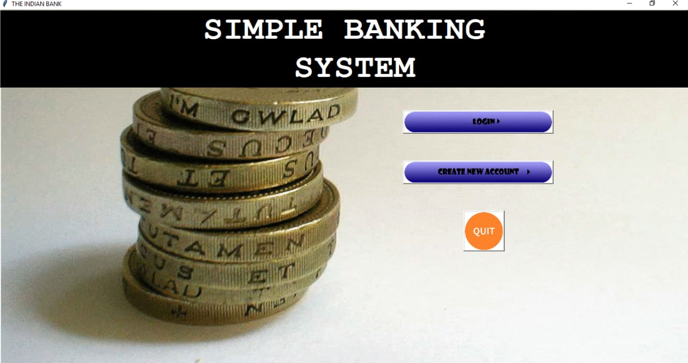

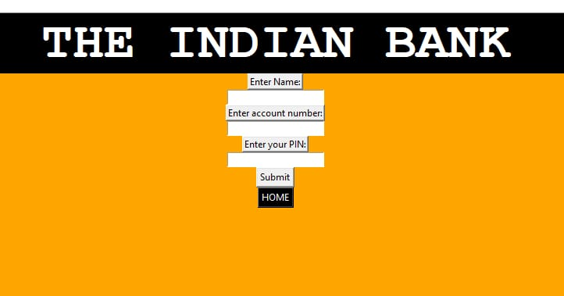

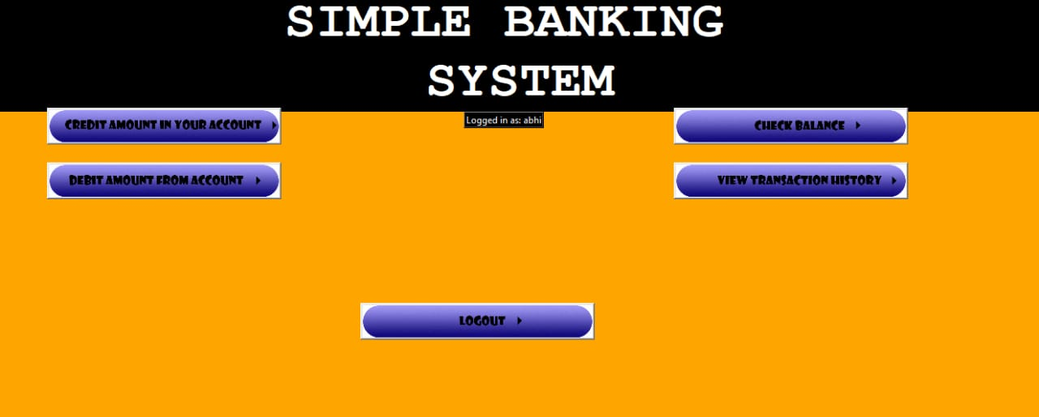



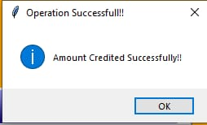

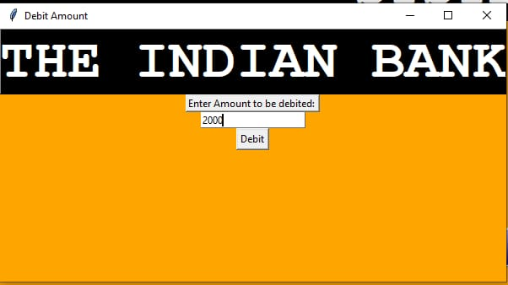







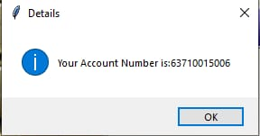

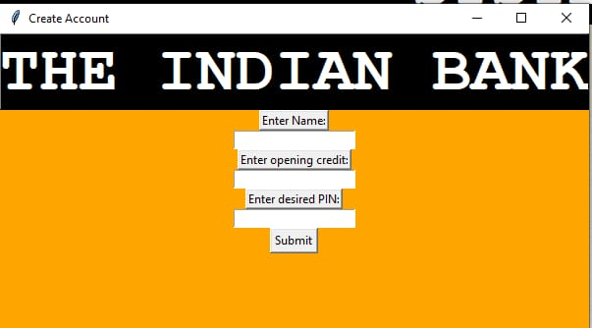

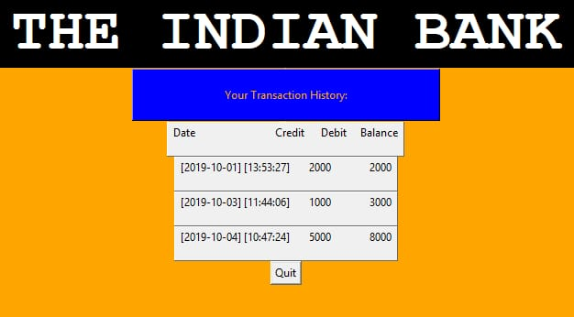

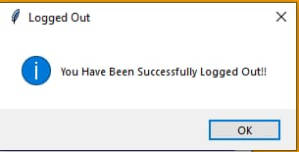

**6.2 CONCLUSION:**

This banking system project will serve as a useful approach to data base

Dialog box to deposit and withdraw the money for the person. It serves as a

Helpful approach for the users. It provides easy way of the deposit and

Withdraws the money. It reduces the time taken by the user to save the money.

Thus the project is the user friendly approach.