**Presented by :**

**Name** : Abhijit Biswas

**Class** : K19KP ; **Sec** : ‘A’

**Reg. No** : 11905339

**Roll No** : RK19KPA20

**Topic : UI/UX designing**

**2020-21**

**Summer Training**

**Synopsis**

**Introduction :**

**What is UI and UX and how are they different ?**

UI stands for User Interface and UX stand for User Experience. These two terms are totally different from each other.

1. UX is human’s first approach to product design while UI is human’s first approach to design the Experience of a product.
2. UX deals with the full experience of the user from the first touch to the last, while UI focuses on the visual touchpoints that allows user to interact with the product.
3. UX creates a structural design solution for the pain points that the user encounters anywhere along the journey with the product while UI creates a combination of typography, color palettes, buttons, animations etc.
4. UX results in the products that delight user with their effectiveness while UI results in a product that delight user aesthetically.

**What my project is all about and what have I learnt ?**

My project is a website UI that I have developed in these days of summer training. The website almost finishes most the pain point that I have gathered from my clients.

In making of this project, I learnt a lot of things,

1. Gathering the pain points from the clients
2. Designing the User Experience Model
3. Designing the paper Trail Model
4. Designing the low feudality model in MS Word
5. Gathering/Making all the Assets in Adobe Photoshop and Adobe Illustrator
6. Icons
7. Images
8. UI kits
9. Wireframes
10. Fonts
11. Creating the Final UI in Adobe XD

**Website Topic:**

It’s basically a day care website where parents can keep their children while they are at work without effecting the child’s nourishment and growth. In such a facility one will get all sort of comfort anything that is required in the growth and nourishment of the child.

**Basically, an Ideal design should have :**

1. A user-friendly design
2. A user centric design
3. Gives good experience to user.
4. Resolves the pain point of user.

**Target People :**

It is target towards those working parents who do a 9to5 job and are not able spend time and take care of their child, for those who could not rely on some maid they have hired.

**User Research**

**Taking interview of the client :**

UX professionals aim to create end-to-end customer experiences that serve the user goals as effectively as possible. To that end, we conduct user research to understand our users, their needs, and the hurdles they may encounter as they are trying to address those needs.  We usually refer to these hurdles as **pain points** — problems in the customer experience with a product or service.

**The phrase ‘customer experience’ is crucial in the definition of a pain point.**

**Finding and defining Pain Points :**

All pain points incur a cost to users — whether it is time and extra steps that they need to take or actual money that they lose.

For example, complicated workflows that are error-prone can result in increased interaction cost — the user will have to take additional steps to fix the error. Or the interface may be so complicated that the user may need to call for assistance (and thus experience an increase in interaction cost).

Other pain points will incur **a time cost** — for instance, if the user needs to wait for a long time for a process to complete.

Occasionally, there is also a **financial cost** to the user. For example, if an internet provider has frequent outages,  users may be forced to use their cell phones as hotspots and incur extra data costs.

**So, we divide pain points in different levels, they are :**

1. **Interaction-level pain point**: A user is passed from support person to support person.

### ****Journey-level pain point:****A user places an order and does not receive it for months.

### ****Relationship-level pain point:****A user pays for a service but still must watch ads.

### Set Ideation of the project :

### **Ideation**is the process of**generating a broad set of ideas on a given topic**, with no attempt to judge or evaluate them.

While the eventual goal of ideation is a high-quality design that solves a specified problem, the focus of ideation is **quantity instead of quality.** Ideation is only one step in the full UX design process; once ideas are generated, separate analysis has to follow to decide which ideas (or parts of ideas) to pursue. The more ideas the better: a broad pool to choose from increases the likelihood that one of the ideas will be the seed for a great design solution.

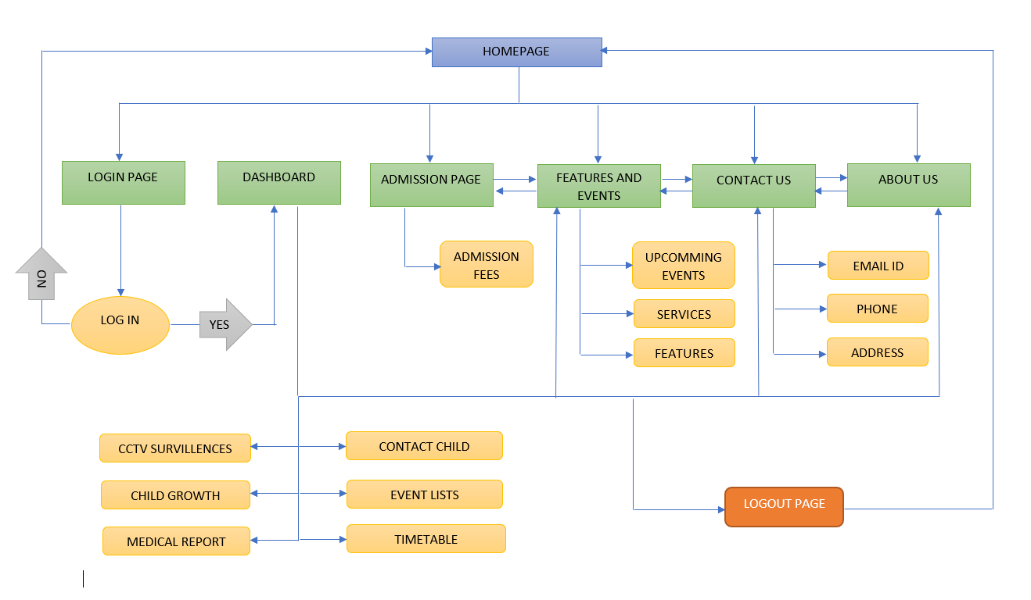

**Flow of Project**

**Wireframe Model**

**Screenshots**

