Basic Linux Commands Assignments

Name: Abhijit Barik Gmail: abro45172018@gmail.com

Assignment-1

Connect and disconnect with login Access

* What happens when you login a non-existent users or username?

Ans) If we try to login with non-existent users then we unable to login in centos

* Provide Screenshot and What you understand, explain in short brief?

Ans) A user has created a directory with files, but the user does not exist in /etc/passwd or /etc/group that is called non existent user

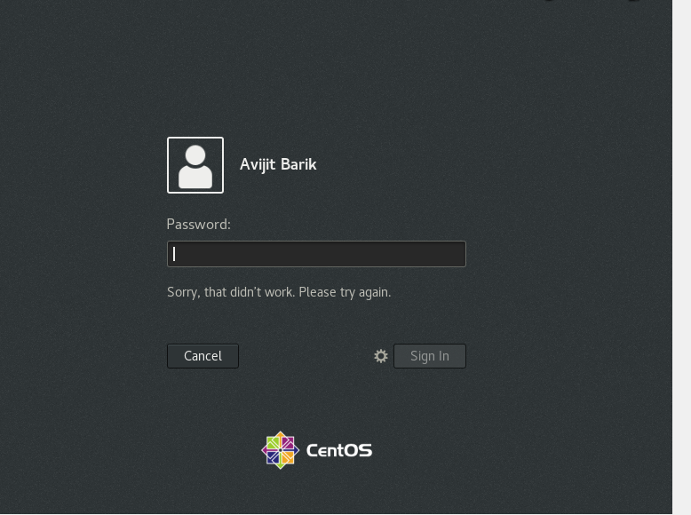

Assignment-2

Password changing

* Login into your account and then change password?

* Change your password into IneuR0n#42 and hit the Enter key

* Explain what happen and give screenshot?

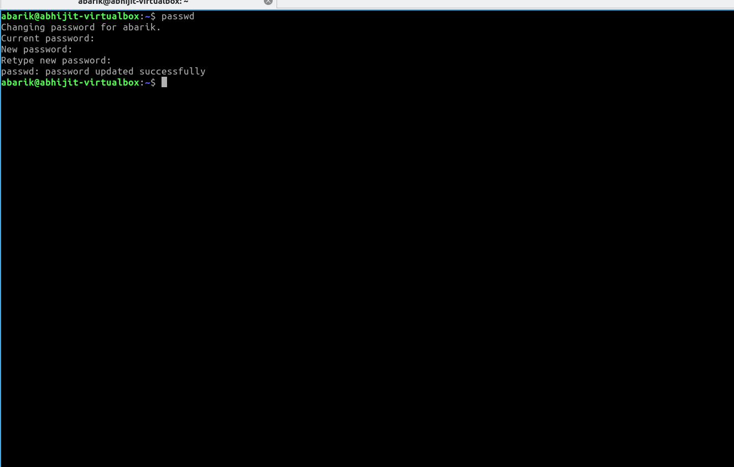

It will change password

* Try again to change password but use like password 1234 or abcd

* Explain what happen and give screenshot?

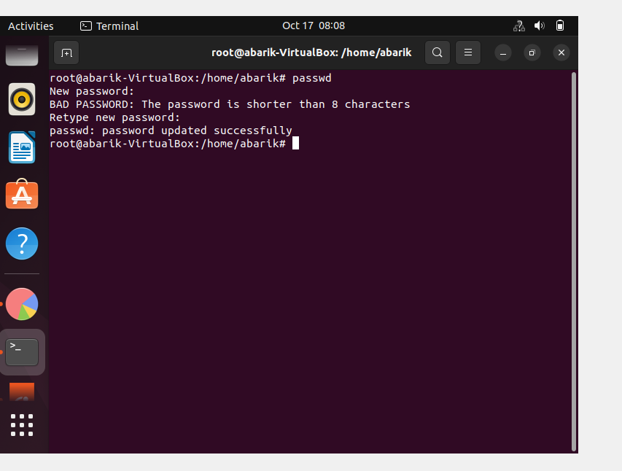

**It will show bad password notification and password update successfully**

* Try again to change password but now don’t use any password just hit Enter key

* Explain what happen and give screenshot?

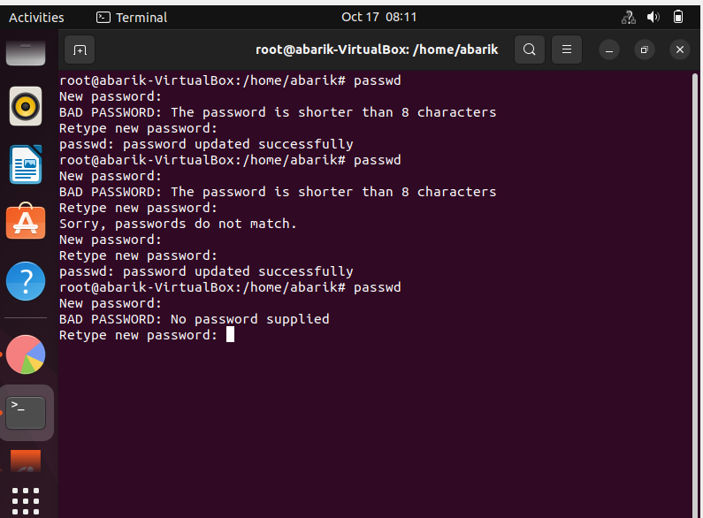

**It will show bad password and authentication failed.**

Assignment-3

Working with Directories

* Enter the command **cd /** and then **ls** and then hit **Enter** key
  + Take screenshot and explain what output we got?

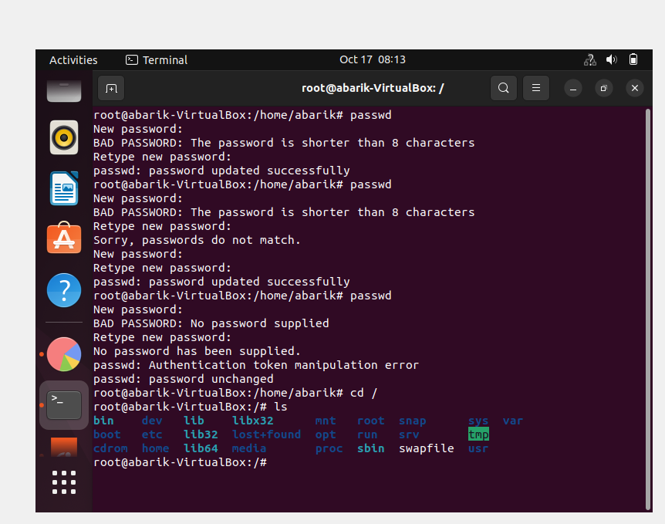

**It will move user in root directory**

* Enter the command now **cd /home** and then hit **Enter** key
  + Do **ls,** provide screenshot and explain what is **/home** directory used for?
  + 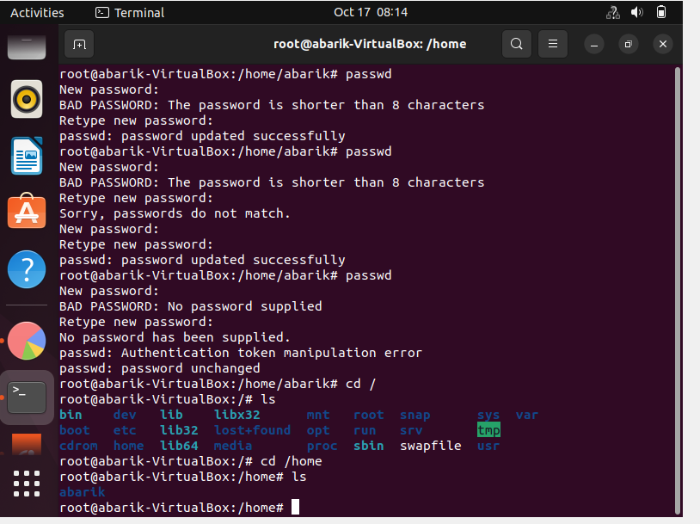

**User will move in home directory**

* Enter **cd ..** and hit **Enter** key [ *Note: here we have space after cd then use double dot*]
  + Check what happen and give screenshot?

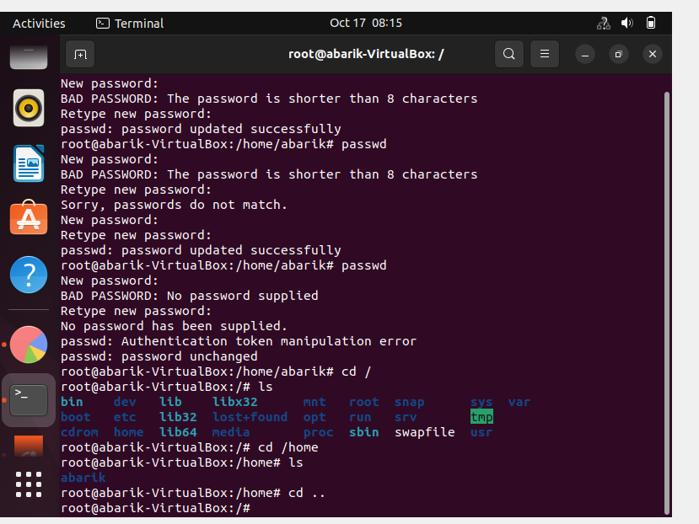

* Now enter **cd /var/www/html** and then type **cd** and hit **Enter** key
  + Explain what happen and give screenshot?

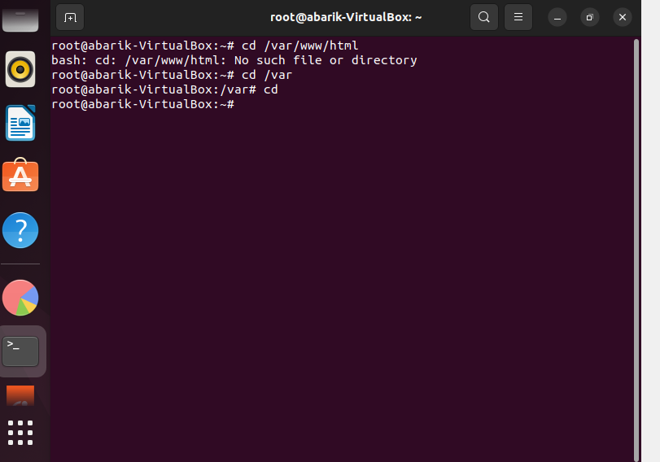

**If u entering cd only then we are moving back root directory**

* Now type **cd /root** and then hit **Enter** key
  + Do **ls,** check any output we have on screen if yes then take screenshot?

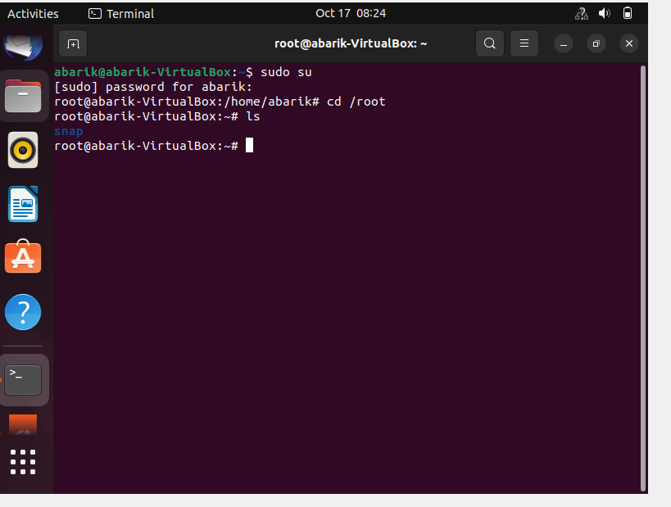

Assignment-4

Working with File Listing

* Go to cd /etc and type ls

* Take screenshot and explain what files you have seeing?

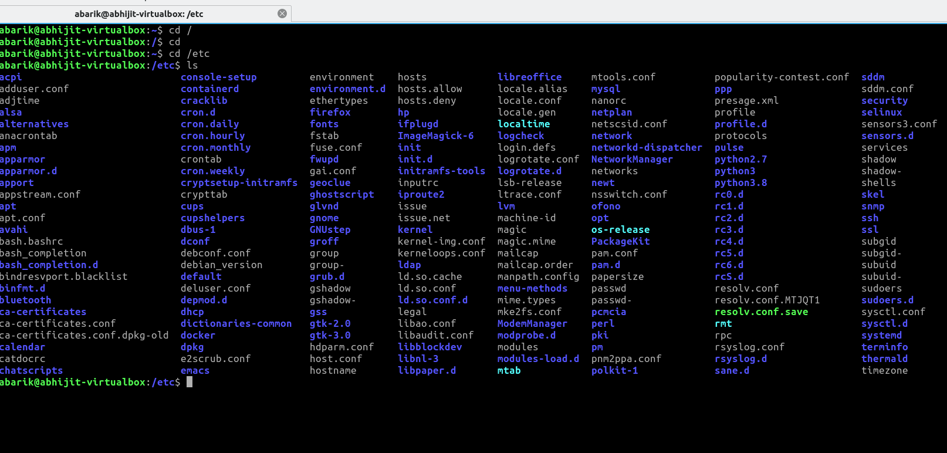

**The /etc maintains a lot of files and directory. Many networking configuration files are in /etc**

* Take screenshot and explain what different output you found compare to previous command you used?

* Then type ls -al and hit Enter key

**You can view hidden files with normal files and directories.**

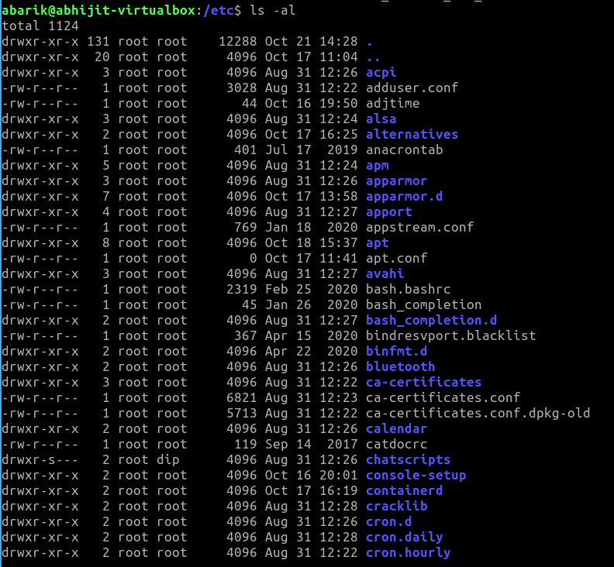

* Take screenshot and explain what new file or directory you found?

* Then use ls -i and hit Enter key

* Now see what different output its shows and take screenshot?

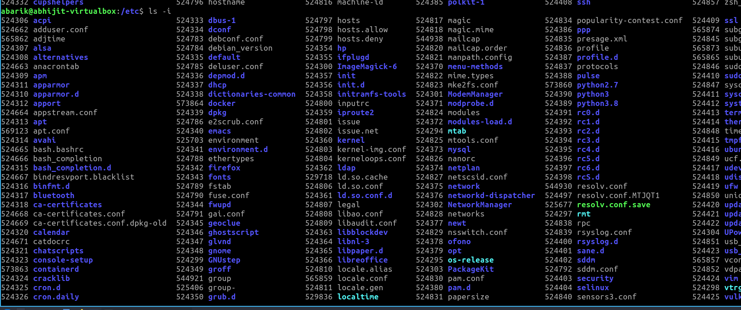

Each file in a file system has an identification number, called an inode number, that is unique in its file system. The inode number refers to the physical file, the data stored in a particular location. A file also has a device number, and the combination of its inode number and device number is unique throughout all the file systems in the hierarchical file system. To display the inode numbers of the files in your working directory

* Then use ls –help and see other options about ls command

* Explore it and try with other attribute we can use with ls command

