WEEK 3 INTERNSHIP REPORT

ADVANCED DATA ANALYSIS AND VISUALIZATION IN LOGISTICS

Project:
Logistics Delivery Analytics

Submitted By:
Abhijit Das

Week:
Week 3

Tools Used:
Python, Pandas, NumPy, Matplotlib, Jupyter Notebook

Dataset:
Zomato Delivery Dataset

============================================================
1. INTRODUCTION
============================================================

The objective of Week 3 was to perform advanced exploratory data analysis (EDA) and visualization on the cleaned logistics delivery dataset prepared during Week 2.

The analysis focused on understanding delivery performance, identifying important patterns and operational factors associated with delivery time, and presenting the findings through statistical analysis and meaningful visualizations.

The cleaned dataset used for the analysis contained 45,584 delivery records and 33 columns. Important variables such as delivery time, road traffic density, weather conditions, multiple deliveries, festival status, delivery-person ratings, vehicle condition, and pickup delay were examined.

Python was used for the analysis. Pandas and NumPy were used for data manipulation and statistical analysis, while Matplotlib was used to create visualizations in Jupyter Notebook.

============================================================
2. OBJECTIVES
============================================================

The main objectives of the analysis were:

• To understand the overall distribution of delivery time.

• To calculate statistical measures such as mean, median, mode, standard deviation, minimum, maximum, and quartiles.

• To examine the relationship between road traffic density and delivery time.

• To analyse delivery performance under different weather conditions.

• To study the relationship between multiple deliveries and delivery time.

• To compare delivery performance during festival and non-festival periods.

• To analyse delivery-person ratings and vehicle condition in relation to delivery time.

• To perform correlation analysis among selected numerical variables.

• To identify important operational patterns and potential bottlenecks.

• To provide practical recommendations based on the analytical findings.

============================================================
3. METHODOLOGY
============================================================

The cleaned dataset generated during Week 2 was imported into a Jupyter Notebook using Pandas.

Before starting the exploratory analysis, an additional quality check was performed. The dataset contained 38 delivery-person age records with a value of 15 years, which were treated as invalid under the selected valid age range of 18 to 60 years.

Instead of deleting the complete records, the invalid age values were replaced using the median of valid delivery-person ages. The valid median age was 30 years. After this correction, the number of invalid age records became zero.

The analysis was then performed using the following approach:

1. Calculation of descriptive statistics for delivery time.
2. Analysis of delivery-time distribution.
3. Group-wise analysis based on traffic density.
4. Analysis based on weather conditions.
5. Analysis of multiple deliveries.
6. Comparison of festival and non-festival deliveries.
7. Correlation analysis among selected numerical variables.
8. Analysis of delivery-person ratings.
9. Analysis of vehicle condition.
10. Interpretation of results and preparation of operational recommendations.

The analysis mainly used Pandas functions such as groupby(), agg(), mean(), median(), mode(), describe(), and corr(). Matplotlib was used to create the visualizations.

============================================================
4. DESCRIPTIVE STATISTICS OF DELIVERY TIME
============================================================

The delivery-time variable was first analysed using measures of central tendency and descriptive statistics.

The results were:

Mean Delivery Time: 26.29 minutes
Median Delivery Time: 26 minutes
Mode Delivery Time: 26 minutes
Standard Deviation: approximately 9.38 minutes
Minimum Delivery Time: 10 minutes
Maximum Delivery Time: 54 minutes
25th Percentile: 19 minutes
50th Percentile: 26 minutes
75th Percentile: 32 minutes

The mean, median, and mode were very close to each other. This indicates that a typical delivery in the dataset took approximately 26 minutes.

Around 75% of the recorded deliveries were completed within 32 minutes.

============================================================
5. DELIVERY TIME DISTRIBUTION
============================================================

A histogram was created to examine the overall distribution of delivery time.

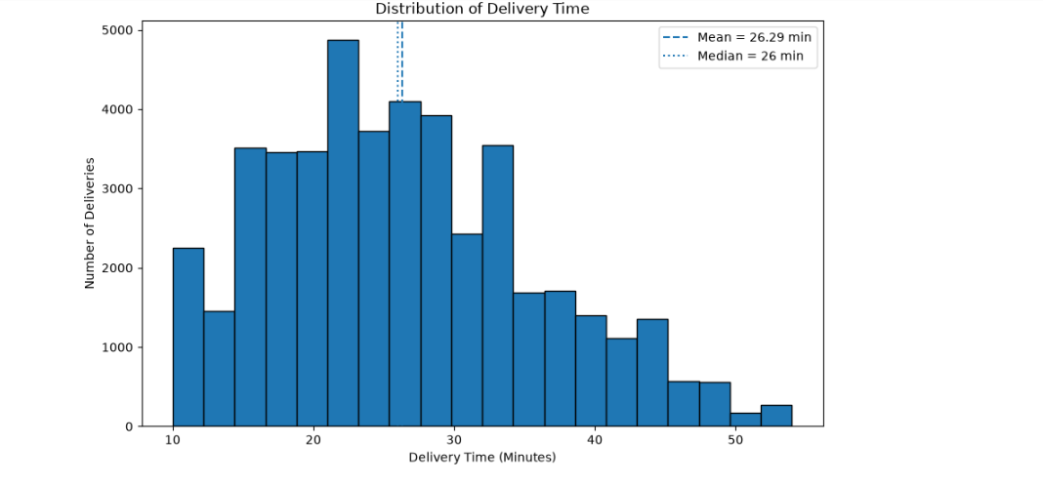
The visualization showed that a large number of deliveries were concentrated around the 20–30 minute range.

The mean delivery time was approximately 26.29 minutes, while the median was 26 minutes. The distribution also showed a tail towards longer delivery times, with some deliveries taking approximately 40–54 minutes.

Visualization Choice:

A histogram was selected because it clearly shows the frequency distribution of a continuous numerical variable such as delivery time.

============================================================
6. ROAD TRAFFIC DENSITY ANALYSIS
============================================================

Road traffic density showed a clear relationship with average delivery time.

The results were:

Low Traffic:
Count = 15,476
Average Delivery Time = 21.27 minutes
Median = 20 minutes

Medium Traffic:
Count = 10,945
Average Delivery Time = 26.70 minutes
Median = 27 minutes

High Traffic:
Count = 4,423
Average Delivery Time = 27.24 minutes
Median = 27 minutes

Traffic Jam:
Count = 14,139
Average Delivery Time = 31.18 minutes
Median = 31 minutes

An additional Unknown traffic category contained 601 records with an average delivery time of 26.54 minutes. It was excluded from the ordered traffic-level visualization because it did not represent a known traffic intensity.

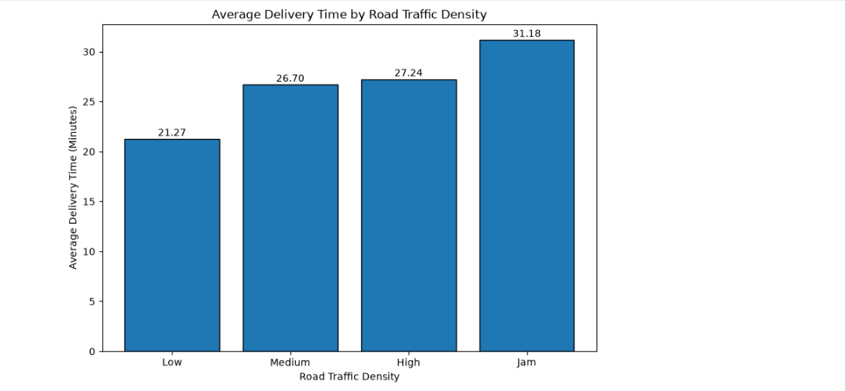
Average delivery time increased from 21.27 minutes under low traffic to 31.18 minutes during traffic jams.

This represents an increase of approximately 9.91 minutes, or about 46.6%, between low-traffic and traffic-jam conditions.

This result suggests that road congestion is an important operational factor associated with longer delivery times.

Visualization Choice:

A bar chart was selected because traffic density consists of categorical levels and the chart makes comparison of average delivery time across the categories straightforward.

============================================================
7. WEATHER CONDITION ANALYSIS
============================================================

Delivery time was also analysed under different weather conditions.

The average delivery times were:

Sunny = 21.86 minutes
Stormy = 25.87 minutes
Sandstorms = 25.88 minutes
Windy = 26.12 minutes
Fog = 28.91 minutes
Cloudy = 28.92 minutes

The Unknown weather category contained 616 records and had an average delivery time of 26.55 minutes. It was excluded from the main weather comparison visualization.

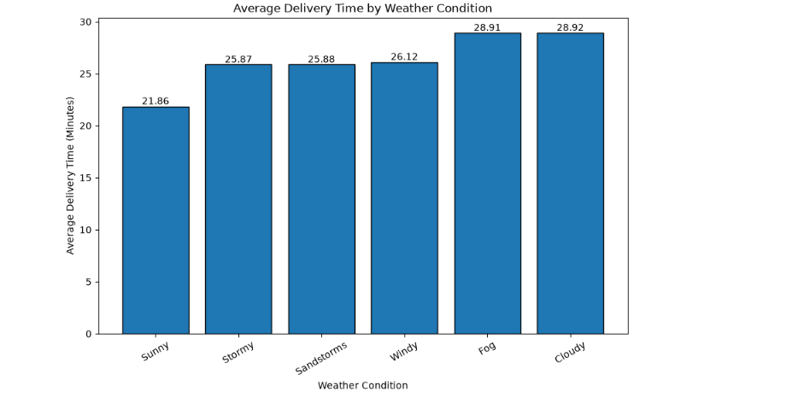
Sunny weather had the lowest average delivery time at 21.86 minutes.

Cloudy and foggy conditions showed the highest average delivery times at approximately 28.92 and 28.91 minutes respectively.

The difference between sunny and cloudy conditions was approximately 7.06 minutes.

The analysis therefore indicates that weather conditions are associated with differences in delivery performance.

Visualization Choice:

A bar chart was used because it provides an easy comparison of average delivery times across different weather categories.

============================================================
8. MULTIPLE DELIVERIES ANALYSIS
============================================================

The number of multiple deliveries showed one of the clearest relationships with delivery time.

The results were:

0 Multiple Deliveries:
Count = 14,094
Average = 22.88 minutes
Median = 22 minutes

1 Multiple Delivery:
Count = 29,144
Average = 26.72 minutes
Median = 26 minutes

2 Multiple Deliveries:
Count = 1,985
Average = 40.45 minutes
Median = 40 minutes

3 Multiple Deliveries:
Count = 361
Average = 47.82 minutes
Median = 48 minutes

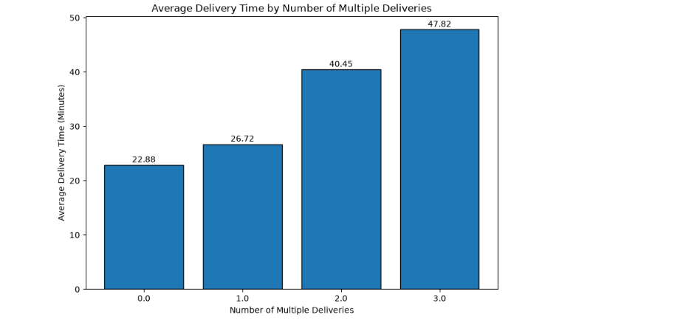
Average delivery time increased from 22.88 minutes for zero multiple deliveries to 47.82 minutes for three multiple deliveries.

This is an increase of approximately 24.94 minutes, or about 109%.

This indicates that records involving higher numbers of simultaneous deliveries were associated with substantially longer delivery times.

However, the group containing three multiple deliveries had only 361 records, so its smaller sample size should be considered while interpreting the result.

Visualization Choice:

A bar chart was selected to clearly compare average delivery time across the discrete numbers of multiple deliveries.

============================================================
9. FESTIVAL VS NON-FESTIVAL ANALYSIS
============================================================

Festival status showed a substantial difference in delivery performance.

The results were:

Non-Festival:
Count = 44,460
Average Delivery Time = 25.98 minutes
Median = 25 minutes

Festival:
Count = 896
Average Delivery Time = 45.52 minutes
Median = 45 minutes

Unknown:
Count = 228
Average Delivery Time = 11.17 minutes
Median = 11 minutes

The Unknown category was excluded from the main festival comparison because the festival status of those records was not known.

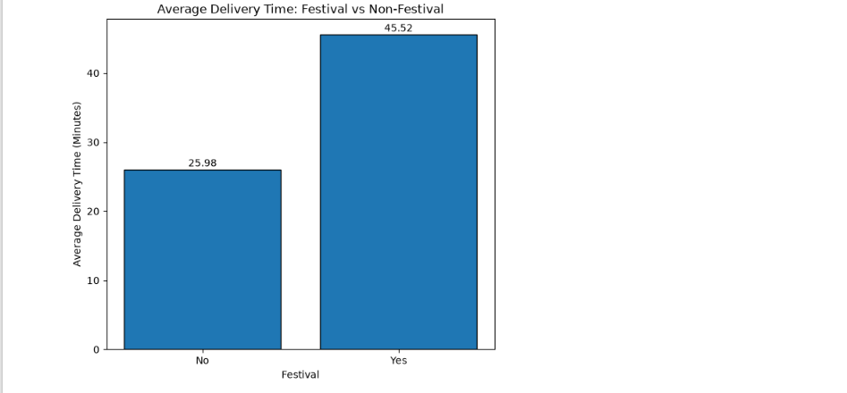
Festival deliveries had an average delivery time of 45.52 minutes compared with 25.98 minutes for non-festival deliveries.

The difference was approximately 19.54 minutes, meaning that average delivery time for the festival group was approximately 75% higher.

Festival periods were therefore strongly associated with longer delivery times in this dataset.

The two groups had very different sample sizes, so this imbalance should be considered when interpreting the comparison.

Visualization Choice:
A bar chart was chosen because it provides a direct visual comparison between festival and non-festival delivery performance.

============================================================
10. CORRELATION ANALYSIS
============================================================

A correlation analysis was conducted to examine relationships among selected numerical variables.

The variables included:

• Delivery Person Age
• Delivery Person Ratings
• Vehicle Condition
• Multiple Deliveries
• Pickup Delay Minutes
• Delivery Time

The correlations with delivery time were:

Multiple Deliveries = +0.38
Delivery Person Age = +0.29
Pickup Delay Minutes = -0.01
Vehicle Condition = -0.23
Delivery Person Ratings = -0.34

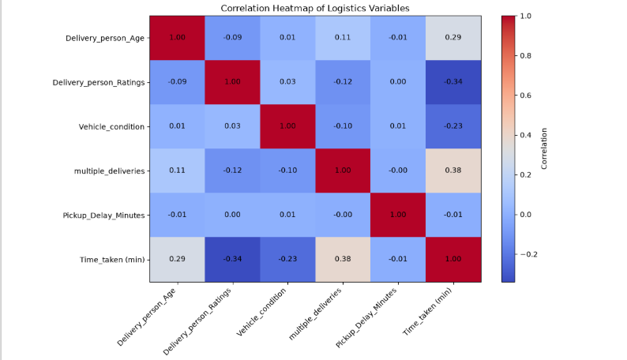
Among the selected variables, multiple deliveries had the strongest positive correlation with delivery time at +0.38.

Delivery-person ratings showed a negative correlation of -0.34, indicating that higher ratings were generally associated with shorter delivery times.

Delivery-person age showed a positive correlation of +0.29.

Vehicle condition showed a weak negative correlation of -0.23.

Pickup delay minutes showed almost no linear relationship with delivery time in this correlation analysis, with a value of approximately -0.01.

It is important to note that correlation represents statistical association and does not by itself establish causation.

Visualization Choice:
A correlation heatmap was selected because it allows several pairwise numerical relationships to be viewed simultaneously and makes positive and negative correlations easier to identify.

============================================================
11. DELIVERY PERSON RATING ANALYSIS
============================================================

Delivery-person rating was further analysed because it showed a correlation of -0.34 with delivery time.

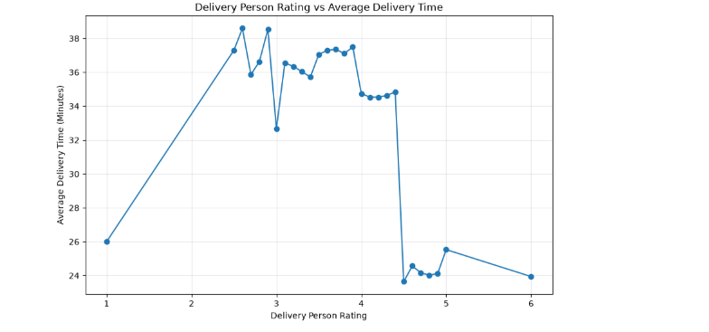
The visualization showed an overall tendency for higher-rated delivery personnel to be associated with shorter average delivery times.

However, the relationship was not perfectly linear. Average delivery time fluctuated across individual rating values, with a noticeable reduction around the higher rating levels.

Therefore, delivery-person rating appears to be associated with delivery performance, but rating alone cannot completely explain delivery time.

Visualization Choice:
A line chart was selected because rating is an ordered numerical variable and the chart helps show how average delivery time changes across rating levels.

============================================================
12. VEHICLE CONDITION ANALYSIS
============================================================

Vehicle condition was also analysed in relation to delivery time.

The results were:

Vehicle Condition 0:
Count = 15,005
Average = 30.07 minutes
Median = 28 minutes

Vehicle Condition 1:
Count = 15,028
Average = 24.35 minutes
Median = 24 minutes

Vehicle Condition 2:
Count = 15,031
Average = 24.45 minutes
Median = 24 minutes

Vehicle Condition 3:
Count = 520
Average = 26.49 minutes
Median = 26 minutes

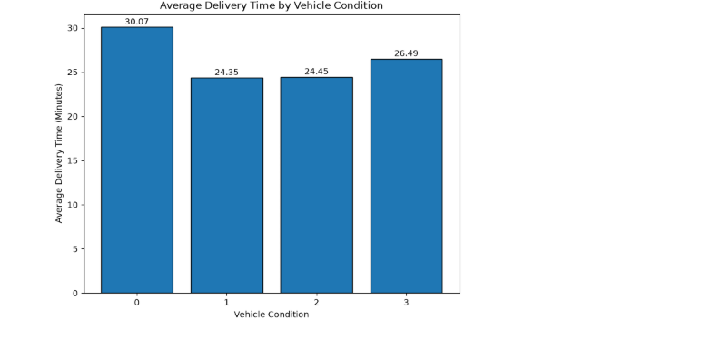
Vehicle condition 0 had the highest average delivery time at 30.07 minutes.

Conditions 1 and 2 had considerably lower average delivery times of approximately 24.35 and 24.45 minutes.

Vehicle condition 3 had an average delivery time of 26.49 minutes, but this category contained only 520 records.

Therefore, the relationship between the vehicle-condition code and delivery time was not strictly linear across all categories.

Visualization Choice:
A bar chart was used because vehicle condition is represented by discrete categories, allowing their average delivery times to be compared clearly.

============================================================
13. KEY FINDINGS
============================================================

The major findings from the Week 3 analysis are:

1. The typical delivery time was approximately 26 minutes.

2. Road traffic was strongly associated with delivery performance. Average delivery time increased from 21.27 minutes under low traffic to 31.18 minutes during traffic jams.

3. Weather conditions were associated with differences in delivery time. Sunny conditions had the lowest average delivery time, while cloudy and foggy conditions had the highest averages.

4. Multiple deliveries were an important operational factor. Average delivery time increased substantially as the number of multiple deliveries increased.

5. Festival deliveries showed considerably longer average delivery times than non-festival deliveries.

6. Multiple deliveries had the strongest positive correlation with delivery time among the selected numerical variables, with a correlation of +0.38.

7. Delivery-person ratings showed a moderate negative association with delivery time, with a correlation of -0.34.

8. Vehicle condition was also associated with delivery performance, although the relationship across its coded categories was not completely linear.

9. Pickup delay minutes showed almost no linear correlation with the final delivery-time variable in the selected correlation analysis.

============================================================
14. OPERATIONAL BOTTLENECKS
============================================================

Based on the exploratory analysis, several potential operational bottlenecks were identified.

Traffic Congestion:
Traffic jams were associated with substantially longer delivery times compared with low-traffic conditions.

Multiple Delivery Workload:
Delivery personnel handling multiple deliveries showed significantly higher average delivery times, especially for two and three multiple deliveries.

Festival Periods:
Festival deliveries showed much longer average delivery times, suggesting increased operational pressure during such periods.

Adverse Weather:
Foggy and cloudy conditions were associated with longer delivery times than sunny weather.

Vehicle Condition:
Vehicle condition 0 showed noticeably higher average delivery time compared with conditions 1 and 2.

These factors can potentially affect customer experience and the reliability of delivery-time estimates.

============================================================
15. RECOMMENDATIONS
============================================================

Based on the findings, the following recommendations can be considered:

1. Improve Route Planning

Real-time or historical traffic information can be incorporated into route planning to reduce delays during high-traffic periods.

2. Optimize Multiple-Delivery Allocation

Excessive simultaneous deliveries should be avoided where possible. Delivery workload can be distributed more evenly among available delivery personnel.

3. Prepare for Festival Demand

Additional delivery personnel and operational capacity can be planned during festival periods to handle increased delivery pressure.

4. Account for Weather Conditions

Delivery-time estimates should consider weather conditions, especially foggy and cloudy conditions where longer delivery times were observed.

5. Maintain Delivery Vehicles

Regular inspection and maintenance of delivery vehicles may help reduce operational problems associated with poor vehicle condition.

6. Learn from Higher-Rated Delivery Personnel

Operational practices followed by higher-rated delivery personnel can be studied to identify potentially useful efficiency practices.

7. Improve Delivery-Time Estimation

Traffic, weather, festival status, multiple-delivery workload, and other relevant factors can be incorporated into future predictive models for more accurate estimated delivery times.

============================================================
16. PYTHON CODE EXCERPTS
============================================================

The following are examples of Python code used during the analysis.

A. Loading the Cleaned Dataset

df = pd.read_csv("Zomato_Delivery_Cleaned.csv")

print("Dataset Shape:", df.shape)
df.head()

B. Delivery-Time Statistics

delivery_mean = df["Time_taken (min)"].mean()
delivery_median = df["Time_taken (min)"].median()
delivery_mode = df["Time_taken (min)"].mode()[0]

print("Mean Delivery Time:", round(delivery_mean, 2))
print("Median Delivery Time:", delivery_median)
print("Mode Delivery Time:", delivery_mode)

C. Traffic Analysis

traffic_analysis = (
df.groupby("Road_traffic_density")["Time_taken (min)"]
.agg(["count", "mean", "median"])
.round(2)
.sort_values("mean")
)

D. Weather Analysis

weather_analysis = (
df.groupby("Weather_conditions")["Time_taken (min)"]
.agg(["count", "mean", "median"])
.round(2)
.sort_values("mean")
)

E. Multiple Deliveries Analysis

multiple_delivery_analysis = (
df.groupby("multiple_deliveries")["Time_taken (min)"]
.agg(["count", "mean", "median"])
.round(2)
.sort_index()
)

F. Correlation Analysis

numeric_cols = [
"Delivery_person_Age",
"Delivery_person_Ratings",
"Vehicle_condition",
"multiple_deliveries",
"Pickup_Delay_Minutes",
"Time_taken (min)"
]

correlation_matrix = df[numeric_cols].corr()

============================================================
17. LIMITATIONS
============================================================

This analysis has several limitations that should be considered.

First, the analysis is exploratory and primarily identifies associations between variables. The observed relationships should not automatically be interpreted as causal effects.

Second, some categories had unequal sample sizes. For example, the festival group contained considerably fewer records than the non-festival group, and vehicle condition 3 had only 520 records.

Third, Unknown categories were present in some variables such as traffic density, weather conditions, and festival status. These categories were excluded from some comparison visualizations because their actual category was unavailable.

Finally, some relationships may be influenced by multiple factors simultaneously. For example, festival deliveries may also occur under heavier traffic or higher multiple-delivery workloads.

============================================================
18. CONCLUSION
============================================================

The Week 3 exploratory data analysis provided useful insights into logistics delivery performance.

The overall average delivery time was approximately 26.29 minutes, with a typical delivery taking around 26 minutes.

The analysis identified traffic congestion, multiple-delivery workload, festival periods, weather conditions, delivery-person ratings, and vehicle condition as variables associated with differences in delivery performance.

Among the selected numerical variables, multiple deliveries showed the strongest positive correlation with delivery time, while delivery-person ratings showed a moderate negative correlation.

The visualizations helped convert the statistical results into understandable operational insights. These findings can support better delivery allocation, traffic-aware planning, festival preparation, vehicle maintenance, and delivery-time estimation.

Overall, the Week 3 analysis demonstrates how exploratory data analysis and visualization can be used to identify logistics patterns, potential bottlenecks, and opportunities for operational improvement.

============================================================
19. FINAL NOTE
============================================================

The analysis was performed using the cleaned logistics dataset prepared during Week 2. Python, Pandas, NumPy, Matplotlib, and Jupyter Notebook were used throughout the analytical process.

The complete analysis code and supporting project files are maintained in the project repository.

