WEEK 4 TASK REPORT

PREDICTIVE MODELING AND OPTIMIZATION IN LOGISTICS SYSTEMS

1. OBJECTIVE

The objective of this task is to develop predictive machine learning models for estimating delivery time in a logistics environment. The analysis uses cleaned logistics data to identify important operational factors, compare different regression models, evaluate predictive performance, and demonstrate how predictive analytics can support logistics planning and optimization.

2. DATASET OVERVIEW

The cleaned Zomato Delivery dataset prepared during the previous data-cleaning stage was used for this analysis.

The dataset contained 45,584 records and 33 columns.

For predictive modelling , the following relevant features were selected:

• Delivery Person Age
• Delivery Person Ratings
• Weather Conditions
• Road Traffic Density
• Vehicle Condition
• Type of Order
• Type of Vehicle
• Multiple Deliveries
• Festival
• City

Target Variable:

Time Taken (min)

The target variable represents the delivery time that the machine learning models were trained to predict.

3. DATA PREPARATION

Before model training, the selected variables were examined for their data types and missing values.

The Delivery_person_Ratings column contained 1,908 missing values. These missing values were replaced using the median rating of 4.7.

After imputation, no missing values remained in the selected modeling dataset.

The input variables were divided into numerical and categorical features.

Numerical Features:

• Delivery Person Age
• Delivery Person Ratings
• Vehicle Condition
• Multiple Deliveries

Categorical Features:

• Weather Conditions
• Road Traffic Density
• Type of Order
• Type of Vehicle
• Festival
• City

Numerical variables were standardized using StandardScaler.

Categorical variables were transformed into numerical form using OneHotEncoder with the handle_unknown="ignore" option.

This preprocessing allowed both numerical and categorical logistics information to be used by the machine learning models.

4. FEATURE AND TARGET PREPARATION

The modeling dataset was divided into input features (X) and the target variable (y).

X contained the logistics variables used for prediction.

y contained the Time_taken (min) variable representing actual delivery time.

The complete dataset contained 45,584 observations.

5. TRAIN-TEST SPLIT

The dataset was divided into training and testing datasets using an 80:20 train-test split.

Approximately 80% of the observations were used to train the machine learning models, while the remaining 20% were reserved for evaluating their performance on unseen data.

A random state of 42 was used to make the split reproducible.

This resulted in approximately:

Training Records: 36,467

Testing Records: 9,117

6. PREDICTIVE MODELING

Three regression algorithms were developed and evaluated:

1. Linear Regression
2. Decision Tree Regressor
3. Random Forest Regressor

These models were selected to compare a basic linear regression approach with more flexible non-linear and ensemble-based machine learning techniques.

7. MODEL 1: LINEAR REGRESSION

Linear Regression was used as the baseline regression model.

The preprocessing pipeline and Linear Regression model were combined so that numerical scaling and categorical encoding were consistently applied during model training and prediction.

The model was trained using the training dataset and evaluated using the unseen testing dataset.

Linear Regression Performance:

MAE: Approximately 5.05 minutes

RMSE: Approximately 6.28 minutes

R² Score: Approximately 0.55

The Linear Regression model provided a useful baseline but was limited in its ability to capture complex non-linear relationships between logistics variables and delivery time.

8. MODEL 2: DECISION TREE REGRESSOR

A Decision Tree Regressor was developed to capture non-linear relationships between logistics variables and delivery time.

The Decision Tree model used controlled tree depth and minimum sample requirements to reduce excessive overfitting.

Decision Tree Performance:

MAE: Approximately 4.08 minutes

RMSE: Approximately 5.20 minutes

R² Score: Approximately 0.69

The Decision Tree performed substantially better than the Linear Regression baseline, indicating that delivery time contains important non-linear patterns.

9. MODEL 3: RANDOM FOREST REGRESSOR

A Random Forest Regressor was developed as the third predictive model.

Random Forest combines predictions from multiple decision trees. This ensemble approach can improve predictive performance and reduce the risk of overfitting associated with a single decision tree.

The Random Forest model was trained using multiple decision trees and the same training and testing datasets used for the other models.

Random Forest Performance:

MAE: Approximately 3.95 minutes

RMSE: Approximately 5.07 minutes

R² Score: Approximately 0.71

Random Forest achieved the best overall performance among the three evaluated models.

10. MODEL EVALUATION METRICS

The predictive models were evaluated using Mean Absolute Error (MAE), Root Mean Squared Error (RMSE), and R² Score.

Mean Absolute Error (MAE):

MAE measures the average absolute difference between the actual and predicted delivery times. A lower MAE indicates better predictive performance.

Root Mean Squared Error (RMSE):

RMSE measures prediction error while giving greater importance to larger errors. A lower RMSE represents better model performance.

R² Score:

R² measures the proportion of variation in delivery time that is explained by the predictive model. A higher R² value represents better predictive performance.

11. MODEL COMPARISON
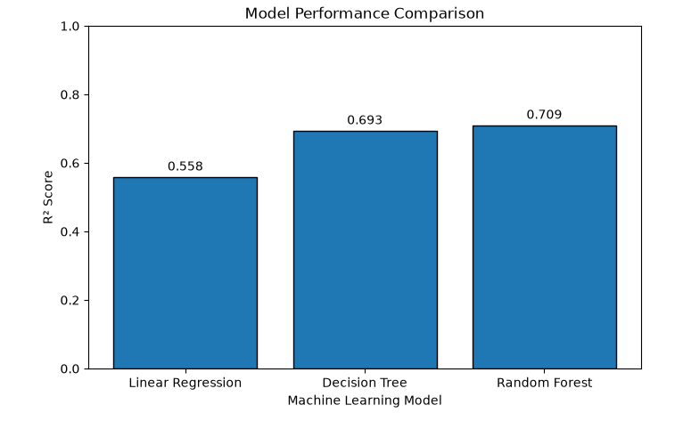

The performance of the three models was compared using MAE, RMSE, and R² Score.

Model MAE RMSE R² Score

Linear Regression 5.05 6.28 0.55

Decision Tree 4.08 5.20 0.69

Random Forest 3.95 5.07 0.71

Random Forest produced the lowest MAE and RMSE and the highest R² score among the evaluated models.

Therefore, Random Forest was selected as the best-performing model for delivery-time prediction.

12. BEST MODEL: RANDOM FOREST

Random Forest achieved an MAE of approximately 3.95 minutes.

This means that the model's predicted delivery times differed from the actual delivery times by approximately 3.95 minutes on average.

The model achieved an RMSE of approximately 5.07 minutes and an R² score of approximately 0.71.

The R² result indicates that the model explained a substantial portion of the variation in delivery time within the testing dataset.

Therefore, Random Forest was selected as the final predictive model for this analysis.

13. ACTUAL VS PREDICTED DELIVERY TIME

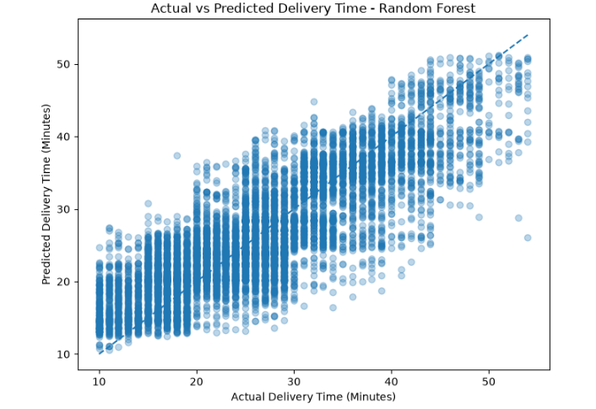

Actual delivery times from the testing dataset were compared with delivery times predicted by the Random Forest model.

A scatter plot was created with actual delivery time on one axis and predicted delivery time on the other.

A diagonal reference line represented perfect predictions where:

Actual Delivery Time = Predicted Delivery Time

The predicted values generally followed the direction of the actual delivery values, demonstrating that the model captured meaningful patterns in delivery time.

However, some prediction errors remained, indicating that additional variables and further model tuning could potentially improve performance.

14. FEATURE IMPORTANCE ANALYSIS

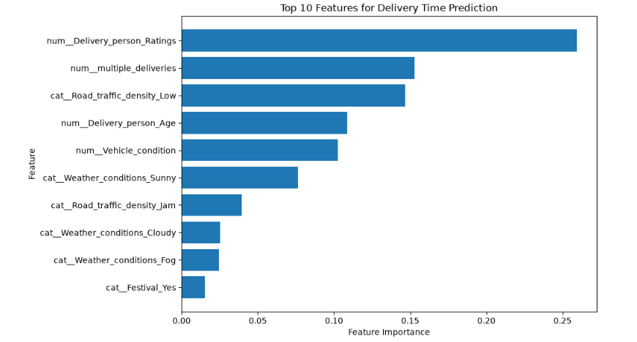

Feature importance analysis was performed using the trained Random Forest model.

This analysis was used to identify which transformed logistics variables contributed most to the model's delivery-time predictions.

The analysis showed that delivery-person-related variables, multiple deliveries, road traffic conditions, vehicle condition, weather conditions, and festival-related variables provided useful predictive information.

Delivery person ratings appeared among the most influential transformed features in the Random Forest model.

Feature importance represents the predictive usefulness of a variable within the model. It should not automatically be interpreted as evidence that the variable directly causes changes in delivery time.

15. SAMPLE DELIVERY TIME PREDICTIONS

The trained Random Forest model was applied to unseen observations from the testing dataset.

For each selected observation, three values were compared:

• Actual Delivery Time
• Predicted Delivery Time
• Absolute Prediction Error

The absolute error was calculated as the difference between the actual and predicted delivery times.

This demonstrated how the trained machine learning model could be used as a prototype for estimating delivery time for unseen logistics records.

16. FUTURE LOGISTICS FORECAST SIMULATION

A hypothetical future logistics scenario simulation was performed using the trained Random Forest model.

Different combinations of logistics conditions were created, including:

• Delivery Person Age
• Delivery Person Ratings
• Weather Conditions
• Road Traffic Density
• Vehicle Condition
• Type of Order
• Type of Vehicle
• Multiple Deliveries
• Festival Status
• City

These hypothetical scenarios were passed to the trained Random Forest model.

The model generated estimated delivery times for each scenario.

The simulation demonstrated how a predictive model could support scenario-based ETA estimation and operational planning under different logistics conditions.

These scenarios represent illustrative model predictions and should not be interpreted as actual future orders or as a time-series demand forecast.

17. LOGISTICS OPTIMIZATION RECOMMENDATIONS

Based on the exploratory analysis and predictive modeling results, the following operational recommendations can be considered:

1. Optimize Multiple-Delivery Allocation

Multiple deliveries were useful for predicting delivery time. Delivery workloads should therefore be distributed carefully to reduce excessive delays.

2. Traffic-Aware Route Planning

Road traffic conditions should be incorporated into route selection and estimated delivery-time calculations. High traffic and traffic jams can contribute important information when estimating delivery time.

3. Predictive ETA Estimation

The Random Forest model can be developed further as a prototype for estimating delivery times using information available for individual deliveries.

4. Monitor Delivery Personnel Performance

Delivery-person ratings were highly useful to the predictive model. Operational teams can investigate the practices associated with efficient and highly rated delivery personnel.

5. Weather-Aware Operations

Weather conditions should be considered when planning delivery schedules and communicating estimated arrival times to customers.

6. Festival Capacity Planning

Additional delivery capacity can be planned during festival periods because the exploratory analysis identified substantially longer delivery times during festival conditions.

7. Vehicle Monitoring and Maintenance

Vehicle condition contributed information to delivery-time prediction. Vehicle condition and maintenance can therefore be considered as part of logistics operations.

18. OPERATIONAL APPLICATION OF THE MODEL

The predictive model could potentially support several logistics activities.

Possible applications include:

• Delivery ETA estimation
• Traffic-aware planning
• Delivery workload allocation
• Festival capacity planning
• Operational monitoring
• Scenario-based delivery planning

The model developed in this project represents a prototype rather than a production-ready logistics system.

Before real-world deployment, the model should be validated using current operational data and tested under real logistics conditions.

19. TOOLS AND TECHNOLOGIES USED

The following tools and technologies were used during the project:

• Python
• Pandas
• NumPy
• Matplotlib
• Scikit-learn
• Jupyter Notebook
• GitHub

20. KEY FINDINGS

The major findings from the predictive analysis were:

• Random Forest provided the best predictive performance among the three evaluated models.

• Random Forest achieved an MAE of approximately 3.95 minutes.

• Random Forest achieved an RMSE of approximately 5.07 minutes.

• Random Forest achieved an R² score of approximately 0.71.

• Decision Tree performed better than the Linear Regression baseline.

• Non-linear machine learning models were more effective for this delivery-time prediction problem than the baseline Linear Regression model.

• Delivery-person-related variables, multiple deliveries, traffic conditions, vehicle condition, weather conditions, and festival-related variables provided useful information for delivery-time prediction.

• Predictive modeling can potentially support ETA estimation and operational logistics planning.

21. LIMITATIONS

Although the Random Forest model achieved the best performance in this analysis, several limitations should be considered.

The model was developed using the available dataset and selected logistics features.

The scenario simulation represents hypothetical conditions rather than actual future demand.

Feature importance represents predictive usefulness and does not prove causal relationships.

The model has not been validated in a live production logistics environment.

Additional operational variables, time-based validation, hyperparameter optimization, and real-world testing could potentially improve the model further.

22. FINAL CONCLUSION

This Week 4 project successfully applied predictive machine learning techniques to logistics delivery-time estimation.

The cleaned logistics dataset was prepared through feature selection, missing-value treatment, categorical encoding, numerical preprocessing, and train-test splitting.

Three regression models were developed and evaluated:

• Linear Regression
• Decision Tree Regressor
• Random Forest Regressor

Among the evaluated models, Random Forest produced the best overall predictive performance.

The Random Forest model achieved an MAE of approximately 3.95 minutes, RMSE of approximately 5.07 minutes, and R² score of approximately 0.71.

The project demonstrated a complete predictive analytics workflow including data preparation, model development, model evaluation, model comparison, actual-versus-predicted analysis, feature importance analysis, sample predictions, hypothetical scenario simulation, and logistics optimization recommendations.

The results demonstrate the potential of machine learning to support delivery-time estimation, workload planning, traffic-aware operations, festival capacity planning, and logistics decision-making.

Overall, Random Forest was selected as the best-performing model for this analysis. However, the model represents a prototype based on the available dataset and should be further validated using real operational and time-based data before production deployment.

