**TECHNITES**

2018-19

LASER -HARP

TEAM Members:

1. Kamal
2. Madhukar
3. Abhijit Kumar Gupta
4. Mahesh

**Contents:**

* Introduction
* Components Required
* Design
* Working
* Issues faced

Introduction

A **laser harp** is an electronic musical user interface and laser lighting display . It projects several laser beams played by the musician by blocking them to produce sounds which are reminiscent of a harp.

It is a light- sensitive musical instrument. It is played by moving hands over laser light sources in order to send MIDI commands when a beam is interrupted. These commands can be sent to different electronic devices such as synthesizers, samplers, controllers and other.

Components Required

**Hardware:**

* Arduino UNO
* Laser Diodes
* LDR (Light Dependent Resistor).
* Resistors
* Multiplexer IC
* 5V power supply
* PCB

**Software:**

* FL-Studio
* Loop MIDI
* Hairless MIDI
* Arduino IDE

**Design**

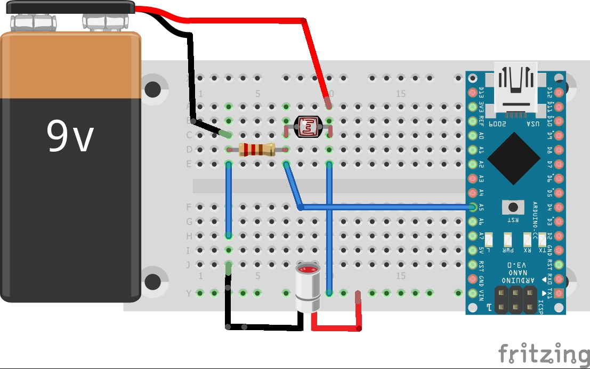

NOTE: The output taken from resistor is fetched to MUX (not given in diagram) and the output of the MUX is given to analog input of Arduino.

Working

LDR: This Light Dependent Resistor varies in resistance depending upon the amount of light falling on it. The current through the LDR increases or decreases in proportion to the amount of light falling on it. Also it can be inferred that the resistance of the LDR varies inversely to the amount of light.

The laser diodes and the LDR setup are arranged on opposite end of the Laser HARP. The laser diode beams are continuously targeted on the LDR, which are powered up from 5V SMPS.

The LDR and the resistor are connected in series that forms a potential divider between 5V supply. When laser beam light falls on these LDR, more current flows through the circuit and hence more voltage is dropped across the resistor. The laser beam on being intercepted by hand causes the change in the sensor data reading. This sensor data is sent to the multiplexer which responds to input depending upon the combination of select lines and gives a single output that is given to analog pin of Arduino. The sensor data is compared with the threshold value( the threshold value is set up depending upon the surrounding light and calibration) and is assigned the values digital 1 or digital 0 depending upon if the value if above or below the threshold respectively. Eight of such circuitry is made and 8 sensor data is continuously read. Depending upon these digital data collected the command corresponding to different tones are transmitted (ie: Sa, Re, Ga, Ma, Pa, Dha, Ni, Sa) from Arduino serially.

The Arduino serially communicates to FL-Studio via Hairless MIDI and LOOP MIDI application software. The commands generated by Arduino are sent to FL-Studio and this application is responsible for producing tones depending upon the command received.

**Issues Faced**

* The laser diodes were regularly dying out and hence had to replaced quite repeatedly.
* Battery operated laser diodes too caused the same issue.
* The alignment of the LDR in the line of sight of the laser beam was challenging and caused problems.
* Tuning the sensitivity of the LDR depending upon the surrounding light was another issue faced.
* The serial communication between Arduino and FL-Studio was often interrupted causing failure.

….Thank You……