NoiseBridge
From Encoder Basics to Deep Research Mathematics
A Step-by-Step Explanation with Figures
Abhijit Kumar — IIIT Senapati, Manipur
Covering: Transformer Basics → Self-Attention → Cross-Entropy → InfoNCE → Jaro-Winkler → PWNIC → GRL Failure

📖 How to Use This Document
This document assumes you know what an encoder-decoder is. It builds from there — every concept is explained before it is used.
Study links are provided at the end of each major section.
Mathematical derivations show every step — no steps are skipped.
Read sequentially: each section depends on the one before it.

Part 1 — Encoder-Decoder: What You Already Know, and What Changes

You already know: the encoder reads an input sequence and compresses it into a context vector. The decoder takes that context and generates an output sequence — like in machine translation.
NoiseBridge is different. It uses encoder-only models (no decoder at all) for a classification task. Before explaining why, let us be precise about what the encoder actually produces.

1.1 What an Encoder Actually Outputs
When you feed the sentence "tera baap madarchod hai" into mBERT or XLM-R, the encoder does NOT output a single vector. It outputs a matrix H ∈ ℝL×d — one d-dimensional vector per input token.
L = number of tokens (subwords) in the sentence. d = hidden dimension (768 for base models).
For a 5-token sentence with d=768: H is a 5 × 768 matrix. Every row is that token's contextual embedding — a representation that encodes not just the token itself, but its relationship to every other token in the sentence.

🔑 Key Difference from Encoder-Decoder Sequence Generation
In seq2seq (e.g., translation): encoder compresses → single context vector → decoder expands.
In encoder-only classification: encoder produces H (all token embeddings) → mean-pool or use [CLS] token → single z ∈ ℝᵈ → linear classifier → hate/non-hate.
No decoder is needed. The classification head replaces the decoder.

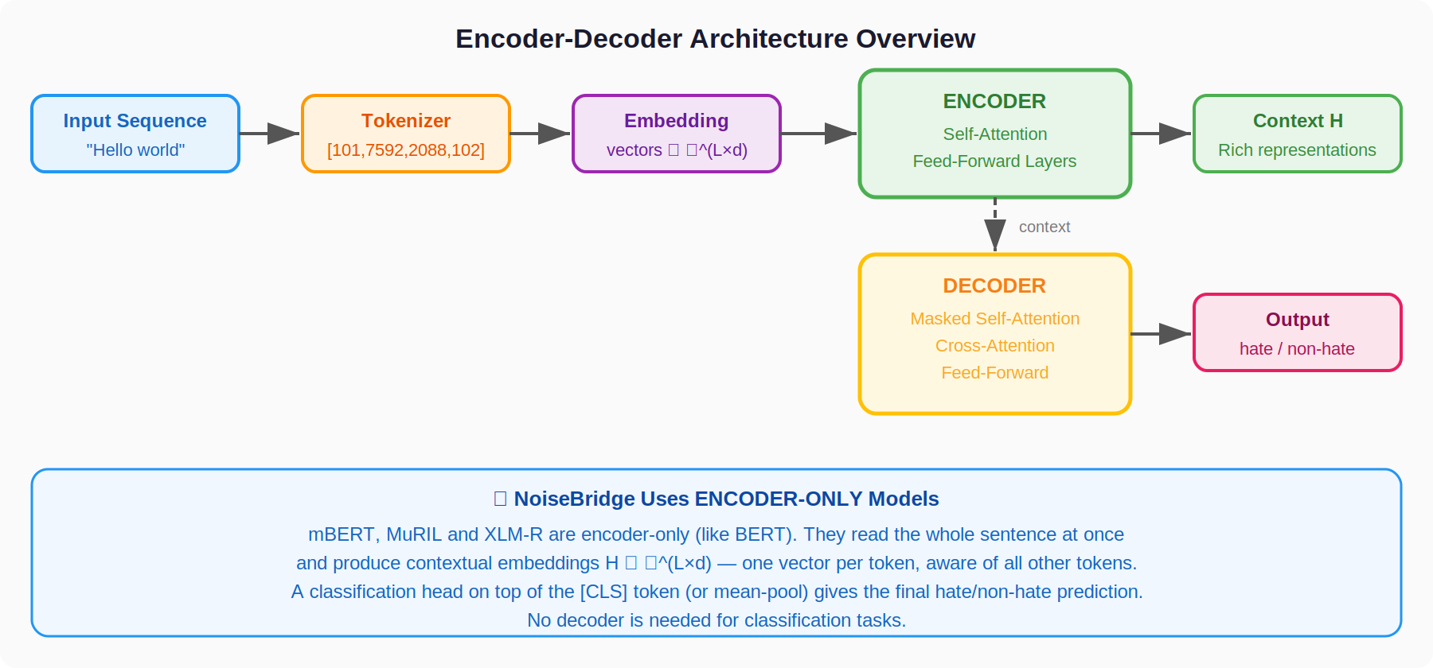
Figure 1: Encoder-Decoder overview vs. Encoder-only classification (used in NoiseBridge)

1.2 The [CLS] Token and Mean Pooling
[CLS] token: BERT-style models prepend a special [CLS] token to every input. The encoder's output at position 0 — H[0] ∈ ℝᵈ — is supposed to aggregate the whole sentence's meaning. For classification, a linear layer maps H[0] to logits.
Mean pooling: Instead of using only H[0], average all real token embeddings (excluding padding): z = (∑ᵢ Hᵢ · mᵢ) / ∑ᵢ mᵢ where mᵢ ∈ {0,1} is the attention mask. NoiseBridge uses mean pooling after applying the noise-aware gate.
Both produce a single vector z ∈ ℝᵈ that represents the whole sentence. A two-neuron linear head on top gives logits for [hate, non-hate].

Part 2 — Self-Attention: The Heart of Every Transformer

Self-attention is the mechanism that allows every token to look at every other token and decide how much to attend to each. This is what gives transformers their ability to handle context — and it is what makes them partially robust to character-level noise even without special training.
We will build it step-by-step, starting from the intuition and ending with the exact matrix operations.

2.1 The Intuition: "What do I need to know from the others?"
Consider the sentence: "tera baap madarchod hai"
When the encoder processes "madarchod", it should recognise that "baap" and "tera" are the target of the insult — this context matters for hate speech classification. Self-attention gives "madarchod" a mechanism to query all other tokens and decide how much to attend to each one.
Each token simultaneously plays three roles:
- Query (Q): "What information am I looking for from others?"
- Key (K): "Here is a summary of what I contain — use it to decide if you want to attend to me."
- Value (V): "Here is my actual content — what you'll get if you do attend to me."

2.2 The Mathematics, Step by Step

Step 1 — Project to Q, K, V
Each token embedding eᵢ ∈ ℝᵈ is projected by three learned weight matrices W_Q, W_K, W_V ∈ ℝd×d_k:
Qᵢ = eᵢ · W_Q Kᵢ = eᵢ · W_K Vᵢ = eᵢ · W_V
Each is a d_k-dimensional vector. For base models: d=768, d_k=64 (with 12 heads)

Step 2 — Compute Attention Scores
For each pair of tokens (i, j), compute a raw attention score measuring how relevant token j is to token i:
score(i, j) = Qᵢ · Kⱼᵀ / √d_k
Dot product measures alignment of query and key. Dividing by √d_k prevents vanishing gradients from large dot products.
Why √d_k? Without scaling, for high-dimensional vectors the dot products tend to be large in magnitude, pushing softmax into regions of very small gradients (the "peaky softmax" problem). Division by √d_k keeps the variance of the scores close to 1 regardless of dimension.

Step 3 — Softmax to Get Weights
Each row of the score matrix is passed through softmax to get a probability distribution — attention weights that sum to 1:
αᵢⱼ = softmax(score(i,:))ⱼ = exp(score(i,j)) / ∑ₖ exp(score(i,k))
αᵢⱼ = "how much does token i attend to token j?" — sums to 1 across j.

Step 4 — Weighted Sum of Values
The output for token i is the weighted sum of all Value vectors:
outputᵢ = ∑ⱼ αᵢⱼ · Vⱼ
Token i's output is a blend of all other tokens' values, weighted by relevance.
In compact matrix form for all tokens at once:
Attention(Q, K, V) = softmax(Q·Kᵀ / √d_k) · V
Full self-attention: [L×d_k] · [d_k×L] → [L×L] · [L×d_k] → [L×d_k]

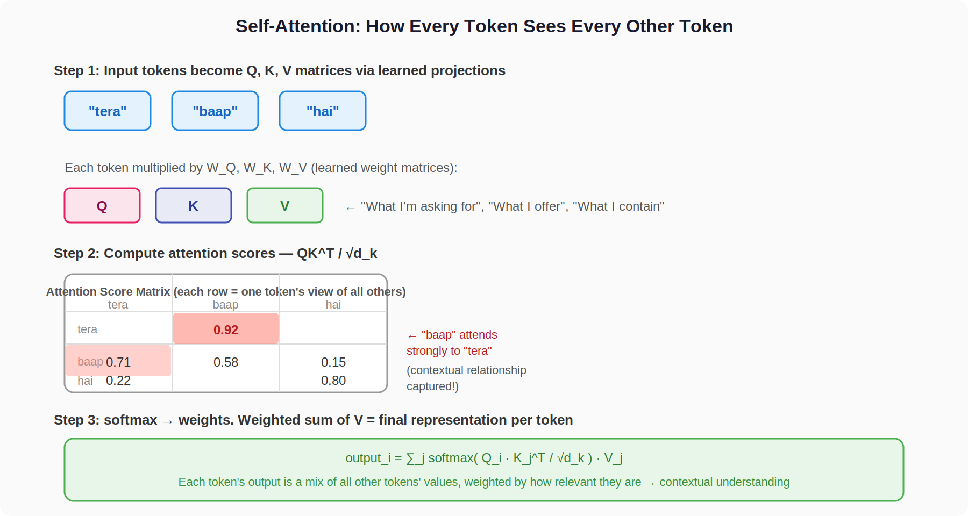
Figure 2: Self-attention — how every token attends to every other, and the score matrix it produces

2.3 Multi-Head Attention
A single attention head learns one type of relationship. Multi-head attention runs h=12 heads in parallel, each with its own W_Q, W_K, W_V. Each head can specialise — one might learn syntactic relationships, another semantic ones, another coreference.
MultiHead(Q,K,V) = Concat(head₁, head₂, ..., headₕ) · W_O
Concatenate all h head outputs, project back to d dimensions.
After concatenation: shape [L × (h·d_k)] = [L × d] (since h·d_k = d). W_O ∈ ℝd×d projects back. This is followed by a Feed-Forward Network (FFN), a residual connection, and layer normalisation per layer.

2.4 Why Self-Attention Already Handles Some Noise
Self-Attention's Natural Noise Robustness
When "madarchod" becomes "madrachd" (a few chars different), the token ID changes — it becomes a different or OOV subword.
BUT: surrounding tokens ("tera", "baap", "hai") are unchanged. Self-attention lets the corrupted token attend to and borrow meaning from its context.
This is why transformer baselines degrade only 1.0–1.7 F1 points from clean to high noise — much less than lexical models (−2.7 pts).
PWNIC provides the additional push to align the corrupted representation explicitly with its clean counterpart.

Study Resource: The Illustrated Transformer — Jay Alammar (best visual explanation on the internet)
Study Resource: Vaswani et al. (2017) "Attention is All You Need" — the original transformer paper

Part 3 — Tokenisers: Why XLM-R Benefits and mBERT Does Not

Tokenisation is the most practically important concept in this paper for understanding the asymmetric results. This section explains exactly what WordPiece and SentencePiece do differently — and why it determines whether PWNIC works.

3.1 What WordPiece Does (mBERT, MuRIL)
WordPiece breaks words into subword units that are common in the training corpus. Crucially, before tokenising, it applies these pre-processing steps:
- Lowercasing: "Madarchod" → "madarchod"
- Accent stripping: removes diacritical marks (é → e, ñ → n, etc.)
- Unicode normalisation: collapses variant forms of the same character
- Subword splitting on the processed text
Now consider what happens to "madarchod" vs its ASR-noisy form "madrachd":
WordPiece Pipeline | Effect on PWNIC
Input: "madarchod" | The pre-normalisation erases many character-level differences.
After normalisation: "madarchod" | By the time PWNIC compares representations, the phonetic
WordPiece tokens: [mad, ##arc, ##hod] | traces of ASR corruption have already been removed.
Input: "madrachd" | PWNIC has no signal to weight — the encoder never saw
After normalisation: "madrachd" | the difference. This is why mBERT/MuRIL don't benefit.
WordPiece tokens: [mad, ##rach, ##d]

3.2 What SentencePiece Does (XLM-R)
SentencePiece (BPE variant used in XLM-R) operates on raw Unicode byte sequences without any normalisation step:
- NO lowercasing, NO accent stripping, NO Unicode normalisation
- Treats the raw text as a sequence of Unicode codepoints
- Learns subword merges from raw text statistics
So "madarchod" and "madrachd" are tokenised into different subwords that still look different to the encoder. The phonetic trace survives.
This is why XLM-R benefits from PWNIC: when it processes a clean-noisy pair, the embeddings carry actual phonetic differences that the Jaro-Winkler weight can measure and that the contrastive loss can act on.

The Core Lesson
PWNIC = phonetic weighting of contrastive loss.
For phonetic weighting to work, the encoder must see the phonetic differences.
WordPiece erases them before the encoder sees the text.
SentencePiece preserves them.
→ Co-design your noise-robustness method with your tokeniser.
Study Resource: HuggingFace NLP Course — Chapter 6: Tokenizers in detail (WordPiece vs BPE)

Part 4 — Cross-Entropy Loss with Class Weights

Cross-entropy is the classification objective. Before NoiseBridge adds PWNIC, the model must learn to classify hate speech using cross-entropy. Understanding it deeply — including the class imbalance correction — is essential.

4.1 From Logits to Probabilities: Softmax
The classifier head produces logits — raw unnormalised scores for each class. For binary classification (hate=0, non-hate=1), the head is Linear(d, 2), producing a vector [z_hate, z_non-hate].
Softmax converts these to probabilities that sum to 1:
p_c = exp(z_c) / ∑_{c'} exp(z_{c'})
For each class c. Result: p_hate + p_non-hate = 1. Both in (0,1).
Example: logits = [2.1, 0.8] → softmax → p_hate = e^2.1 / (e^2.1 + e^0.8) = 8.166 / (8.166 + 2.225) = 0.786, p_non-hate = 0.214

4.2 Cross-Entropy Loss
For a single example with true label y (one-hot vector) and predicted probabilities p:
L_CE = − ∑_c y_c · log(p_c)
Sum over classes. Since y is one-hot, only the true class contributes.
Example: True label = hate (y_hate=1, y_non-hate=0). Predicted p_hate=0.786.
L_CE = −(1 · log(0.786) + 0 · log(0.214)) = −log(0.786) ≈ 0.241
If the model predicted p_hate=0.99: L_CE = −log(0.99) ≈ 0.010 (very low — good prediction)
If the model predicted p_hate=0.05: L_CE = −log(0.05) ≈ 3.00 (very high — bad prediction)
Intuition: Log of a probability close to 1 is near 0. Log of a small probability is a large negative number, negated to give large positive loss. Cross-entropy is 0 only if the model is 100% confident and correct.
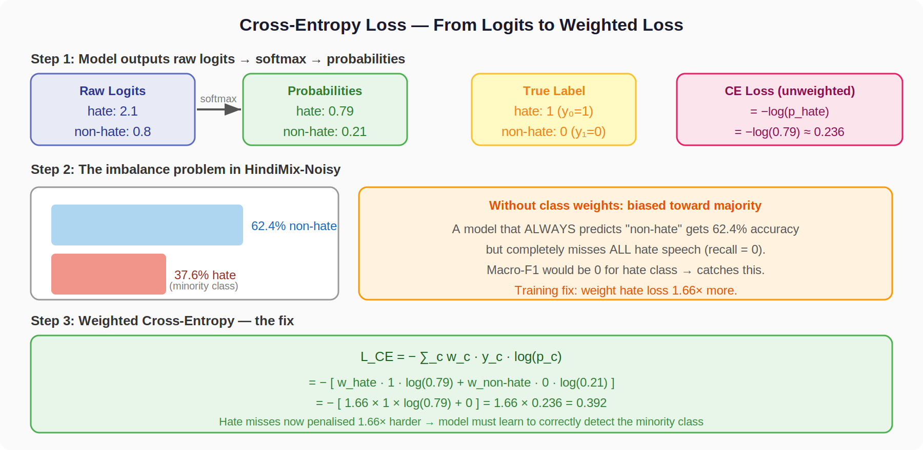
Figure 3: Cross-entropy loss explained with class imbalance correction (1.66:1 hate weighting)

4.3 The Class Imbalance Problem and the Fix
The HindiMix-Noisy clean training set has 37.6% hate and 62.4% non-hate. This is a class imbalance — the minority class (hate) is what we most need to detect.
Problem: A model that always predicts "non-hate" achieves 62.4% accuracy but detects zero hate. Macro-F1 would be ~0.38 (F1=0 for hate class, F1=0.77 for non-hate class, average=0.38). Plain cross-entropy allows this lazy solution.
Fix: Weighted cross-entropy gives higher penalty to misclassifying the minority class:
L_CE_weighted = − ∑_c w_c · y_c · log(p_c)
w_c = inverse class frequency. w_hate = 1/0.376 ÷ norm, w_non-hate = 1/0.624 ÷ norm
In practice: w_hate = 1.66, w_non-hate = 1.0. Now a hate miss costs 1.66× more than a non-hate miss. The model must learn to catch hate speech.
Study Resource: ML Cheatsheet — Cross-Entropy Loss (concise reference)

Part 5 — InfoNCE: The Foundation of Contrastive Learning

InfoNCE is the loss function that PWNIC generalises. You must understand InfoNCE deeply before PWNIC makes sense. This section builds it from scratch: what problem it solves, what the formula means, and what happens during training.

5.1 The Problem: Representations That Drift Under Noise
Suppose you have a clean sentence "tera baap hai" and its ASR-noisy version "tera bap hia". The encoder produces embeddings z^c and z^n for these.
Without any special training, z^c and z^n can be far apart in embedding space even though they mean the same thing. The encoder was trained on clean text and has no incentive to keep noisy representations close to their clean counterparts.
Consequence: the classifier trained on z^c (clean text) may completely fail on z^n (noisy text) because it lives in a different region of embedding space — one the classifier never trained on.

What Contrastive Learning Does
Pull TOGETHER: representations of the SAME utterance (clean and noisy) should be close in embedding space.
Push APART: representations of DIFFERENT utterances should be far from each other.
Result: the encoder learns representations that are noise-invariant — the same content maps to similar embeddings regardless of corruption level.
This is the same idea behind SimCSE, SpokenCSE, and NoiseBridge.

5.2 InfoNCE Loss — Step-by-Step Derivation
Setup: We have a batch of N (clean, noisy) pairs. For pair i:
- p^c_i = π_ξ(z^c_i) — clean projection
- p^n_i = π_ξ(z^n_i) — noisy projection
- π_ξ — a 2-layer MLP projection head (separate from the classifier)

Why a Separate Projection Head?
Chen et al. (2020) SimCLR showed that contrastive gradients should not flow through the main classification space. The projection head π_ξ creates a separate contrastive space where alignment happens. This prevents PWNIC from distorting the features the classifier relies on.

The InfoNCE Formula
For a batch of N pairs, we treat each clean embedding p^c_i as an anchor:
L_InfoNCE = −(1/N) ∑ᵢ log [ exp(sim(pᵢᶜ, pᵢⁿ) / τ) / ∑_{k≠i}^{2N} exp(sim(pᵢᶜ, pₖ) / τ) ]
sim(a,b) = aᵀb / (‖a‖ · ‖b‖) (cosine similarity) τ = temperature = 0.15

Unpacking Each Part
Numerator exp(sim(p^c_i, p^n_i)/τ): similarity between the CORRECT pair (anchor clean, its own noisy version). We want this to be LARGE.
Denominator ∑_{k≠i}^{2N} exp(sim(p^c_i, p_k)/τ): sum over ALL 2N embeddings in the batch (N clean + N noisy) EXCEPT the anchor itself. This includes all wrong pairings.
log[num/denom]: taking the log of a fraction. Maximising this = making the correct pair similarity dominate the denominator.
Negating and averaging: we minimise the loss, which maximises the similarity to the correct pair and minimises it to all others.
Temperature τ=0.15: low τ makes the distribution sharper — the model must push the correct pair MUCH closer than all negatives. High τ is more permissive. τ=0.15 is from SimCSE.

A Concrete Example with Numbers
Say N=3 pairs. p^c_1 is the anchor (clean embedding of pair 1). Batch has 6 embeddings: [p^c_1, p^c_2, p^c_3, p^n_1, p^n_2, p^n_3].
Cosine similarities (τ=1 for simplicity):
Similarities | Type
sim(p^c_1, p^n_1) = 0.85 ← CORRECT pair | sim(p^c_1, p^n_2) = 0.20
sim(p^c_1, p^c_2) = 0.30 | sim(p^c_1, p^n_3) = 0.15
sim(p^c_1, p^c_3) = 0.25 | ← all negatives (wrong pairs)

loss_1 = −log(e^0.85 / (e^0.30 + e^0.25 + e^0.20 + e^0.15)) = −log(2.34 / (1.35 + 1.28 + 1.22 + 1.16)) = −log(2.34 / 5.01) = −log(0.467) ≈ 0.762
After training, if sim(p^c_1, p^n_1) = 0.98 and negatives stay at 0.2: loss_1 = −log(e^0.98 / (e^0.2×4)) ≈ −log(2.66 / (1.22×4)) = −log(0.545) ≈ 0.607 — loss decreases. This is the learning signal.
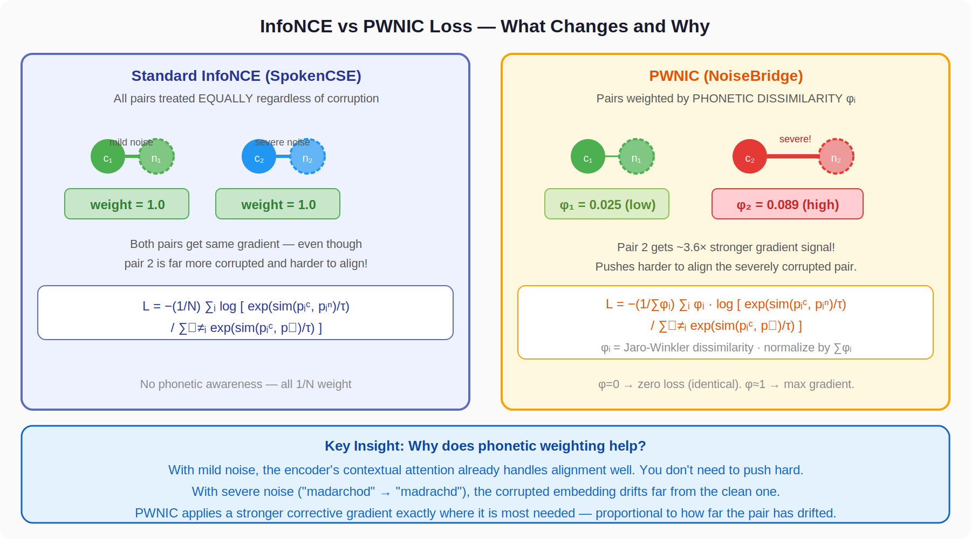
Figure 4: InfoNCE (uniform weights) vs PWNIC (phonetic weights) — what changes and why
Study Resource: van den Oord et al. (2018) — Contrastive Predictive Coding (original InfoNCE paper)
Study Resource: Gao et al. (2021) — SimCSE (best tutorial for InfoNCE in NLP)

Part 6 — Jaro-Winkler Similarity: The Phonetic Measure

Jaro-Winkler is the metric used to measure how phonetically similar a clean word is to its ASR-corrupted version. It determines the weight φ in PWNIC.

6.1 Why Not Use Edit Distance?
Edit Distance | Jaro-Winkler
Edit distance ("madarchod" vs "madrachd") | Jaro-Winkler ("madarchod" vs "madrachd")
Distance = 2 (swap + delete) | JW ≈ 0.974 (very similar)
Between "cat" and "car": distance = 1 | Between "cat" and "car": JW ≈ 0.944
Between "aaaa" and "zzzz" (len=4): distance = 4 | Between "aaaa" and "zzzz": JW ≈ 0.0
NOT bounded — hard to use as a weight | BOUNDED [0,1] — directly usable as weight
Treats all substitutions equally | Rewards prefix matches (phonetically motivated)

6.2 Jaro Similarity — Full Formula
Given two strings s and t:
Step 1: Compute matching window size: w = floor(max(|s|, |t|) / 2) − 1
Step 2: Characters s[i] and t[j] match if they are the same character AND |i−j| ≤ w
Step 3: Count m = number of matching characters
Step 4: Count transpositions t' = number of matching chars in different order / 2
Jaro(s,t) = (1/3) · [ m/|s| + m/|t| + (m − t')/m ]
= 0 if m=0. Components: recall (m/|s|), precision (m/|t|), transposition penalty ((m−t')/m)

6.3 Jaro-Winkler: Add Prefix Bonus
Words with common prefixes are more likely to be phonetically similar (e.g., "mad..." vs "mad..."). JW adds a bonus:
JW(s,t) = Jaro(s,t) + l · p · (1 − Jaro(s,t))
l = common prefix length (max 4 chars). p = 0.1 (standard scaling factor).

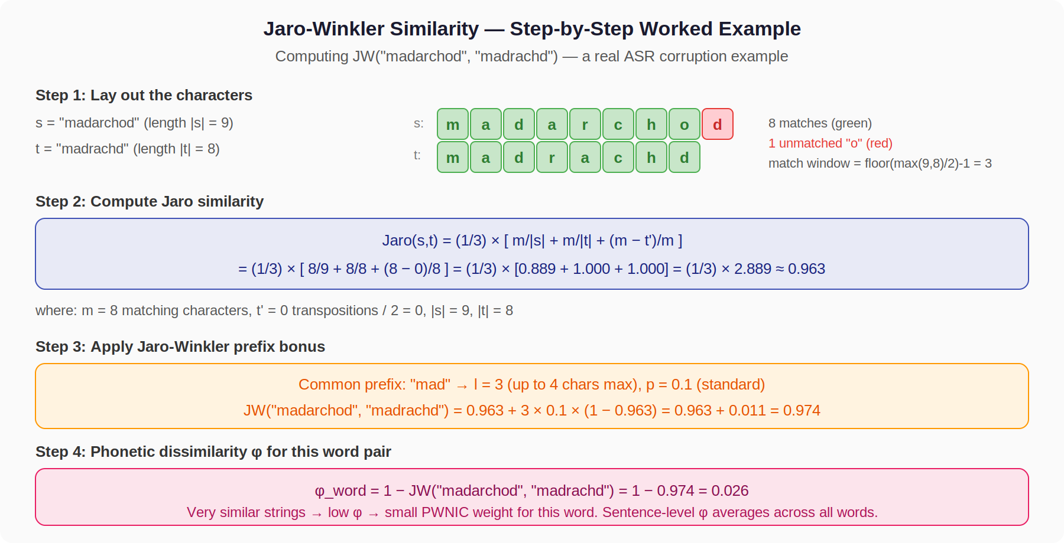
Figure 5: Full Jaro-Winkler computation for "madarchod" vs "madrachd" — a real ASR corruption

6.4 From Word-Level JW to Sentence-Level φ
PWNIC operates at the sentence level. φ is computed over aligned word pairs:
φ(x^c, x̃) = 1 − (1/M) ∑_{j=1}^{M} JW(w_j^c, w_j^n)
M = max(|x^c|_words, |x̃|_words). Unpaired words (unequal length) contribute JW=0 → similarity 0 → full dissimilarity.
φ ∈ [0, 1]. φ=0: texts are word-for-word identical. φ=1: completely different words. φ is the WEIGHT in PWNIC — higher φ means more contrastive pressure.
Empirical values from the paper: mean φ = 0.025 (low noise), 0.039 (medium), 0.056 (high). This confirms the weighting correctly escalates with noise level.
Study Resource: Wikipedia: Jaro-Winkler distance (with worked examples)

Part 7 — PWNIC Loss: The Full Derivation

Now that you understand InfoNCE and φ separately, PWNIC is simply InfoNCE with per-pair weighting by φ. This section derives it fully and explains every design decision.

7.1 The Problem with Uniform InfoNCE for Noise
In a training batch, you have some pairs with mild noise (φ≈0.025) and some with severe noise (φ≈0.056). Standard InfoNCE gives them identical weight 1/N.
But the severely corrupted pairs need more corrective force — their embeddings drift further and require stronger gradients to pull back into alignment. Uniform weighting wastes gradient budget on easy pairs and under-serves hard ones.

7.2 PWNIC: Full Formula
L_PWNIC = −(1/∑ᵢ φᵢ) · ∑ᵢ φᵢ · log[ exp(sim(pᵢᶜ, pᵢⁿ)/τ) / ∑_{k≠i}^{2N} exp(sim(pᵢᶜ, pₖ)/τ) ]
Where φᵢ = phonetic dissimilarity of pair i, τ=0.15, sim = cosine similarity

7.3 Every Design Decision Explained

Why normalise by ∑φᵢ instead of N?
If you divided by N (as in InfoNCE), the loss scale would depend on how many high-φ pairs happen to be in the batch. By dividing by ∑φᵢ, you normalise across the actual total phonetic work being done in the batch. Loss is comparable across batches with different noise compositions.
Edge case: If all pairs have φᵢ=0 (clean text, no noise), then ∑φᵢ=0. Each φᵢ·log[...] = 0·(finite) = 0, and 0/0 is handled by adding ε=1e-8 to the denominator. The loss is correctly 0.

Why use the denominator sum over 2N embeddings?
The denominator includes all 2N embeddings (N clean + N noisy) EXCEPT the anchor p^c_i. This means:
- In-batch negatives: other clean embeddings (different utterances) are negatives
- Cross-stream negatives: noisy embeddings of OTHER pairs are also negatives
- NOT a negative: p^n_i (the correct noisy pair of p^c_i) — this is excluded because it's the positive
Using 2N negatives gives a richer, harder contrastive problem than just N negatives — the model must distinguish p^c_i from both clean and noisy embeddings of all other utterances.

What does ∂L_PWNIC/∂p^c_i look like?
For a single pair i, the gradient with respect to the clean projection is approximately:
∂L_PWNIC/∂pᵢᶜ ∝ φᵢ · ( softmax(pᵢᶜ, all_negatives) − pᵢⁿ )
Higher φᵢ → larger gradient → stronger push to move p^c_i toward p^n_i (and away from negatives).
When φᵢ = 0: gradient is 0. Encoder weights unchanged for this pair. When φᵢ = 0.056 (high noise): gradient is 2.24× larger than a pair with φᵢ = 0.025 (low noise).

7.4 Special Cases — Proving Correctness
Proof: PWNIC reduces to InfoNCE when all φᵢ = φ (constant)
L_PWNIC = −(1/∑φᵢ) · ∑ᵢ φ · log[...]
= −(1/Nφ) · Nφ · (1/N) ∑ᵢ log[...]
= −(1/N) ∑ᵢ log[...]
= L_InfoNCE ✓
PWNIC is a strict generalisation. With uniform weights, it IS InfoNCE.

Proof: PWNIC = 0 when all pairs are identical (φᵢ = 0)
Each term: φᵢ · log[...] = 0 · log[...] = 0
Normalisation: ∑φᵢ = 0, but each term is 0 (0/ε → 0)
L_PWNIC = 0 ✓
No need to align representations that are already identical — the loss correctly vanishes.

7.5 The Projection Head π_ξ
π_ξ is a 2-layer MLP: Linear(d, d) → ReLU → Linear(d, proj_dim). It maps sentence representations z ∈ ℝd to a contrastive projection space.
Why it is crucial: Without π_ξ, the PWNIC gradients flow directly into the encoder representations that the classifier uses. This interferes with the classification objective — the encoder learns to be contrastive at the expense of being discriminative.
With π_ξ: contrastive gradients are absorbed by π_ξ. The encoder learns representations that are good for BOTH classification (via L_CE) and contrastive alignment (via PWNIC through π_ξ). This separation is exactly the finding of Chen et al. (2020) SimCLR.
At inference time: π_ξ is discarded. Only z (the encoder output after the gate) is passed to the classifier. PWNIC has already shaped the encoder to produce noise-invariant z — the projection head was just the training scaffold.

Part 8 — Noise-Aware Gate and Auxiliary Loss

8.1 The Noise-Aware Attention Gate
The gate is a per-token sigmoid filter applied to the encoder's hidden states:
g_ψ(H) = H ⊙ σ(W_g · H + b_g)
W_g ∈ ℝᵈˣ¹. σ = sigmoid ∈ (0,1). ⊙ = element-wise multiplication (broadcast across d).
Each token position i gets a scalar gate value gᵢ ∈ (0,1). The token's d-dimensional hidden state Hᵢ is scaled by gᵢ. Tokens the gate assigns values near 0 contribute little to the sentence representation; those near 1 contribute fully.

⚠️ Critical Finding: The Gate Alone Hurts Performance
Gate only (no PWNIC): Avg F1 = 0.8339 (vs 0.8394 baseline) — WORSE by 0.0055.
Why? Without PWNIC, the gate has no external signal telling it what "corrupted" means.
It learns to suppress arbitrary tokens, accidentally suppressing informative ones.
PWNIC provides the supervision: tokens that contribute to misalignment with the clean counterpart should be down-weighted.
Gate + PWNIC: Avg F1 = 0.8401 — recovers and exceeds baseline by +0.0007.
Gate + PWNIC + Aux: Avg F1 = 0.8434 — further improvement.

Mean pooling after the gate:
z = ∑ᵢ [g_ψ(hᵢ) · mᵢ] / ∑ᵢ mᵢ
mᵢ ∈ {0,1} = attention mask (0 for padding tokens). Weighted mean of gated representations.

8.2 Auxiliary Noise-Level Classifier
A separate linear head q_η: Linear(d, 4) predicts the noise level of the NOISY representation z^n. The 4 levels are: clean=0, low=1, medium=2, high=3. Loss is standard cross-entropy:
L_aux = − ∑_{k=0}^{3} y_k^noise · log q_η(z^n)_k
Applied only to the noisy stream. At inference: q_η is discarded.
Why it helps: Forcing the encoder to produce representations from which noise level is predictable encourages the encoder to develop noise-level-aware features. These features help the main classifier implicitly distinguish clean from noisy input characteristics.
Auto-disable: If all examples in a batch come from the same noise level, all y^noise labels are identical (constant target). The classifier trivially outputs the same class always. The L_aux gradient would carry no useful information — only noise. Therefore: L_aux is set to 0 if the batch contains fewer than 2 distinct noise levels.

8.3 Total Training Objective
L = L_CE + α · L_PWNIC + γ · L_aux
α = 0.15, γ = 0.20. Class-weighted CE on both clean and noisy streams.
Gradient flow summary: L_CE → entire encoder + classifier. L_PWNIC → encoder + gate + projection head π_ξ. L_aux → encoder + gate + q_η. All three simultaneously.
Training data: Both baselines AND NoiseBridge train on the FULL dataset: clean (78,778) + low (14,951) + medium (14,951) + high (14,951) = 123,631 examples. One model per encoder, evaluated on each of 4 test conditions independently.

Part 9 — Why Gradient Reversal Failed: The Full Analysis

NoiseBridge v1 included a Gradient Reversal Layer (GRL) — a technique that works in domain adaptation but fails structurally here. This is one of the most important findings in the paper.

9.1 What GRL Does in Domain Adaptation
DANN (Ganin et al., 2016) applies GRL to make an encoder produce domain-invariant representations. Architecture:
- Encoder produces z
- Task classifier uses z → minimise task loss
- Domain discriminator tries to predict domain (source vs target) from z
- GRL reverses the gradient from the discriminator: encoder is trained to FOOL the discriminator
Result: encoder cannot encode domain information → features are domain-invariant → better generalisation.
Works in DANN because: source domain and target domain are ALWAYS distinct (e.g., real photos vs sketches). The discriminator always has a non-trivial target.

9.2 The Failure Mode in NoiseBridge v1

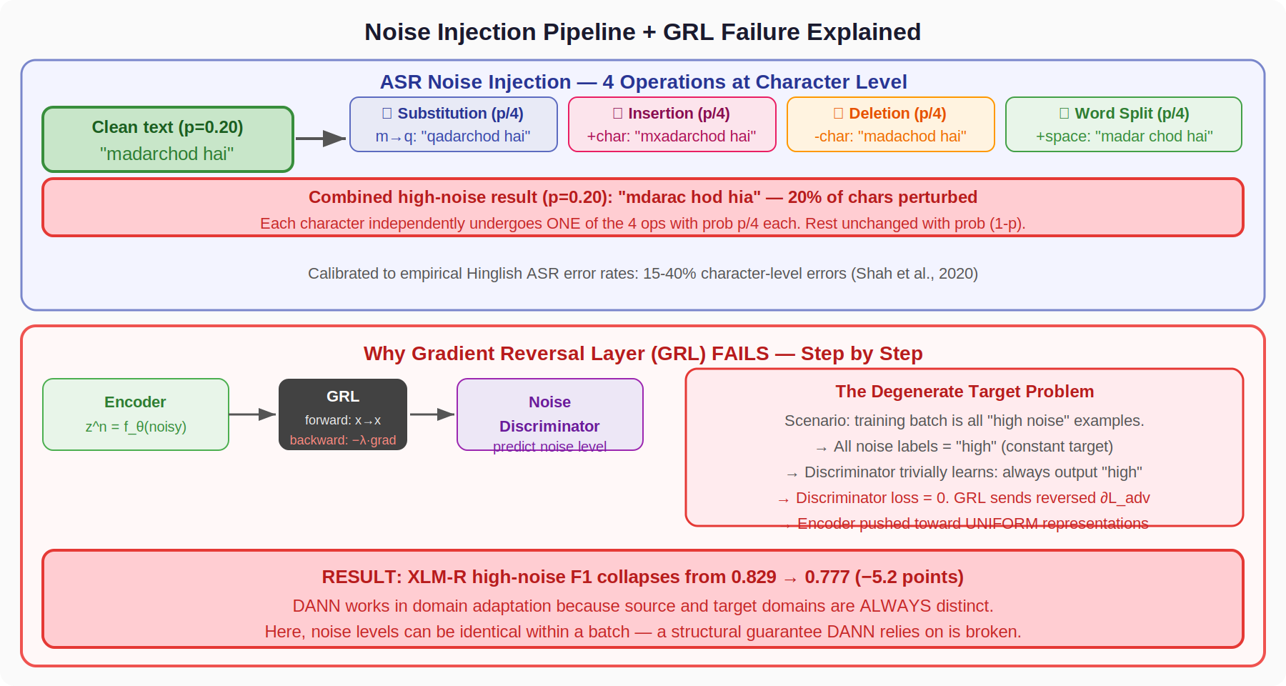
Figure 6: Noise injection pipeline and GRL failure — the degenerate target problem visualised
Failure Mode 1 — Degenerate Targets:
In the NoiseBridge training loop, batches can come from a single noise level (e.g., the "high noise" subset). In this case:
- All noise labels in the batch = "high" (constant)
- The adversarial noise discriminator achieves zero loss trivially by always predicting "high"
- The discriminator loss ∂L_adv = 0 (or near-zero, since gradient is flat at minimum)
- GRL reverses this zero/flat gradient → pushes encoder toward uniform representations
- Classification loss catastrophically degrades: XLM-R high-noise F1: 0.829 → 0.777 (−5.2 pts)

Failure Mode 2 — Contradictory Gradients:
The auxiliary head (γ=0.10 in v1, NO reversal) and adversarial head (β=0.3, WITH GRL reversal) operate on the same z^n with opposite objectives:
- Aux head: "make noise level predictable from z^n" (encoder learns structure)
- Adv head + GRL: "make noise level UNpredictable from z^n" (encoder destroys structure)
With β=0.3 > γ=0.10, the adversarial gradient dominates. The aux head becomes noise. MuRIL medium collapse: 0.831 → 0.786 (−4.5 pts).

The Fix: Remove GRL Entirely (v2)
Keep: L_CE + L_PWNIC + L_aux (no GRL).
Add auto-disable for L_aux when batch has < 2 noise levels.
Result: XLM-R high-noise recovers to 0.835 (+0.56 over baseline).
The lesson: adversarial objectives require a structural guarantee that targets are always non-trivial. Noise levels can collapse to a single class within a batch — DANN's guarantee does not hold here.
Study Resource: Ganin et al. (2016) — Domain-Adversarial Training (original DANN paper)

Part 10 — Putting It All Together: The Complete NoiseBridge Pipeline

With all components understood individually, here is how they work together end-to-end during one training step.

10.1 One Training Step, Traced Through
- Input: A batch of N sentence pairs. Each pair: (x^c_i, x̃_i, y_i, noise_level_i). x^c = clean text, x̃ = noisy version, y = hate/non-hate label, noise_level ∈ {0,1,2,3}.
- Tokenise: x^c_i and x̃_i are tokenised separately. XLM-R SentencePiece preserves phonetic differences.
- Compute φᵢ: Jaro-Winkler dissimilarity between x^c_i and x̃_i (precomputed, stored as float in the dataset).
- Encode: Both x^c_i and x̃_i are fed through the SHARED encoder f_θ. Outputs: H^c_i, H̃_i ∈ ℝ^{L×d}.
- Gate: Apply g_ψ to both. Gate down-weights noisy tokens. Mean-pool with mask: z^c_i, z^n_i ∈ ℝ^d.
- Classify: clf_head(z^c_i) → logits_clean. clf_head(z^n_i) → logits_noisy. L_CE = class-weighted CE on both.
- Project: π_ξ(z^c_i) = p^c_i. π_ξ(z^n_i) = p^n_i. Compute L_PWNIC across batch with φ weights.
- Aux: If |{noise_level in batch}| ≥ 2: q_η(z^n_i) → predict noise level. Compute L_aux.
- Total loss: L = L_CE + 0.15·L_PWNIC + 0.20·L_aux. Backpropagate. AdamW step.
- Repeat: 5 epochs, 3 seeds. Best checkpoint on validation macro-F1.

10.2 What Each Component Contributes
Component | Role
L_CE (weight 1.0) | Core classification signal — learn hate vs non-hate
L_PWNIC (weight 0.15) | Pull clean/noisy pairs together, weighted by φ
L_aux (weight 0.20) | Regularise encoder to be noise-level-aware
Noise-Aware Gate | De-emphasise corrupted tokens before pooling
Projection Head π_ξ | Isolate contrastive gradients from classification space

10.3 Final Numbers to Know by Heart
Configuration | Result
XLM-R baseline (avg F1) | 0.8394
XLM-R + NoiseBridge (avg F1) | 0.8434 (seed 42), 0.843 (avg)
XLM-R + NoiseBridge (high noise) | 0.835 ± 0.002
mBERT + NoiseBridge (avg F1) | Within seed variance of baseline
MuRIL + NoiseBridge (avg F1) | Within seed variance of baseline
Gate alone (avg F1) | 0.8339 (−0.0055 from baseline)
Gate + PWNIC (avg F1) | 0.8401 (+0.0007 from baseline)
Gate + PWNIC + Aux (avg F1) | 0.8434 (+0.0040 from baseline)
NB v1 with GRL (avg F1) | 0.8237 (−0.0157 from baseline)
XLM-R baseline high noise | 0.8294
XLM-R v1 (GRL) high noise | 0.777 (−5.2 pts)

End of Deep Explanation Document
For the complete panel Q&A, proofs, and code reference: see RESEARCH_DEEP_REFERENCE.md and CLAUDE_CODE_CONTEXT.md

