Week 02 – Portfolio Entry
Explanation of Activities
Week 2 tutorial was on the setup of the static IP addresses with several approaches and testing network connectivity with the ping command in a simulated environment.
This project consisted of four Linux host machines and an Ethernet switch, which were installed and interconnected to form a Local Area Network (LAN). A local, IPv4 (e.g. 10.1.1.0/24) IP network was selected, and each host was assigned its own IP address in this IP network.
There were three methods of setting up the static IP addresses:
GNS3 Configuration Interface:
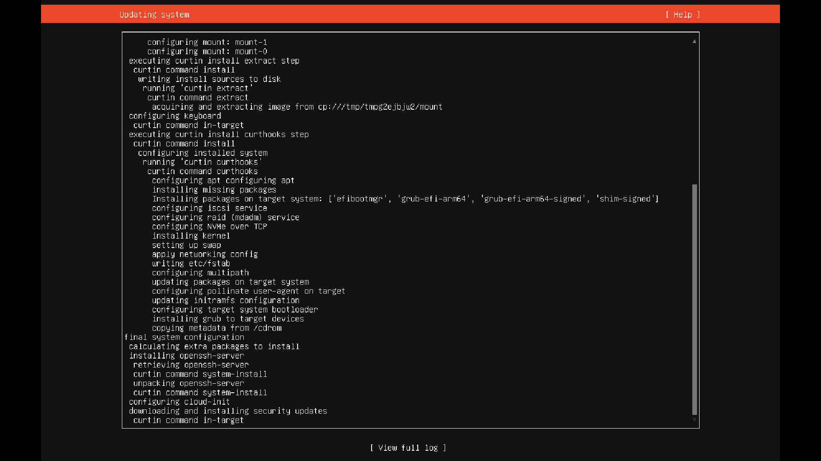
Figure 1: Proxy Configuration Screen During Linux Installation
The default GNS3 menu of Configure was used in the case of the first two hosts to set the IP addresses. This is a simple approach that enables users to set network settings prior to the node being booted, and is also maintained across reboots.
Manual Setup with /etc/network/interfaces:
On the third host, the IP was manually assigned by changing the /etc/network/interfaces file with the help of a text editor (nano).
Using the ip Command:
This IP command achieves changes without a restart of the interface and is short-lived and will not persist after a reboot.

Figure 2: Markdown File Rendering
Once all the hosts were configured, the IP address show command was executed on each of the nodes to make sure that all the IP addresses were assigned. Evidence in the form of screenshots of the console output of each host and the network topology was taken.
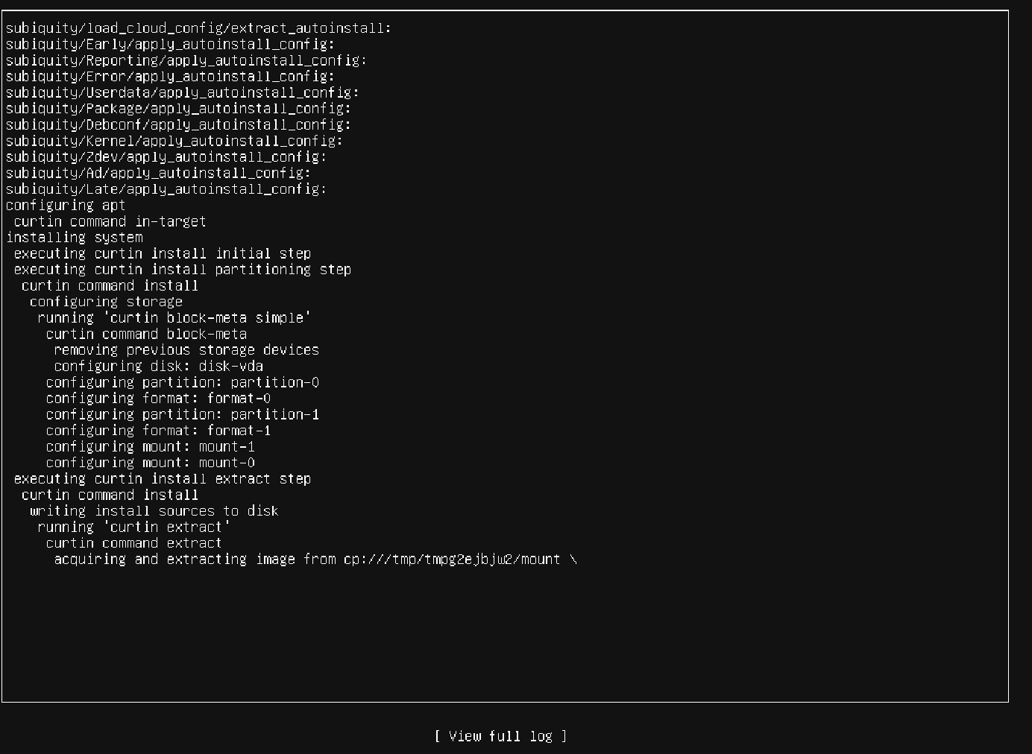
Figure 3: First Portfolio Entry Commit
The second task was on the connectivity test, where we used the ping command. Firstly, a ping test between two hosts was performed successfully, an exercise that confirmed the network reachability as well as round-trip time (RTT). Measurements derived (statistically) included transmitted packets, received packets, packet loss and average delay.
Ping test was run to a nonexistent IP address. This provided no answers, and this confirms that all the 100% of the packets are lost, and this reveals how ping can be used in determining the inaccessibility of the devices.
Finally, different ping options were tested, such as the number of packets (-c), interval (-i) and packet size (-s). Such distinctions helped in the perception of how the network performance and behaviour can be studied in different situations.
Reflection and Learning
Week 2 assisted me considerably in understanding the IP address configuration and troubleshooting networks. Two approaches to the allocation of IP addresses, as well as knowledge about them, provided an understanding of the long-term and short-term settings. I have also realised that the GNS3 interface is user-friendly, but manual configuration would offer extra control and understanding of the work of the Linux network.
The editing of the /etc/network/interfaces file was particularly helpful as it demonstrated how settings can be set and applied at the system's level. However, there were some challenges in making changes, as I did not restart the interface. This enabled me to understand the importance of good reloading of the configuration.
The ip command was fast and effective to use, though I was informed that it cannot be applied in permanent settings. This contrast between temporary and permanent settings is above all in the reality network.
The ping exercises proved to be eye openers. I have developed a better understanding of the measurement of connectivity and the use of RTT and packet loss to gauge network performance. The graphical representation of the ping's successful and unsuccessful outcomes helped to substantiate the concepts of reachability and troubleshooting.
My testing of ping options enabled me to experiment with the customisation of network testing. The delay and transmission were affected by the size of the packet or the time interval, for example.

