Week 04 – Portfolio Entry
Explanation of Activities
Week 4 tutorial focused on the comprehension of routing tables, their functionality in an attempt to send packets and an explanation of dynamic routing built on the basis of OSPF in a simulated network.
In Task 1, I developed a GNS3 project called View-Routes-studentid. Network topology comprised three Linux-based hosts, a Linux-based router and an Ethernet switch. The two hosts were connected to the router (one subnet), and the third host connected directly to the router (another subnet). This installation made it possible to communicate between the two networks.
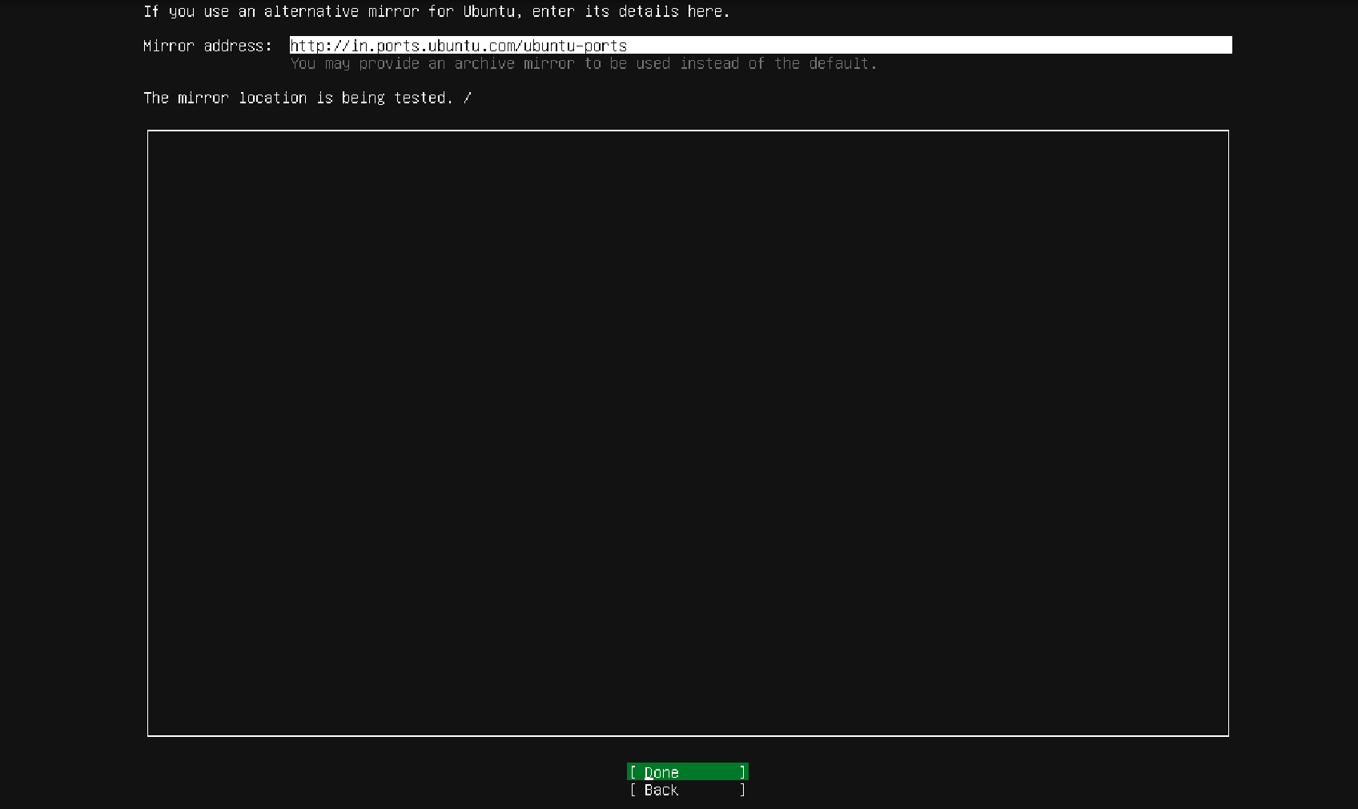
Figure 1: Portfolio Update with Weekly Progress
All the devices were given a fixed IP address in accordance with two distinct IPv4 subnets (e.g., 10.1.1.0/24 and 10.1.2.0/24). The router was set in such a way that it had two interfaces that were connected to two subnets. With the hosts, a default gateway was created which pointed to the IP address of the router of the respective subnet.
To change the net.ipv4.IP forwarding to 1 and forwarding packets between subnets, the router was altered. Forwarding on the hosts was turned off (net.ipv4.ip_forward=0) to make the hosts act as end devices but not as routers.
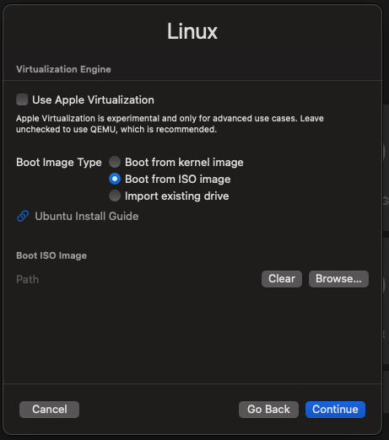
Figure 2: Linux Virtualisation engine
After all the nodes had been started, I typed in the following command:
ip route show
In order to connect the hosts, I used ping tests between different hosts within dissimilar subnets. The router was correctly routing packets inter-networks, which was manifested by the effective responses. Evidence was captured in the form of Routing table screenshots, IP settings and ping output.
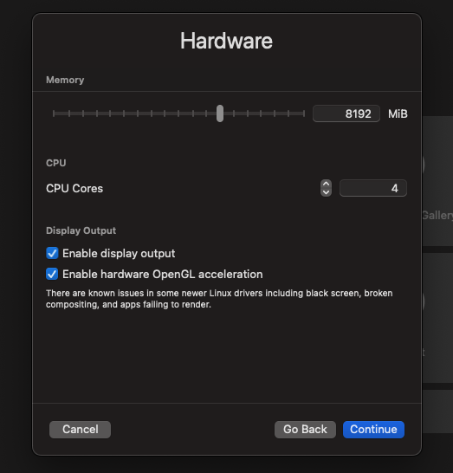
Figure 3: Hardware
Task 2 was to import a pre-configured project in GNS3 to have a go at dynamic routing using OSPF. This network comprised two hosts and four FRR routers set up with OSPF.
These instructions indicated the neighbour routers, dynamically learned routes, and the routing table overall utilised to forward.
Then I started by typing in the traceroute command to trace the path that packets took between two hosts. The initial action was to utilise traffic according to the optimal trail determined by OSPF. I disabled one of the NETem nodes and tried to simulate a network failure. This was followed by an execution of traceroute, which showed that the route had been altered, demonstrating how OSPF dynamically calculates the routes whenever there are topological changes.
Reflection and Learning
Week 4 provided a better insight into the routing experience in both intra- and inter-network. I also familiarised myself with the fact that routing tables are crucial in determining how packets are placed and that all devices have their own understanding of the network.
A use of the default gateway was among the lessons taken. Without adequately setting up the gateway on the hosts, the hosts would not be able to communicate across subnets. This reiterated the essence of a good network set-up in practice.
Application of IP forwarding on and off helped me to draw a clear distinction between the roles of hosts and routers. I came to know that routers must be operational in forwarding packets, but the hosts will not. This is one of the major differences in network design.
Of interest was the dynamic routing using OSPF. Another difference between OSPF and traditional routing is that, unlike traditional routing, OSPF automatically is capable of updating the routing tables based on network changes. The Resourcefulness and adaptability of dynamic routing algorithms were noted through the changes in routes as a result of link failure.
The traceroute tool enabled me to see the actual routes the packets take on the network. This gave life to the abstract routing concepts, and it became easier to comprehend.
One of the issues that arose was in decoding routing tables and OSPF output because they were too technical. However, I would be able to understand them provided that I focus on such points as destination networks and next-hop addresses.

