Week 05 – Portfolio Entry
Explanation of Activities
Week 5 tutorial included configuring Virtual Local Area Networks ( VLANs ) on a switch, and permitting VLANs to inter-communicate via a router.
In Task 1, I created a GNS3 project named Vlan-Basics-<studentid>. This topology had four Linux hosts, which were connected to an open-source switch. Each of the hosts was then given an IP address in the same subnet to check basic connectivity. After starting all the nodes, I made sure that all of the hosts could communicate with other hosts using ping.
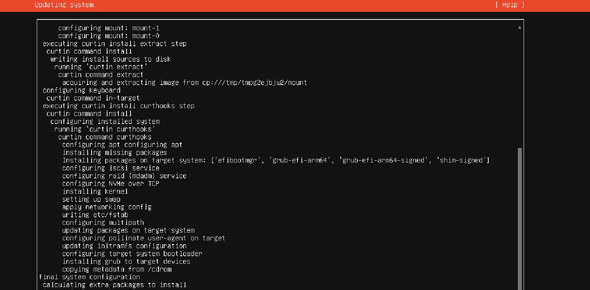
Figure 1: Testing Results and Command Output
The switch was then configured with VLANs to make the network logically isolated. There were two hosts that were allocated to a single VLAN, and the remaining two to another VLAN through commands.
After implementing VLAN settings, connectivity tests indicated that in the same VLAN, hosts could communicate, but in different VLANs, cross-communication was not possible. This showed the isolation of network traffic by VLANs. I also checked ARP tables to determine how addresses got learned only by the devices in its VLAN.
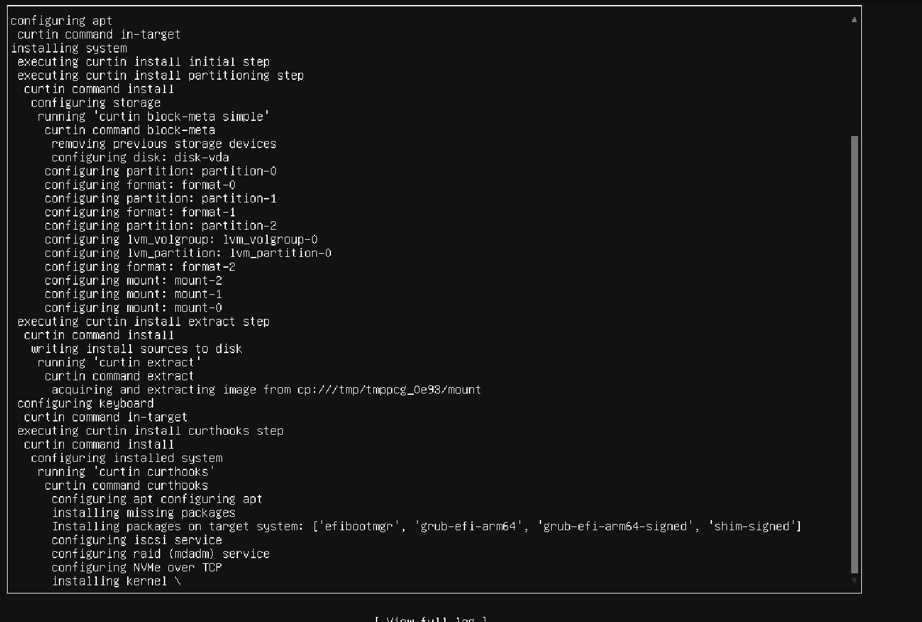
Figure 2: Reflection and Learning Summary in Portfolio
Task 2, in which I was able to set up a Linux router by enabling communication between VLANs (inter-VLAN routing). This project was duplicated to Vlan-Router- <studentid>. The router was hooked up between the switch and port eth0.
The router has been configured to allow the traffic of various VLANs by configuring the switch port.
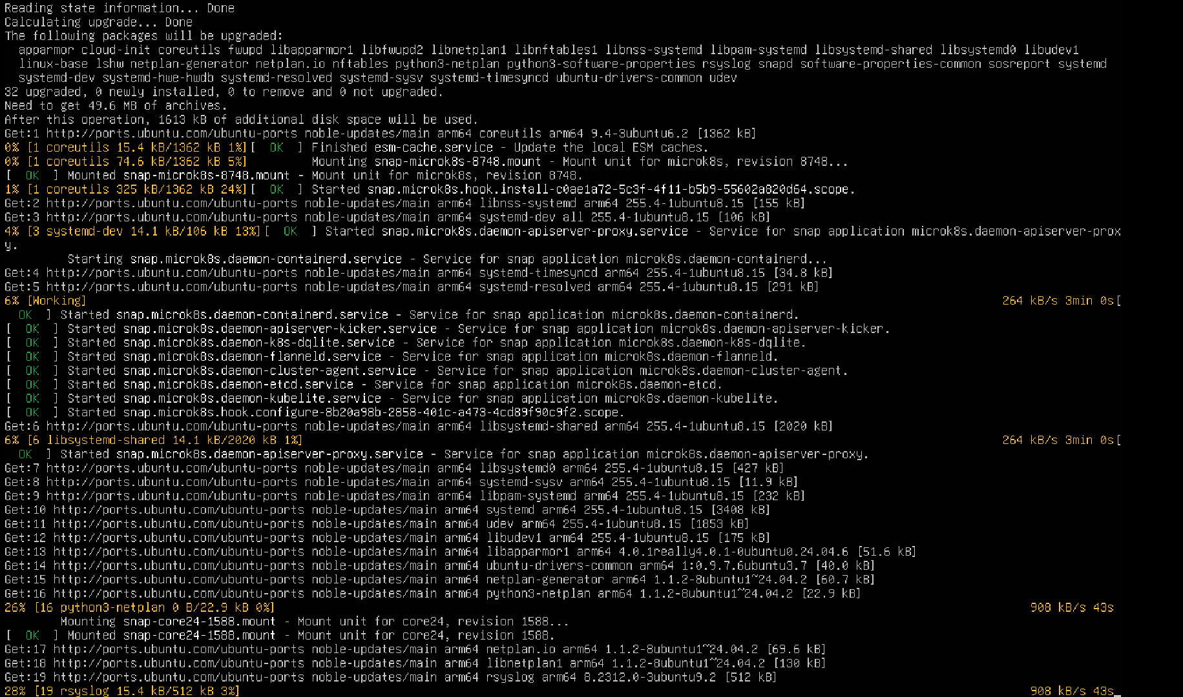
Figure 3: Code Execution and Output Verification
The sub-interfaces were given an IP address of the respective subnet of the VLAN. Hosts were also reconfigured to two different IP subnets depending on their membership of VLAN.
After configuration, again I tested the connectivity. This was the first time the hosts were able to communicate with each other through the router, and this was an indication that inter-VLAN routing was a success. Network topology, VLANs setup and outputs were captured as screenshots.
Reflection and Learning
Week 5 provided a practical example of VLANs in improving network organisation and security of a network by breaking it down into smaller logical groups to improve organisation. I realised that although devices may be physically linked to the same switch, VLANs may limit traffic and minimise unnecessary traffic.
Some of the lessons included the difference between access ports and trunk ports. Access ports are used to join end devices and are part of one VLAN, whereas trunk ports transmit traffic between two or more VLANs. It forms a usual notion in the real-world enterprise networks.
Installing VLANs in the router on sub-interfaces was not that simple initially, especially without understanding of how to have one physical interface to support a huge number of VLANs. However, after it was implemented, I realised how routers can be used in the process of communication between the isolated VLANs.
As also on bare knowledge of the effects of the segmentation and routing, the value of testing before and after VLAN setting proved helpful.

