Week 06 – Portfolio Entry
Explanation of Activities
In Week 6, the tutorial was about how the devices translate IP addresses to hardware addresses through the assistance of ARP, and how the default gateways make communication between various networks possible.
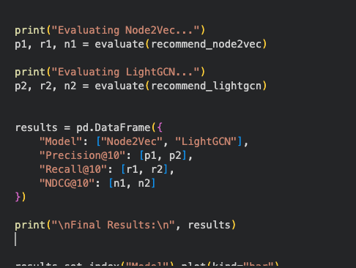
Figure 1: Evaluation Results of Node2Vec and LightGCN Models Using Precision, Recall, and NDCG Metrics
In Task 1, I used the network which I had previously constructed, which had four Linux hosts, linked together with a switch. The ARP table of one host (Host A) was analysed. Initially, the ARP table had few or no entries due to the host not communicating with other devices yet.
I re-examined the ARP table after having sent a ping request to Host B, sent by Host A. A new line was shown that indicated that the mapping of the IP address of Host B to the hardware (MAC) address of Host B was done. This indicated the way in which ARP is used to list the devices in the local network dynamically in a table.
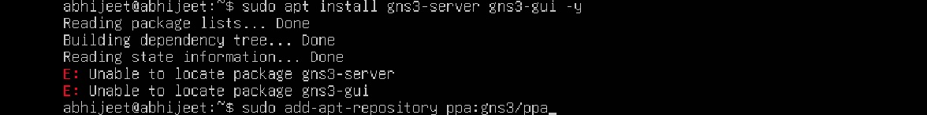
Figure 2: Final Portfolio Structure
Then, when another host (Host C) communicated with Host A, the ARP table of Host A was updated again. More entries were made, indicating that ARP is a continuous learner and constantly updates mappings as communication takes place. I also observed some states in the ARP table, such as REACHable, which is a valid and active connection. With time, I realised that entries that are not in use can be cleared, indicating that ARP tables are dynamic and temporary.
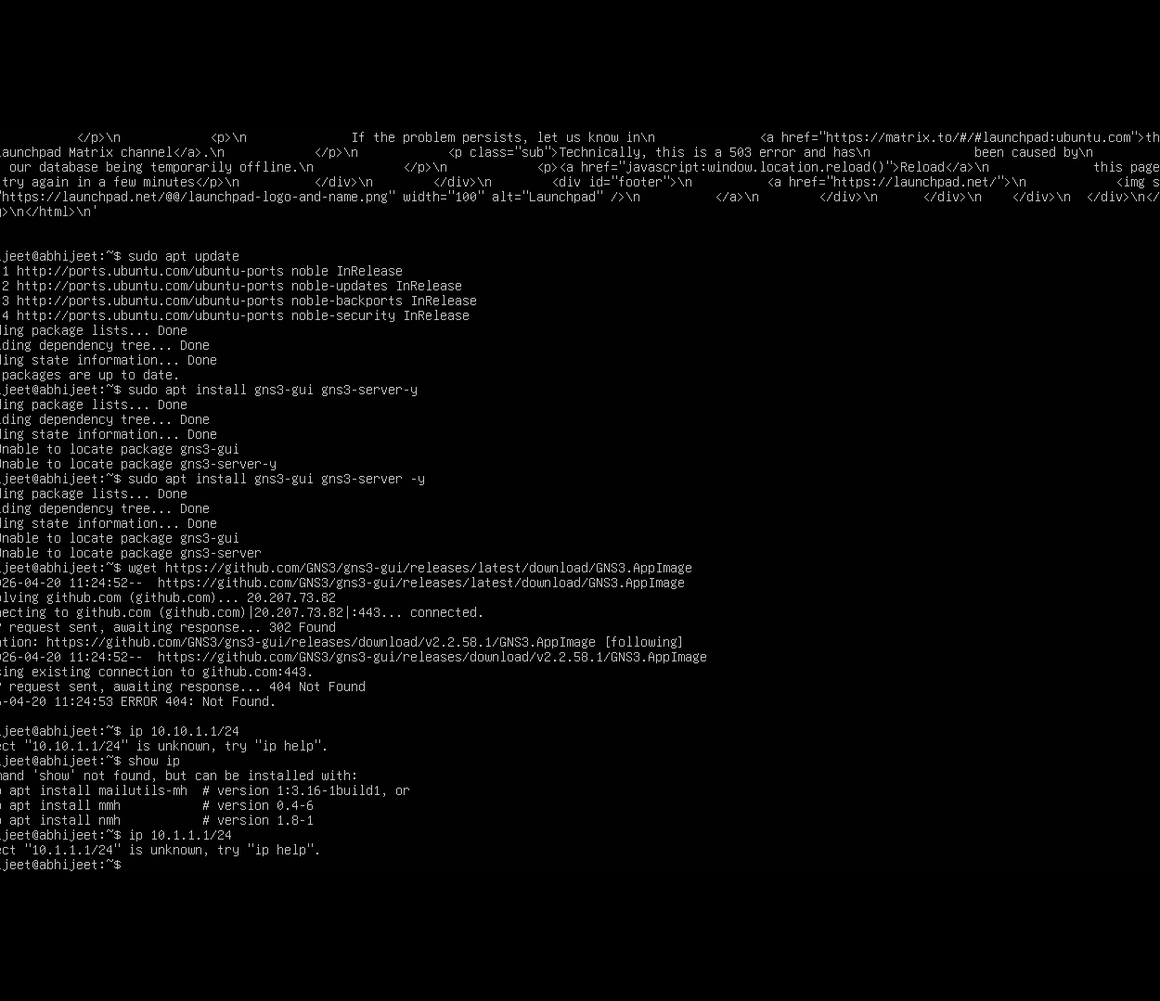
Figure 3: Output Results
In Task 2, I created a more complex network, which had two separate LANs that were connected by two routers. Each LAN had two hosts that were connected using a switch, and the routers were connected, thus comprising three subnets.
IP addresses were given to each device, and default gateways were set to hosts. Routers were forwarding enabled so that they could pass on the packets between networks, but the hosts were not forwarding enabled. I have then looked at routing tables after bootstrapping all of the devices to comprehend my traffic flow between subnets.
And finally, I tested connectivity by ping between hosts on other subnets. Good communication made default gateways, and routing was appropriately configured. The IP settings, routing table screenshots and the ping success were recorded.
Reflection and Learning
This week made me realise two basic concepts of networking: ARP and default gateways. I also got to know that ARP is the one that is relevant in communication within a local network since it gets to change the logical IP address into the physical hardware address. Devices would not be able to offer data at the data-link layer without ARP.
The dynamic change of the ARP table in real time gave me a more appropriate idea about the working of networks in real time. It further showed the role of communication as not only sending out the packets, but also the role of communication as locating and maintaining information about the devices.
The second exercise highlighted the role played by default gateways in bridging networks. I noted that unless there is a well-configured gateway, devices are not able to communicate outside their local subnet. This further supported the notion that routers are the intermediaries between networks.
Among the challenges I encountered was the way of routing tables and gateways in collaboration. Still, by studying the topic of packet flow and connectivity tests, I had the opportunity to learn how data flows in different networks.

