
MODE OF PAYMENT :
All payments are to be made only by demand draft (Nationalized bank only) in
favor of “PRINCIPAL, Sinhgad College of Engineering” payable at Pune.

ACCOMMODATION :
Accommodation will be available on concession rate.

HIGHLIGHTS :
- Selected papers in each track will be published in Journal Of Advances
in Engineering Science.
- Award will be given for the best paper submitted by any participant in RTCE-08

ADVISORY COMMITTEE:

Prof. M. G. Bhat, Prof. N. B. Pasalkar
Director, Engineering, STES DTE, MS., Mumbai

Dr. Mrs. K. C. Khare Prof. P. W. Wani,
Vice-Principal, SCOE Dean Faculty of Engineering
University of Pune.

Mr. J. N. Pitambare Prof. P. V. Garje
Dean, T & P, STES Chairman, BOS, Computer Engineering

INVITED TALK & INVITEES | TECHNICAL COMMITTEE
Dr.Umesh Bellur,IIT Mumbai  Dr.P.K.Sinha,C-DAC,Pune  Prof.A.W.Rohankar, SCOE Pune  Mr.Manish Mukhawani, AMDOCS Pune  Mr.Pavan Rathore, AMDOCS Pune.  Mr.Rajesh Jangam, BladeLogic Pune  Mr. G.K.Palshikar , TRDDC Pune  Mr. Manish Deshpande, AMDOCS, Pune. | Dr.A.V.Deshpande, SKNCOE, Pune.  Dr.Mrs.Rajurkar, MGM, Nanded.  Dr. Bhurchandi, Nagpur  Dr.S.G.Bhirud, VJTI, Mumbai.  Dr.Debhanis Dhar, MRSAC,Nagpur  Dr.Aditya Abhyankar, MAE, Alandi.  Mr.Anand Khobragade, MRSAC, Nagpur  Mr.Chintamani Deshpande,TCS, Pune.  Mr. Vithal Kulkarni, AMDOCS, Pune

ORGANISING COMMITTEE
Prof. Mr.M.M.Kodmelwar 9860154499
Prof. Mrs.G.G.Chiddarwar 9226588871
Prof. Mr.S.P.Bholane 9860999940
Prof. Mrs.D.D.Gatade 9422471991
Prof. Mrs.M.R.Dhage 9423020204
Prof. Mrs.E.Jayanthi 9821358864
Prof. Mrs.D.P.Salapurkar 9960686448
Prof. Mr. D.M.Bardale. 9960683967
Mrs. K. P. Wagh 9922113472
Mr. B. R. Devhare 9860940251

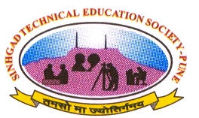
RTCE 2008

SINHGAD COLLEGE OF ENGINEERING, PUNE
DEPARTMENT OF COMPUTER ENGINEERING
(Accredited by NBA)
ORGANIZES
National Conference on
RECENT TRENDS IN COMPUTER ENGINEERING
RTCE-2008

February 18th- 20th, 2008

SPONSORED BY UNIVERSITY OF PUNE

PATRONS

Hon. Dr. Mrs. S.M. Navale Hon. Prof. Mr. M.N. Navale Founder Secretary, STES, Pune Founder President, STES, Pune

CONFERENCE CHAIR
Dr. Mr. A. S. Padalkar
Principal, SCOE, Pune

Prof.Mrs.S.R.Hiray Prof.Mr.P.R.Futane
Organizing Secretary Convener
srhiray.scoe@sinhgad.edu hodcomp.scoe@sinhgad.edu

Prof.Mr.U.A.Mande Prof.Mrs.S.A.Josh
Track Coordinator Track Coordinator
Data Mining & Warehousing Distributed System
uamande.scoe@sinhgad.edu sajoshi.scoe@sinhgad.edu

Prof.Mr.M.P.Wankhade Prof.Mr.P.M.Kamde
Track Coordinator Track Coordinator
Software Architecture Soft Computing
mpwankhede.scoe@sinhgad.edu pmkamde.scoe@sinhgad.edu

Sinhgad Technical Education Society’s
SINHGAD COLLEGE OF ENGINEERING
Vadgaon (BK), Pune-411041, (MS), India.
Tel: (020) - 24354705-509/508 Fax: (020) - 24357243
Website : www.sinhgad.edu
Email : osrtce.scoe@sinhgad.edu, cortce.scoe@sinhgad.edu

SINHGAD TECHNICAL EDUCATION SOCIETY’S (STES)

While the need for professionals was gathering momentum in the early 90’s in Pune, Prof. M.N.Navale with visionary objective established Sinhgad Technical Education Society (STES) to provide quality education in the field of Engineering & Technology, Health Science, Management, Architecture, Pharmacy, Law, Arts, Science, Commerce and School Education. There are 63 institutes under the aegis of STES offering full–fledged primary, secondary and higher education & Ph.D. programs in various branches of Engineering, Science & Management.
All the institutes under STES are recognized by the concerned statutory authorities and meticulously fulfill the norms and standards laid down by them. To serve the interest of the student community as well as the corporate industrial sectors, STES maintains a close liaison with the industry and other leading organizations.

SINHGAD COLLEGE OF ENGINEERING (SCOE)

Sinhgad College of Engineering was established in the year 1996 under STES. The campus is located at Vadgoan (Bk), Pune. The college offers eight AICTE approved degree courses in Engineering - Computer, Biotechnology, Civil, Chemical, IT, Mechanical, E & TC and Production. The College also offers Post- Graduate courses in Civil, IT, Chemical, Mechanical and E & TC disciplines. SCOE is recognized research center of university of Pune. This center offers Ph.D. programmes in many disciplines.
The department of Computer Engineering was established in 1996, accredited by the National Board of Accreditation, (NBA), and New Delhi. The aim of the department is to establish a state of the art knowledge center in computer educational research which produces engineers imbibed with the spirit of professionalism and responsible citizenship.

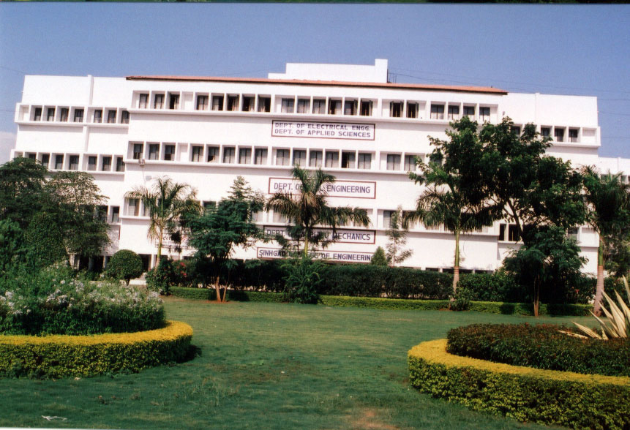

RTCE-2008

OBJECTIVE
RTCE-08 focuses on young researchers in the field of Computer
Engineering & aims of making them achieve the following
- Giving stimulus for innovation in upcoming Computer Technologies.
- Enhancing the technical knowledge of IT professionals, faculties and researchers by exploring recent trends in IT Industry.
AREAS & SCOPE
Original contributions are solicited on topics covered under areas listed below (but not limited to):
1. Distributed System: Distributed Architecture, Distributed O.S, DFS, File Server, DS & Synchronization, Communication in DS, Fault Tolerance, Case Studies.
2. Data Mining & Warehousing: Data mining Algorithms, Clustering, OLAP, Data ware housing, Decision trees.
3. Soft Computing: Image Processing, Pattern recognition, Ven Algorithm, Algorithm complexity, Neural Network, Fuzzy Logic.
4. Software Architecture: Model driven architecture, Pervasive sys arch, Service oriented arch, Java arch, Net Architecture, Pattern Oriented s/w arch, Component based development, HPN arch.

IMPORTANT DATES
Events Dead Lines
Submission of Full Paper 19th January 2008
Acceptance Notification 30th January 2008
Camera Ready Submission 8th February 2008
Registration 8th February 2008
RTCE-08 conference 18th ,19th & 20th Feb 2008

PAPER SUBMISSION
Technical papers describing are invited in all above mentioned areas.

- Submissions will undergo Blind Review.
- Papers should not exceed 6 single-spaced pages including figures & references in two-column IEEE conference paper format.
- Full paper & all queries must be sent by e-mail to:
osrtce.scoe@sinhgad.edu, cortce.scoe@sinhgad.edu

REGISTRATION
Registration form can be downloaded from www.sinhgad.edu & sent to the convener along with demand draft.
Students (PG/Research Scholar) Rs. 500/-
Academician (R&D Personnel) Rs. 1000/-
Industry Professional Rs. 1500/-
You can register online at: http://sinhgad.edu

