**PUNE INSTITUTE OF COMPUTER TECHNOLOGY, PUNE - 411043**



**Department of Electronics & Telecommunication Engineering**

**Research paper on**

**Covid based society monitoring system**

Group No. : 21

Abhijit D. Jadhav (42329)

Tushar S. Sharma (42361)

Vrunda V. Jabras (42366)

**Abstract -** Since outbreak in early 2020, 233 million patients across world with 4.7 million deaths globally were happened due to the novel coronavirus pneumonia COVID-19. Due to the Covid outbreak, there is an urgent need to keep an eye on corona carriers to prevent community spread. Many public places are opening and there is an urgent need to take some preventive actions towards keeping our society and community safe. India has faced community spread for several times in this last one year of Covid pandemic, just because we were not having system which will trace back Covid carriers. Greater population & urbanization in our country leads to the more crowded places, which finally results in community spread. Solution for this problem is to strictly restrict unnecessary outgoings of the people. Another reason for transmission of Covid-19 virus is inappropriate usage of mask. This problem further can be tackled by designing a ML based system which would identify the proper usage of the mask by that individual. In this project we are planning to build RFID based system which will record entry & exit of each society member & it will be stored on remote server which can be displayed on website. This data will be analyzed for detecting the possible covid carrier which will help to restrict people from going outside of the society many times.

**Keywords:** RFID, cloud storage, face mask detection, web based system

1. **Introduction**

Keeping records of society members, visitors and people coming into the society or going outside of the society became important after covid-19 community spread. Traditional methods like making records using paper registers, hiring watchmen to keep an eye on entry/exit gates has several disadvantages. These methods are inefficient in terms of time for data evaluation, it takes too much time for that as complete record is handwritten. Keeping records for huge numbers of entries is another demerit for this kind of methods. Also when it comes to searching of data in this records it becomes hectic. Data can be easily tampered as it is recorded on paper.

Alternative system to all this problems we can propose is by using biometric technology like fingerprint recognition or radio frequency identification (RFID) technology with an extension of web application and face mask detection with storage efficiency. Using biometric technology is very good for authorizing person uniquely. However, there exist some limitations of the biometric system. The fingerprint system has a problem of human physical contact which can be a cause of covid-19 virus carriers. The fingerprint sensor usually touched by a many people which causes this. There can also be inaccuracy in matching fingerprints due to dry and dirty fingers. In this case RFID is very good option for this kinds of systems[1]

1. **Requirements**
2. **Hardware**

A wireless technology of communication of electromagnetic waves between the RFID reader and th RFID tag in order to automatically collect the stored information, uniquely identify and trace the RFID tag is known as Radio Frequency Identification Technology[2]. There are three types of RFID tags- active, passive and semi-passive. The main difference between these tags is that active and semi-passive tags require an internal battery to work but the passive tags do not. Passive tags acquire the required power from the RFID reader[3]. In the proposed system we have used passive RFID tags only. Each and every RFID tag has unique ID stored in it.

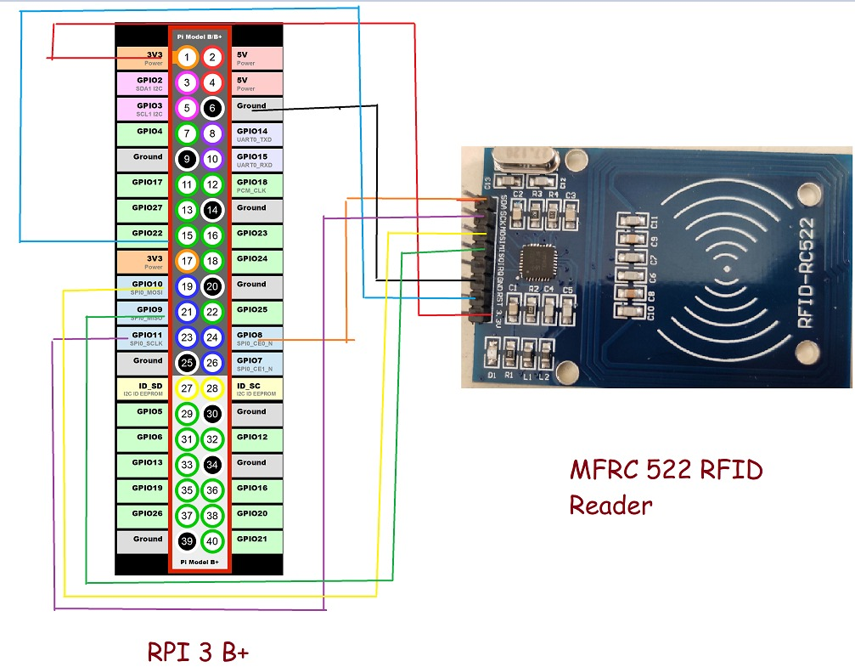

Fig.1

In order to communicate, it is not necessary to have a line of sight. The RFID readers can easily read the RFID tags from a significant distance[4]. The RFID reader we have used in this system is showan in Fig.1.

1. **Software**

Software components of the system are installed on the RPi and most of the working for website and memory storage is on AWS cloud. The relations between the components and to users and external systems are shown in Fig.2.

**AWS Cloud**

Web service

Database

RPi

RFID

User

Fig.2

The web services component provides interface to the user with system with website. It has been developed by using the HTML, CSS and JavaScript for frontend. And for backend Python has been used. This component provides easy and quick handling of profiles and data which are allocated to the user with their tags. This helps them to manage their account by updating vaccination status and certificate, profile and entry/exit activity can also be seen here. In this way, the data stored by the cloud dataset is easily made available for use in other systems at the end of user.

The database contains several tables with data on RFID tags, basic information like name, contact no, mail id, flat no, vaccination status, entry & exit count and many more. It is implemented by using MySQL. This database is used by all other software components of the cloud for data retrieval and persistence.

1. **Methodology**

Covid based society moitoring system designed in this paper is shown in the Fig.3

Covid based Society management

User registration

User login

User data management

User in-out data management

User restrictions according to profile

User face mask detection

Fig.3

1. User registration: The module of user registartion is the initial step. All the rights to register the new user are given to the admin only.
2. User login: In the module of users login, different permissions are set for users according to their different types, so as to open different functions. The user group of the system is divided into two parts, whose rights are as follows.
3. System admin: Only one. It has the highest authority of the system and can manage all personnel.
4. System user: system users are those who will be registered with the system and will get allocated RFID tags.
5. 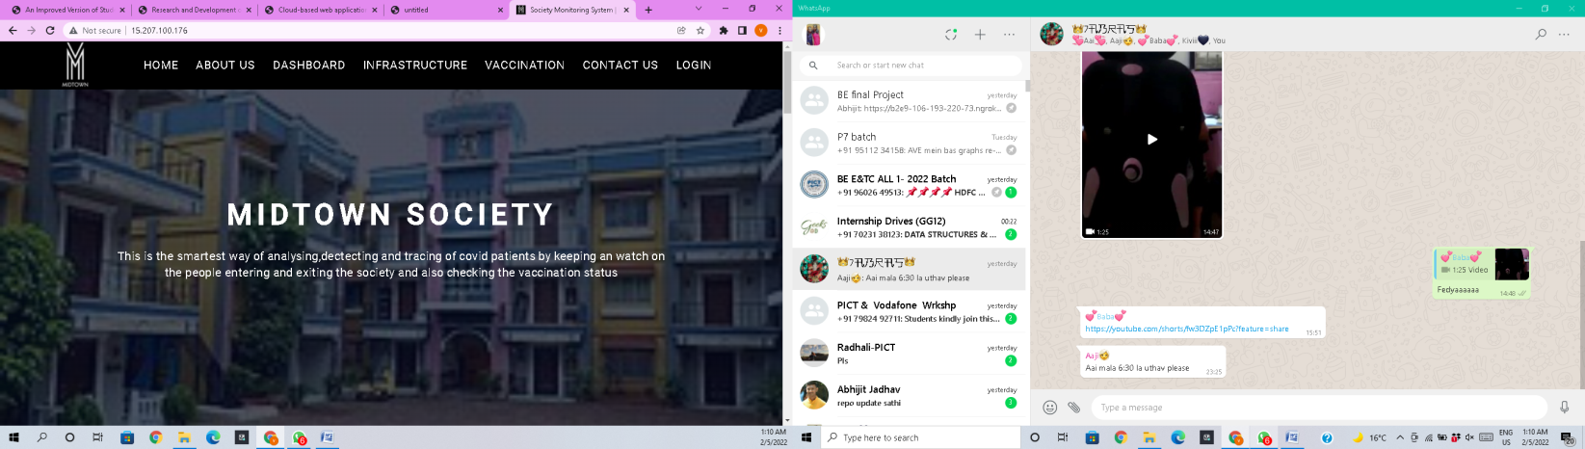User data management: After successfully registering the user into database, the admin collects user’s information. Data collected will be stored and used for information and communication purpose. User’s mail id as login id and passwords will be stored in this data.
6. User in-out data management: Here user’s entry count, time, date at the time of entering into the society or exit count at exit point of the society will be stored for record and will be used for user restrictions for going outside of the society.
7. 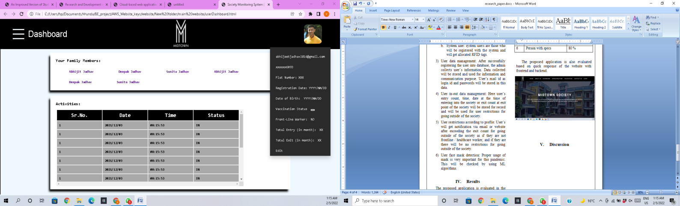User restrictions according to profile: User’s will get notification via email or website after exceeding the exit count for going outside of the society as if they are not frontline / healthcare worker; and if they are there will be no restrictions for going outside of the society.
8. User face mask detection: Proper usage of mask is very important for this pandemic. This will be checked by using ML algorithms.
9. **Results**

The proposed application is evaluated in the form of accuracy for the face mask detection. The system should meet the accuracy of detection according to different faces and manner of wearing mask.

|  |  |  |
| --- | --- | --- |
| **Sr. no.** | **Different faces / masks** | **Accuracy** |
| 1 | Women face with colored mask | 92.4 % |
| 2 | Men face with colored mask | 91 % |
| 3 | Men face with moustache | 85 % |
| 4 | Women face with open hairs | 89 % |
| 5 | 14 – 18 years old kids | 96 % |
| 6 | Person with specs | 80 % |

The proposed application is also evaluated based on quick response of the website with frontend and backend.

1. **Discussion**

Recording the entry – exit data along with time and date of user is a very hectic job in a society environment. A web enabled automated system for the purpose of recording this data in a society environment is proposed here. The proposed application offers multiple user accounts each of which has its own profile. Our application provides online access of all users to view and analyze the profile and entry-exit counts of their family members. For more flexibility and lower cost of hardware and software resources, the cloud platform has been integrated with our system. Therefore the web interface and database are stored on the cloud servers with more access security and backups.

**REFERENCES**

[1] Danijel Mijić, Ognjen Bjelica, Jelena Durutović, Miloš Ljubojević, “An Improved Version of Student Attendance Management System Based on RFID,” 18th International Symposium INFOTEH-JAHORINA, 20-22 March 2019.

[2] Yangzi Chen, Xiaofeng Li*, “Research and Development of Attendance Management System Based on Face Recognition and RFID Technology,” 2021 IEEE International Conference on Information Communication and Software Engineering

[3] Sai Ba Oo∗, Nang Hlaing Myat Oo†,Suparat Chainan‡ , Arpha Thongniam§, Waralak Chongdarakul, “Cloud-based Web Application with NFC for Employee Attendance Management System,” The 3rd International Conference on Digital Arts, Media and Technology (ICDAMT2018)

[4] Srinidhi MB, Romil Roy, “A Web Enabled Secured System for Attendance Monitoring and Real Time Location Tracking Using Biometric and Radio Frequency Identification (RFID) Technology,” 2015 International Conference on Computer Communication and Informatics (ICCCI -2015), Jan. 08 – 10, 2015, Coimbatore, INDIA