**A Mini Project Report**

**on**

# “RECOMMENDATION SYSTEM FOR COUNSELLING”

Submitted to the

Savitribai Phule Pune University

In partial fulfillment for the award of the Degree of Bachelor of Engineering in

## Information Technology

by

**Abhijit Phapale [UIT20M1047]**

**S.Y. B. Tech Information Technology**

Under the guidance of

## Prof. D. P. Bhamare



**Department of Information Technology SRES’s Sanjivani College of Engineering, Kopargaon 423603**

**2021-2022**

### SRES’s Sanjivani College of Engineering, Kopargaon 423603 Department of Information Technology



# CERTIFICATE

This is to certify that the Mini Project report entitled **“Recommendation System For Counselling”** being submitted by **Abhijit Phaphale [UIT20M1047]** is a record of bonafide work carried out by them under the supervision and guidance of **Prof. D. P. Bhamare** in partial fulfillment of the requirement for **S.Y (Information Technology)** of Savitribai Phule Pune University, Pune in the academic year 2021-2022

|  |  |  |  |
| --- | --- | --- | --- |
| Date: /06/2022 |  |  |  |
| Place: Kopargaon |  |  |  |
| **Prof. D. P. Bhamare** | **Dr. M. A. Jawale** |  | **Dr. A. G. Thakur** |
| Guide | H. O. D |  | Principal |

This Mini Project report has been examined by us as per the Savitribai Phule Pune University, Pune requirements at **Sanjivani College of Engineering, Kopargaon-423603** on ……...............

Internal Examiner External Examiner

I

## ACKNOWLEDGEMENT

The entire session of Mini- Project completion phase so far was a great experience providing us with great insight and innovation into learning various data security concepts and achievement of it. As is rightly said, for the successful completion of any work, people are the most important asset our project would not be materialized without the cooperation of the people involved.

First and foremost, we are very thankful to our respected project guide Prof. D. P. Bhamare for their leading guidance and sincere efforts in finalizing this topic. They took deep interest in correcting the minor mistakes and guided us through our journey so far. Also, they have been persistent source of inspiration for us.

We are also very thankful of Dr. M. A. Jawale, Head of Department of

Information Technology for the symmetric guidance and providing necessary facilities and we express deep gratitude to all the faculty members and our department’s technical Staff for providing us needed help.

**Abhijit Phapale [ Roll - 46 ]**

II

### Abstract

To ensure the quality teaching-learning process in Institutions, right from the entry of the student through competition, streamlining of admissions is one of the important parameters. With this view and to resolve the generic problems faced by the candidates, their parents, and state administration during Entrance test/counselling/admissions in all courses during admissions of student it is decided to be made based on the merit of entrance tests.

To bring in 100% transparency and to make the admissions highly cost-effective and to minimize the travel by the candidates and parents, The Student Counselling System is designed to enhance the counselling experience during the admission process. This system will provide great help not to the students but also to the parents who are there to invest money in children’s education.

The Student Counselling System is developing to improve the counselling, which fully works as online software. Through this system, the student will be able to report then register for the counselling as he is eligible after if the student is qualifying the criteria, then it will get the information regarding the colleges and the universities to which he can apply.

A student can also get information regarding how many seats have been booked and vacant seats available in the institution. This will help a student in selecting the branch in which they are interested and not what the colleges are offering. All this information will give in sort interval time to the student which speeds up the process reduce the institutes time.

This software is not only providing ease to the students but also helps the institution to manage their whole procedure of the counselling by minimizing the paperwork which decreases their carbon footprint on the environment and the time factor will also get minimized as all the process is happening online.

III

### Contents

Acknowledgement I

Abstract II

Abbreviations III

List of Figures IV

|  |  |  |  |  |  |
| --- | --- | --- | --- | --- | --- |
|  | **Sr.** |  | **Chapter** | **Page**  **No** |  |
| **1.** |  | **Introduction to Recommendation System for Counselling** |  |
|  | 1.1 | Introduction to student counselling system | 06 |
|  | 1.2 | Motivation behind student counselling system | 06 |
|  | 1.3 | Aim and Objective(s) of the work | 06 |
| **2.** |  | **System Architecture and E R Diagram** | 07 |
| **3.** |  | **Library Files** | 08 |
| **4** |  | **Report Analysis** |  |
|  | 4.1 | Fig 4.1 | 09 |
| **5.** |  | **Reports of Student Counselling Management System** | 09 |
| **6.** |  | **Scope of Project** | 10 |
| **7.** |  | **Features of Project** | 11 |
| **8.** |  | **Conclusion** | 12 |
|  |  |  |  |

IV

### LIST OF FIGURES

|  |  |  |
| --- | --- | --- |
| **Figure No.** | **Figure Name** | **Page No.** |
| 2.1 | System Architecture | 07 |
| 2.2 | E R Diagram | 07 |
| 4.1 | Student counselling form | 09 |

## CHAPTER 1

### Introduction To Recommendation System for Counselling

#### • Introduction to Project

Python is a high_ level, interpreted, interactive and object-oriented scripted language. It is designed to be highly readable. It provides various options for developing graphical interfaces (GUI’s).

This is python project which help in student counselling form which created using python and tkinter.

#### • Motivation behind project

This project is chosen to save time and resources of counsellors as well as students and to overcome the existing drawbacks in maintaining records

#### • Aim and Objective(s) of the work

**Project Aim**

The purpose of the project is to build an application program to reduce the manual work for managing the Results, Merit List, Grade, Student.

**Project objectives**

* It tracks all the information of Grade, Counselling, Allotted college, branch etc.
* Manages the information of Selected and Allotted colleges.
* It generates the SQL file on Student Information, Selected and Allotted College List.
* Provides the searching facilities based on various factors, such as Results, student, Counselling, Registrations.
* Provide filter reports on Student, Counselling, Registrations.
* You can also export the report into csv format for Results, Merit List, Registrations
* To increase efficiency of managing the Student Information, Selected and Allotted College List.
* Integration of all records of Registrations.

## CHAPTER 2

### System Architecture

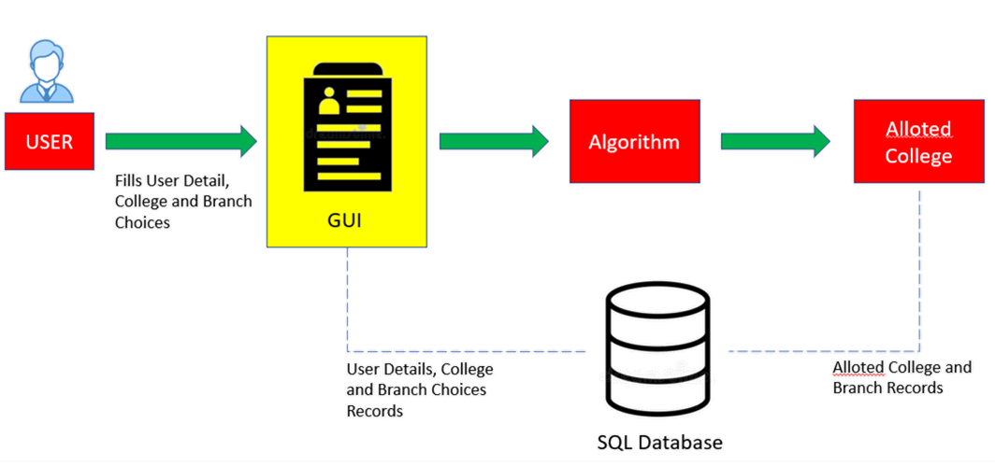Fig 2.1

### E R Diagram

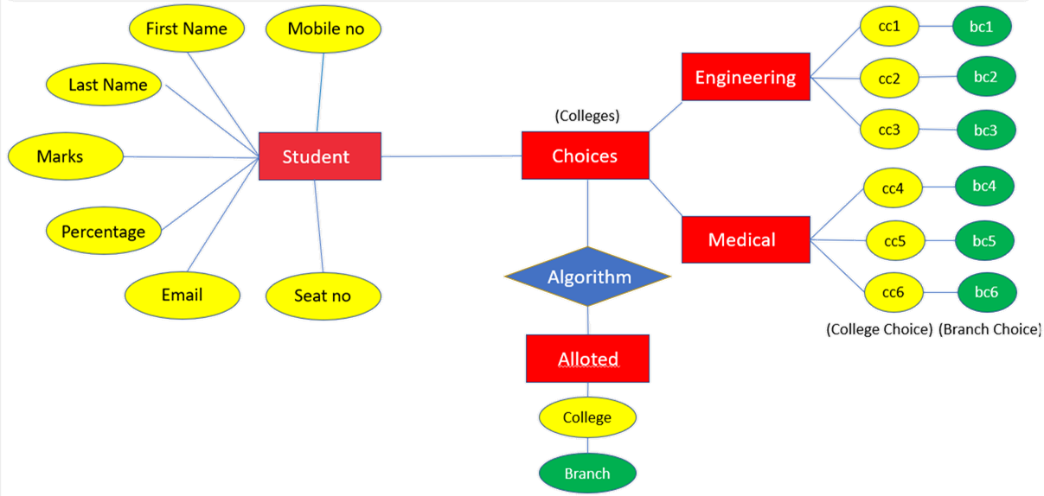

Fig 2.2

## CHAPTER 3

### Library File

#### Tkinter

Tkinter is a standard library in Python which is used for GUI application. Tkinter has various controls which are used to build a GUI-based application.

#### OpenCV

OpenCV is a Python library that is used to solve computer vision problems. Computer vision include understanding and analysing digital images by the computer and process the images or provide relevant data after analyzing the image.

**Random**

Python has a built-in module that you can use to make random numbers.

#### Pillow

Pillow is built on top of PIL (Python Image Library). PIL is one of the important modules for image processing in Python. It supports wide variety of images such as “jpeg”, “png”, “bmp”,

“gif”, “ppm”, “tiff”. You can do almost anything on digital images using pillow module.

#### SQLite3

SQLite3 can be integrated with Python using sqlite3 module, You do not need to install this module separately because it is shipped by default along with Python version 2.5x onwards.

## CHAPTER 4

### Report Analysis

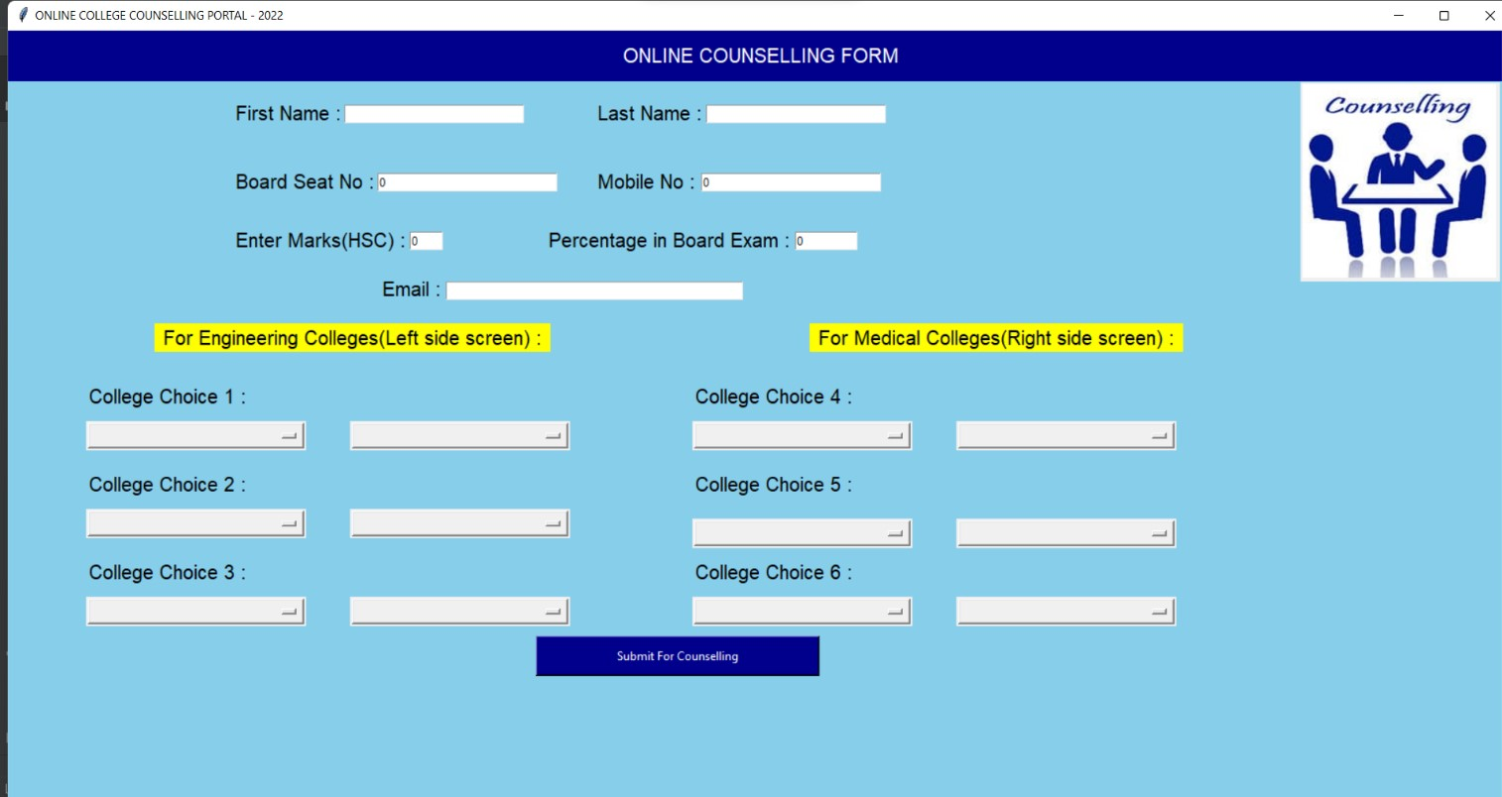

Fig 4.1

## CHAPTER 5

### Reports of Student Counselling Management System

* It generates the report on Student, Counselling, Selected and Allotted College List

* Provide filter reports on Registrations, Results, Grade, Selected and Allotted Colleges

* You can easily export Excel file for the Student Information, Selected and Allotted College List.

## CHAPTER 6 Scope of the Project

It may help collecting perfect management in details. In a very short time, the collection will be obvious, simple and sensible. It will help a person to know the management of passed year perfectly and vividly. It also helps in current all works relative to Student Counselling Management System. It will be also reduced the cost of collecting the management & collection procedure will go on smoothly.

Our project aims at Business process automation, i.e. we have tried to computerize various processes of Student Counselling Management System.

In computer system the person has to fill the various forms & number of copies of the forms can be easily generated at a time.

* In computer system, it is not necessary to create the manifest but we can directly. print it, which saves our time.
* To assist the staff in capturing the effort spent on their respective working areas.
* To utilize resources in an efficient manner by increasing their productivity through automation.
* The system generates types of information that can be used for various purposes.
* It satisfies the user requirement
* Be easy to understand by the user and operator
* Be easy to operate
* Have a good user interface
* Be expandable

**Future Scope of the Project :**

* We can give more advance software for Student Counselling Management System including more facilities
* We will host the platform on online servers to make it accessible worldwide.
* Integrate multiple load balancers to distribute the loads of the system
* Create the master and slave database structure to reduce the overload of the database queries
* Implement the backup mechanism for taking backup of codebase and database on regular basis on different servers

## CHAPTER 7

### Features of the project Student Counselling Management System

* Product and Component based

* Creating & Changing Issues at ease

* Query Issue List to any depth

* Reporting & Charting in more comprehensive way

* User Accounts to control the access and maintain security

* Simple Status & Resolutions

* Multi-level Priorities & Severities.

* Targets & Milestones for guiding the programmers

## CONCLUSION

Recommendation System for Counselling led to a better organization structure since the counselling of the students is well designed and also helps to better as well as efficient utilization of available resources.

Digitization helps to use time more efficiently. The importance of any automated system is reducing human errors, efforts and time.

Online Student Counselling System can be used by education institutes to maintain the records of students and their counselling easily. Achieving this objective is difficult using a traditional system as the physical interaction of students is not possible in this pandemic and collecting relevant information of students may be very time consuming. All these problems are solved using this project.

Our project Student Information Management System was developed by all four of us. We, a team of four persons took a step-by-step approach in order to reach our goal. We applied the knowledge we gained during our academic period at our college and developed this project “Recommendation System For Counselling”