**MAI272 - Advanced Machine Learning**

Register Number : 2448503

Name : Abhijith E

Experiment Number : 1

Date : 18/10/2024

1. .Data Collection and Preprocessing:
2. Importing Required Libraries:

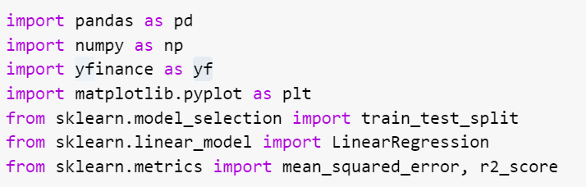

1. Collecting Stock Data and Find Moving Average:

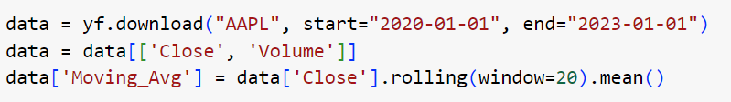

1. Removing Missing Data:



1. Preparing Data for Simple Prediction:

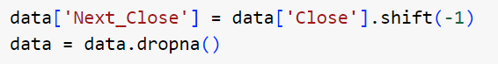

1. .Simple Linear Regression Implementation:
2. Setting Features and Target for Simple Prediction:

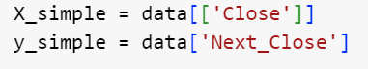

1. Splitting Data into Training and Testing:



X_train_simple, X_test_simple, y_train_simple, y_test_simple = train_test_split(X_simple, y_simple, test_size=0.2, random_state=42)

1. Training the Model:

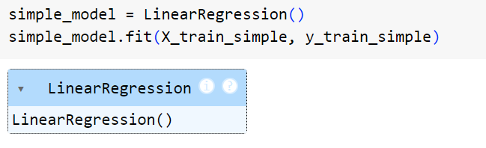

1. Making Predictions and Checking Accuracy:

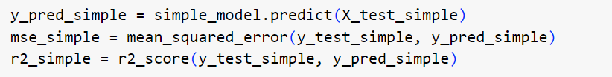

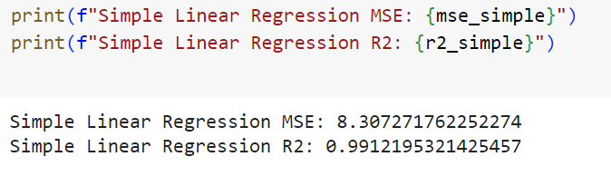

1. Plotting the Simple Linear Regression:

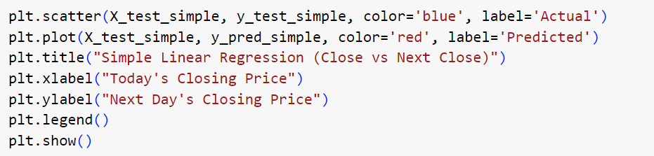

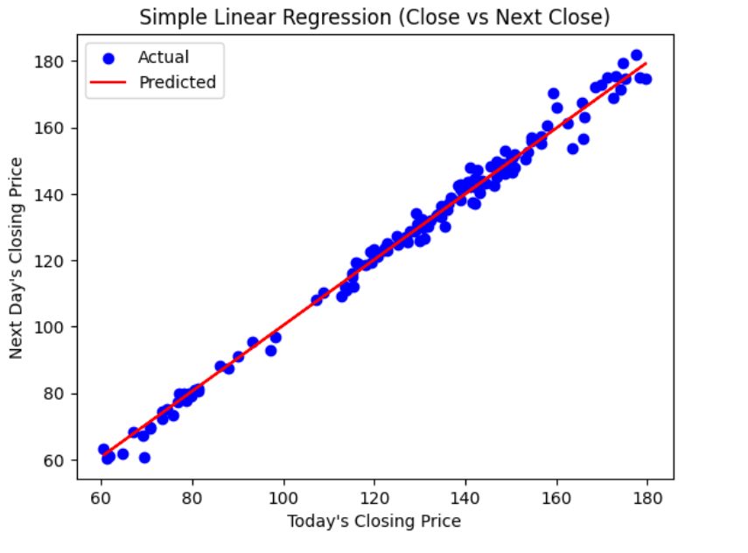

1. .Multiple Linear Regression Implementation:
2. Preparing Data for Multiple Prediction:

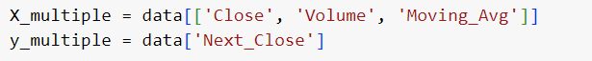

1. Splitting Data Again:



X_train_multiple, X_test_multiple, y_train_multiple, y_test_multiple = train_test_split(X_multiple, y_multiple, test_size=0.2, random_state=42)

1. Training the Multiple Linear Regression Model:

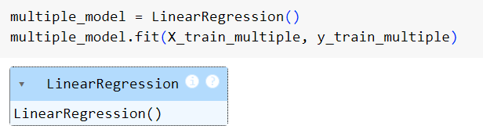

1. Making Predictions and Checking Accuracy (Multiple Features):

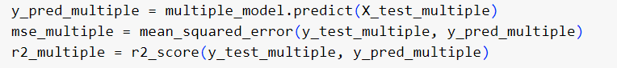

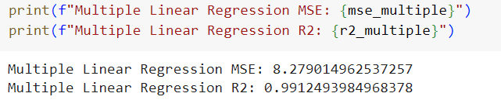

1. Plotting the Results for Multiple Linear Regression:

