**Christ (Deemed to be University), Bengaluru.**

**MAI272 - Advanced Machine Learning**

**Lab Exercise 2**

**Department of Computer Science**

**Name : Abhijith E**

**Reg No : 2448503**

1. Data Preparation:

* Load the dataset.

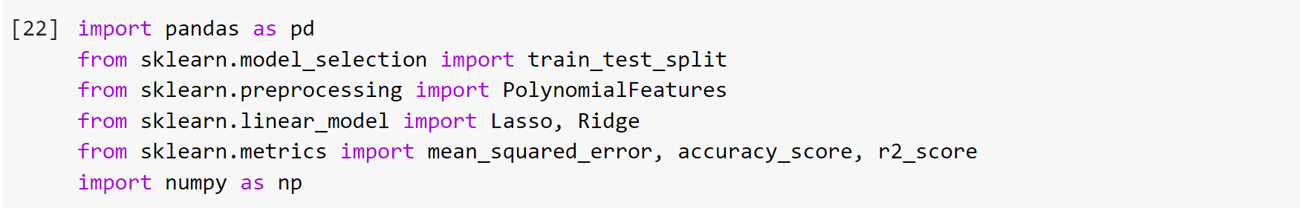



Output :

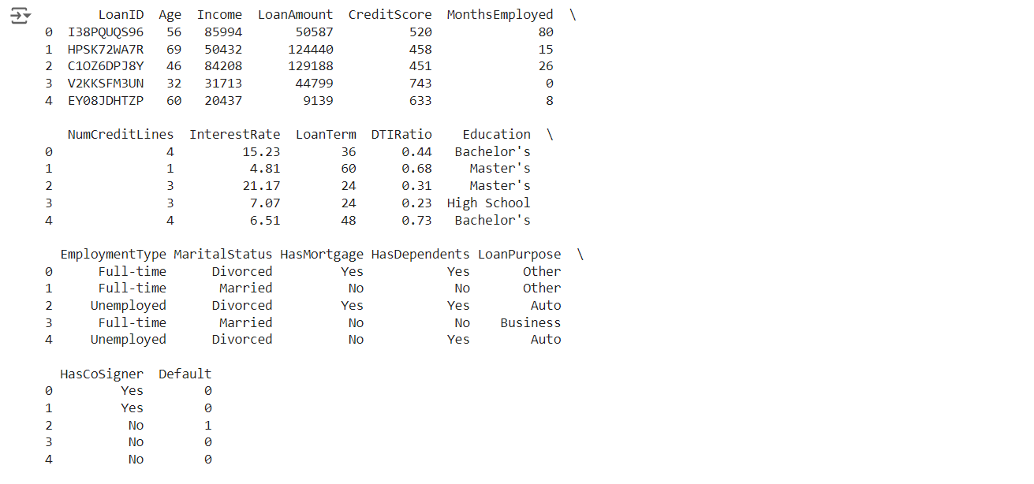

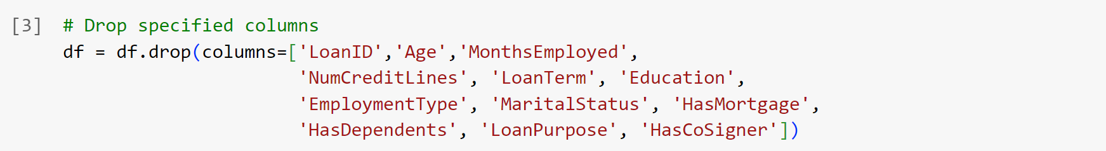



Output :

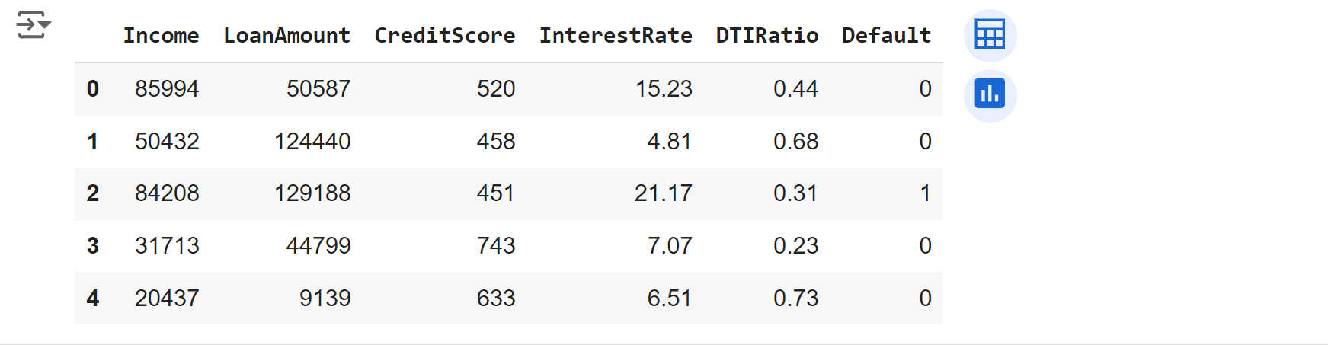



Output :

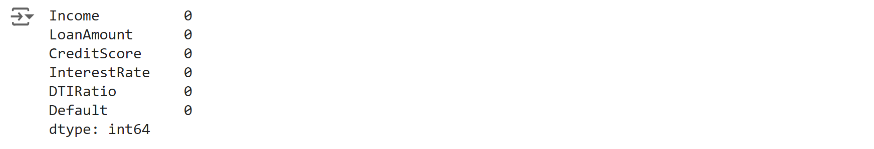

* Split the data into training and testing sets (80-20 split).





1. Polynomial Feature Transformation:

* Convert the features into polynomial features of degree 2 or 3 to capture

non-linear relationships.

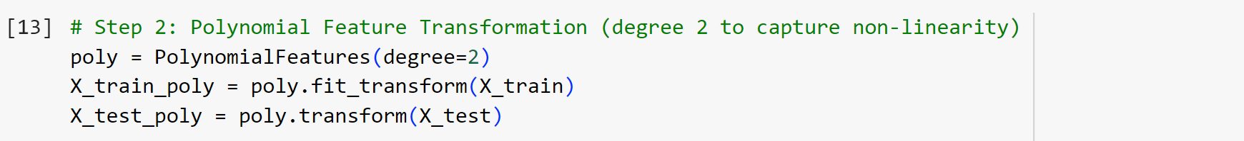

1. Apply L1 (Lasso) and L2 (Ridge) Penalty:

* Build two models:
* One with Lasso regression (L1 penalty) to enforce sparsity,

potentially eliminating some features.



Output :



* Another with Ridge regression (L2 penalty) to reduce the impact

of less important features by shrinking their coefficients.



Output :



1. Model Training and Testing:

* Train both models on the training dataset.

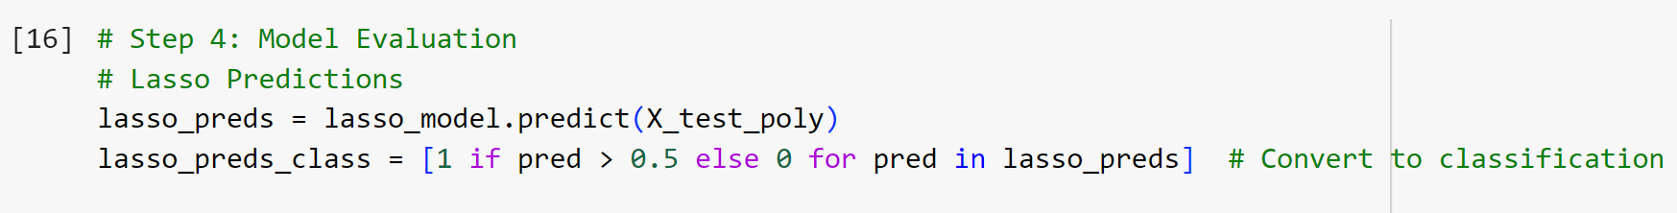



* Test them on the testing dataset and compare performance using

evaluation metrics like Mean Squared Error (MSE) and R-squared.

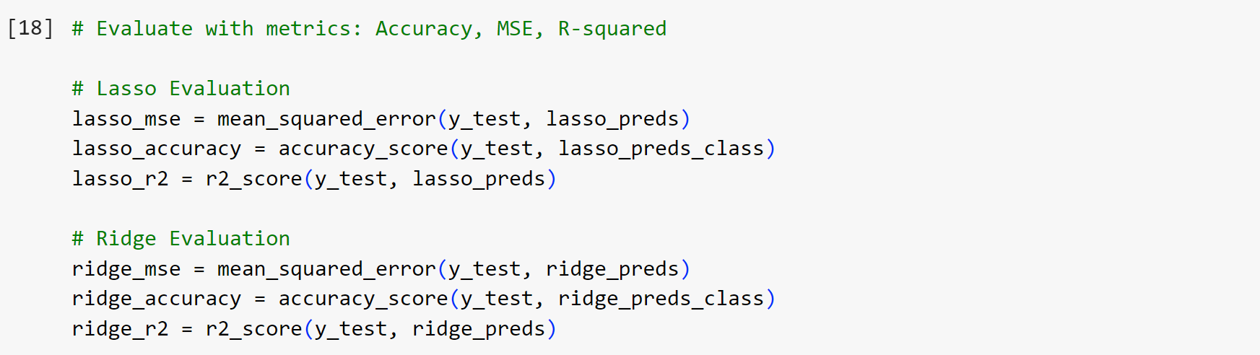

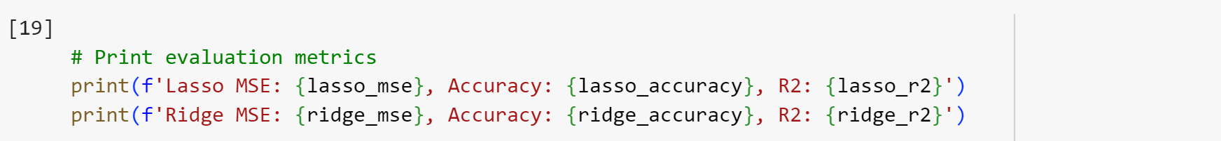

Output :



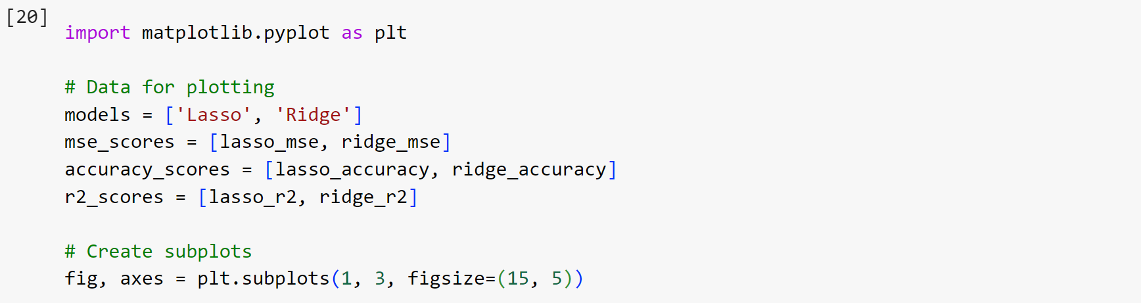

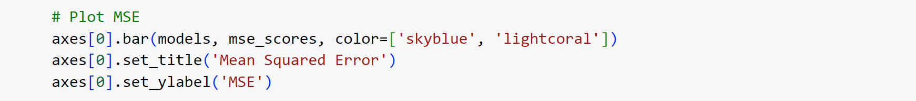

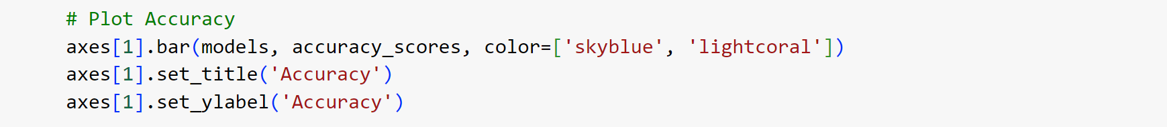

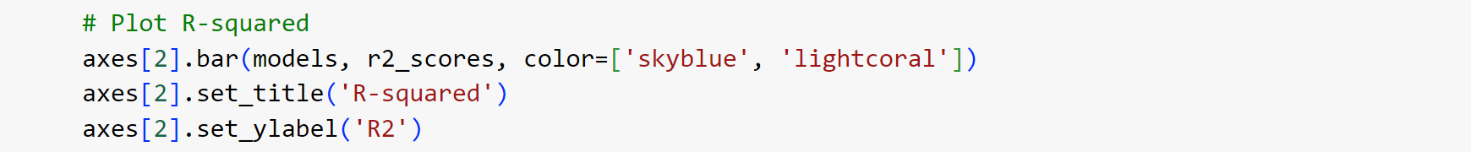



Output :

