**CHRIST(Deemed to be University)**

Department of Computer Science

MAI271-JAVA Programming

Name : Abhijith E

Reg No : 2448503

Date:23-10-2024

Lab-Exe:2

Program 1:

Output :

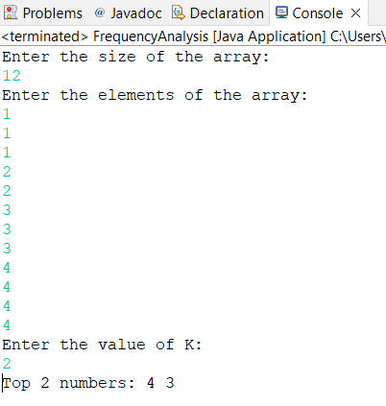

Program 2 :

Output :

