Postdoctoral Fellowships
Centre for Quantum Technologies and Complex Systems (CQTCS)
Christ University, Bengaluru
Applications Invited

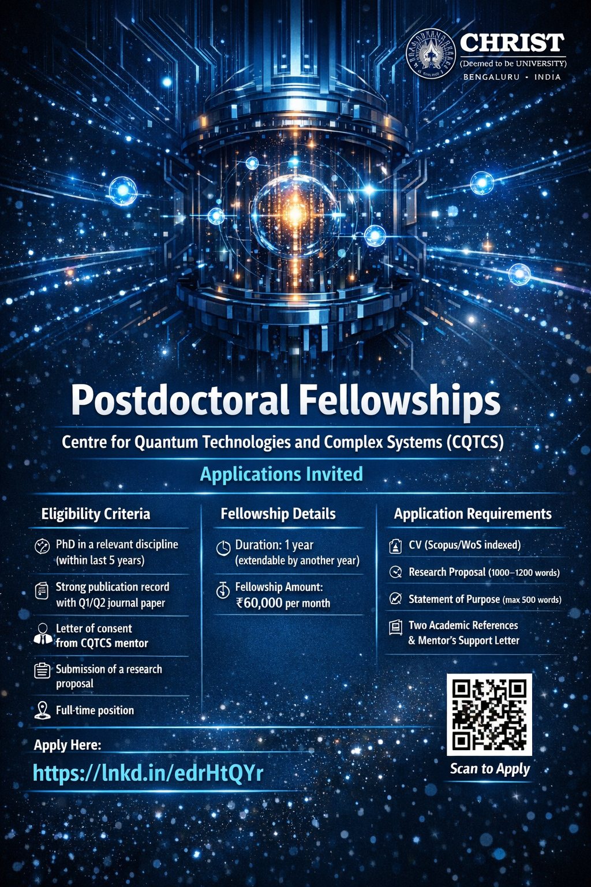

Eligibility Criteria
- PhD in a relevant discipline (awarded within the last five years)
- Strong publication record with at least one Q1/Q2 journal paper as first or corresponding author
- Letter of consent from a CQTCS mentor
- Submission of a research proposal
- Full-time position

Fellowship Details
- Duration: 1 year (extendable by another year based on performance)
- Fellowship Amount: ₹60,000 per month

Application Requirements
- CV (with publications indexed in Scopus/WoS)
- Research Proposal (1000–1200 words)
- Statement of Purpose (max 500 words)
- Two academic references (one from PhD supervisor)
- Letter of support from proposed mentor at CQTCS

Apply Here
https://lnkd.in/edrHtYQr

