Domino's Pizza Bangalore – Sales Performance Analysis
H1 2023 | January – June

Project Overview
This project focuses on analyzing the sales performance and operational efficiency of Domino's Pizza outlets across Bangalore. By leveraging a comprehensive dataset of over 100,000 transactions spanning the first half of 2023, the analysis aims to identify high-performing locations, peak ordering hours, and popular product categories. The insights generated are intended to help stakeholders optimize inventory management and refine localized marketing strategies.

Dataset Summary
Transactions Table: Contains 110000 rows recording every sale from January 1, 2023, to June 30, 2023. Key attributes include transaction_date, transaction_time, store_id, and transaction_qty.
Products Table: Lists 14 unique menu items across categories like Veg Pizza, Non-Veg Pizza, Sides, Beverages, and Desserts, along with their unit_price and size.
Stores Table: Details 10 specific locations in Bangalore (e.g., Indiranagar, Koramangala, Whitefield), classified by location_type as either "Prime" or "Regular."

Data Cleaning & SQL Procedures
Step 1: Database Initialization
Created the dominos_pizza database and imported the CSV structures.
Step 2: Column Standardization
Handled encoding issues by renaming ID columns (e.g., ï»¿transaction_id to transaction_id).
Step 3: Data Type Optimization
Converted transaction_date from string format to DATE. Converted transaction_time from string format to TIME to allow for hourly trend analysis.

Exploratory Data Analysis (SQL Questions)
Q1: What is the total sales for each month and the Month-on-Month (MoM) % change? 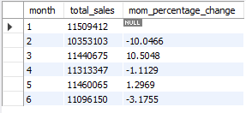

Q2: What is the total quantity sold for each month and the MoM % change?
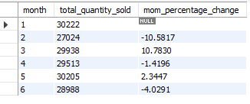
Q3: How many total orders were placed in each month and calculate mom% change?
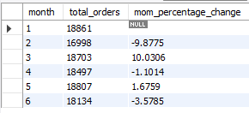
Q4: Compare "Prime" vs "Regular" location types based on total sales.
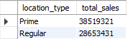
Q5: Determine the total sales for each individual store location
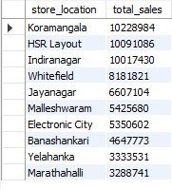
Q6: Find the Average Sales Value for each month.
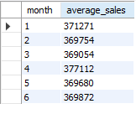
Q7: What is the total sales contribution of each product category?
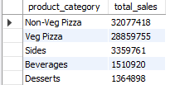
Q8: Identify the top 3 best-selling products by revenue.
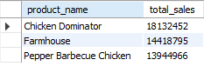
Q9: What are the total sales trends broken down by day of the week and hour of the day? 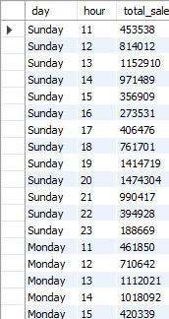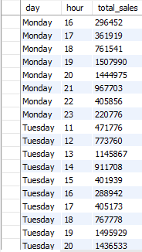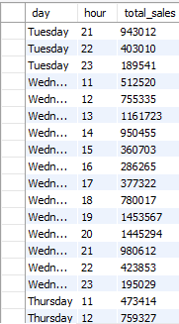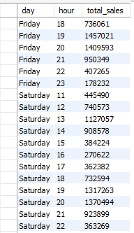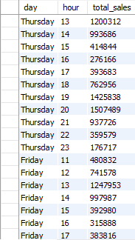
Q10: What are the total sales trends broken day of weeks?
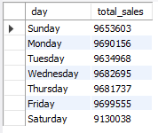
Q11: What are the total sales trends broken down by hours?
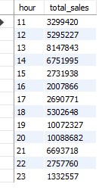
Q12: What are the total sales trends by weekends and weekdays?
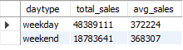

Dashboard in Power BI
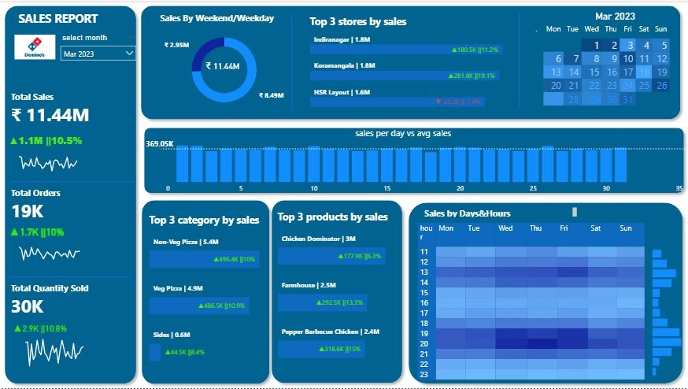

Business Recommendations
1. Prioritize Non-Veg Pizza inventory across all stores. Non-Veg Pizza leads at ₹32M Chicken Dominator and Pepper Barbecue Chicken together make up two of the top three products.
2. Run app-exclusive deals during off-peak hours (pre-noon and post-9 PM). Peak demand clusters at 12–1 PM and 7–9 PM. Off-peak slots are idle capacity that can be activated without affecting peak margins.
3. Introduce weekend-specific offers to reduce the weekday-weekend sales gap. Weekdays generate ₹48M vs. ₹18M on weekends — . Family deals targeting residential zones like Whitefield can improve weekend contribution.
4. Use HSR layout and Koramangala as a benchmark for underperforming stores.
6. Set up MoM alerts in Power BI to catch revenue dips early.

