12/11/2024

6COM2012-0901-2024

PRACTICAL ASSIGNMENT

Name: Abhijith Saji

SRN: 21063294

Contents

Simple Sugarscape Analysis 2

Observation: 2

At turn 1 3

At turn 50 (Figure 2a) 3

At turn 500 (Figure 2a) 4

Evolution in Sugarscape 5

Average Sight Over Time 5

Number of Agents Over Time 6

Empowerment in the Sugarscape 7

Empowered vs. Non-Empowered Agents Over Time 7

Average Energy Levels of Empowered vs. Non-Empowered Agents 8

# Simple Sugarscape Analysis

Total Agent Energy Over Time

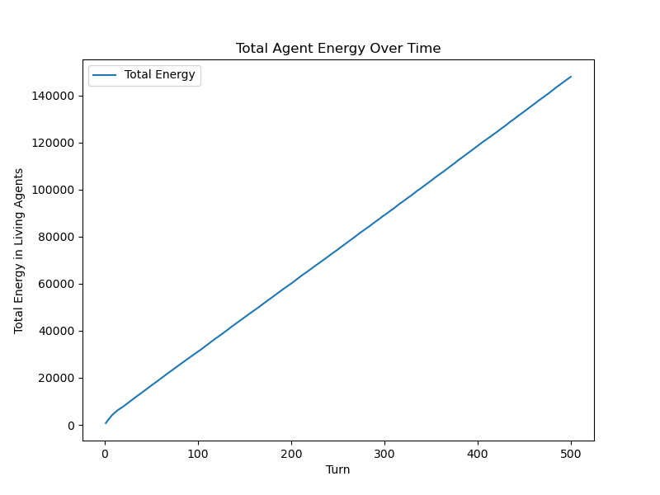

*Figure 1: Total Agent Energy Over Time*

This graph illustrates how the collective energy of agents evolves over time. Initially, energy levels rise as agents efficiently locate and consume sugar-rich areas and as agents deplete local sugar crops and compete for the remaining sugar the agent’s energy starts to stabilize or decline. This trend reflects the dynamic balance between sugar regrowth and agent consumption, highlighting the sustainability challenges within the Sugarscape environment.

## Observation:

In the graphs below the Agents are marked in red and sugar levels are represented through a heatmap overlay

### At turn 1

*Figure 2a: Agent Positions and Sugar Distribution at Turn 1Figure*

The agents are seen to be uniformly distributed across the grid and all the sugar levels are at their maximum capacity

### At turn 50 (Figure 2a)

*Figure 2b: Agent Positions and Sugar Distribution at Turn 50*

The agents have migrated towards higher sugar concentrations leading to a cluster in resource rich area. This clustering increases competition for these resources, leading to selective survival as agents for access to sugar patches. The sugar heatmap shows varying levels, indicating areas of consumption and regeneration.

### At turn 500 (Figure 2a)

*Figure 2c: Agent Positions and Sugar Distribution at Turn 500*

The agent population has likely stabilized or decreased due to energy depletion and competition. Most of the agents are concentrated around one area now and the sugar levels exhibit a pattern of depletion and regeneration based on agent activity.

# Evolution in Sugarscape

## Average Sight Over Time

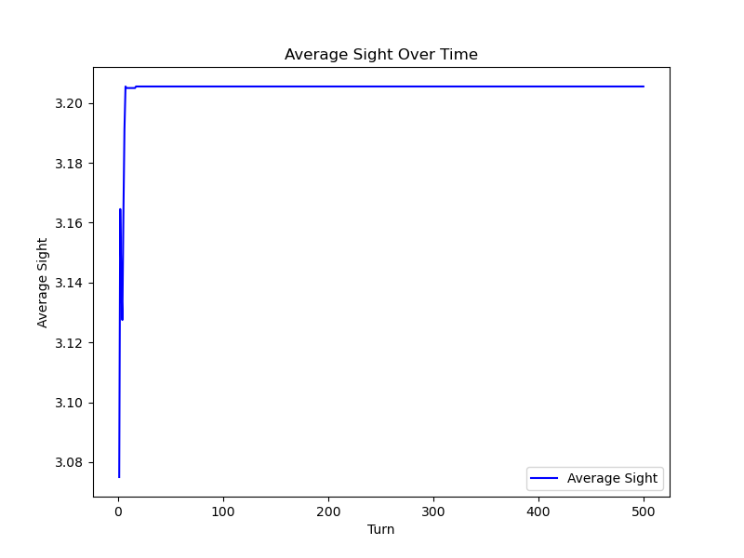

*Figure 3: Average Sight Over Time*

This graph represents the average sight range of the agent population across the turns from 1 to 500 of the simulation. The upward trend indicates that the agents with higher sight ranges ate increasingly prevalent in the population, suggesting that enhanced visibility offers significant survival and reproductive advantages.

In the beginning we can observe that there is a light dip in the agent’s sight this might imply that the excessive sight ranges lead to over competition or resource depletion, disadvantaging agents despite their enhanced visibility

## Number of Agents Over Time

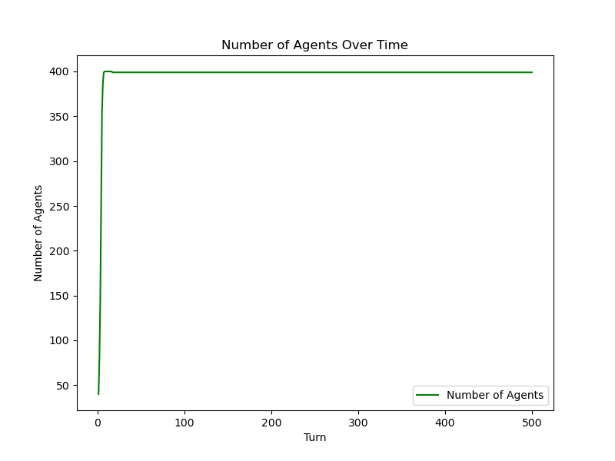

*Figure 4: Number of Agents Over Time*

The number of Agents are seen to have a rapid and steady increase in the beginning due to the agents successfully reproducing, benefiting from high energy levels and effective sugar consumption

There is a small decline after the rapid growth indicating the depletion outpacing the sugar regrowth. This leads to the insufficient energy for survival and reproduction.

The population seem to stabilize afterwards as resources become scarcer due to increased consumption and competition, reproduction rates may decline, and mortality rates may rise, leading to population stabilization.

# Empowerment in the Sugarscape

## Empowered vs. Non-Empowered Agents Over Time

*Figure 5: Empowered vs. Non-Empowered Agents Over Time*

This graph compares the **average energy levels** of empowered and non-empowered agents across the simulation turns.

Initially, there is a brief fluctuation in energy as agents begin to consume sugar and position themselves in resource-rich areas.

Over time, the average energy stabilizes for both groups. Empowered agents maintain a slightly lower energy level compared to non-empowered agents.

This suggests that the trade-off between immediate sugar gain and future mobility considerations may lead empowered agents to suboptimal immediate gains, balancing out long-term advantages.

## Average Energy Levels of Empowered vs. Non-Empowered Agents

*Figure 6: Average Energy Levels of Empowered vs. Non-Empowered Agents*

The population of both empowered and non-empowered agents grows initially as agents reproduce.

By the middle of the simulation, the number of agents stabilizes, with empowered agents maintaining a slightly larger population compared to non-empowered agents.

This suggests that empowered agents have a small but consistent advantage in survival and reproduction, potentially due to their ability to optimize future mobility alongside sugar consumption.