ASSIGNMENT-2

LOGIC CIRCUIT DESIGN

SUMBITTED BY:
ABHIJITH SANTHOSH

Design and Simulation of a 32-bit Ripple
Carry Adder using Verilog HDL

1. Introduction
In digital electronics, adders are fundamental components used for performing arithmetic operations. Among the various adder types, the Ripple Carry Adder (RCA) is one of the simplest. It operates by adding binary numbers bit by bit, with each bit's carry propagating to the next bit in sequence.

Scope of the Report
This report covers the entire design process of a 32-bit Ripple Carry Adder, from the initial concept and Verilog implementation to the simulation and synthesis phases. The report will also provide insights into the performance and resource utilization of the design on an FPGA platform.

2. Design Methodology

Ripple Carry Adder Overview
A Ripple Carry Adder is composed of a series of Full Adders, where each adder handles a single bit of the sum. The carry-out of each adder is passed to the next adder as its carry-in. The propagation of carry through each bit results in the "ripple" effect, where each successive adder waits for the carry from the previous one.

32-bit Ripple Carry Adder Architecture
The 32-bit Ripple Carry Adder is designed by instantiating 32 instances of the 1-bit full adder. Each full adder takes the corresponding bits of the two input operands and the carry from the previous bit. The carry from the last adder is the final carryout.
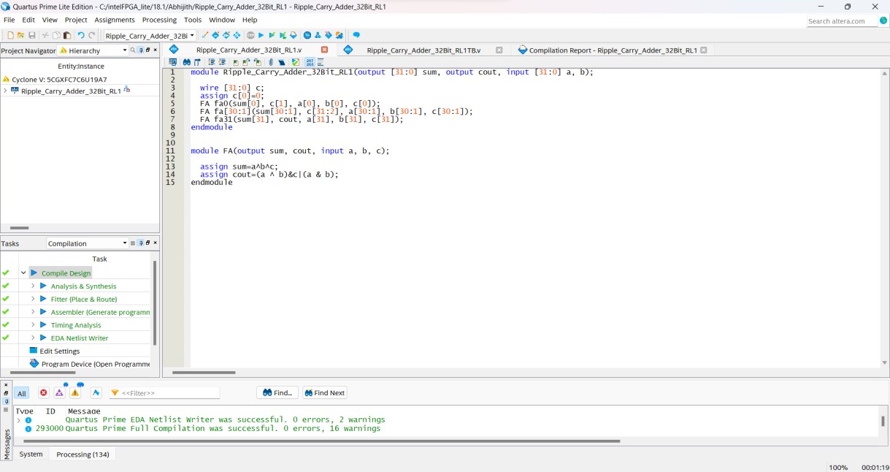

3. Testbench and Simulation

Testbench Creation
To verify the functionality of the 32-bit Ripple Carry Adder, a testbench was created. The testbench applies various input values and checks the correctness of the sum and carry-out values.

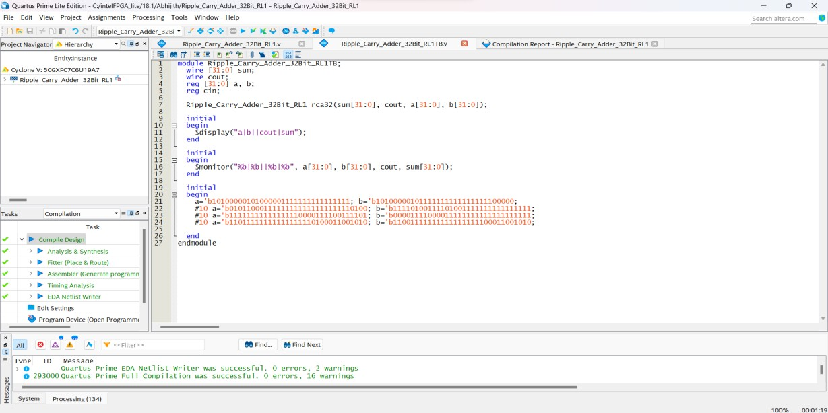

Results and Observations
The simulation results showed that the 32-bit Ripple Carry Adder worked correctly. Upon simulation, the output waveform showed the characteristic ripple effect of the RCA, with the final carry-out and sum bits stabilizing after the delay across all 32 stages. This delay is a result of each full adder waiting for the carry signal from the previous adder, as depicted in the simulation waveform.
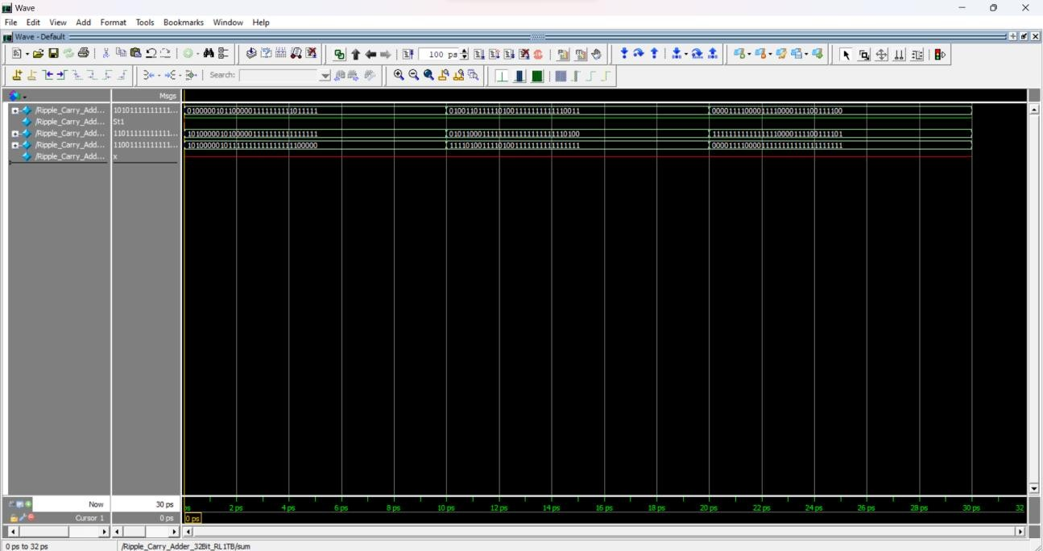

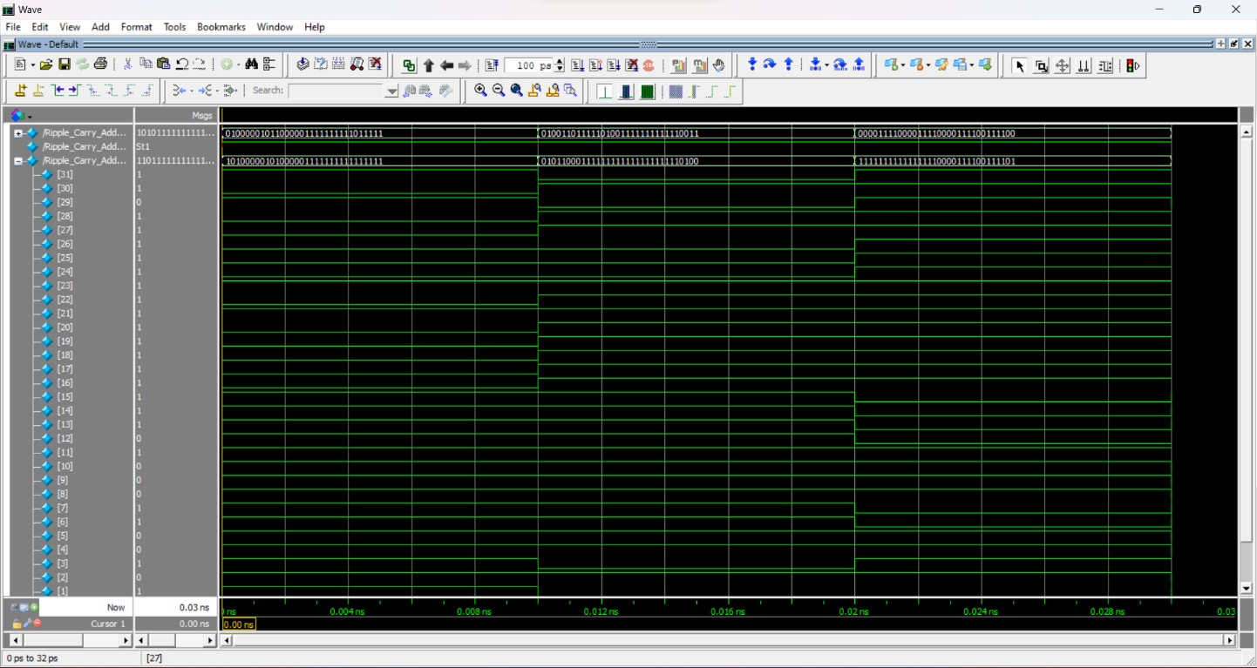

4. Synthesis

RTL Schematic
The RTL Schematic generated by Quartus showed the interconnections between 32 full adder modules and their carry-out and sum lines.

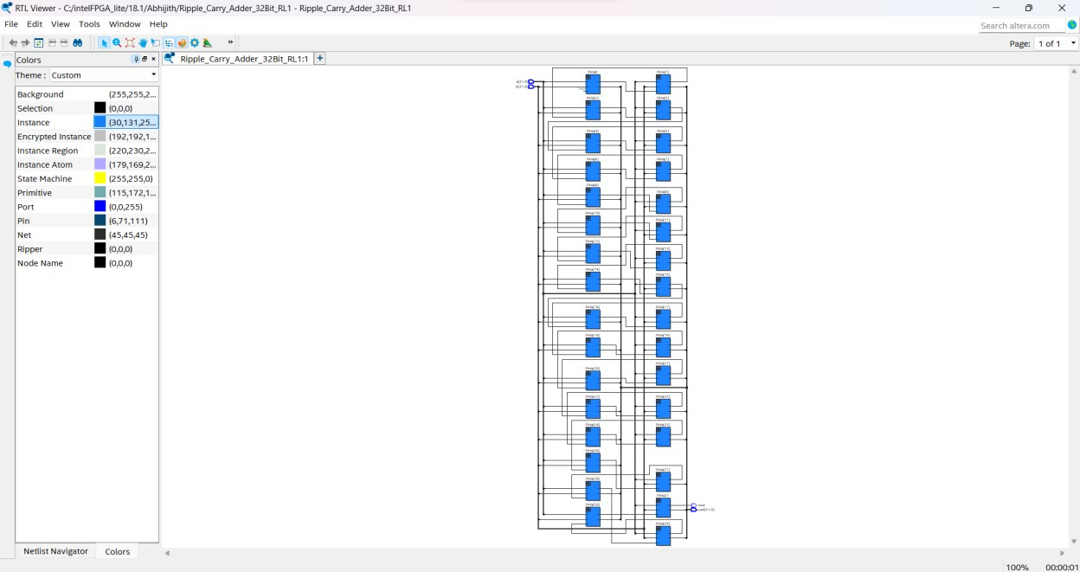

Technology Schematic
The Technology Schematic revealed how the RTL design mapped to FPGA primitives such as LUTs (Look-Up Tables) and flip-flops. The schematic displayed the mapping of logic gates and the carry propagation logic.
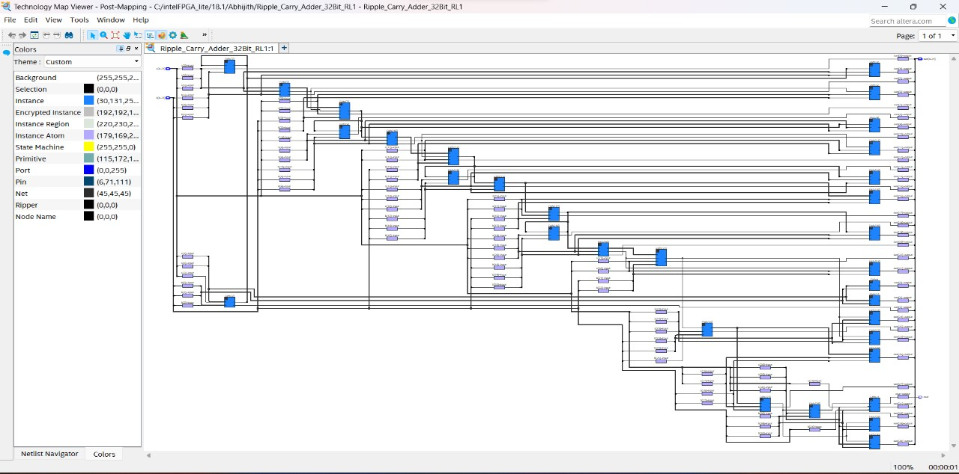

5. Device Utilization

Flow summary
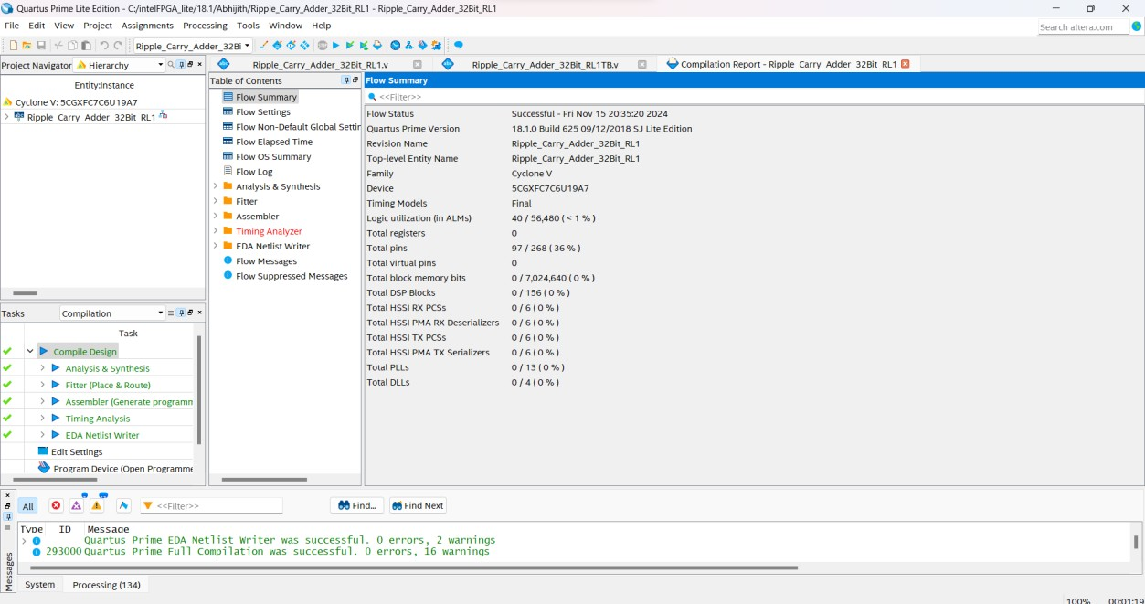

Resource Usage Summary
The 32-bit Ripple Carry Adder design uses approximately 64 LUTs to implement the sum and carry logic, with around 32 slices depending on the FPGA’s architecture. Since it is a purely combinational circuit, no flip-flops or registers are needed.
The Device Utilization Summary from Quartus showed that the 32-bit Ripple Carry Adder used:
- Combinational ALUT usage for logic: 63
- I/O Pins: 97
- Total fan-out: 375

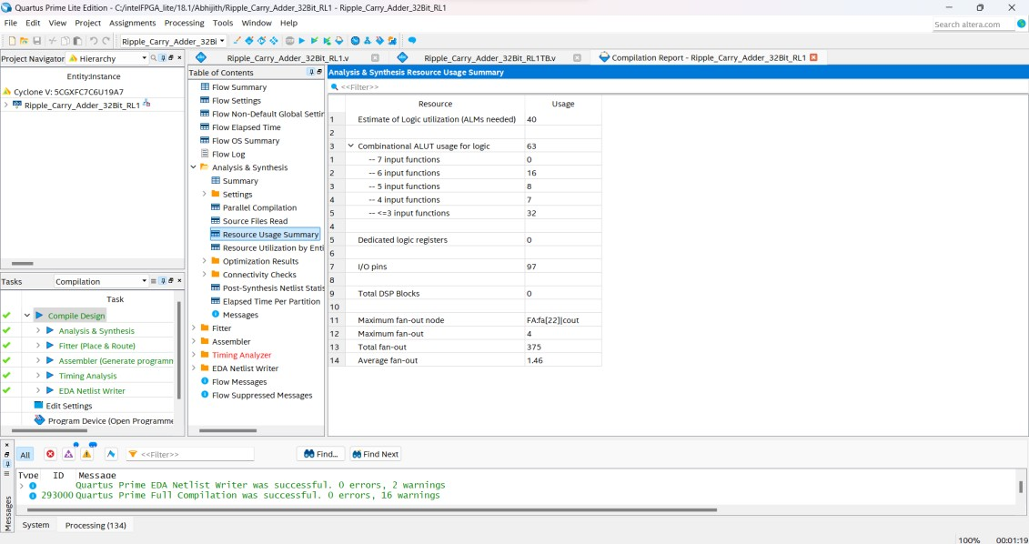

6. Conclusion
The 32-bit Ripple Carry Adder was successfully designed and simulated. It produced correct results in all test cases. The synthesis results showed reasonable FPGA resource utilization, with a relatively simple structure using only basic LUTs and flip-flops.

