**BASIC SKILL TRACKER TOOL**

**Requirements :**

1. **Tkinter** - sudo apt-get install python3-tk (linux)
2. **db-sqlite3** – db-sqlite3 pip install db-sqlite3 (linux)

https://www.tutorialspoint.com/sqlite/sqlite_installation.htm (Windows)

1. **DB Browser for SQLite** - <https://sqlitebrowser.org/dl/>

**About the code :**

1. The code follows **flake8** standards

( Eg: line length less than 72 char, 2 lines after each function definition, etc)

1. Minimal & necessary commenting
2. Docstrings used as per necessary
3. Self explanatory variables
4. Indentation for SQL maintained
5. Sufficient amount of spacing for readability

**Execution steps :**

1. Once all the requirements are installed and set, for easy execution, one can copy the code and run it on ipython kernel/ Jupyter notebook



1. Once run, it gives a pop-up box which is the simple & basic skill tracker tool

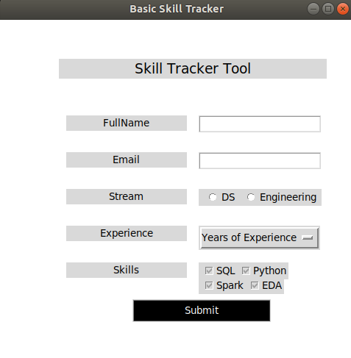



3. Fill in all the boxes and click submit. Once submitted, you can close the tracker

4. Now to check your data, search for the keyword “Skill_Tracker.db” .

Note : One needs to install **DB Browser for SQLite** (<https://sqlitebrowser.org/dl/>) to view the output

